APPENDIX

DARK AGE HISTORY
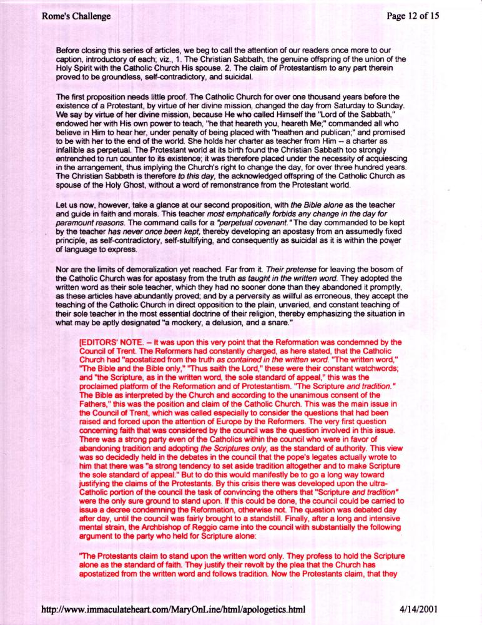
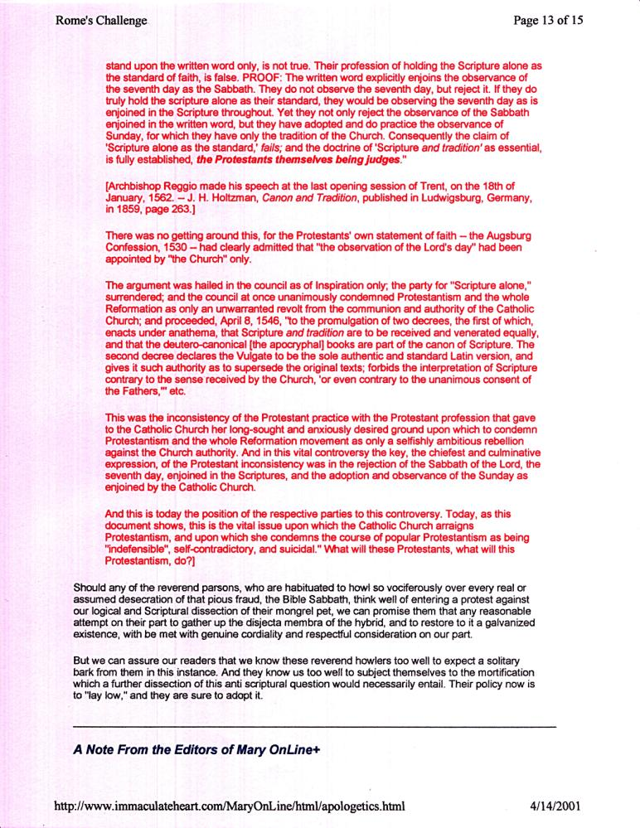
Note: That site was taken down when I first used it on my web site www.mosescats.com I wonder why?
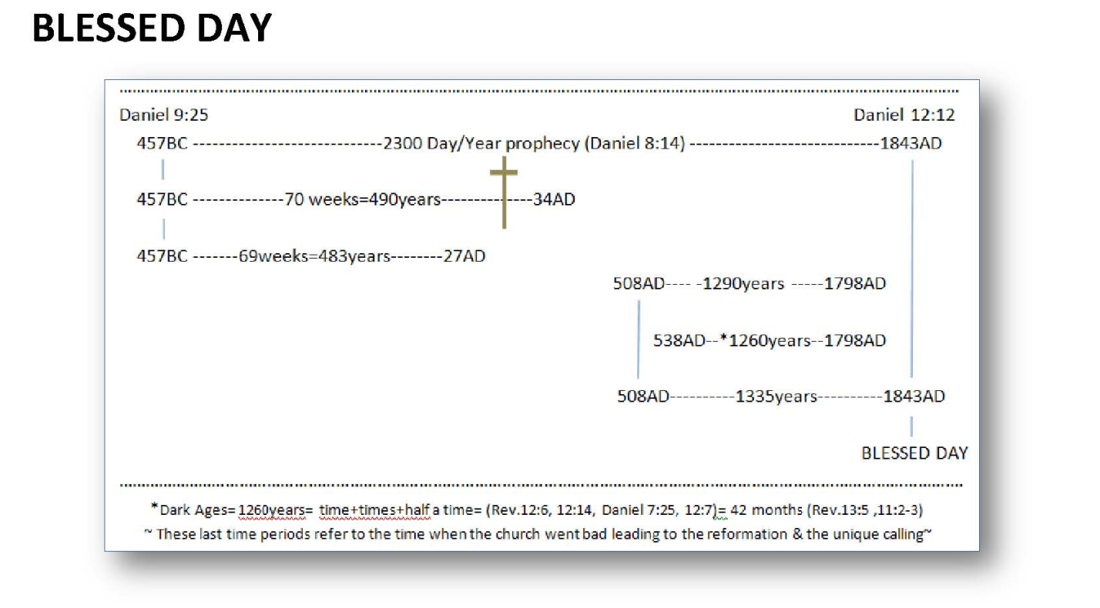

For a complete study of the Judgment beginning in 1844, and under what circumstances mankind (the second church) discovered that information via this prophecy; see “Yom Kippur” on my web site.

SIR ISAAC NEWTON

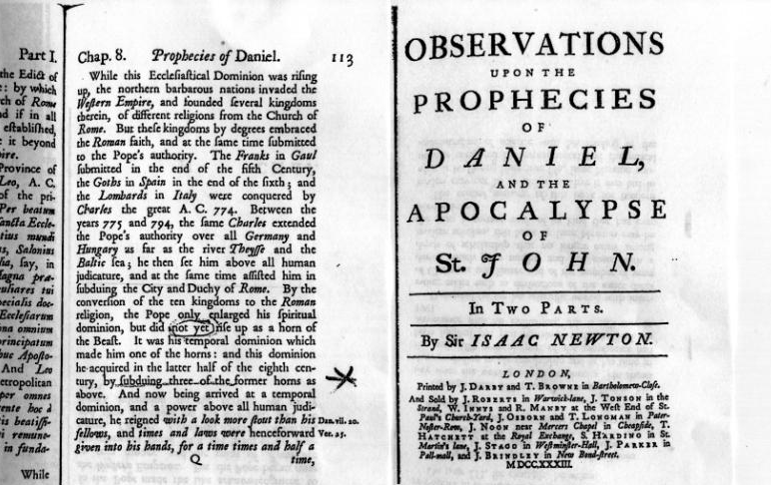
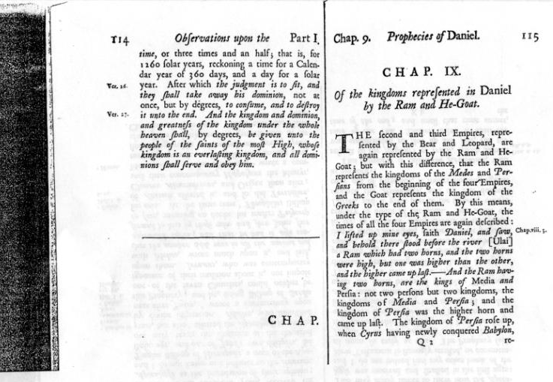

SAMUEL MORSE

Notice what Samuel Morse the inventor of Morse Code said about what the Protestants thought of the Papacy in his book under a sudo name. Notice the year this book was published;

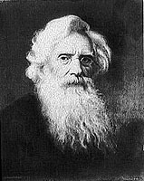
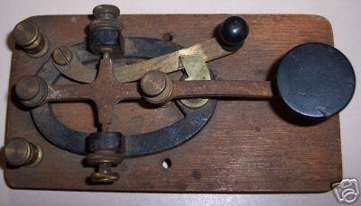

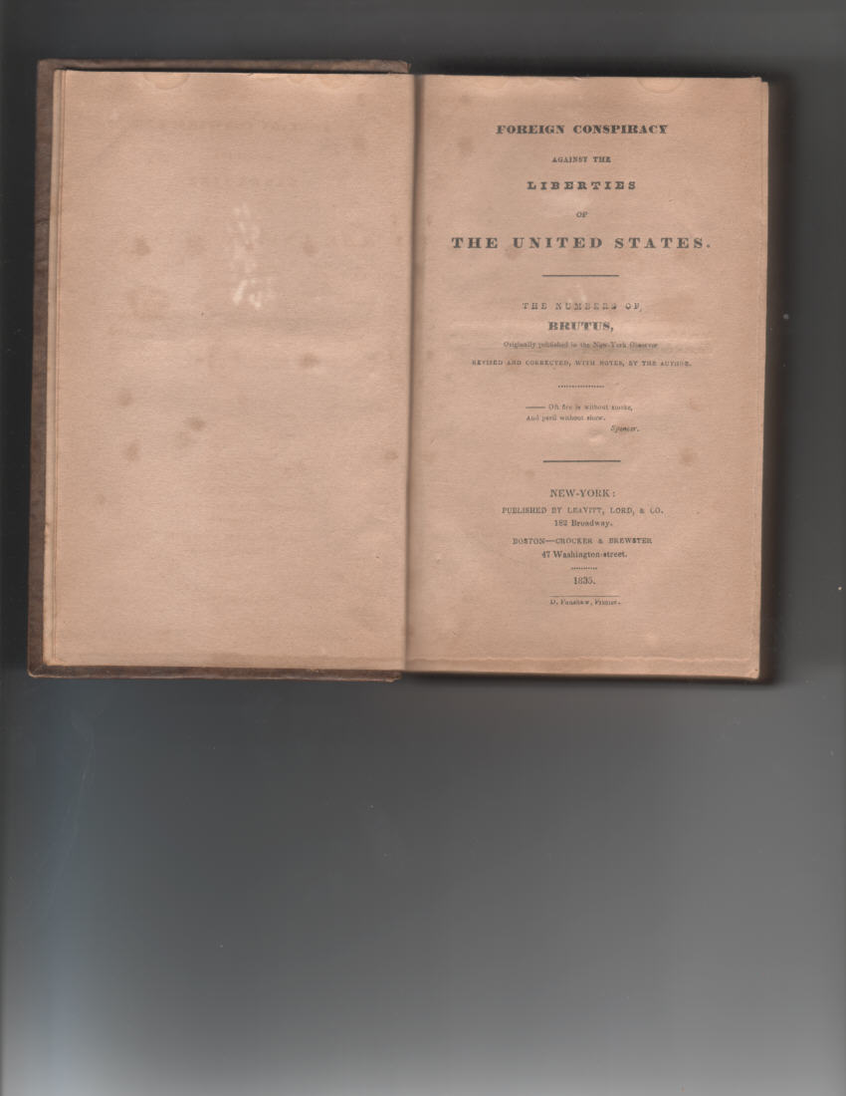

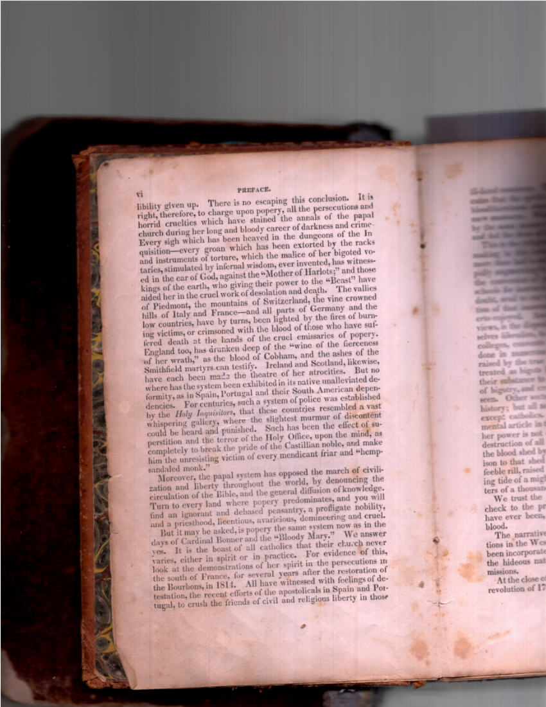

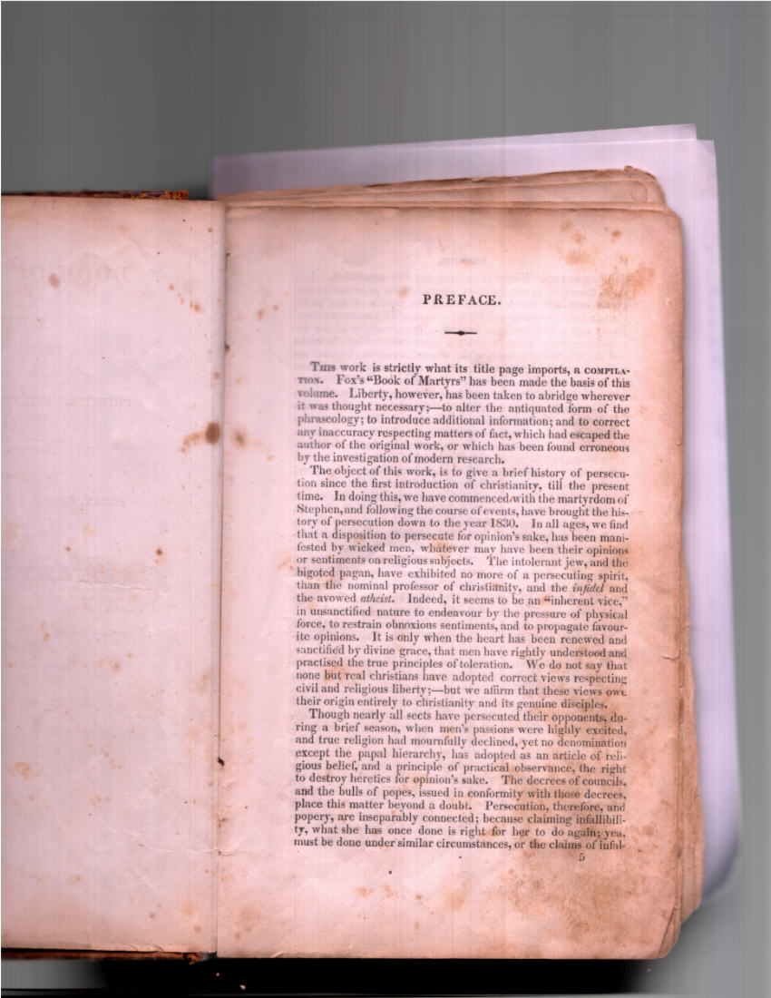

This book was written before the civil war, by Morse who was personal friend of President Lincoln.

The following are Abraham Lincoln’s words to a x-Roman Catholic priest who also wrote a book published in 1886;

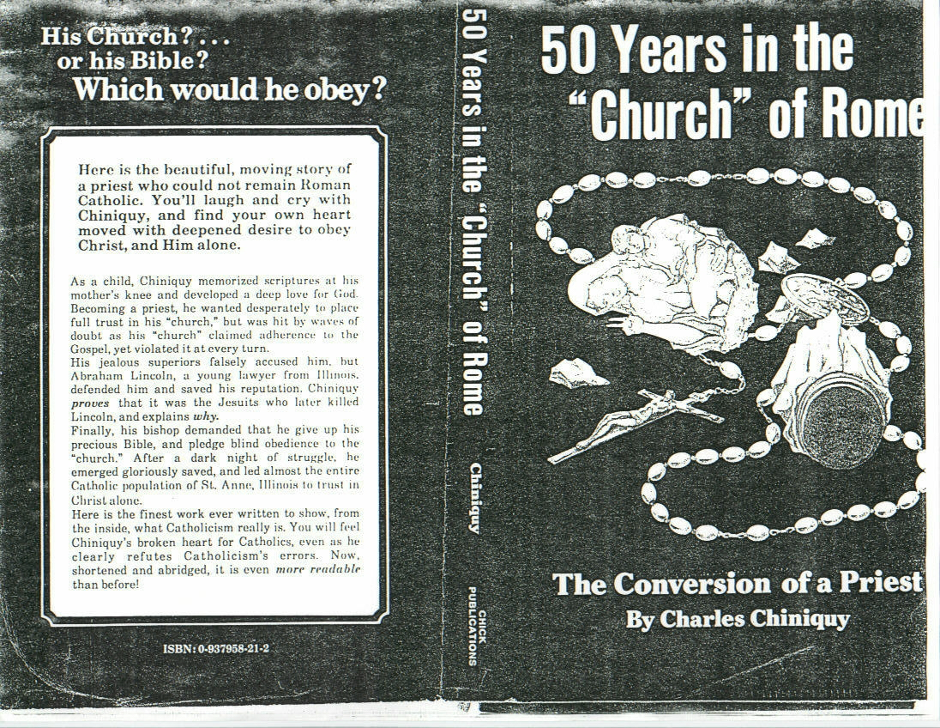

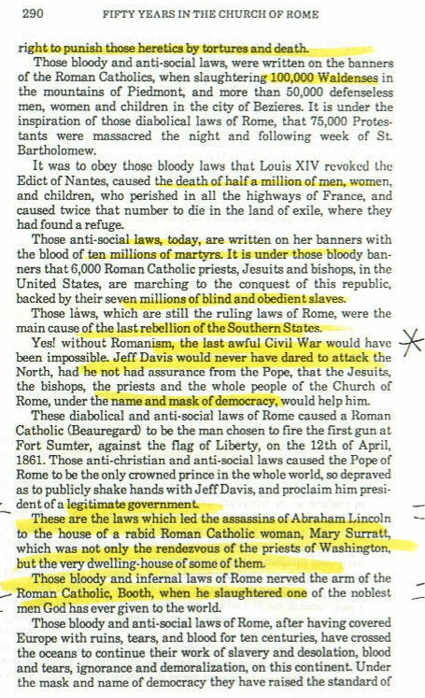
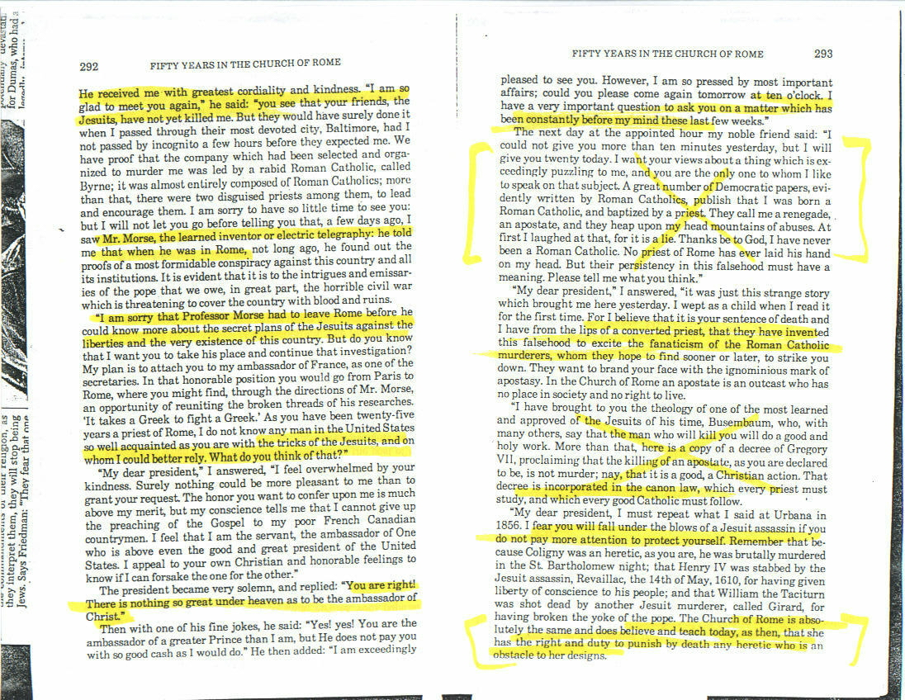

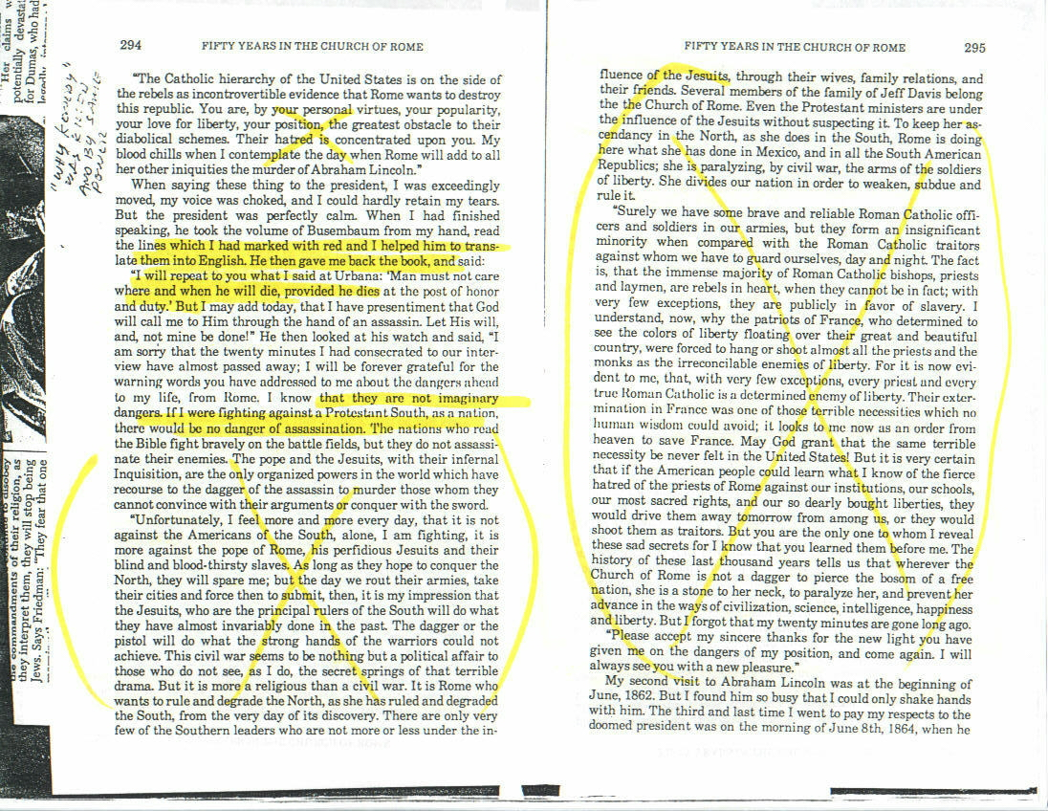

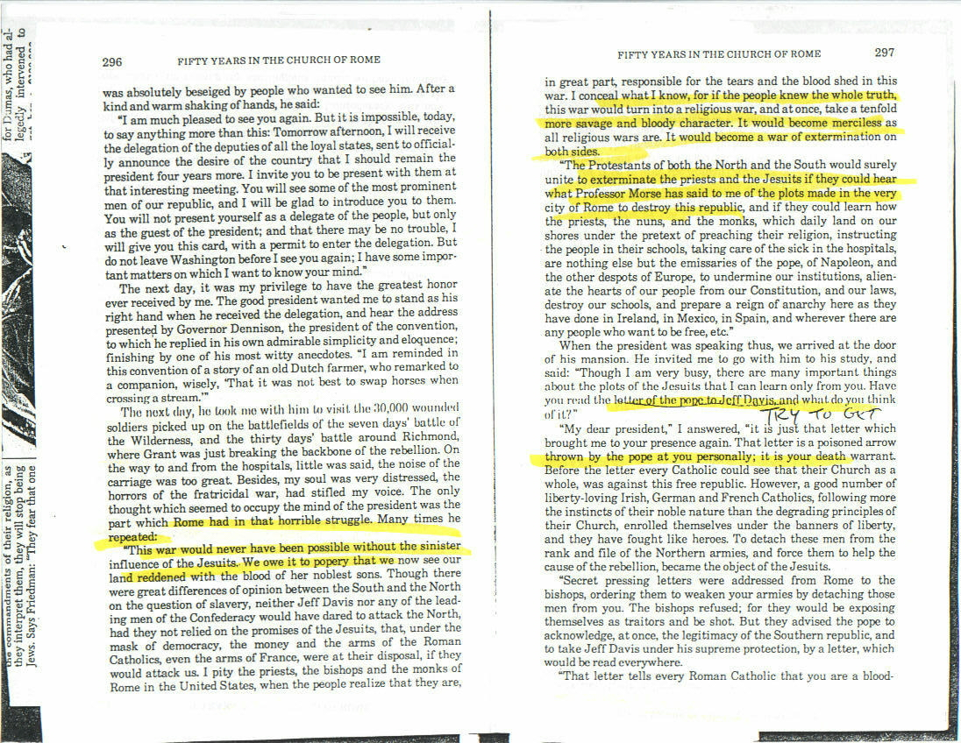

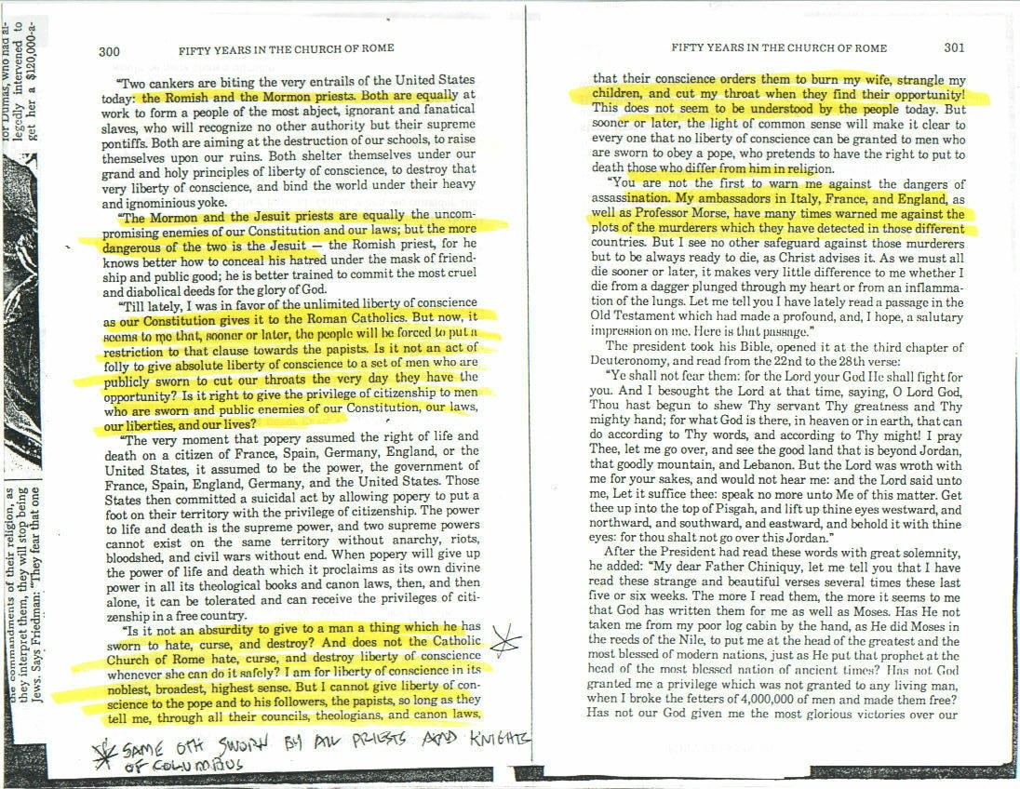

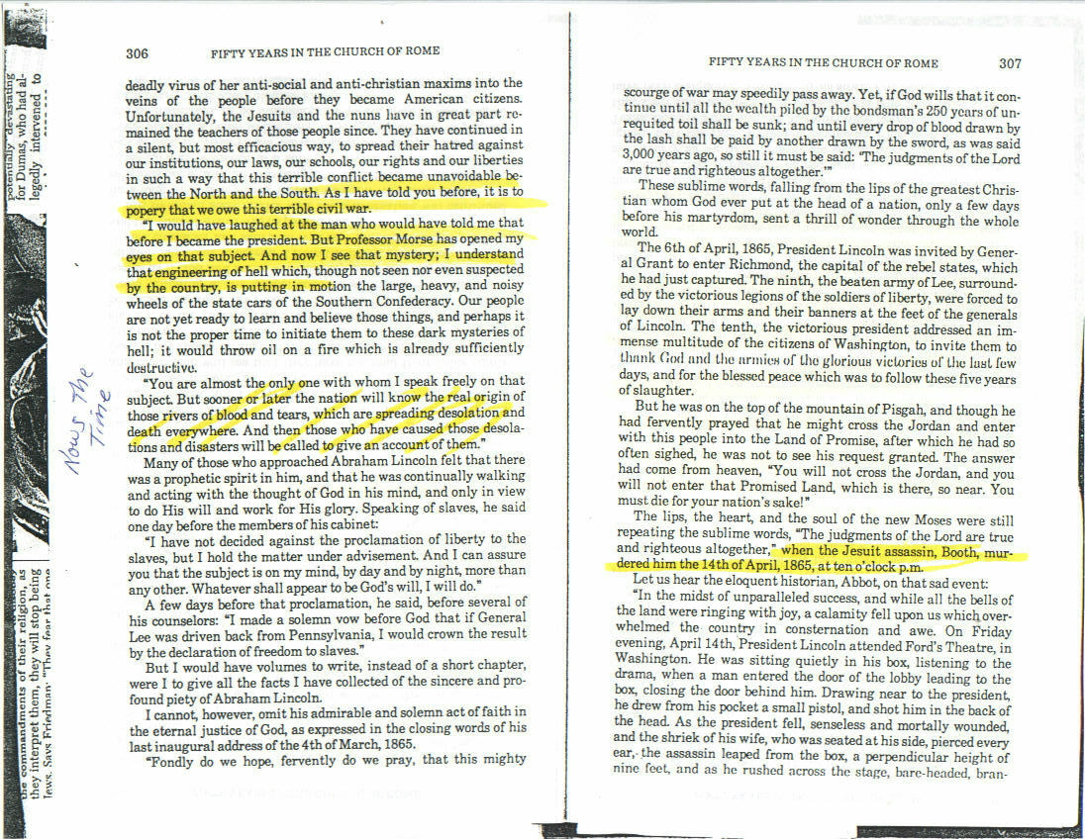

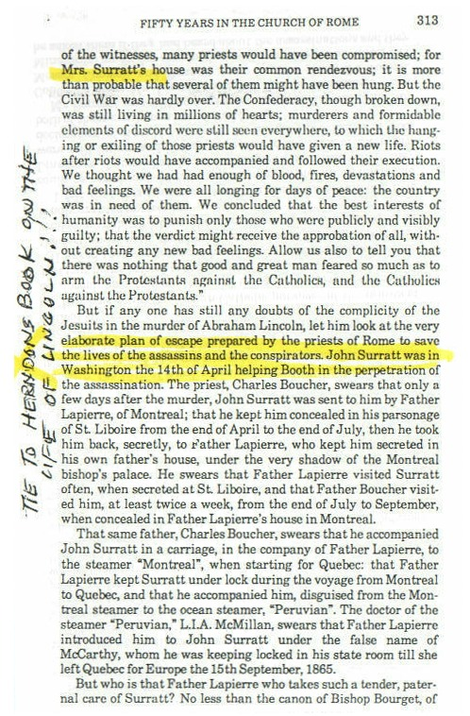

Someone might say there is no connection of Lincoln and this priest?

Take a look at this note found in the Library of Congress records; which connects Lincoln with Chiniquay. There is also a signed reciept from lincoln to Chiniquay for services he preformed for him that directly lead to his death warrant.

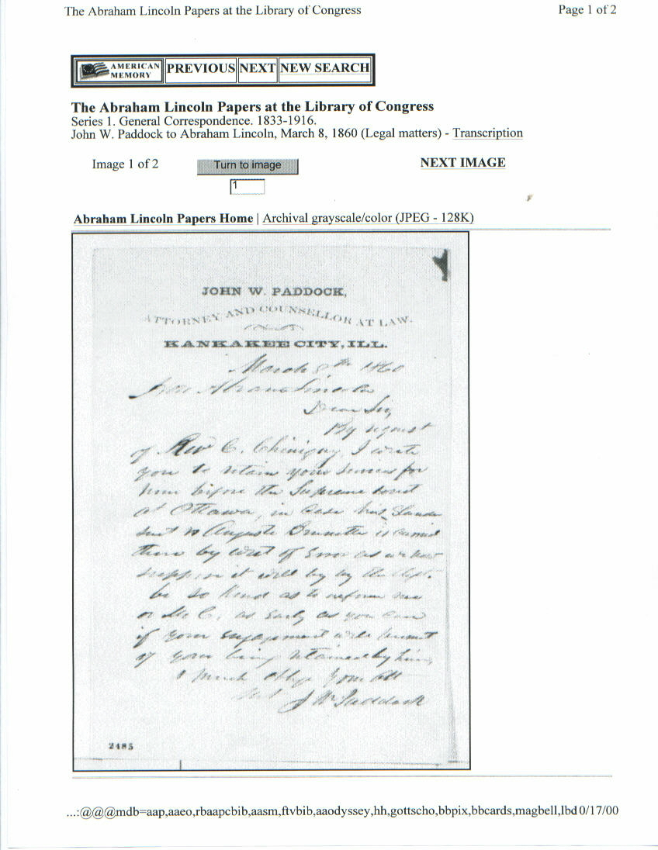

THE PAPACY

What does the Papacy say about the chage of the S-Abba-th?

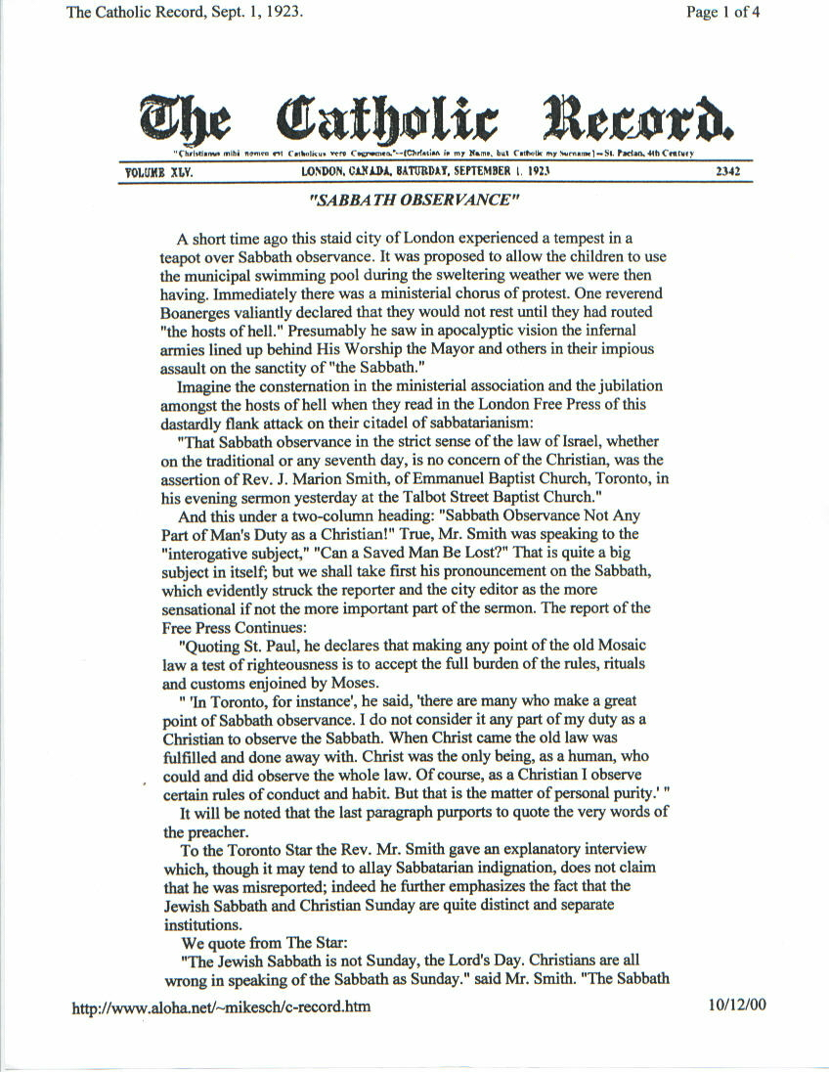

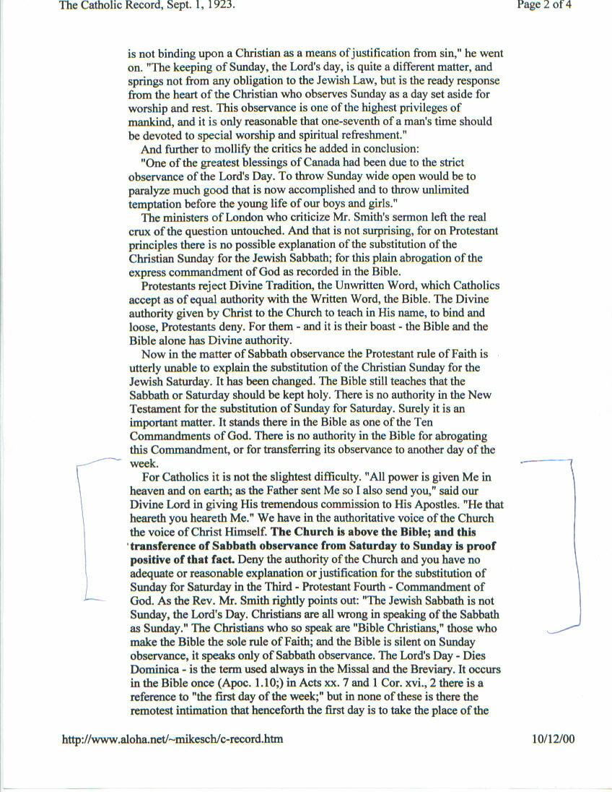

1798
The year of the deadly wound 1798 AD “exactly 1260 years from the date” the ex-Roman emperior Justentine turned over the remanents of the defeated rag tag remnants of the /Roman Empire to the church thus she had full control both religiously and politically from (538 AD). Politics and Religion a deadly combination “one that will take down the USA on the road to the end”, just hide in the bushes and you will see. Sunday blue laws of the 1888 AD congress was just a start, and it could have happened then but I believe God gave us a little more time before the last events begin, marked by a Sunday Law mandating Religion and who’s religion? The BEAST’S!
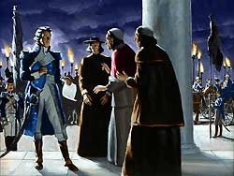
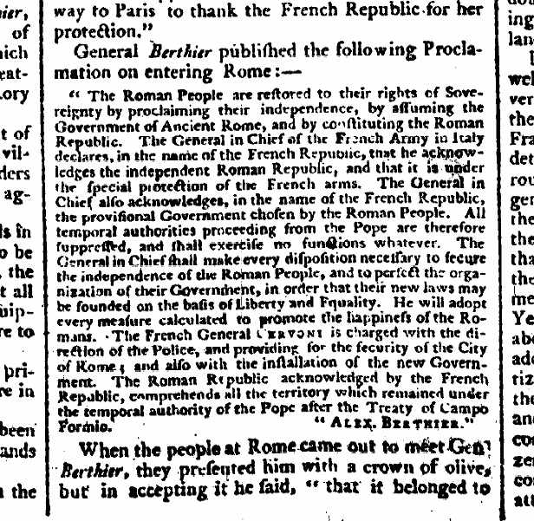
The wound healed?

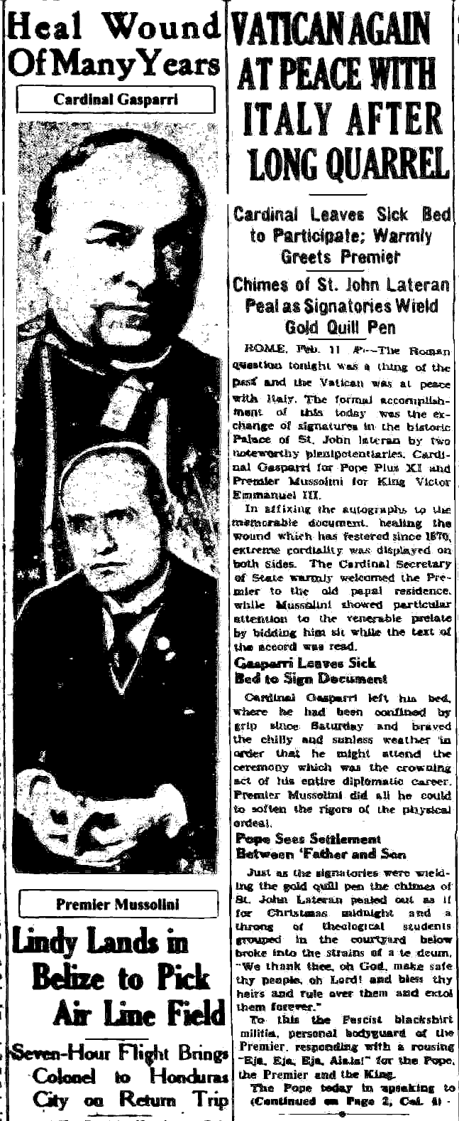

Using the Bibles very words!!

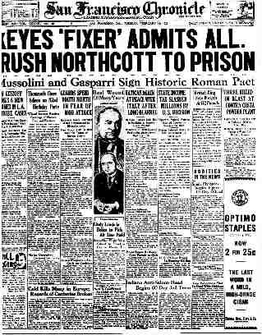

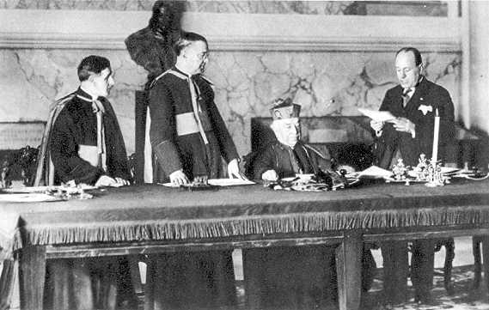
MOUSALINI GIVING THE POPE BACK HIS POWER IN 1920

CREDITS

Most Bible texts are from;
The Holy Bible: King James Version. Electronic ed. of the 1769 edition of the 1611 Authorized Version. Bellingham WA : Logos Research Systems, Inc., 1995, S. Re 22:1-21

All other media -Via Internet;
If you put it out there anyone can use it. If you didn’t post it, then be glade someone did! It might just bring you the fame and fortune you covet, that’s all you want any way, you have no care for the welfare of others, just profit! You make me sad, but, what do you think it does to God, or don’t you care? How you handle this is proof one way or the other of whose side you are on.

10:05 pm

The day I finished editing the first round of this book, Feb. 27, 2015~

Presidential candidate from Texas stated;

“We are on liberal justice away from the Supreme Court ordering the TenCommandments monuments from being torn down all across the country.”

What has been Satans attack from heaven to heaven?

You tell me, but the clues leave no guessing….

7:29 PM

The day I finished editing the second round of this book, June 25, 2016~

The supreme court passes what every state and the president wanted;

(((News)))

(((Text)))

You tell me if it isn’t getting near the end?

~mosescats~

