CONVINCED
©
BY THE LIES OF THE CHURCHES
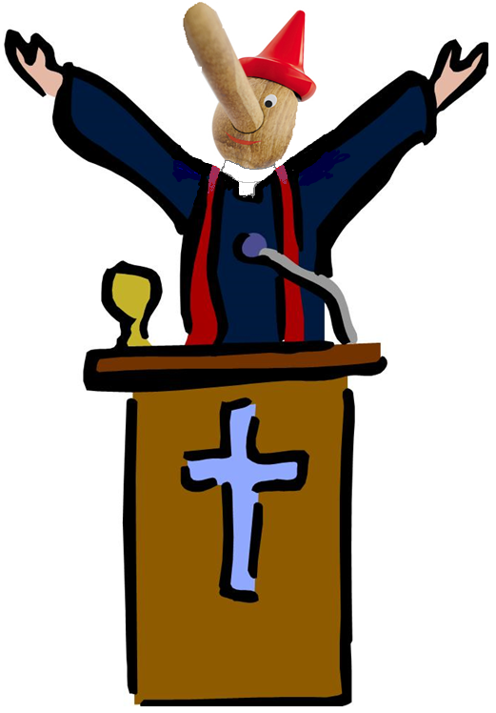

BY MOSESCATS

CONVINCED……
by THE LIES OF THE CHURCH?
At any given time, under the right circumstances, the right convincing, a person can be swayed in their thinking and belief system, in about any direction, and, this is especially true when it comes to religion.
How else can you explain; people being convinced, “from religious teachings mind you”, that it’s ok to kill the innocent “just because they believe something different” than what their religious leaders teach or taught, or killed because they didn’t/don’t believe the doctrines of “the biggest” of the churches of religion teach; from the snake handlers in the hills of West Virginia to the Tibetan monks or gurus that set on the highest plateaus of the world, and it is especially true, when the unknowing are young, they can easily be convinced, as I’m saying, of about anything.

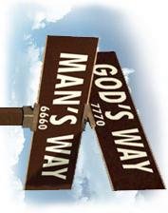

Older people have no excuse however, and I’m speaking particularly of the baby boomer generation, of whose parents were born before the compromises, we see today among Christianity, had taken them over! (small “c” yes)
The following study is a prime example “from history” past/prophetic/present/future history, of Christianity having been taken over by those compromises and “CONVINCED” thereby.
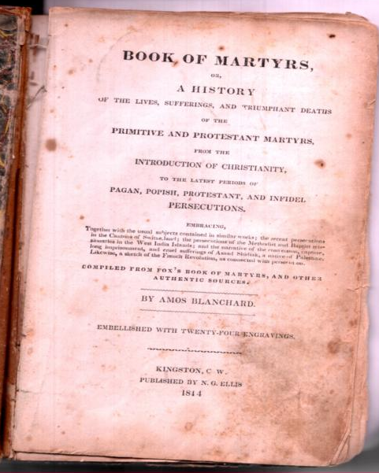

Protestant Christians - being pulled apart and skinned alive in
church monasteries - in basement Torture chambers during Dark Ages

Notice: the date of this book
Published in an age when books
were verified for authenticity

After centuries of persecution during the Dark Ages, as foretold by God through Prophecy, (Daniel 7, Rev. 12) how is it today the Protestants can’t see through this religion when their “founders” were well aware of her past? (See Appendix “Samuel Morse”)
You know the “one” they are falling over themselves to patronize when she hasn’t changed, nor can she change, or, she will lose her claim as the forever and only “Vicar” of Christ over this earth, in place of or ‘higher than’ the Son of God in an unbroken line of infallible Popes starting with Saint Peter, or so is their unprovable claim, proven only by their word and misapplied scripture.
God however describes her clearly; first to Daniel 605 BC (Daniel 7:24-25, 8:23-25) describing her as a little horn power over 2000 years before she would receive that wound, which came in 1798AD, and God describes her as a full beast to John in 96 AD (Rev. 13:6-7) later describing her as she started the dark ages and then after her wound healed she would sway the churches and even the kings “heads of states and countries” (we see happening today). (1922AD+ Rev. 13)
All this is old prophetic news anyone who studies the Bible should know, due to the fact that God composed two whole prophetic books dedicated to her revealing’s, perversions and her deceptions. YET, to this day nearly all the religious world seems to be wondering after this beast; the beasts from the sea “and” the ones from the land, both pictured below “at work fulfilling prophecy”. (Revelation 13:3, 11-12 How clear?)
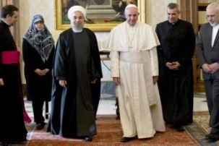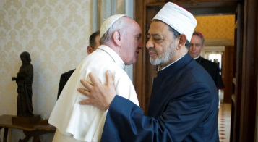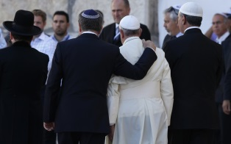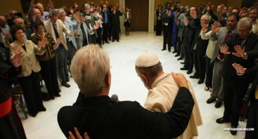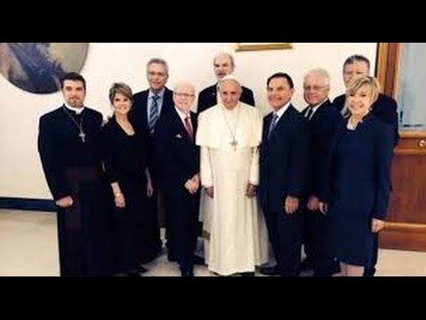
100’s of religions coming to meet (worship) the Pope. Just a few shots of the many posted on line.

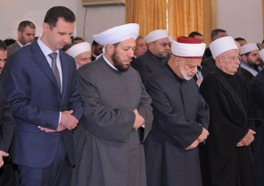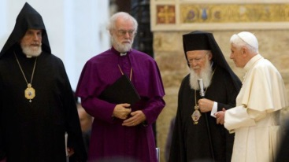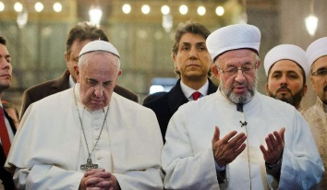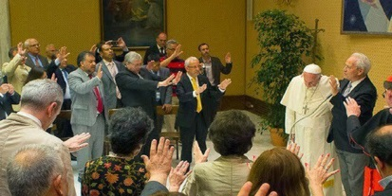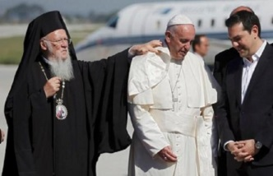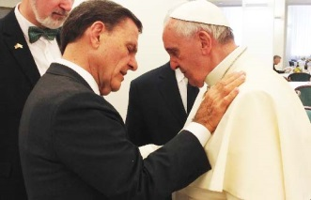
See also Appendix, for the capturing of a very “Eye Opening Site”, one I am not endorsing but, they are on the right track.

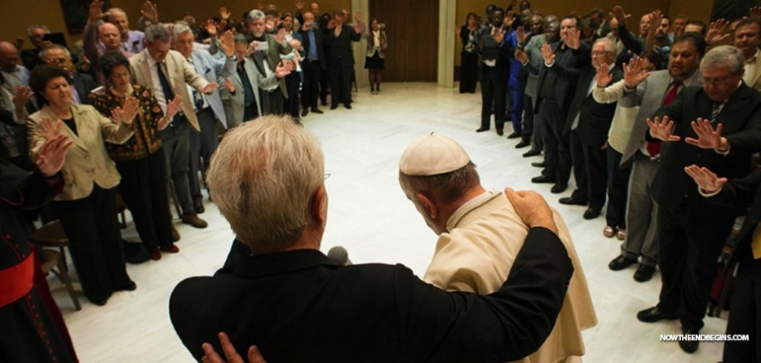
Even praying for and with, and the laying on of hands or wanting to, “Protestants no doubt”! If that isn’t joining in my friend I don’t know what else it could be? My-my how they have forgotten what God told them, (Revelation 13:3, 11-12) just like the Jews, mind you. Is your religion identified here? Look closely most were, and the list is (on line very exhaustive, but, again I’m not endorsing this site however very informative to be taken though with an open mind, please). Christian unity sounds good but under the osmosis of the Papacy what could be more prophetic and dangerous? (Rev.13:14-18 Clear enough?)
Meeting with unbelievers doesn’t get the same response they have of him, composite picture or not?

Haven’t you ever asked yourself; “why is it we have literally 1000’s of Christian churches alone out there”?
Each teaching something different from the rest and interpreting the Bible their own way, other than by God’s word “that interprets itself”. (II Peter 1:19-21)
The reason people are convinced by preacher so and so, or smooth talking Sunday evangelists like Joel, Rick, Kenneth, Benny or Jimmy, even Billy and a once spokesman for the Pope, Tony Palmer (the slickest and most cunning manipulator of the scriptures so far) endorsing Roman Catholicism, and also the most effective in destroying the clear scripture, and, in Convincing the unlearned (Matthew 24:24) but always remember the bottom line; (Isaiah 8:20)
Then we’ve got those experts and sure sounding masters of divinity (so claiming) like most “Sunday” Baptists, Evangelicals, Pentecostals etc. etc., defining now about all Protestantism as those above, because, they are all under a common worship that’s not Gods but mans.
The simple reason though people have been convinced of false teachings is; “People do not read, much less study the Bible on their own anymore” as they did many years ago.
It’s just too confusing they say, it’s out dated they add, the Old Testament is for the Jews not Christians, and, we only study the New Testament, and guess what? It’s true, they are taught mostly out of Paul’s writings, and most have made him their exclusive doctrine source, despite the Bibles warning of false prophets, (II Peter 3:15-16) and when they quote the Old they interpret it from the New Perspective, when it should be the other way around. (I Corinthians 10:4) Christ the same today, yesterday and forever!
Some Masters of divinity actually say, and many believe, we are to forget the Old testament; “it’s under the curse of the Law” (a prime example of taking Paul’s words out of context), and they use all kinds of misconnected texts, and lame arguments (most unbiblical), and they hold fast to their half-truths, whether they can prove them or not Historically, or with sound scripture, as the many texts I’m going to give here “in context” so there’s no question whether it’s Biblical or not.
It’s “tradition” they say “we hold” despite Tony’s claim, and friend; in most cases their arguments and even their traditions are not sound “much less Biblical” and, that’s why I’m going to address a few of the most popular ones right now as I promised to expose “the lies of the church” today as before.
This, so you can see from the Bible “for yourself”, whether they are Biblically sound or false teachings from the Dark Ages, which, in most cases they are “historically speaking.”

HISTORY:
Do you know anything at all about that age of darkness; that loosely fell between the death of Christs church 3-4th century AD to the wounding of the beast, with the amalgamation of the church filled with Roman practices and traditions rather than the Holy Scriptures, scriptures that were established by God “from creation to the Messiah”, yet during that Dark Age, lasting nearly a century and a half, (Literally 1260 years as God defined it), was a period of scriptural compromises that lasted clear up until the age when the Protestant reformation finally was able to take hold, and, “just as God predicted” with the wounding of the beast. (See “Time Chart” Appendix)
This period of time, God gave in symbolism calling it a “time, times and a half a time”, was to be (and was) a “fixed period in history” out there in the future that God predicted through prophecy in the 7th century BC, and it was to begin “at a given time and date in history”, and believe it or not, “He told us the exact year” when it would begin back there in Daniels time 7th century, and He also told us that it would end with the deadly wound of the “beast power of Revelations” through prophecies given to both Daniel and John.
The beast was described to His prophet Daniel as a “little horn power”, Daniel 7:8, 25) and it’s a prophecy we are told to “know and understand” by our Lord when He came to this earth. (Matthew 24:15) But Daniels book was to be closed until the time of the end. (Daniel 12:4) Daniel was told to seal it because it wouldn’t be understood until the prophecies were fulfilled, after Christ’s time obviously, and even after Johns time, who was told as Daniel to write it all down for us, and then the Lord added to Daniels ancient prophecies, via God’s word He, the Lord, sent down to John and us! (Rev. 1:1-3, 22:10)
The “Little Horn Beast” of Daniel, was described to His prophet John as the full “Beast of Revelation” by our Lord when He commissioned John to write the last book of our Bible, giving the “end time prophecies in full detail”, and his book was to be “an open book” not like Daniel’s (Rev. 22:10 , Matthew 24:15) , adding as I said to what He had already shown to Daniel in part.
“Seal not” the Lord said and remember His words He said. “Know and understand”, do we?
Do we even want to?
Some do, but can’t accept the knowledge they are receiving, it just seems so hard to believe, and then, you have those who won’t believe it despite Gods clear descriptions of a religion, in reality, descriptions that can only apply to one power alone, being the one that operated, and fulfilled prophecy, during that “1260 years”, and, that long of a period my friend can only fit where it does, because there is no other place 1260 years can fit; between the crucifixion and the founding of America gap, where else?
You tell me.
That Age of 1260 prophetic days which equal 1260 literal years that can only fit between the cross and the founding of America, “was rightly called the Dark Ages”, because; it was a period when the Bible was nearly wiped out of existence. By not only the “literal burning of it”, and the historical “burning at the stake of the people” like Wycliffe, Hus, Tyndale etc. who taught it or upheld it, to the destruction of the truth by all the false doctrines that were set up during those years, and it’s this; we are going to discuss.
THE LIES OF THE CHURCH that have CONVINCED nearly all of religion that they are Biblical truths, when all it takes is just a study of this phenomenon for us to see the reality of it “happening in about all the churches worldwide”, while the non-Christian religions have their own problems of reality, and that reality is antichrist as Biblically defined.
This eminent Biblical apostasy of the churches is based on those false doctrines the church in charge made up for her own benefit, her own control over religion, like she had once during that long period of “a time, times and a half a time” a period clearly given by God as 1260 prophetic days or literal years, and being the exact time in which the aforementioned power was ruling religion, by actually enforcing her own and not Gods religion on the people He called, through the use of persecution, and by keeping the common people from the Bible, and, also by confusing scripture in making up her doctrines, which we are going to discover are really the doctrines of devils, and worse, those doctrines are still held “sacred as it were”, still to this day by most of the ‘c’hristian churches out there “as truth?”
Its these doctrines, that people have been “CONVIENCED” are truth, when in reality, they are in direct opposition to the truth the Bible clearly presents, but, they have been held as traditions so long, and taught by such sly and cunning teachers (II Timothy 4:3 itching ears) and preachers who know better, thus; over the many years they have CONVINCED their flocks and themselves with these “half-truths” so long, they honestly think they are bearers “of full truth”, NOT!
I got back on the interstate once heading for Florida after a pit stop and I honestly thought I was heading in the right direction, but it wasn’t long until I saw a familiar site I had passed before, and I knew then I was “honestly going in the wrong direction”, what did I do?
Keep on going once I realized I was going in the wrong direction?
If I was honest with myself, I would immediately turn around and head into the right direction to arrive where I wanted to be.
Too many people “honestly” think they are in the right religion, mom and pops religion, the biggest religion that couldn’t be wrong. “How could a billion people be going in the wrong direction I’ve heard stated?”
But they are my friend, and when truth smacks them in the face and they see it’s wrong what do most do? They just continue to go wrong despite the many warnings they have been given by our Lord and, according to the Bible they will never make their goal in that religion, because truth is paramount, is it not, when it comes to God?
You tell me…
This idea that people, can and have been convinced that their religion is right for so long, and the road is so familiar, even if it’s leading them in the wrong direction, change is unlikely. They just follow their deceived leaders into oblivion, and, if you recall this was the first thought I started this piece out with, in that; these claiming men and women of the “spotted” cloths, “in unison with their new humble leader”, have nearly overwhelmed all of Christendom into believing their lies, (how else can you say it? (Rev. 22:15)
What does God say about their lies against His religion, and the keeping of His Covenant laws each and every “one”, not just the ones those false religions have accepted, picking and choosing by their will and not Gods? (James 2:10-13, Psalms 40:8) and they can pray all they want among themselves but God isn’t listening, in fact their lies are an abomination to Him. (Proverbs 28:9) As they continue to spread those beliefs to a world that “doesn’t ever check out their religious views to see if they are Biblical or not, causing them to be deceived as the end result.”
Why do I say that so bluntly?
Is it because I think I’m some kind of know it all?
No, I’m just repeating what their favorite author said when he warned the church of this happening “in his future”, and friend; Paul’s words are clear and fulfilling right now in our very ears this day, and God is deciding our fate as we speak, and, it all focuses around “TRUTH” verses errors, notice;

2 Thessalonians 2 King James Version (KJV)
2 Now we beseech you, brethren, by the coming of our Lord Jesus Christ, and by our gathering together unto him,
² That ye be not soon shaken in mind, or be troubled, neither by spirit, nor by word, nor by letter as from us, as that the day of Christ is at hand.
³ Let no man deceive you by any means: for that day shall not come, except there come a falling away first, and that man of sin be revealed, the son of perdition;
⁴ Who opposeth and exalteth himself above all that is called God, or that is worshipped; so that he as God sitteth in the temple of God, shewing himself that he is God.
⁵ Remember ye not, that, when I was yet with you, I told you these things?
⁶ And now ye know what withholdeth that he might be revealed in his time.
⁷ For the mystery of iniquity doth already work: only he who now letteth will let, until he be taken out of the way.
⁸ And then shall that Wicked be revealed, whom the Lord shall consume with the spirit of his mouth, and shall destroy with the brightness of his coming:
⁹ Even him, whose coming is after the working of Satan with all power and signs and lying wonders,
¹⁰ And with all deceivableness of unrighteousness in them that perish; because they received not the love of the truth, that they might be saved.
¹¹ And for this cause God shall send them strong delusion, that they should believe a lie:
¹² That they all might be damned who believed not the truth, but had pleasure in unrighteousness.
¹³ But we are bound to give thanks alway to God for you, brethren beloved of the Lord, because God hath from the beginning chosen you to salvation through sanctification of the Spirit and belief of the truth:

Did you see Paul is speaking of this beast power who magnifies Himself or is magnified above all, even God?
Did you see our salvation is conditional on believing and accepting the Truth of God and that through Sanctification?
Did you see the place of truth Paul sets down here, that we have been warned to uphold, and Gods penalty for not doing so?
That’s “deception” my friend according to God, not me, and it’s when we allow someone else to fill our minds and hearts with half-truths “and” never once check them out as to whether what they teach is of Gods design or Satan’s, and , if we allow them to continue to deceive us, especially when we see their errors through scripture, then we will remain deceived and, as we read; God will allow us to have our own way and remain under our delusion even “sealing it Himself”, and our end is not with Him but without Him, and we will be found with those outside the gates of heaven, it’s just that simple.
Revelation 22 King James Version (KJV)
¹⁰ And he saith unto me, Seal not the sayings of the prophecy of this book: for the time is at hand.
¹¹ He that is unjust, let him be unjust still: and he which is filthy, let him be filthy still: and he that is righteous, let him be righteous still: and he that is holy, let him be holy still.
¹² And, behold, I come quickly; and my reward is with me, to give every man according as his work shall be.
¹³ I am Alpha and Omega, the beginning and the end, the first and the last.
¹⁴ Blessed are they that do his commandments, that they may have right to the tree of life, and may enter in through the gates into the city.
¹⁵ For without are dogs, and sorcerers, and whoremongers, and murderers, and idolaters, and whosoever loveth and maketh a lie.
¹⁶ I Jesus have sent mine angel to testify unto you these things in the churches.

But Churches (people) these days are as the Jews, they are so established in their religion, their inherited mom and pops religion, or, so deceived by their religion they see no need of change, despite the clear scripture, scripture my friend “they will come to see before the end” that’s just how God works that none be lost save by their own choice.
Some day we all will face the truth by Gods fair design; so that no one will not have seen His truths, so that all will have been given the opportunity of life forever, and that being, I repeat; the choice to follow Him or reject Him, His Word, His Covenant, His ways, His laws (Gods Commandments); all set up that we might know His Truth, His will and His ways of eternal life, “that will once again be part of His kingdom to come on earth as it is in heaven.
A kingdom on earth and heaven “wherein there will never be another rise of sin nor sinner, and why?”

For all will have chosen Gods will
and they would die rather than
reject it ‘forever and ever’

Thus sin (Transgression of God’s law I John 3:4-12) sin will never enter into any new born soul, nor raise its ugly head again, get it?
Sure, we are all sinners, and will never be anything different of ourselves.
We are born into sin and have the spots of sin, as a leopard and can’t remove them to be eligible for life eternal, BUT; and only through our schoolmaster of the law (that points out the knowledge of sin for us to overcome as Paul. (Romans 7:7)
That is; “if” we will just let God place them into our hearts and minds through the spirit of truth “to work out His salvation through and for us” (that’s the sanctification process Exodus 31:13 as it has always been, as John told us from the beginning I John 3:1-11), it’s only then when we let God in by faith (belief in His ways) my friend; can we be more than overcomers of sin and it’s deception’s, its grips.
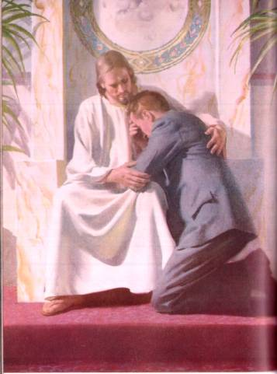
Thus, it’s only when we choose His way of overcoming, “the way that works”, then, He can come in and begin His work of sanctification in our life.
The same process; was symbolized in the first Covenant with the “two laws” working together for the repentant sinner and it was shown to them and us in graphic symbology from the beginning.
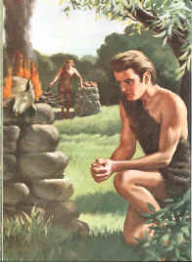
That process of salvation, as does ours, comes in three steps “we must take”, and each is a prerequisite for the next step (the 1st must be taken before we can take the next, for it to work in our salvation.

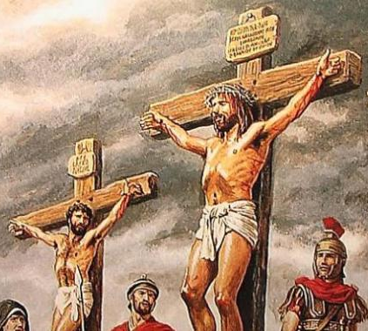
The thief on the cross, used as an example that all we need is faith and not works, but, that thief in reality just took the first step, why?
Because death was his next work, but my friend, had he come down alive, “the second step” would have been required.
The 1st step is Justification; bringing the lamb to the temple in faith as for Israel was their only work “but yet a required work. The bringing of the Lamb in faith justified the pennant sinner. We pray today in the same faith for the blood of Jesus to cover each and every sin, do we not? (Romans 2:2-12, 13 notice vs. 13 our work).
Sanctification 2nd step; after leaving the sanctuary back there in Israel, they were to not sin that same sin again “or” another sacrifice was required.
It’s the same for us, we must ask again for forgiveness for each and every sin, not just one prayer to be saved as the once saved always saved lie teaches, and not by confession to a priest who then prays for us, as only he can they claim falsely? (Leviticus 20:8, John 17:17-19 there’s the place of truth again in the process even for our Lord Himself!)
Glorification, the 3rd step (Isaiah 45:25) something Israel, nor can we do of ourselves, “but only the Lord can” as we just read “through Him” we can be glorified, and that’s done by us allowing Him access to our hearts and minds remember, and yes, we as the seed of Israel, we can receive through Abraham the promise of glorification we are told; (Galatians 3:29)
When?
When we, not as Israel who rebelled against the Lord, (Hebrews 10:26-29) when we, allow the law (schoolmaster) to bring us unto Christ from within vs. 24-29 ourselves, our soul, our minds and heart, He then promises to come in and make us more than overcomers of the laws (Gods) justified demands, and eligible for life eternal in a world without sin forever.
If however we reject His will, His ways, His laws of life etc. then we will never let Him in “as did Israel”, and be rejected as a church as a people, (Matthew 23:37-38) and listen for this is extremely important; “should we be given access to heaven as law breakers, sin could easily rise again through us”!
But, all who breach Gods Covenant willfully, having the knowledge of the truth yet reject it - “will themselves be rejected”. (Hebrews 10:26-31) and they do despite to the spirit of Grace!
It’s those who believe and love the lies of men or their CHURCH (their religion), (II Thessalonians 2:8-12) those who believe their lies and perpetuate them as do the churches knowingly, as Paul says, are under the influence of the master liar himself and his men of sin who will meet there end as well, and, will be with those who will remain without the gates Rev. 22:10- and whose reward is eternal loss within.
Oh no, not from without by the fires of hell will they receive their reward and suffer, but it will be from the realized loss of what they could have had but they gave up, for what?
Israel was “a church” and not just a Jewish community, please, and were rejected as a people not following God (Matthew 23:37-38), but, even for them, through all the many years He didn’t force His will on them, and He won’t force His will on us, but, He must let us go to follow our own course if that’s our choice. Doing so though, and after a while of so doing, despite His ever calling for us to return to Him, we will soon not even hear His Holy Spirit trying to woo us back, to His ways, and into His camp and out from the worlds camp (Unity) and their ways which have a grip on us, including those grips of Satan’s religions etc. etc. Because of love
Jerimiah 24:7 As Israel of old so is the Israel of new and God still waits..
I got off my subject in my attempts to help you see a different Jesus, being the one who wants to come in and write His laws in us, as has been the theme of the Bible since the first fall against Gods specific command (just one then) by the powers of deception and notice, using the same lines;

⁴ And the serpent said unto the woman, Ye shall not surely die:
⁵ For God doth know that in the day ye eat thereof, then your eyes shall be opened, and ye shall be as gods, knowing good and evil.

That’s what the Pope thinks of himself right, himself as God, and predicted as such? (II Thessalonians 2:1-4)
It is these things we need to see, for things are getting serious and Satan’s cohorts are saying the same things like; “our eyes are open today to a new law for we know good from evil, and it’s through our unity, less all those Jewish doctrines, that will save you, not kill you as the cursed law can do if you try to keep it, let it go eat of our fruit, be free just have faith as we do, they say, believe as we do, for it’s those who continue to protest that are holding you back, trying to tie you to the law, it’s those who are the real enemy!
Friend the times are getting dark again, as in the beginning when we didn’t have all the knowledge from Genesis to the Messiah when the church still didn’t have the knowledge of God, just as it was in the Dark Ages of the past when the truth could not be found, as it will be after this last probationary period of the blessed day (Daniel 12:9-12, Matthew 24:20-22) and that darkness is now closing in as we have seen, men and women returning to that same power of deception. Begging us then, to continue to discuss this, so that our Convincing comes from God, and not man.

FALSE DOCTRINES
Let’s list just a few of the False teachings that have Dark Age roots and then, look at them “from a Biblical viewpoint” and please, not from some master or doctor of divinities writings, or some favorite evangelist, or even from our own interpretations “but from Gods” point of view (Remember II Peter 1:19-21), and why is this so important especially today here in the end of time?
The Truth can only be found, interpreted, and then applied though “searching the Scriptures alone” for the answers, for nowhere else is found truth, only God’s word alone, and “it’s His word that all else is checked by” not the other way around. He even says check me out, (John 5:39, Jeremiah 29:13) and listen, that’s a big point today since there are some many Biblical experts out there, all claiming to know and hold the truth from their distorted views, including those of the church given over to traditions (despite their claims) and errors of the past and here’s just a few.
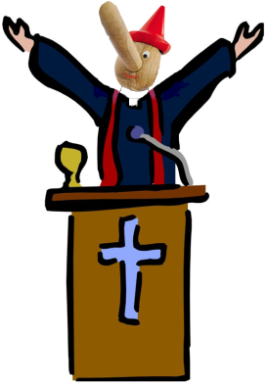

Topical outline of the lies and the confusions of Biblical Truths – and what God has to say about each “not man”;
- Life, the spirit and soul, from Gods point of view!
  - Life after death
  - Immortality of the soul and spirit
- Hell
  - When, where and what is Hell really
- Fate of mankind, fate of Satan
- What are the requirements of Life eternal
- The Covenant
- Salvation
- Justification
- Sanctification
- Glorification
- Three angles messages of Revelation
- The place of prophecy
- The testimony of Jesus
- The Mark of the Beast

A. What does life have in common with the spirit and soul?
We see it best in the creation of Adam;

Genesis 2:7 King James Version (KJV)
⁷ And the Lord God formed man of the dust of the ground, and breathed into his nostrils the breath of life; and man became a living soul.

Look how simple the equation is to define a living soul, or the soul, and what gave it life? It was “the breath of life” as God defines, not a spirit infused into the mind by God, but as He defines; “into the nostrils” a physical aperture He created for that purpose, the same way we still breathe in “life” today and live.
So, we have the body plus the breath of life making up the soul.
Take away the breath of life and what happens to the soul?
It’s like a box built of nails and wood, made from a pile of wood representing the body and a pile of nails representing the breath of life; put them together and you’ve got a box, done right of course, next we take the nails and the wood apart and where’s the box?
It doesn’t exist anymore, and it’s the same with the soul.
They say the soul is our consciousness and it continues to exist in the spirit as it leaves the body and goes back to God as the Bible text seems to tell us, to heaven of course we assume, since it’s going back to God?
What about then the spirit that goes to hell?
Was it Satan that breathed the breath of life into that body so when it dies it goes back to him, and into hell of course?
So essentially those religions, who subscribe to the soul going back to God, are saying we are not souls at all “but spirits”, however that doesn’t fit the equation of what makes up life as God defines it either.
Is it then God takes the body and breaths into it the soul and man becomes a living spirit?
In that case when he dies the soul goes back to either heaven or hell.
Don’t you see the soul and spirit are not interchangeable?
God “breathed” that’s a physical thing, the breath of life like we breathe in every day and that’s supplied by God right? However, take away the breath and we die. Soul or no soul, our consciousness then is like the box it just doesn’t exist anymore.
Body physical, the breath of life physical even if we can’t see it, and the soul is the combination of the two.
A baby has a soul but no spiritual consciousness at first.
Animals have souls for they have the breath of life, but no spiritual consciousness most always.
Man became a living soul, alive, having life, and life is the opposite of death, we could go round and round with assumptions, conjecture and even science, or we can just accept and believe all those out of body experiences doctors claim to have had, but, to get this straight we must find Gods definition of death to fully understand what really happens when we die.
Does our spirit move on after death, does our consciousness really move on as a spirit and ascend to heaven or?
Remember the box; it comes into being as the spirit comes into the body, but when the spirit goers out of the body as when the box is dissembled, like when we die, so, what happens to this soul or spirit or consciousness when our body is laid in the grave?
It’s so confusing it seems, but, God gives us the answer “as always if we but just seek to know the truth”, and it’s the same with every conflict of scripture we are faced with.
You say what’s the big deal, what does it matter “what happens at death?”
It’s a very big deal my friend; for there is a real spirit world out there (Ephesians 6:12) and if Satan can get you to believe that our spirit continues to exist somewhere out there when we die, then he can use that against us to convince us of anything.
An example real quick; Your mother or dad dies, let’s say they were Catholic (who actually came up with this doctrine of life right after death, called the doctrine of the immortality of the soul), and your parents believed that your soul goes in limbo or to purgatory as they call it, and it’s headed either for hell or heaven, and, it’s up to you to pray them out of purgatory and/or pay a penance, they call indulgences, to get them out, so that they don’t go to hell but heaven.
Of course once you pay your indulgence, a priest will pray them out of hell and into heaven for you “in time of course” that is, if you keep on giving. Trust me I know all about this having grown up in an extended Catholic family, and listen; this is the very thing that Martin Luther (16Th century) said was unbiblical, but, your mother and dad in our scenario believed this was “the true way of religion before they died, (and of course they will be judged having not known better it’s not our call nor a priests) but anyway, they passed that belief on to their siblings.
However, later on in life you discover that that belief is a lie as Luther defined, a lie that was perpetrated by the church during the dark ages, to build St. Peters cathedral etc. and all the wealth the church has accumulated to date, and we learn God says; all those indulgences and priests prayers have no power according to His Word. (Isaiah 8:19-20 shouldn’t we consult God first, to end the confusion?)
So when it comes to praying people out or in, when it comes to where the soul or spirit goes neither you nor me nor father/cleric nor does any so and so have that power!
God determines mankind’s fate by their works, and not just any works, (Rev. 22:12, James 2:12, Romans 2:6-12) and its Him who determines and tells us what happens to those people, all people when they die, and to which resurrection they will come up from the grave as their reward (John 5:25-29), and He doesn’t leave us in the dark as to “when they will come up” in which resurrection and yes there are two resurrections “we just read it.”
Jesus even enlightens us regarding the soul and death, and it appears true “our choice holds our souls fate;”

Matthew 10:26-28 King James Version (KJV)
²⁶ Fear them not therefore: for there is nothing covered, that shall not be revealed; and hid, that shall not be known.
²⁷ What I tell you in darkness, that speak ye in light: and what ye hear in the ear, that preach ye upon the housetops.
²⁸ And fear not them which kill the body, but are not able to kill the soul: but rather fear him which is able to destroy both soul and body in hell.

Now I’m really confused, this text does seem to imply the soul goes on after death?
Don’t let the deceivers fool you friend, the soul He is speaking of here is those who believe, and it’s those, of whom the deceivers can’t kill their soul “for God will raise them it at the resurrection of the righteous, but, if we follow after those who deceive us, once we know the truth, then our soul is in jeopardy and it’s those, who make that choice, that will come up in the resurrection of the lost and ultimately be cast into hell, the second death.
Who do we fear God or man?
Who we follow then is our fear; the fear of God is clean “if” we are following Him. (Hebrews 4:1, 10:26-27, 31) Chapters 11 & 12 of Paul’s book tells us the history of those who followed in fear, being a Godly fear, but, if we are, following a lie and perpetuating that lie “knowingly”, as Paul said in Hebrews 10:26-29, we not only do despite to the blood of Jesus but disgrace to the spirit, our own spirit and Gods spirit as well, and friend, “that’s the spirit part” and the second death will be our end.
Just what then is the Bibles definition of death which can clear all this confusion up, for it seems the soul that we know as our consciousness, that was created when the spirit of life entered the body, is something that does physically exist and can be destroyed in hell, but in the same respect it could go on and live in heaven after death, purgatory or whatever?
It’s vital then we don’t just take our mother and fathers, and especially our churches word for what happens to the soul, our consciousness, at death, for what did God tell us through His prophet Isaiah? Seek God for the answers, (the God of the law and the testimony of the prophets of course) so, it is what the Bible (the whole Bible) us tells “that is the last word.”
All it takes my friend is really just two texts of the many we could read to clear it all up as to what happens to us when we die, and it tells us “exactly when our soul ascends into heaven or is cast into hell;”

Job 14:12-15 King James Version (KJV)
¹² So man lieth down, and riseth not: till the heavens be no more, they shall not awake, nor be raised out of their sleep.
¹³ O that thou wouldest hide me in the grave, that thou wouldest keep me secret, until thy wrath be past, that thou wouldest appoint me a set time, and remember me!
¹⁴ If a man die, shall he live again? all the days of my appointed time will I wait, till my change come.
¹⁵ Thou shalt call, and I will answer thee: thou wilt have a desire to the work of thine hands.
When is that call given?

1 Corinthians 15:52-53 King James Version (KJV)
⁵² In a moment, in the twinkling of an eye, at the last trump: for the trumpet shall sound, and the dead shall be raised incorruptible, and we shall be changed.
⁵³ For this corruptible must put on incorruption, and this mortal must put on immortality.

One more text that tells us clearly what happens when we die, and when “this trumpet call sounds and the graves opened and those asleep in Christ will regain consciousness”, and when He will once again breath the breath of life into our “new body”, and then we, with Paul, “just then” at the trumpet sound of His coming, it’s then that we will all receive our reward of immortality, that Jesus brought with Him we already discovered. (Rev. 22:12)

1 Corinthians 15:51-53 King James Version (KJV)
⁵¹ Behold, I shew you a mystery; We shall not all sleep, but we shall all be changed,
⁵² In a moment, in the twinkling of an eye, at the last trump: for the trumpet shall sound, and the dead shall be raised incorruptible, and we shall be changed.
⁵³ For this corruptible must put on incorruption, and this mortal must put on immortality.
Keep in mind “to live in heaven requires immortality”, there’s no death there!
One more text for your enlightenment;

1 Thessalonians 4 King James Version (KJV)
¹³ But I would not have you to be ignorant, brethren, concerning them which are asleep, that ye sorrow not, even as others which have no hope.
¹⁴ For if we believe that Jesus died and rose again, even so them also which sleep in Jesus will God bring with him.
[“From the grave” is the context! “Not down from heaven”, to what?
Re-enter the grave just to be raised again – that’s preposterous “ignorant”. Those that God brings with Him (inferring as was Jesus was brought from the grave) raised from the grave of sleep. God will bring those too from that grave, that sleep, “as” He brought Jesus, being those who were asleep “in Christ” and worthy of the reward of immortality]
¹⁵ For this we say unto you by the word of the Lord, that we which are alive and remain unto the coming of the Lord shall not prevent them which are asleep.
¹⁶ For the Lord himself shall descend from heaven with a shout, with the voice of the archangel, and with the trump of God: and the dead in Christ shall rise first:
¹⁷ Then we which are alive and remain shall be caught up together with them, in the clouds to meet the Lord in the air: and so shall we ever be with the Lord.

The Lord comes “doesn’t touch down”

The redeemed, “dead in Christ”
are awakened & rise first up to
meet Him in the air….. Then next, those redeemed
“in Christ” that are alive go up
next to meet Him in the air…..

Both given new immortal bodies

THEN THEY ALL GO TO HEAVEN “ONLY THEN”
We are no longer ignorant brethren…..

There it is vs. 14 the infamous text that is used to prove the saints go to heaven after death, conflicting with all we’ve read about death, making that “Dark age derived doctrine a lie.”

1 Thessalonians 4 King James Version (KJV)
¹³ But I would not have you to be ignorant, brethren, concerning them which are asleep, that ye sorrow not, even as others which have no hope.
¹⁴ For if we believe that Jesus died and rose again, even so them also which sleep “in Jesus” will God bring with him.

Just think about it logically; if the dead “in Christ” are asleep (sleeping in heaven I assume) then raised from their sleep at the last trump by the voice/call of the ark angel, and they come up from their graves as we now know the Bible plainly tells us, why then, would Christ, when He comes supposedly bringing the saints with Him? (as the verse “seems” to imply in trying to prove their false doctrine).
I ask you why; “if they were in heaven after they died (sleeping??) and had already received eternal life (immortality) why would they need to come back be put back asleep (no wait they were sleeping in heaven) why would they need to come back to be put back in the grave (still sleeping I assume) and then come up, at Christ’s coming call and then receive immortality just then with Paul as he says that’s when he will revive his reward of immortality?
Can’t you see how that doesn’t even make sense, is Paul contradicting himself?
Paul mentions only two groups not three, one alive in which he “includes himself” (big point) and one asleep in the graves on earth?
So, bottom line, at the next funeral, when the preacher preaches the dead person into heaven saying; “don’t grieve, their looking down on us right now”, you can know by the Word of God (if that means anything to you at all) “that preacher is a false shepherd”, (II Timothy 3:5, II Thessalonians 2:10-11) a liar, who makes Paul out to be a liar, and worse God as well for inspiring him with confusion. When God, throughout the scriptures makes it perfectly clear what happens to a person when they die; “the breath of life air leaves their body and their soul (consciousness/spirit whatever you want to call it) “ceases to exist” but, is awaiting in the grave, asleep, is, that (consciousness actually unconsciousness) that went to the grave, having been judged “in Christ” as to what resurrection God will raise them in, (Job 7:9-10, Psalms 6:4-5, Ecclesiastes 9:10, Isaiah 38:18 + many more) and that consciousness will not come awake till then at the resurrection. (John 5:25-29)

Ezekiel 37:12-14 King James Version (KJV)
¹² Therefore prophesy and say unto them, Thus saith the Lord God; Behold, O my people, I will open your graves, and cause you to come up out of your graves, and bring you into the land of Israel.
¹³ And ye shall know that I am the Lord, when I have opened your graves, O my people, and brought you up out of your graves,
¹⁴ And shall put my spirit in you, and ye shall live, and I shall place you in your own land: then shall ye know that I the Lord have spoken it, and performed it, saith the Lord.

Notice; when He brings us up from the grave what does He do?
“He puts the spirit of life back into us”, just like He did Adam, just like He did when we were born, and, for all those who have died and been resurrected He will do the same, but, not until the resurrection “please!”
Friend it all fit’s, and makes sense, not like the doctrines that confuse the scriptures for the sake of indulgences, or to twist and pervert the truth to make us believe their lies just to fit their faith. Lies they have been told so long they will continue to believe them, even when the truth is staring them in the face. “As the church does, so do the people.”
All by the influence of Satan to make us join him and be lost, “as a raging lion” he the devil seeks to destroy us. (I Peter 5:8, Ezekiel 22:25-26 If God dealt so with even prophets back then, how can He treat us different today and still be just? Think about it!)
Satan my friend is bent on the destruction of all who call on God, being those with open minds and hearts to His (Gods) truths, His laws, His commandments that “open heaven’s gate”. (Rev. 22:14)
For the man or woman, that is, “who chooses to follow God, and not the beast or her/his “daughters who today have taken on that same image of the beast, having been deceived through the worship of her false doctrines, as have the kings of this earth. (Rev. 17:1-6) Remember the current pictures earlier.
Why else then Has God warned us, by exposing her in two whole books of the Bible “Daniel and Revelations”, books only opened and understood completely by and for this last generation?
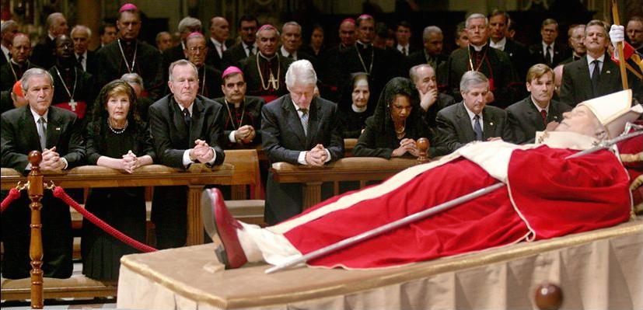
Billions of people mourned this man, including the kings of the earth, and God predicted it. (Rev. 13:3, Daniel 2:20-21) Some even converted!

Let’s go back to our scenario about our mother and dad having died with a belief that the dead live on after death somewhere, and let’s say you never read these texts nor challenged the churches beliefs about life after death, and continued to believe that your parents spirit or soul lived on after they died.
The spirit world is Satan’s domain, and since you believe your parents are in heaven as spirits, Satan can then come to you impersonating your parents and CONVINCE you of anything that any church teaches, even teaching that the heretics (that’s anyone against the church who doubt her/their teachings-“kill the serpent” is an extreme Baptist statement and it’s been used on me so they can’t deny it) teaching that the heretics are worthy of death, and if you go along with that, you will be a part in fulfilling the beasts deceptions, and will believe he has the power of God on earth that can judge and can kill the heretic, as she did in the past mind you, and will again in the future but this time not alone but with and through her daughter churches. (Rev. 13:9, 15)
Or Satan and his angles can convince you of anything by impersonating your parents and lead you to join in the Taliban and kill the innocents (imbeciles) by God’s will. Different religion – but same beliefs.
Can’t you see how dangerous the belief, that the dead are not really dead can be?
And friend, today in all media we are being inundated by fiction zombies and such, and the false realities of the spirit world (and of course “there is a spirit world but they aren’t our dead loved ones”) but, this whole doctrine of “life directly after death” is setting us up for a belief that will take us away from the truth and into errors “that can”, as the Lord said kill our soul, our consciousness, (Matthew 10:28) leading us into hell when we do regain our consciousness in the second resurrection and not the first resurrection of the saved. (John 5:28-29)
The resurrection from sleep; (Jesus just defined) will find us either with Paul and receive our reward of life again in a new resurrected body, and the soul of the consciousness we fell asleep with “in Christ” filled with the Holy spirit, the breath of life again, or, our resurrection from death will find us alive once again with the same consciousness of soul we went down with, still evil minded, just to receive the second death from the real hell and, not the Roman Catholic Dark Age doctrine one, but the one we are now going to see from the Bibles definition of when and where is Hell.
Here are a few more of the many things in the Bible about;
Soul/Spirit/Death/Reward etc.
Ezekiel 18:4

Genesis 2:7
And the Lord God formed man of the dust of the ground, and breathed into his nostrils the breath of life; and man became a living soul.

Genesis 3:19
In the sweat of thy face shalt thou eat bread, till thou return unto the ground; for out of it wast thou taken: for dust thou art, and unto dust shalt thou return
.
Job 27:3
All the while my breath is in me, and the spirit of God is in my nostrils;

[There’s where the spirit is! With the nose we breathe in life!]

Psalm 104:29
Thou hidest thy face, they are troubled: thou takest away their breath, they die, and return to their dust.

Psalm 146:4
His breath goeth forth, he returneth to his earth; in that very day his thoughts perish.

[Conclusive]

Ecclesiastes 12:7
Then shall the dust return to the earth as it was: and the spirit shall return unto God who gave it.

[Here is a picture of the difference between Spirit/Breath/Soul/Death]

Ecclesiastes 3:17-21
¹⁷ I said in mine heart, God shall judge the righteous and the wicked: for there is a time there for every purpose and for every work.
¹⁸ I said in mine heart concerning the estate of the sons of men, that God might manifest them, and that they might see that they themselves are beasts.
¹⁹ For that which befalleth the sons of men befalleth beasts; even one thing befalleth them: as the one dieth, so dieth the other; yea, they have all one breath; so that a man hath no preeminence above a beast: for all is vanity.
²⁰ All go unto one place; all are of the dust, and all turn to dust again.
²¹ Who knoweth the spirit of man that goeth upward, and the spirit of the beast that goeth downward to the earth?

Exodus 31:14
Ye shall keep the sabbath therefore; for it is holy unto you: every one that defileth it shall surely be put to death: for whosoever doeth any work therein, that soul shall be cut off from among his people.

Peter speaking about David Acts 2:34, 29

When we get our reward based on our recompense Luke 14:14 Matthew 16:27

Rev 22:12
Paul speaking of himself; I Corin. 15:53, 52

When we receive our reward; II Peter2:9 John 5:28-29

Daniel 12:2 John 11:11-14 sleepers comes forth

[What story did Lazarus have about the afterlife? Surely that would have made the Bible?]

Say no more….
B. Hell – what and where?
If I had just one text that tells what, where and when the fires of Hell with be kindled and devour the wicked, including all animate and inanimate connections to sin, telling us even “Hell itself” will be devoured!

Revelation 20:4-15 King James Version (KJV)
⁴ And I saw thrones, and they sat upon them, and judgment was given unto them: and I saw the souls of them that were beheaded for the witness of Jesus, and for the word of God, and which had not worshipped the beast, neither his image, neither had received his mark upon their foreheads, or in their hands; and they lived and reigned with Christ a thousand years.
⁵ But the rest of the dead lived not again until the thousand years were finished. This is the first resurrection.

[At the last trump the righteous come forth at Christs coming, we discovered-right? The wicked dead do not rise until when? After the 1000 years]

⁶ Blessed and holy is he that hath part in the first resurrection: on such the second death hath no power, but they shall be priests of God and of Christ, and shall reign with him a thousand years.
⁷ And when the thousand years are expired, Satan shall be loosed out of his prison,
⁸ And shall go out to deceive the nations which are in the four quarters of the earth, Gog, and Magog, to gather them together to battle: the number of whom is as the sand of the sea.
⁹ And they went up on the breadth of the earth, and compassed the camp of the saints about, and the beloved city: and fire came down from God out of heaven, and devoured them.
¹⁰ And the devil that deceived them was cast into the lake of fire and brimstone, where the beast and the false prophet are, and shall be tormented day and night for ever and ever.
¹¹ And I saw a great white throne, and him that sat on it, from whose face the earth and the heaven fled away; and there was found no place for them.
¹² And I saw the dead, small and great, stand before God; and the books were opened: and another book was opened, which is the book of life: and the dead were judged out of those things which were written in the books, according to their works.
¹³ And the sea gave up the dead which were in it; and death and hell delivered up the dead which were in them: and they were judged every man according to their works.
¹⁴ And death and hell were cast into the lake of fire. This is the second death.
¹⁵ And whosoever was not found written in the book of life was cast into the lake of fire.

Malachi 4:1-3 King James Version (KJV)
4 For, behold, the day cometh, that shall burn as an oven; and all the proud, yea, and all that do wickedly, shall be stubble: and the day that cometh shall burn them up, saith the Lord of hosts, that it shall leave them neither root nor branch.

(See my book on Heaven Hell for more detail if needed?)
Next subject;

C. Fate of mankind and Satan
All I need are two texts to prove this is a false teaching, to prove that the wicked of mankind and Satan and his angles are not given “immortality” just to be burned for ever and ever as verse 10 above seems to imply.
Please keep something very important in mind; “if the Bible contradicts itself at any point within its covers” it’s not God’s word.
But, we know better don’t we?
Do we?
If not, shut it up and become a Muslim or Jehovah Witness or try Zen Buddhism like I did once, before I started checking every false claim against the Bible and the Bible only to establish the truth against Satan’s claims.
Speaking of Satan;

Ezekiel 28:18 King James Version (KJV)
¹⁸ Thou hast defiled thy sanctuaries by the multitude of thine iniquities, by the iniquity of thy traffick; therefore will I bring forth a fire from the midst of thee, it shall devour thee, and I will bring thee to ashes upon the earth in the sight of all them that behold thee.
Speaking of the lost;

Malachi 4:1-3 King James Version (KJV)
4 For, behold, the day cometh, that shall burn as an oven; and all the proud, yea, and all that do wickedly, shall be stubble: and the day that cometh shall burn them up, saith the Lord of hosts, that it shall leave them neither root nor branch.
² But unto you that fear my name shall the Sun of righteousness arise with healing in his wings; and ye shall go forth, and grow up as calves of the stall.
³ And ye shall tread down the wicked; for they shall be ashes under the soles of your feet in the day that I shall do this, saith the Lord of hosts.

D.
a. Requirements of life eternal
Keep in mind the requirements of eternal life have always been, and, will always be forever and ever, and, (huge point) they equally applied to all who have ever lived, and who will ever live on this earth as in heaven, as in the whole of the universe, thus “The Universal Religion” being what I am attempting to present here.
To say anything different means that God treats different people different than the others in all ages, and that He treated the Old Testament people different than us.
If this is true; “how could He be a fair and righteous judge?” (Think hard about that)
Take for instance the recording [must be an important example by God to have this recorded] there was a man who picked up sticks on the 7th day of the week breaking Gods 7th day S-Abba-th of creation, and breaching His Covenant (The Ten Commandments) that He gave His first organized church back there in Israel.
It was back then when He gave His “first church”, His knowledge of sin, when He spoke it Himself on the mountain, the judgment terms for His heavenly plan of salvation, His forever constitution for the universe, you know the one Satan challenged in heaven, and we know what that got him and will get him, including all who challenge Gods will (Psalms 40:8, I John 2:17, Matthew 7:21-23)from thence, being His laws, His Ten Commandments of the Covenant He made with the church/mankind.
Notice this next text, one I didn’t get its significance to the above statement, till I was working on this study. See if you get the connection to our subject as Jesus is teaching us how to pray;

Matthew 6:9-10 King James Version (KJV)
⁹ After this manner therefore pray ye: Our Father which art in heaven, Hallowed be thy name.
¹⁰ Thy kingdom come, Thy will be done in earth, as it is in heaven.

His will is the same for us as it was in heaven, get it?
Thus eternal!
What is Gods will?
David knew…as these thoughts were spiritually supplied to him by our Lord do you not think?

Psalm 40:8
I delight to do thy will, O my God: yea, thy law is within my heart.

John 14:15 (In context)
How is it we think now that His same universal principles don’t apply to the church today?
These are the principals that we, as mankind are given, for life or death it’s that straight forward. God can’t change His principals or He would be unjust, judging one man’s fate, or, putting one man fate against another, to Satan’s delight, if that were true. But it’s not, however, we as mankind have a choice, always have, despite the Covenants; (Hebrews 9:1,15, 10:9, 16 put these together in their context – Paul is clear about Gods will being His law of the Ten Commandments. Those He gave to the first church, He also gave the second being us, being the second (New) Covenant; “the one without sacrifices” which were given symbolically showing His plan of salvation, physical sacrifices required for the first church “before the Lamb of God came” but not after, now it’s not a physical sacrifice but a spiritual one in that He promises He will place in us spiritually His law of the Ten Commandments everyone unadulterated, (John 14:26, Hebrews 10:16)
Under either Covenant sin is sin and requires a sacrifice and the example given of the man who picked up sticks tells us the results of rejecting Gods Covenant any one including the 4th unadulterated;

Numbers 15:28-36 King James Version (KJV)
²⁸ And the priest shall make an atonement for the soul that sinneth ignorantly, when he sinneth by ignorance before the Lord, to make an atonement for him; and it shall be forgiven him.
²⁹ Ye shall have one law for him that sinneth through ignorance, both for him that is born among the children of Israel, and for the stranger that sojourneth among them.

[Non Jew’s too? Thus His laws are for all]

³⁰ But the soul that doeth ought presumptuously, whether he be born in the land, or a stranger, the same reproacheth the Lord; and that soul shall be cut off from among his people.
³¹ Because he hath despised the word of the Lord, and hath broken his commandment, that soul shall utterly be cut off; his iniquity shall be upon him.
³² And while the children of Israel were in the wilderness, they found a man that gathered sticks upon the sabbath day.
³³ And they that found him gathering sticks brought him unto Moses and Aaron, and unto all the congregation.
³⁴ And they put him in ward, because it was not declared what should be done to him.
³⁵ And the Lord said unto Moses, The man shall be surely put to death: all the congregation shall stone him with stones without the camp.
³⁶ And all the congregation brought him without the camp, and stoned him with stones, and he died; as the Lord commanded Moses.

I ask you probably the most important question in this study, please think about it, and pray about it, our souls “may” require a conclusion on this at some point in time, and listen it’s a fact “we are not convinced very quickly on religious matters”, and time is short. For God, cannot allow anyone into heaven that might raise sin up again in some future time, just because they haven’t made up their minds on this earth as to whom their worship is directed to, God or man, (Rev. 14:9-10, 7) on Gods holy day of worship will we also be judged (James 2:10-12) as to what day of the week we keep; Gods or man’s day, a day, a change that God never made nor made holy, being one of the many holy days man has created?

Q. If God put a man to death for breaking His Holy 7th day S-Abba-th (in context Numbers 15:32-36) “at any point in time”, even if we have only one example of this, “by the Lord mind you” who said (Exodus 31:13-15, I Corin. 10:4), then how can we possibly think today, He can let mankind (in any age) freely break it or pervert it with pagan worship practices? If only in the name change alone, and not suffer the same result of disobedience the stick man did?
He can’t and remain just! Treating everybody “eternally/universally the same, under the same laws is what makes God a Just and fair God.
Think about it; if He didn’t treat everyone the same what kind of God would that be?
I change not He says and my ways are equal regardless of man’s accusations. (Malachi 3:6, Ezekiel 18:25) (See book “S-Abba-th or Sunday” this site for conclusive Biblical proof)
And No! (In Numbers 15:28-31 we read above) God wasn’t abdicating two different laws as some interpret these texts, but simply telling us “how the law applies “in ignorance” of His laws and Commandments. He forgives sins yes with a slap on the hand as it were, like ignorant transgressions “if” one confesses of that sin whatever it may have been. But, if one knows better and goes presumptuously (being an antediluvian, Jew, Gentile, Roman, Greek, man, woman, child etc. Romans 2:9-11) If any one of God’s creation even an angle, commits the breaking of God’s law knowing better “even His seventh day S-Abba-th Commandment” they remain lost until they confess and keep it.
Fortunately for us God deals with us under the new Covenant differently today than in the days of the stick man, in that the penalty for a sins have always been recorded in the books of heaven, even today as in olden times, but today no rocks are flying and the penalty of death has been reserved till the judgment. (Rev. 20:12)
That record however can be blotted out (by the blood) “if” we just confess it in repentance, but, if it remains on the books unconfessed, even if it was done in innocence (like Cain with the fruit - an innocent lesson learned) or by presumption (like Cain killing Able and wouldn’t repent), the penalty for that sin is death regardless, and the carrying out of its penalty will be death, though it not be with rocks today I repeat (to our disadvantage), if it remains on heavens book and not blotted by the blood (Acts 3:19), the carrying out of the judgment will be given at the day of the second coming. (II Thessalonians 2:8) then finally after the 1000 years (Rev. 20:4-6, 12)
Now we know the truth about when the judgment will be executed obviously “before His coming”, after all decisions will have been made, for He comes with mankind’s rewards either; forever death or forever life, and it’s our choice each and every time we are faced with sin innocent or not. (Rev. 22:12, I John 3:4-11)
Thus the requirements of eternal life have never changed despite the Covenants, that first were given by word of mouth as the Lord gave to Adam and Even at creation in just one commandment; “obey and live disobey and die” (essentially the first of the Ten once He wrote them down), in disobeying our first two procreating humans saw the results of disobedience first hand, as do we “right”?
Then our first parents passed that knowledge, by word of mouth, down the generations before the flood (only three generations mind you so nothing got lost), and then after the flood it was passed down by Noah down to Abraham (Noah’s son overlapped with Abraham so only one generation past nothing lost) then down to Moses, who at Sini received them from The Lords own mouth, and it was then the Lord Himself with “His own finger wrote them down on two tablets of stone”, and from hence the terms of life and death have been recorded for posterity, for us - as well as the church.
Deuteronomy 30:19
I call heaven and earth to record this day against you, that I have set before you life and death, blessing and cursing: therefore choose life, that both thou and thy seed may live:

Deuteronomy 4:1
Now therefore hearken, O Israel, unto the statutes and unto the judgments, which I teach you, for to do them, that ye may live, and go in and possess the land which the Lord God of your fathers giveth you.

Deuteronomy 4:10
Specially the day that thou stoodest before the Lord thy God in Horeb, when the Lord said unto me, Gather me the people together, and I will make them hear my words, that they may learn to fear me all the days that they shall live upon the earth, and that they may teach their children.

[Sounds to me like He was speaking of us down here on the earth?]

Deuteronomy 5:33
Ye shall walk in all the ways which the Lord your God hath commanded you, that ye may live, and that it may be well with you, and that ye may prolong your days in the land which ye shall possess.

Deuteronomy 30:6
And the Lord thy God will circumcise thine heart, and the heart of thy seed, to love the Lord thy God with all thine heart, and with all thy soul, that thou mayest live.

Deuteronomy 5:29

In the school of the prophets (Matthew 5:17) the book of Deuteronomy was to be learned by heart.

I wonder why?

Do you suppose, for the sake of argument, as the agnostics or the commandment do-away-er’s do, or do you suppose; just because Jesus didn’t attend their schools, do you once think He didn’t know Deuteronomy by heart?

No need to guess “He was the author” my friend!

It was Him who created the world and the S-Abba-th. (John 1:1-3, Mark 2:27) It was Him that led the first church, organized at Sini when He gave the church its marching orders to the promise land, a trek we are still on mind you! (I Corinthians 10:1-4) It was Him the church/people rejected throughout their journeys and even “in His presence” to the present. (Deuteronomy 5:29) (Matthew 23:36-38)

Proverbs 4:4
He taught me also, and said unto me, Let thine heart retain my words: keep my commandments, and live.
In Context | Full Chapter | Other Translations

Proverbs 7:2
Keep my commandments, and live; and my law as the apple of thine eye.

Bet you didn’t know this about Solomon; (I kings 3:12) and his stance (actually Gods who gave him the wisdom right?) his stance on the Ten Commandment Covenant Law for “mankind” was, read and weep the next verse since we are “mankind”, (Ecclesiastes 12:13-14) and the judgment is pending as yet!

Remember David was the root and offspring…

Revelation 22:16 King James Version (KJV)
¹⁶ I Jesus have sent mine angel to testify unto you these things in the churches. I am the root and the offspring of David, and the bright and morning star.

What did Solomon’s father have to say about the requirements of eternal life?

Psalm 89 King James Version (KJV)
89 I will sing of the mercies of the Lord for ever: with my mouth will I make known thy faithfulness to all generations.
² For I have said, Mercy shall be built up for ever: thy faithfulness shalt thou establish in the very heavens.
³ I have made a covenant with my chosen, I have sworn unto David my servant,
⁴ Thy seed will I establish for ever, and build up thy throne to all generations. Selah.
⁵ And the heavens shall praise thy wonders, O Lord: thy faithfulness also in the congregation of the saints.
⁶ For who in the heaven can be compared unto the Lord? who among the sons of the mighty can be likened unto the Lord?
⁷ God is greatly to be feared in the assembly of the saints, and to be had in reverence of all them that are about him.
⁸ O Lord God of hosts, who is a strong Lord like unto thee? or to thy faithfulness round about thee?
⁹ Thou rulest the raging of the sea: when the waves thereof arise, thou stillest them.
¹⁰ Thou hast broken Rahab in pieces, as one that is slain; thou hast scattered thine enemies with thy strong arm.
¹¹ The heavens are thine, the earth also is thine: as for the world and the fulness thereof, thou hast founded them.
¹² The north and the south thou hast created them: Tabor and Hermon shall rejoice in thy name.
¹³ Thou hast a mighty arm: strong is thy hand, and high is thy right hand.
¹⁴ Justice and judgment are the habitation of thy throne: mercy and truth shall go before thy face.
¹⁵ Blessed is the people that know the joyful sound: they shall walk, O Lord, in the light of thy countenance.
¹⁶ In thy name shall they rejoice all the day: and in thy righteousness shall they be exalted.
¹⁷ For thou art the glory of their strength: and in thy favour our horn shall be exalted.
¹⁸ For the Lord is our defence; and the Holy One of Israel is our king.
¹⁹ Then thou spakest in vision to thy holy one, and saidst, I have laid help upon one that is mighty; I have exalted one chosen out of the people.
²⁰ I have found David my servant; with my holy oil have I anointed him:
²¹ With whom my hand shall be established: mine arm also shall strengthen him.
²² The enemy shall not exact upon him; nor the son of wickedness afflict him.
²³ And I will beat down his foes before his face, and plague them that hate him.
²⁴ But my faithfulness and my mercy shall be with him: and in my name shall his horn be exalted.
²⁵ I will set his hand also in the sea, and his right hand in the rivers.
²⁶ He shall cry unto me, Thou art my father, my God, and the rock of my salvation.
²⁷ Also I will make him my firstborn, higher than the kings of the earth.
²⁸ My mercy will I keep for him for evermore, and my covenant shall stand fast with him.
²⁹ His seed also will I make to endure for ever, and his throne as the days of heaven.
³⁰ If his children forsake my law, and walk not in my judgments;
³¹ If they break my statutes, and keep not my commandments;
³² Then will I visit their transgression with the rod, and their iniquity with stripes.

This Psalm inspired by our Lord our God who can’t change for any generation remember, especially this last one which sits on top of all of Gods knowledge in the law. (Hebrews 10:16)

Obviously, these next instructions; “to us/mankind/church” was led by the Holy Spirit to influence Solomon, the wisest man (who gave him the wisdom? I Kings 3:13) What made him write down this next almost unbelievable proverb (passage/instruction/eternal life knowledge) for us? I had a man quote to me John 20:29 after reading this the first time…

Proverbs 28:9 King James Version (KJV)
⁹ He that turneth away his ear from hearing the law, even his prayer shall be abomination.
Remember the stick man…

Keep in mind too what Jesus said about: “Him, not coming to change anything the prophets said” (Matthew 5:17-18) including the next prophets counsel (influenced by the Holy Spirit of the Lord of course).

Nor did He come to destroy what the Law of the Ten Commandments requires of us (down to the crossing of any “t” or the dotting of any “i”), and He said not one of His Commandments of the Covenant are to be removed/changed/done away with/altered etc. etc. (James 2:10) till when?

His coming!

That’s when the heavens and the earth will be done away with; including all of its inhabitants mind you (did you get that, you left behind deceived, “who will be left behind for real”. Remember, when He comes; all the saints from Adam to the last, the righteous dead, rise first to go to heaven, followed by the righteous living, but, the wicked including all those struck dead by the brightness of His coming and those already dead will remain in their graves till after the thousand years, so there’s no left behind.

Revelation 18:8
Therefore shall her plagues come in one day, death, and mourning, and famine; and she shall be utterly burned with fire: for strong is the Lord God who judgeth her.

2 Peter 3:12 King James Version (KJV)
¹² Looking for and hasting unto the coming of the day of God, wherein the heavens being on fire shall be dissolved, and the elements shall melt with fervent heat?

The timing of these events appears to be the last ones before the second coming?

Revelation 8:7-13 Revelation 16:17-21 II Thessalonians 2:8-9

Even after the coming and the earth destroyed it will not be fully done away with till after the 1000 years remember, (Rev. 20) then all will be cast into the fires of hell sent down from God out of heaven, as the righteous watch safe inside the gates of the New Jerusalem (Rev. 22:14-15) as God recreates “from the ashes” (Ezekiel/Malachi) a new earth and heaven (Rev.21:1-3) where in dwells all who chose Gods ways over mans to be their will, as did Adam/David/Jesus/John etc., this despite our short comings, we will be given a new heart didn’t we just read, and that being with Gods help, something we could not do without Him.

But, as we are going to read now; it requires a lot from us “this renewing of the mind and heart”, of us sinners, telling us clearly and strongly the requirements of eternal life.

Read and weep; Learn and comply, for our life depends on it, and so does others’ lives Ezekiel says;

Ezekiel 18:4
Behold, all souls are mine; as the soul of the father, so also the soul of the son is mine: the soul that sinneth, it shall die.

Ezekiel 18:20
The soul that sinneth, it shall die. The son shall not bear the iniquity of the father, neither shall the father bear the iniquity of the son: the righteousness of the righteous shall be upon him, and the wickedness of the wicked shall be upon him.

Ezekiel 18:27
Again, when the wicked man turneth away from his wickedness that he hath committed, and doeth that which is lawful and right, he shall save his soul alive.

The following almost represents todays attitude of the majority of the Christian churches when it comes to Gods law, but notice; Gods answer to those who lightly regard, or willfully reject, “or pervert” it by altering it, and teaching people to do so, and that being any part of the Covenant sealed by the blood of our Savior. (Hebrews 10)

Preachers today, in nailing the Ten Commandment Law to the cross, are therefore removing it from Gods salvation process, and, by doing so say it serves no purpose, thus works are dead and serving God is only by faith and love no rules save the ones they make up;

Malachi 3:14-18 King James Version (KJV)
¹⁴ Ye have said, It is vain to serve God: and what profit is it that we have kept his ordinance, and that we have walked mournfully before the Lord of hosts?
¹⁵ And now we call the proud happy; yea, they that work wickedness are set up; yea, they that tempt God are even delivered.
¹⁶ Then they that feared the Lord spake often one to another: and the Lord hearkened, and heard it, and a book of remembrance was written before him for them that feared the Lord, and that thought upon his name.
¹⁷ And they shall be mine, saith the Lord of hosts, in that day when I make up my jewels; and I will spare them, as a man spareth his own son that serveth him.
¹⁸ Then shall ye return, and discern between the righteous and the wicked, between him that serveth God and him that serveth him not.

Matthew 5:17-20 King James Version (KJV)
¹⁷ Think not that I am come to destroy the law, or the prophets: I am not come to destroy, but to fulfil……

[Christ came to live out the Laws for our example, fulling His/our Fathers will for mankind. How much more evidence do we need to see this? To take it into our minds and hearts? (Psalms 40:8, Deut. 5:29)]

¹⁸ For verily I say unto you, Till heaven and earth pass, one jot or one tittle shall in no wise pass from the law, till all be fulfilled.
¹⁹ Whosoever therefore shall break one of these least commandments, and shall teach men so, he shall be called the least in the kingdom of heaven: but whosoever shall do and teach them, the same shall be called great in the kingdom of heaven.
²⁰ For I say unto you, That except your righteousness shall exceed the righteousness of the scribes and Pharisees, ye shall in no case enter into the kingdom of heaven.

Romans 2:11-16 King James Version (KJV)
¹¹ For there is no respect of persons with God.
¹² For as many as have sinned without law shall also perish without law: and as many as have sinned in the law shall be judged by the law;
¹³ (For not the hearers of the law are just before God, but the doers of the law shall be justified.
¹⁴ For when the Gentiles, which have not the law, do by nature the things contained in the law, these, having not the law, are a law unto themselves:
¹⁵ Which shew the work of the law written in their hearts, their conscience also bearing witness, and their thoughts the mean while accusing or else excusing one another;)
¹⁶ In the day when God shall judge the secrets of men by Jesus Christ according to my gospel.

Hebrews 10:16-31 King James Version (KJV)
¹⁶ This is the covenant that I will make with them after those days, saith the Lord, I will put my laws into their hearts, and in their minds will I write them;
¹⁷ And their sins and iniquities will I remember no more.
¹⁸ Now where remission of these is, there is no more offering for sin.
¹⁹ Having therefore, brethren, boldness to enter into the holiest by the blood of Jesus,
²⁰ By a new and living way, which he hath consecrated for us, through the veil, that is to say, his flesh;
²¹ And having an high priest over the house of God;
²² Let us draw near with a true heart in full assurance of faith, having our hearts sprinkled from an evil conscience, and our bodies washed with pure water.
²³ Let us hold fast the profession of our faith without wavering; (for he is faithful that promised;)
²⁴ And let us consider one another to provoke unto love and to good works:
²⁵ Not forsaking the assembling of ourselves together, as the manner of some is; but exhorting one another: and so much the more, as ye see the day approaching.
²⁶ For if we sin wilfully after that we have received the knowledge of the truth, there remaineth no more sacrifice for sins,
²⁷ But a certain fearful looking for of judgment and fiery indignation, which shall devour the adversaries.
²⁸ He that despised Moses' law died without mercy under two or three witnesses:
²⁹ Of how much sorer punishment, suppose ye, shall he be thought worthy, who hath trodden under foot the Son of God, and hath counted the blood of the covenant, wherewith he was sanctified, an unholy thing, and hath done despite unto the Spirit of grace?
³⁰ For we know him that hath said, Vengeance belongeth unto me, I will recompense, saith the Lord. And again, The Lord shall judge his people.
³¹ It is a fearful thing to fall into the hands of the living God.

1 John 3:1-4 King James Version (KJV)
3 Behold, what manner of love the Father hath bestowed upon us, that we should be called the sons of God: therefore the world knoweth us not, because it knew him not.
² Beloved, now are we the sons of God, and it doth not yet appear what we shall be: but we know that, when he shall appear, we shall be like him; for we shall see him as he is.
³ And every man that hath this hope in him purifieth himself, even as he is pure.
⁴ Whosoever committeth sin transgresseth also the law: for sin is the transgression of the law.

1 John 3:5-11 King James Version (KJV)
⁵ And ye know that he was manifested to take away our sins; and in him is no sin.
⁶ Whosoever abideth in him sinneth not: whosoever sinneth hath not seen him, neither known him.
⁷ Little children, let no man deceive you: he that doeth righteousness is righteous, even as he is righteous.
⁸ He that committeth sin is of the devil; for the devil sinneth from the beginning. For this purpose the Son of God was manifested, that he might destroy the works of the devil.
⁹ Whosoever is born of God doth not commit sin; for his seed remaineth in him: and he cannot sin, because he is born of God.
¹⁰ In this the children of God are manifest, and the children of the devil: whosoever doeth not righteousness is not of God, neither he that loveth not his brother.
¹¹ For this is the message that ye heard from the beginning….

“From when”, the beloved said under the influence of the Holy Spirit, has this been the message”?

The Lords final words to us;

Revelation 22:11-16 King James Version (KJV)
¹¹ He that is unjust, let him be unjust still: and he which is filthy, let him be filthy still: and he that is righteous, let him be righteous still: and he that is holy, let him be holy still.
¹² And, behold, I come quickly; and my reward is with me, to give every man according as his work shall be.
¹³ I am Alpha and Omega, the beginning and the end, the first and the last.
¹⁴ Blessed are they that do his commandments, that they may have right to the tree of life, and may enter in through the gates into the city.
¹⁵ For without are dogs, and sorcerers, and whoremongers, and murderers, and idolaters, and whosoever loveth and maketh a lie.
¹⁶ I Jesus have sent mine angel to testify unto you these things in the churches. I am the root and the offspring of David, and the bright and morning star.

I’ve just picked a few of the hundreds of texts I could give to support Gods requirements of eternal life or does your preacher disagree?

If so, I’ve got one more text for you; here is the Lord speaking of false churches led by the mother church into perdition in the last days as we saw in the pictures above;

Revelation 18:1-5 King James Version (KJV)
18 And after these things I saw another angel come down from heaven, having great power; and the earth was lightened with his glory.
² And he cried mightily with a strong voice, saying, Babylon the great is fallen, is fallen, and is become the habitation of devils, and the hold of every foul spirit, and a cage of every unclean and hateful bird.
³ For all nations have drunk of the wine of the wrath of her fornication, and the kings of the earth have committed fornication with her, and the merchants of the earth are waxed rich through the abundance of her delicacies.
⁴ And I heard another voice from heaven, saying, Come out of her, my people, that ye be not partakers of her sins, and that ye receive not of her plagues.
⁵ For her sins have reached unto heaven, and God hath remembered her iniquities.

I John 3:4

D. b. Salvation
We just discussed the terms of eternal life, of which our salvation depends, as it did for Satan in heaven, for Adam and Eve our first parents and for those of the Old Testament times “and us in the New Testament times” and for the future people in the end of time as well as the churches. (Rev. 22:14 “His” and “right” are the key words, as well as “without”) saying all others are outside lost. This is our Lords message speaking of our Fathers “His” commandments, and not some breveted two “but” all ten including an unaltered 4th we’ve discovered in a hundred ways? This is a message given to “the end time people/church” through a prophecy!
What is Gods process when it comes to salvation, and do the Ten Commandments really play a part today under the new Covenant?
Can we determine this from the old “Testament” as well as the new “Testament” and since they are the same author “do they agree with each other” as the ways of God?
Our Savior who wants all of us, all (Mankind) to live forever, if so, then does He give or tell us “plainly”, without the need of interpretation, “the steps to eternal life”, and “yes, there are steps”, as we will see; (Matthew 19:16-20, Mark 10:17-21)
Did you notice in Marks account; The Savior “loved the man”?
Why?
It’s obvious; the man was doing “what He/Jesus was doing” in obeying His /their/our Fathers will, and listen, it’s not debatable what “Commandments” Jesus was in reference to, as far as “how to be saved” He quotes a few of the 10.
You tell me what else one needs to know about eternal life and its requirements other than our Lords example, His own words?
These steps, towards eternal life, “are conditional however” on each level; in that we must take the first step to be able to take the second.
Now I know that sounds ridiculous, but, God is not ridiculous nor does He give commandments lightly.
Sin is a deadly business, and requires dedication and perseverance on man’s part, and following the right way, or, as we see in religion today; there are so many ways to choose how to follow God, no one really knows the right way, and many today “like believing the lies” knowing better, it’s more convenient, it’s an easier path to follow but one that leads to sin, iniquity and transgression against Gods law which we discovered is His will. (Matthew 7:13-14, 7:21-23)
Those passages given by Matthew and Mark above; give us heavens “first step”, in which the man or men Jesus encountered had already taken, but they weren’t willing to take the second step?
Which was what?
Simply following Jesus’ being Gods example of righteousness.
There are Key words to look for in the next few texts of the many I could give on this subject of salvation.
key words like; “our righteousness”, “Commandments/Covenant/Law”, “mercy”.
See if you can get what they all have in common “in helping us be righteous”, and further more helping us see “the need to be”, and “how to be” by Gods design not mans! Deut. 6:25, Daniel 9:18, Luke 1:69-75, Matthew 5:17-20.
Aren’t the Jews accused today of works by keeping the cursed law?
They claimed to believe the Law, yes, they just didn’t keep it! And they perverted it to the point it had no power to save and ultimately led to the killing their only hope, but, get this;
“What would Jesus say then about the churches today who don’t even believe the law, calling it a curse and dissolve it down to just two, thus, removing not just “one jot or title but all”, by calling it unnecessary unless that is it conforms with their doctrines” an d the 4th doesn’t (James 2:10), as did the Jews, while they all gather in Biblical “hypocritically” around the one who changed it claiming power over Christ and obviously over the law, thus so, they will never take the first step according to Jesus (Matthew 19:16-17), and, actually just as did the Jews; denying not only Christs Godhead themselves, but worse denying their people eternal life.
How else can one say it, how much more clearer can it be?
Given all the Biblical evidence of God’s plan, of Gods design for salvation, from both the Old and the New “Testaments/testimony”? (I John 3:1-7, Rev. 19:7-11, Rev. 22:8-17)
The first step of faith, and second step of works are prerequisite of the third, thus, having taken them first and “in order” then, we will be eligible for the last step, and, listen;
We are only able to take those steps, any steps for that matter, with “the help of the Holy spirit”, (John 16:7-13) the Spirit that the Lord promised us He would send us to help us keep His Covenant, (John 14) all Ten of “Gods/Jesus’” Commandments (including the S-Abba-th over Sun-day) that, we might live in “a universe someday where only righteousness prevails” (Deuteronomy 6:25) and, “all who live there from earth all from Adam to the last righteous one (Luke 1:69-79) having already (Pre-judgment) decided to live that way for God, as He requires without reserve”.
All the others from earth are described by Gods own words; given to us through the Lord, Holy Spirit and prophet, given to us here in the end of the world in which we live, saying, as in olden times, “it is only those who have decided to follow God, His ways, His will, His covenant, His Laws, Commandments etc. etc. will have the right to enter into heaven saved.” Not just by faith alone but by works as well… (Rev. 22:12-15)
I could say no more but it’s imperative that we know Gods way to eternal life, through the steps He has provided for us to do “one by one”, steps we might take, no, steps we must take to live forever, if that’s still our goal?
The “Bible only” is to be our soul guide to eternal life, for only God gives it and not our religion, or our good deeds outside of “Gods deeds”. Gods deeds however we must take, and why?
“Because of all He has done for us” that’s why, isn’t it?
But, the first step of doing this is simply “Faith” believing this, believing in Him and His will for us, the second then is applying it to our lives, because we love Him enough to do so, don’t we?
Sadly few there be that are willing to take these steps because of earthly reasons (and not just riches), things that bind us to this earth, not heavenly things, but things like even religion influencing us, by all of the compromises the churches have fallen into, as we have already out lined, that we have been Convinced are of God, NOT!

THE STEPS: Same in Old Testament times as they are in the New, same testament as we have seen, I pray that we have?
Now let’s define those steps from God’s word;

Ϯ Justification is the first step;
Romans 2:10-13 There it is!
Paul of course was familiar with the “Sanctuary service” of old as well as the Ten Commandments of God. He knew working together they were “God’s plan of salvation” as shown in graphic symbolisms (we are going to see), and he also knew that message didn’t get through to the first church, (Isaiah 66:3, Matthew 23:37-38) the message of Gods heavenly requirements for eternal life from sin and death, or, they would have been ready for the Messiah as commanded by the Lord way back there in Daniels time, (Daniel 9:24) and not killed Him, as predicted, because they didn’t get the implication of the prophecy. (vs.26-27)
Why?
Because they misinterpreted the prophecy, perverted it for their own purposes as they do today, but, mostly because they didn’t recognize Him, His works, His testimony. (John 14:11-12)
In that text He was talking to the disciples yes, instructing them for the Gentile church they were to establish, and of course He included the Jews which most of them were or had converted from, and yes, He was talking also to His church/us down here if you read the context starting with John 14:1-3! How is it we claim those first few texts but seem to deny the rest of His promises and commands He gave in this chapter “about doing what His Father commands” just as He was doing – Why? (Vs. 23-24)
Now to the “Sanctuary service”, and the laws of God’s plan of Salvation, foreshadowing also His plan “post” Messiah, and, this is what separates the two Covenants, yet, both are subject to the keeping of the Ten Commandments as we are going to plainly see.
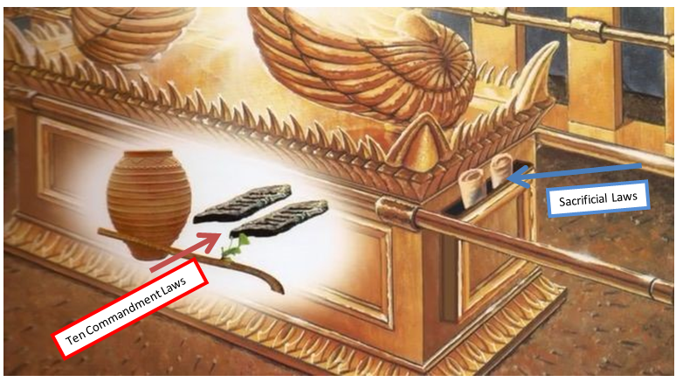
THE ARK OF THE COVENANT THE HOLIEST THING EVER CONSTRUCTED AND THAT BY GODS DESIGN AND FOR HIS PURPOSE
In the Sanctuary service plan; the law required a lamb sacrifice, representing the Savior, that the sorrowful & penitent sinner was to bring for each and every sin he or she committed, that is, having sinned, “knowing better”, and not through ignorance (Numbers 15:29-31) meaning they had received and believed that the knowledge of sin comes by the Ten Commandments, and knowing also that the laws regarding the sacrifices, they are bound to obey as well.
“The two laws” working together for the salvation of mankind back then, under the first Covenant, foreshadowing the requirements for salvation under the second Covenant, and Paul makes it clear how it worked for them back there and how it works for us today, (Romans 7:7, Hebrews 10:26-29 in context of whole chapter) both laws given to them from above, working together for their salvation under the 1st Covenant.
One pointed out their sin and the other pointed to the Messiah who would remove that sin, if of course, the penitent sinner confessed, repented, and committed that sin no more.
If they did however, transgress the Law of the Ten Commandments again as Paul said; as the last text tells us; if we sin a sin again we are guilty again and there remains “no sacrifice for that sin”, or better said; the sacrifice will not cover their sin “unless confessed, repented, with a new sacrifice etc. was made again.

The point was/is “each time one transgresses Gods law”, including the Seventh Day S-Abba-th, even the least one of the Ten, (Matthew 5:19) a sacrifice would be required, “today as well as back then.”
Sin is sin regardless of the ages, in heaven or on earth, the only difference from today and back then is; they took the lamb physically/symbolically while we take it spiritually in prayer to the Father in the name of Jesus as our only salvation. (I John 3:4-8)
Back then however, this process of sacrifices, despite the fact that they pointed to the soon to come Savior as the Lamb of God “slain from the foundations of the earth for the sins of mankind”, (Hebrews 9:26) despite this well known fact even back then; soon that process became burdensome as Isaiah described, (Isaiah 66:3) burdensome because they lost site of the fact that it wasn’t the physical lamb that gave forgiveness; it merely represented the Lamb of God “Himself” offering/giving His life for them/us, thus, it was never the sacrifice the Lord wanted them to realize from this graphic example, but it was the heart and mind God was wanting them/us to change, (Psalms 51:16-17, Hebrews 10:1-10)
Why is this so important for us to know even to today, and why do I linger on it and repeat it in about every study I publish?
Because of the magnitude of sin! In that death is still a reality despite our season of mercy and grace, given to us for to prepare us for the judgment, (Ecclesiastes 12:13-14) and yes that includes Gods worship over mans, and yes, it’s that black and white friend and that serious, despite the fact that religion in general has forgotten Gods Laws, despite the fact that God hasn’t, and they still remain as the bases of His judgment, (James 2:12) they are still the knowledge of His will.
Think about this; on one side is Gods character His the terms of His will for us, and on the other side (as it were) are the terms of sin and the character of sin, both seen on His perfect document.
THE FRONT SIDE DESCRIBES
GODS CHARACTER

THE BACK SIDE DESCRIBES
UNREPENTANT MANS
CHARACTER

IV

Those terms of sin have never changed since Adam and Eve began to die, with the world, from the disobedience of God’s law, and this by one single “seemingly innocent”, “seemingly small and insignificant sin”, but friend it was that transgression of Gods Law, that “disregarding” of Gods “one command” (not ten) is what “allowed sin to enter into the world”, and friend, “it’s still around”, and, the terms of sin, the knowledge of sin, and the penalty of sin are “still the same for us here in the end despite the Covenants.” (Ezekiel 18:20-23, Matthew 5:19, 15:9 Revelation 22:14 Revelation 14:9-14)
Those graphic sacrificial examples were meant for the purpose of removing sin, no more so than today when we offer our prayers of contrition and confession of the sin/sins we fall prey to and, how we get relief from that sins death decree “is the same regardless!” (I Corinthians 10:1-12)
The sinner was only justified “if” he brought the lamb to the temple according to the laws, yes laws;
The first law, they needed to have faith in was the Ten Commandments that pointed out their sin. (Step one remember? Romans 7:7)
The second was the law of the sacrifices they needed to preform or their sin would remain.
Today the only difference in the salvation process is; we need not bring the lamb because “He” has already come, as foreshadowed by all those sacrifices, to die once for the ultimate sacrifice of sin for all that is who “are willing” to repent confess of their sins, as you remember Paul made clear; (Hebrews 10:8-10)
One death for all sin, past, present and future, BUT and this is a big but; we still need forgiveness today because “sin is still rapid”, and only the blood of the Savior, the slain lamb of God, offers us forgiveness of sins and justifies us before God, “BUT” again; if we do not confess and repent and ask for forgiveness “we will not be forgiven”, saying; if we break Gods law whether that sin be murder the transgression of the 6th, lying the 9th, or perverting the 7th day S-Abba-th “the middle one the 4^{th”} thinking, presumptuously mind you, thinking your day is a holy day, yet, it was made by man (the beast no doubt), and it was never made Holy as was Gods Day “by God!”, and if we don’t believe in Gods worship day and continue to break it or pervert it with “sun”day-worship we remain guilty.
Unless we, even to today, believe what John did, and call on the Savior for forgiveness, for He is still “faithful and just to forgive us of our sins and grant us eternal life.” (I John 1:9)
Justification is prerequisite of taking the first step “we ourselves haft to take so that we can be forgiven”, and that includes accepting all that the law points out as sin (Romans 7:7, Romans 2:13) and this by asking for forgiveness from our transgression, (I John 3:4, James 2:10-12) that’s each and every sin not the modern doctrine of once saved always saved – “deception alert.”
As the first church got tired of Gods laws (under the new Covenant before the Messiah came – the anti-typical lamb of God), the church leaders made up their own laws, and get this; “even to the point of killing their only hope and sacrifice from sin!”
The church today (and the people it has deceived) have grown tired of God’s law which stands in the face of man’s law (particularly the Sabbath command that they hate) thus; not only has the church done away with the whole commandments (which of course is not possible) saying it was nailed to the cross, even claiming it is a curse to keep it, and they do this by misinterpreting and twisting Pauls’ words. (2 Peter 3:15-16)
The church and its people thus, by so believing, have just assuredly as the Jews killed their only hope “in misrepresenting Him, His Father, their laws, and their will for mankind the same today as it has always been (I John 3:11 Romans 13:8-11), but my friend in following the beast and her false doctrines as we saw the churches doing in the pictures above, the second church has breached the Covenant of God, the same as did the first church “with the same results”, heavenly rejection and worse leading others away from God not to Him. (Matthew 23:36-38 in context)

Ϯ Sanctification is the second step towards salvation after justification, and can only be taken, or more accurately said it can only have a true effect on us, if we have taken the first step “which is the bases for it being the terms of sanctification”.
Justification you remember, as Paul said, are the ways in which we are led to become sanctified, (Romans 2:13) perfected through Gods knowledge and this by Gods design and accomplished through his power to save. (Matthew 5:16, 20, 48, 6:33 7:7-8, 13-21)

In the Sermon on the Mount, before a mixed multitude, (Jews, Greeks, Romans etc. Gentiles); the Lord put forth the ways of Sanctification through justification as shown in those preceding excerpts from that sermon I clipped above.

These things were not new, but the church had gotten away from them through religious doctrine, false prophecy, Jewish customs, confusion and compromises. (Matthew 7:28-29, 5:20)
All of the things He said, for the true church and His true followers of His unadulterated religion, are the ways in which His Spirit will led us to be Sanctified, for it is only though His ways, His doctrines, His will of the Father can we become perfect as He commanded us to be. (Matthew 5:48, John 14:10-12) Perfect within of course our own sphere of righteousness. (Deut. 6:25, Matthew 11:27-30)
Of course as John also reminds us in I John ; we are all sinners, yes, but; “if we walk in His light with our Lord, and not in the darkness in which the world’s religions have fallen, He will lead us into the Fathers ways of becoming sanctified”, we must, well, let’s let John say if from that little book;

⁵ This then is the message which we have heard of him, and declare unto you, that God is light, and in him is no darkness at all.
⁶ If we say that we have fellowship with him, and walk in darkness, we lie, and do not the truth:
⁷ But if we walk in the light, as he is in the light, we have fellowship one with another, and the blood of Jesus Christ his Son cleanseth us from all sin.

I, II, III John

Then we can grow having been cleansed by the blood, forgiven of our sins, “Justified”, it is then we are open for His complete purging of us from sin which is the work of a lifetime of “Sanctification” not once saved always saved I repeat. For friends we are under 6000+ years of the influence of sin that needs constant cleansing through the blood, the law and the Spirit. (I John 1:8, John 16:13 things like the S-Abba-th)

Let’s look at all the aspects of Sanctification before we go on to the last step, and remember; we must take the first step to be able to take the second, and the third and last step is prerequisite by the first two.

John 17:17
Sanctify them through thy truth: thy word is truth.

John 17:19
And for their sakes I sanctify myself, that they also might be sanctified through the truth.
Hebrews 10:14
For by one offering he hath perfected for ever them that are sanctified.

Hebrews 10:29
Of how much sorer punishment, suppose ye, shall he be thought worthy, who hath trodden under foot the Son of God, and hath counted the blood of the covenant, wherewith he was sanctified, an unholy thing, and hath done despite unto the Spirit of grace?

Jude 1
¹ Jude, the servant of Jesus Christ, and brother of James, to them that are sanctified by God the Father, and preserved in Jesus Christ, and called:

Exodus 31:13
Speak thou also unto the children of Israel, saying, Verily my sabbaths ye shall keep: for it is a sign between me and you throughout your generations; that ye may know that I am the Lord that doth sanctify you

Leviticus 20:7
Sanctify yourselves therefore, and be ye holy: for I am the Lord your God.

Isaiah 66:17
They that sanctify themselves, and purify themselves in the gardens behind one tree in the midst, eating swine's flesh, and the abomination, and the mouse, shall be consumed together, saith the Lord.

Ezekiel 20:12
Moreover also I gave them my sabbaths, to be a sign between me and them, that they might know that I am the Lord that sanctify them.

1 Thessalonians 5:23
And the very God of peace sanctify you wholly; and I pray God your whole spirit and soul and body be preserved blameless unto the coming of our Lord Jesus Christ.

2 Thessalonians 2:13
But we are bound to give thanks alway to God for you, brethren beloved of the Lord, because God hath from the beginning chosen you to salvation through sanctification of the Spirit and belief of the truth:

1 Peter 1:2
Elect according to the foreknowledge of God the Father, through sanctification of the Spirit, unto obedience and sprinkling of the blood of Jesus Christ: Grace unto you, and peace, be multiplied.

If you read all of Johns little books you will see the ways of God, as opposed to the ways of false religion, and man’s false interpretation of scripture, especially of Paul’s writings, (II Peter 3:15-16) in which those who are not founded in the things of “all scripture” both Old and New Testaments, “then they can easily be CONVIENCED of any of the many false doctrines out there, doctrines that will lead them in man’s ways and not Gods ways, and only His ways lead us to Sanctification though our Lord and Savior by the Spirit. (John 14 in context to that thought)
It’s the Lord that sanctifies us. (Exodus 31:13)
[In soul and spirit, and here’s one you can’t misinterpret Paul on!]

1 Thessalonians 5:23
And the very God of peace sanctify you wholly; and I pray God your whole spirit and soul and body be preserved blameless unto the coming of our Lord Jesus Christ.

Work of lifetime….wholly blameless….
Listen Sanctification is not done through earthly priests anymore, nor a religion, but only though a relationship between us and our Savior “who promised to come into us and work out Gods will through us.” (John14:23-26)
We however need to first accept His ways of His law if we are to be justified, (Romans 2:13, John 14:15-16) and to be able then to willfully accept Jesus’s invitation to come into us and help us keep our Fathers law being His will to perfection. (Matthew 5:48, Matthew 6:9-10) To do His will on earth, is the same will as is done in heaven, and this since the beginning of the universe, and will be so in the end of time and throughout the universe, and is prerequisite to eternal life. (Rev. 22:12-14, for the first church and people (Deuteronomy 30:19) and for the end time church and people just prior to the second coming. (Rev. 14:12-14)
The conclusion is obvious Biblically;
Only after having taken the first two steps, and not just as works but “willfully, heart fully, mind fully physically, spiritually”, after we have taken the first steps “in order” can we take, or, “really will we be eligible for, or will we be given” the gift of the third step which is glorification.
Being then, a part of those who will attend the New Jerusalem that descends from heaven to earth, thus becoming the throne of God in “the new heaven and earth” (Rev. 21:1-3), where every S-Abba-th (for those who have accepted it on earth) will all the universe come before God and worship (Isaiah 66:22-23) for ever and ever, and this my friend describes glorification “glory” only realized “then”, and not at death we discovered.
Can’t you see how far away from the Bible “the Holy Scriptures” (Old and New) the churches have strayed?
God, here in the end of time, is speaking to us “His last words”, given to us in the last book of His Holy Scriptures, telling us of His desire for us to be saved and live with Him in His glory, which the false prophets, the false churches, and their false doctrines have caused us to be in the wrong camp, that of the lost, less we receive His messages for those He has called, being you and me, calling us out from in under the influence of the beast and her daughters and into His camp of those who have right (the ability) to live in His presence as it is in heaven so will it be in the end. (Rev. 22:14-16) The two camps are pictured by Him in His closing words to us, but do we see it? Do we see Him the same Lord as David knew, with the same will for us?
Will we enter into His “glory” saved by His grace and light, (Luke 11:35) or be left outside the gate lost, remaining in the dark in the end?
Knowing better?

Ϯ Glorification can be ours, but only after we have taken the first two steps can it be a possible outcome for us, something God is trying to make it happen for us!
What more can be said about His plan of Salvation?

Ϯ The three angles message outlines these steps for the end time people. (Rev. 14:6-14)
This is the place of prophecy for us, as it has been given from the beginning, leading us to mankind’s promise land and life forever with our Lord and Savior.
What was it Jesus said when He first began His ministry on earth:
(Matthew 5:17-18)
What was it he sent back to the earth as a reminder when it comes to Prophecy? (Rev.22:12-21)
Let’s look at the three angles messages, breaking it down, and see if we can see the three steps to salvation incorporated therein?
First angle;

Revelation 14:6-14 (KJV)
⁶ And I saw another angel fly in the midst of heaven, having the everlasting gospel to preach unto them that dwell on the earth, and to every nation, and kindred, and tongue, and people,

[Not New Testament gospel, nor new covenant gospel, but “Everlasting Gospel” from age to age binding everyone from Adam to the last with the same message; love for God, His law, Commandments etc. etc. everything I’ve been trying to say! Who else, what else do you want to be bound to?]

⁷ Saying with a loud voice, Fear God, and give glory to him; for the hour of his judgment is come: and worship him that made heaven, and earth, and the sea, and the fountains of waters.

[ I Peter 4:17, Romans 2:1-13, Ecclesiastes 12:14, James 2:10-13 including the S-Abba-th, from which commandment this reference is made check it out; Exodus 20:11, Fearing and worshiping the God of creation, “of the old and new Testaments”, has something to do with judgment, and notice, His phrasing; Judgment “has come”, has already come for us here in the end, and to whom this was written, for us here in the end who are reading the cannoned scriptures, for the judgement came (began in heaven) in 1844AD according to the prophecy Daniel 8:14 see time chart appendix. Daniel 12:9-13 Daniel and all will stand in the judgment with us, of course we won’t be there, but our Lawyer will be! Our Savior, who will plead His blood for all who repented of their sins before the Father.]

⁸ And there followed another angel, saying, Babylon is fallen, is fallen, that great city, because she made all nations drink of the wine of the wrath of her fornication.

[Remember the pictures above? We are seeing this prophecy “in real time” fulfilling]

⁹ And the third angel followed them, saying with a loud voice, If any man worship the beast and his image, and receive his mark in his forehead, or in his hand,

[Apostate Protestantism, if only in “worship alone”, given over to the beast in doctrines and worship days, which is no more different than those who worship on Fridays or Wednesdays, or, those who think they can worship all week and fulfill the “One” Gods Commandments/Covenant all ten - “not!”]

¹⁰ The same shall drink of the wine of the wrath of God, which is poured out without mixture into the cup of his indignation; and he shall be tormented with fire and brimstone in the presence of the holy angels, and in the presence of the Lamb:
¹¹ And the smoke of their torment ascendeth up for ever and ever: and they have no rest day nor night, who worship the beast and his image, and whosoever receiveth the mark of his name.

[“Worship” get it yet, and listen to her blasphemy admitting Sunday is her mark of authority in these next statements, although old, don’t once think she has changed, she just disguises it better today;

"Of course the change (from Sabbath to Sunday) was her act ..... and the act is a MARK of her ecclesiastical power and authority in religious matters." (signed by H.F.Thomas, Chancellor for Cardinal Gibbons, in a letter dated Nov. 11, 1895)
"Sunday is our MARK of authority ... the church is above the Bible, and this transference of Sabbath observance is proof of that fact." (Catholic record of London, Ontario, Sept. 1, 1923)]

Nothing’s changed today my friend; it’s just put in a way that continues to deceive those “deceived already” who accept her word as truth. (II Thessalonians 2:1-12) Paul knew the prophecies and saw it coming, we who know the prophecies have seen it come, why don’t you see it?]

¹² Here is the patience of the saints: here are they that keep the commandments of God, and the faith of Jesus.

[Step 1 and 2 through the Lords faith, by sacrifice (1), obedience (2) and testimony (3) leading us to do the same. (John 14:10-12) God’s works could never be a curse or He would be the author of a curse? Never happen! The curse’s God did make were on those “who broke His law not kept it”! Cain of course was the first who wouldn’t repent, the next was Ham, and then all their descendants hence, all by their own “choice”. (Deut. 30:19, Joshua 24:15) and were the prophet here today he would say the same thing to them as He is saying to us! (Matthew 5:20 in context]

¹³ And I heard a voice from heaven saying unto me, Write, Blessed are the dead which die in the Lord from henceforth: Yea, saith the Spirit, that they may rest from their labours; and their works do follow them.

[Rev. 22:12,14 Gods works, including the S-Abba-th, are what we will be judged by, either marked or not (Romans 2:3-13, James 2:10-13, Matthew 5:16-20, Mark 7:6-7, Isaiah 8:16, 19-20) marked by whom? God or the beast!

¹⁴ And I looked, and behold a white cloud, and upon the cloud one sat like unto the Son of man, having on his head a golden crown, and in his hand a sharp sickle.

[This my friend is an end time message, for the next thing John sees, as the Lord is describing for mankind the angles messages, is, the second coming we just read (Vs. 14), and it’s telling us who it applies to, and listen, there are only “two sides” listed there; one lost the other saved. Those saved are those who have died in the Lord (living or dead) and the Lord being the one who sanctified them, that is, if they were willing to keep the Fathers Covenant of the forever Gospel! That’s love! (John 14:23-24, I John 3:1-3, 11, Romans 13:8-10)

Full circle….

E. The Place of Prophecy

What then is our place in prophecy?
(Rev. 14) Describes two groups one saved, and “how”, the other lost “and why”, and two whole prophetic books has God dedicated to prophecy, for our knowing and our understanding (Matthew 24:14-15) and following of those prophecies. (Newton’s book appendix)
Why did He give us these books strictly dealing with prophecy if He didn’t want us to follow their courses in time and religion, and this is what the early church, after the blessed day came to fruition wanted to know and sought for the answers from God through His word?
So why did He give us these books?
Simply put “so that we are not deceived by the false prophets and false churches out there” and as of now, in abundance today, and especially the big (Beast) fulfilling the true prophecy trying to unify all the rest under “her doctrines”, and the most of them we’ve seen are not Gods.
Those who know, and study prophecy, like Paul, (II Thessalonians 2) will come out of the false churches and not partake in her deadly deeds “of Satan’s design” as do the deceived, being those who allow themselves to be deceived, as Paul says; “God Himself sends a delusion to, that they believe a lie and not the truth. (Rev 19)

F. The Testimony of Jesus
“Is” that “Spirit of Prophecy” as spoken of above. (Rev. 19:10 please see my book on line that goes into this in detail.)

G. The Mark of the Beast
God has already told us this who it is how it formed wound last day rise to power as deceiver, persecutor, killer, God impersonator, marker of the lost, S-Abba-th destroyer etc. etc. (and her false churches with her in the end), (Rev.14:9) and listen; she has confirmed it by her actions predicted by God a forehand, as we read above, but, it’s her worship day over Gods that’s the big one, and part of the prophecies that God told us, and get this; “where she and her apostate protestant churches (Image) wants to place her mark of Sun-day in us, we just read it, if you read between the lines of vs. 9 “in our minds and hands”, and it’s more than prophetic it’s the most severe warning carrying the worst punishment by God recorded. Because where she wants to place “her mark” is exactly where God wants to place His (always wanted) and that is to place His law in us! (Deut. 6:8) That my friend is “the Everlasting Gospel” John recorded in the last book of the Bible, Prophecies that God sent to Jesus who sent it to the angle to John to us for our minds (forehead/hearts) and hands (His works). (Rev. 1:1-3, 14:6-21)

All of the above are things the churches today, including the big ones, are telling us lies about, concerning their importance to God, and unless we get the picture we will find ourselves in the wrong church “plain and simple” and I can’t make it any clearer for you.
It’s going now to take the Holy Spirit to get you to see these things are what the Bible teaches, and how they are different than what the churches today are teaching.
All I’ve done is point you in the Bibles direction in hopes you see, as all the Prophets and kings we’ve read about have seen, throughout mankind’s existence, including the Apostils and Christ Himself, from a child, the Way of God and His true religion His true followers.
Things Martin Luther and all the Dark Age martyrs saw. What Sir Isaac Newton expounded upon, breaking prophecies Biblical codes in a time when we were still in the dark ages religiously speaking, pointing to the source of the darkness “the Beast power and those who look like her (images)” as the Bible describes having departed from the truth.
What Truths the church of Christ knew “and held” (Rev. 12) as it went into the dark ages carrying this testimony, and what same Truths “the remnant church” that emerged from that long dark age carrying “the eternal truths” held from the beginning of mankind, and have been trying to get the religious world’s attention ever since.
Are you listening to truth or error?
Are you searching for Gods truths or blindly following the state of the art of religions out there in abundance?
Will you make it your challenge to find the truth before time is cut short?

Revelation 22 King James Version (KJV)
¹⁰ And he saith unto me, Seal not the sayings of the prophecy of this book: for the time is at hand.
¹¹ He that is unjust, let him be unjust still: and he which is filthy, let him be filthy still: and he that is righteous, let him be righteous still: and he that is holy, let him be holy still

I close with His last words; recorded for us, and may they set you on a quest to know Him and His truths that will set you free….

Revelation 22 King James Version (KJV)
22 And he shewed me a pure river of water of life, clear as crystal, proceeding out of the throne of God and of the Lamb.
² In the midst of the street of it, and on either side of the river, was there the tree of life, which bare twelve manner of fruits, and yielded her fruit every month: and the leaves of the tree were for the healing of the nations.
³ And there shall be no more curse: but the throne of God and of the Lamb shall be in it; and his servants shall serve him:
⁴ And they shall see his face; and his name shall be in their foreheads.
⁵ And there shall be no night there; and they need no candle, neither light of the sun; for the Lord God giveth them light: and they shall reign for ever and ever.
⁶ And he said unto me, These sayings are faithful and true: and the Lord God of the holy prophets sent his angel to shew unto his servants the things which must shortly be done.
⁷ Behold, I come quickly: blessed is he that keepeth the sayings of the prophecy of this book.
⁸ And I John saw these things, and heard them. And when I had heard and seen, I fell down to worship before the feet of the angel which shewed me these things.
⁹ Then saith he unto me, See thou do it not: for I am thy fellowservant, and of thy brethren the prophets, and of them which keep the sayings of this book: worship God.
¹⁰ And he saith unto me, Seal not the sayings of the prophecy of this book: for the time is at hand.
¹¹ He that is unjust, let him be unjust still: and he which is filthy, let him be filthy still: and he that is righteous, let him be righteous still: and he that is holy, let him be holy still.
¹² And, behold, I come quickly; and my reward is with me, to give every man according as his work shall be.
¹³ I am Alpha and Omega, the beginning and the end, the first and the last.
¹⁴ Blessed are they that do his commandments, that they may have right to the tree of life, and may enter in through the gates into the city.
¹⁵ For without are dogs, and sorcerers, and whoremongers, and murderers, and idolaters, and whosoever loveth and maketh a lie.
¹⁶ I Jesus have sent mine angel to testify unto you these things in the churches. I am the root and the offspring of David, and the bright and morning star.
¹⁷ And the Spirit and the bride say, Come. And let him that heareth say, Come. And let him that is athirst come. And whosoever will, let him take the water of life freely.
¹⁸ For I testify unto every man that heareth the words of the prophecy of this book, If any man shall add unto these things, God shall add unto him the plagues that are written in this book:
¹⁹ And if any man shall take away from the words of the book of this prophecy, God shall take away his part out of the book of life, and out of the holy city, and from the things which are written in this book.
²⁰ He which testifieth these things saith, Surely I come quickly. Amen. Even so, come, Lord Jesus.
²¹ The grace of our Lord Jesus Christ be with you all. Amen.

~mosescats~

APPENDIX:
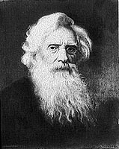
Samuel Morse
Notice what Samuel Morse the inventor of Morse Code
said about what the Protestants thought of the Papacy
in his book written under a sudo name;

Notice date

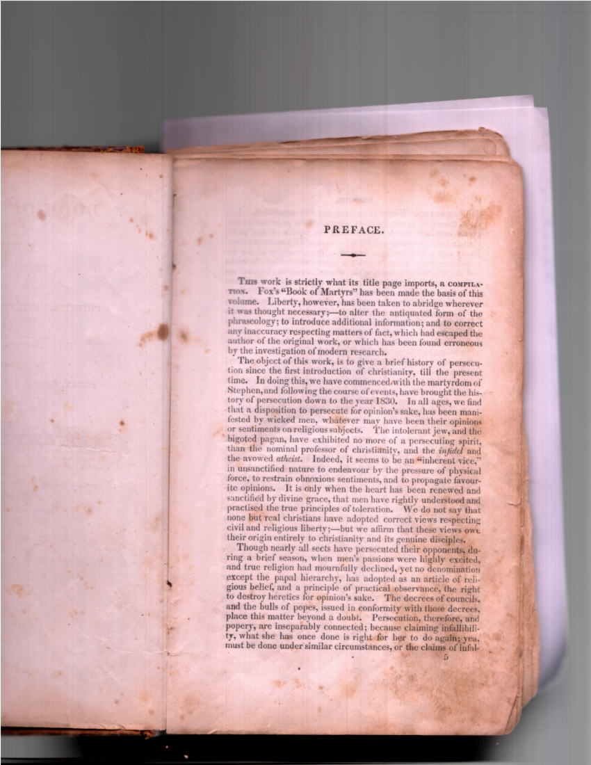

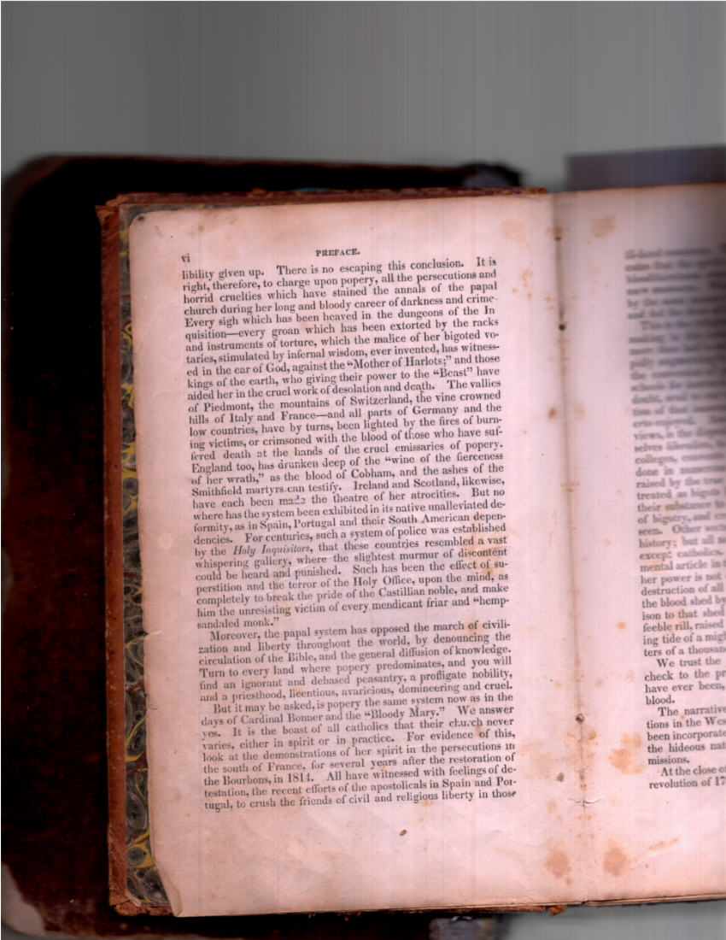

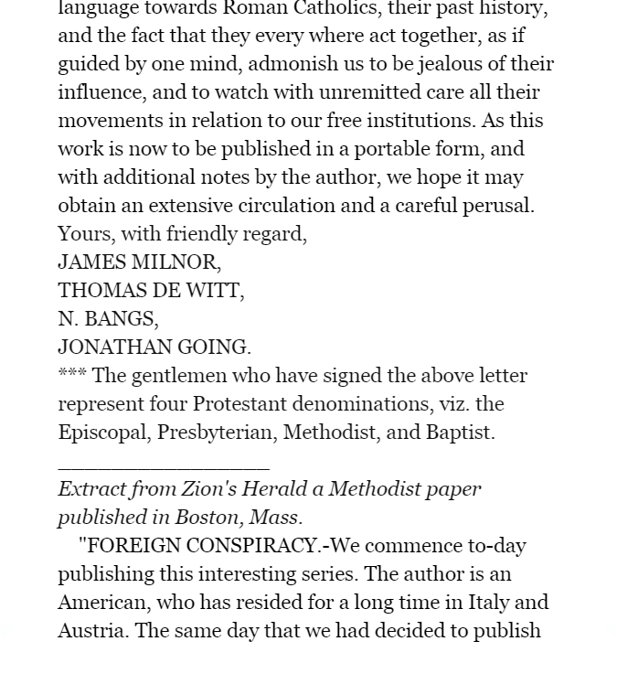
This clip shows what religions supported Morse’s claims taken from an Amazon clip of the above book (“look inside” their book for the list, and you might be surprised considering the pictures of them today or will be soon when it comes to religion. (Rev. 13:3).

TRUTH?
EXCERPT FROM A BOOK ON BAHIRAS HISTORY AND OURS - IN TRUTH?
Today one can simply take a pile of their works, spread them out on one’s desk and see clearly that together they embody the ‘sectarian milieu’ of the late antique and early Islamic Middle East. One would then see a mosaic of competing self-images that are grounded in cultural elements common to all Near Eastern peoples: literary genres, prophetic history, concepts of contact between the human and the Divine, and types of philosophical argumentation. Through complex strategies of adaptation and rejection of these shared elements, each community came away with its own coherent, exclusive and exclusivist self-image. The polished treatises that the apologists produced were meant to impose these self-images on—but are also as such products of—what lies underneath: the unpredictable world of individuals whose identities consisted of many more facets than religious convictions alone. These individuals also happened to be clan members or Baghdadis or scientists or craftsmen or poets or youngsters or lovers or neighbors or slaves. They had practical and emotional grounds to question their attachment to their parental faith and perhaps also reasons to be indifferent. Some of them did not fail to notice that the self-evident truth, to which they were told they had access, did not translate into a homogeneous society or into a just society. That is how questions came up about the abstractions made by religious authority figures— critical questions which believers asked themselves, along with critical questions that others asked for them. In response to the threat of the disintegration of their communities and the dilution of religious identity, the apologists of all the different Christian churches in the Middle East became particularly devoted to the reinforcement of their coherent self-image. The fact that new and increasingly challenging questions kept on emerging, both from people within their communities and from those extraneous to them, meant that new and increasingly intricate answers needed to be constructed over time. It need not surprise us, then, that along with these evolving apologetics and evolving ideas about what Islam meant to the Christian communities, the ‘idea’ of an encounter between the Prophet Muhammad and a Christian monk changed as well. The stories about this alleged encounter mutated over a number of centuries to answer different questions at different times. Although Christians were eager to narrate the story to serve as an explanation of much of Islamic doctrine, eventually, in light of discussions about God’s intervention in human history and the lasting power of Muslims over the Christian communities, it was the story itself which needed to be explained. The present study addresses the question of the evolution of this ‘idea’ in the light of the development of Eastern Christian apologetics vis-a-vis Islam. It explores the interplay of anti-Muslim polemic and Christian apologetics in the many narratives that revolve around this encounter. [Keep in mind Bahira was a Roman Catholic monk first and foremost thus a false prophet re: Isaiah 8:19-22]

Ejaz. The Legend Of Sergius Bahira (Kindle Locations 186-194).

NEWTON
Sir Isaac Newton “the numbers man”, able to figure out Gods prophetic time frames (unless you put more stock in your religion), who expounded on the books of Daniel/Revelation. Notice an excerpt concerning the 1260 years and the Identity of the beast in His time “during those spiritually Dark Ages” none the less;
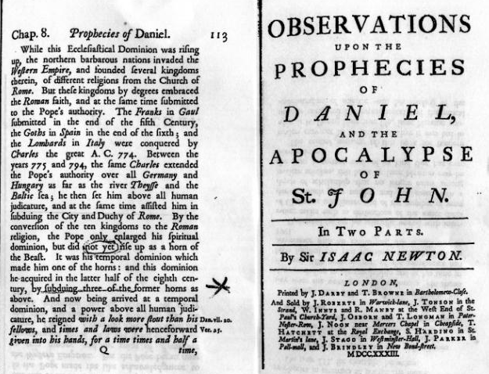

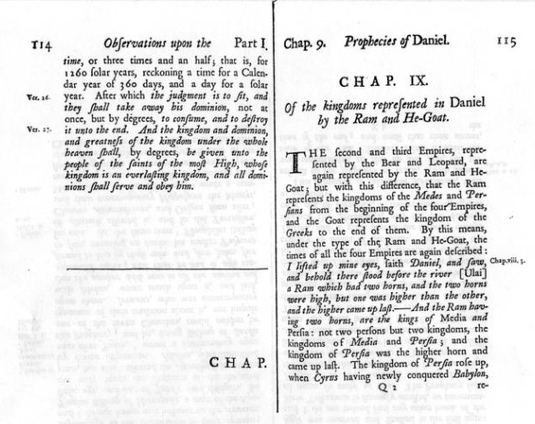

PROTESTANT COMPROMISE
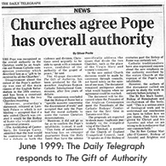
WOUND HEALED
The Mother church was reinstated in France, but the wound didn’t become fully healed until 1929 as follows, and notice the newspapers caption and “how it reads is very significant!”
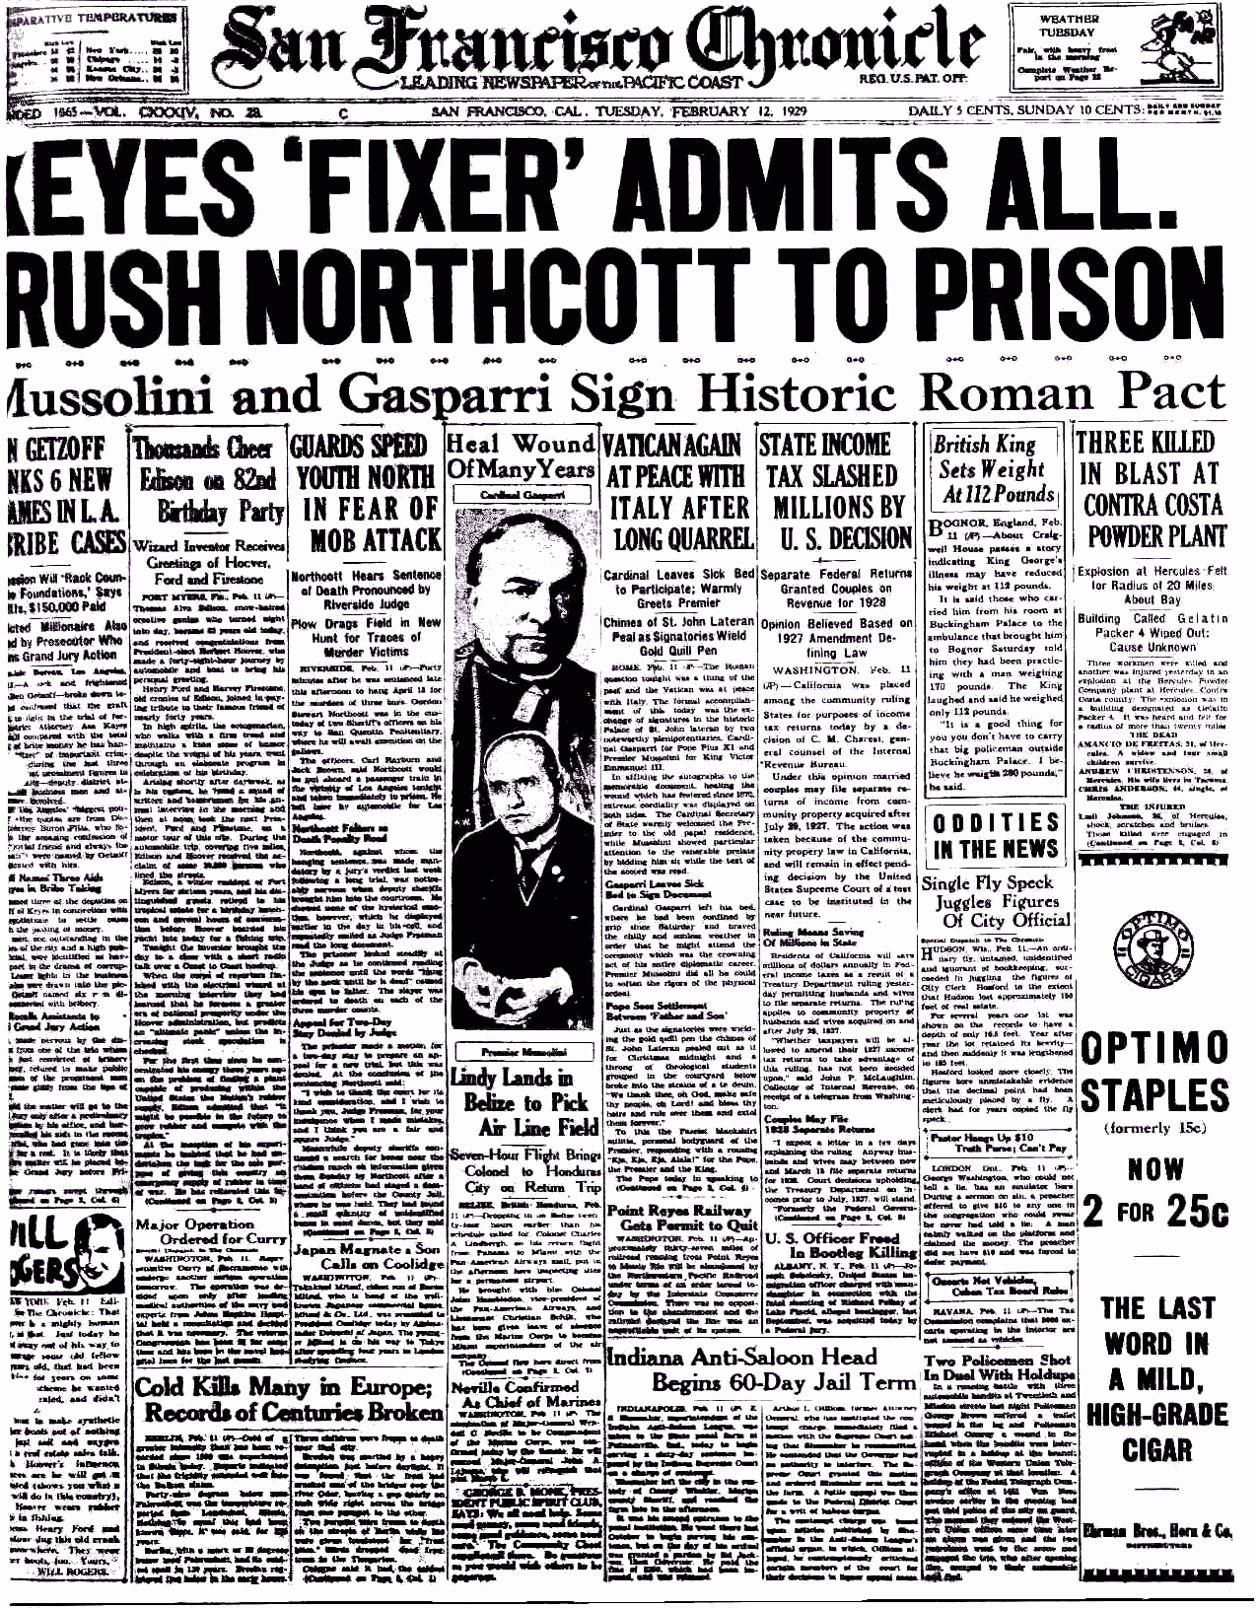
Odd way for the newspaper to title this historical event isn’t it?
Or, was it for future proof of a the accuracy of Gods prophecy?

The following depicts when the wound was given;
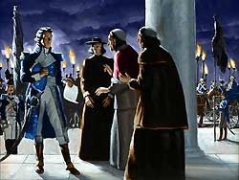
French General Berthier removing Pope from throne in 1798 (See Time chart)
Taken from a London newspaper…
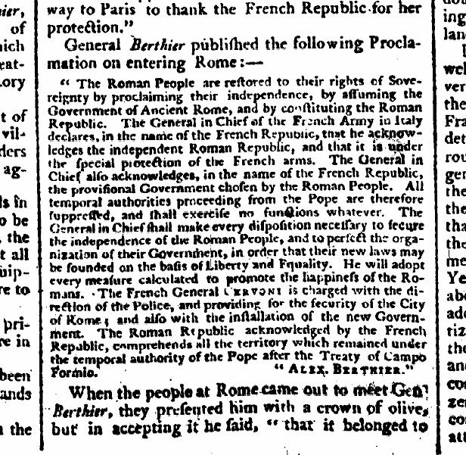

EYE OPENING SITE (Not endorsed but on right track)
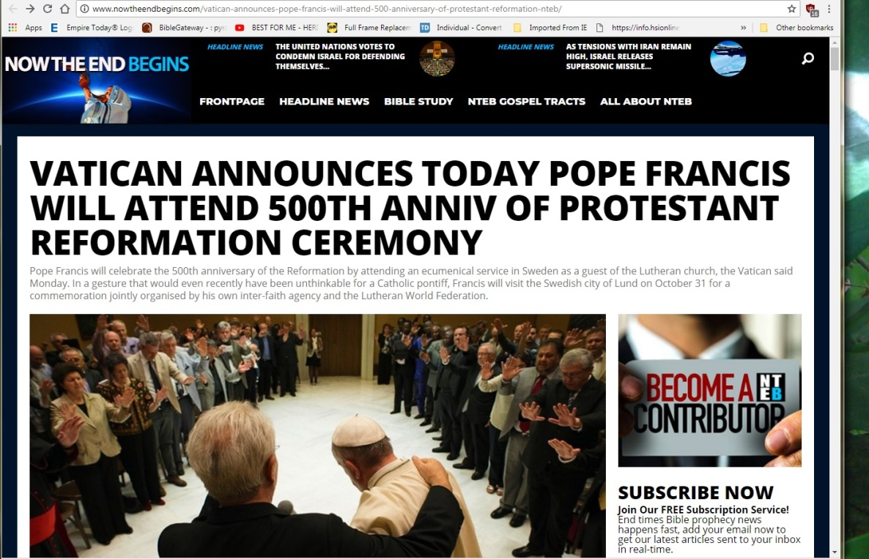

Video hyperlink
Like I said in the beginning of this study; at any time, out of context, what is being said sounds right and can convince anyone…
(Cont’d article above)

~end~

TIME CHART
In 1844 the Judgment in heaven began (Daniel 8:14, 12:9-14)
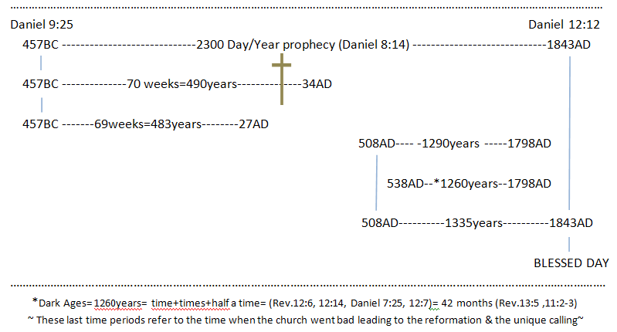
The setting up of the abomination of desolation (Daniel 8:13-14, 12:11, Matthew 24:11-15)

SCROLLS
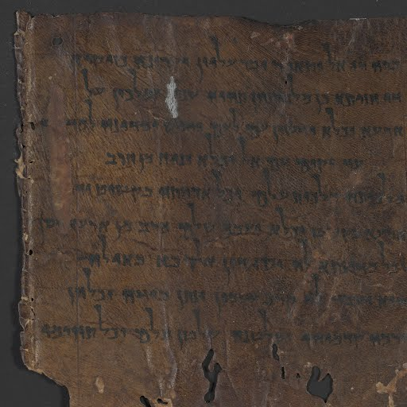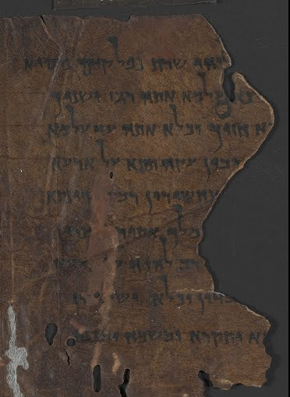

APOCRYPHON OF DANIEL
4Q Apocryphon of DanielDate: 50–1 bce, Herodian Period
Language: Aramaic
The Dead Sea Scrolls contain extensive apocalyptic literature relating to the final messianic battle at the End of Days. The Aramaic Apocryphon of Daniel describes either a messianic figure or a boastful ruler that will arise as “Son of God” or “Son of the Most High”, like the apocalyptic redeemer in the biblical book of Daniel.

NOTES:

CONVINCED©
©
BY THE LIES OF THE CHURCHES
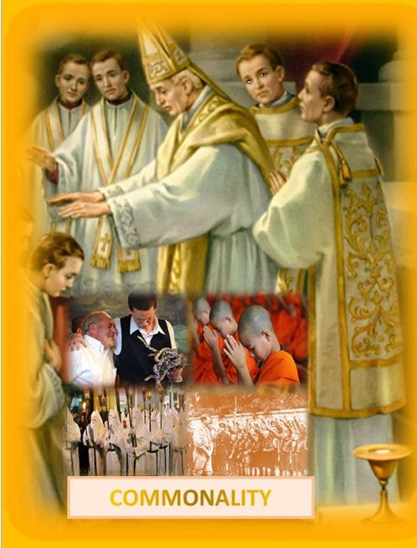
BY MOSESCATS - 2018

What do Islamic religions and Catholicism have in common, except for Bahira? Both have killed innocent people because they didn’t or don’t believe in their religion/god. One got the idea from deception the other from the other; I wonder which one first convinced which one? Prophecy tells us friend, no need to guess. Of course to the history student there’s no need of guessing because the answer is obvious. History however, has been so contaminated with falsehoods that it’s hard to distinguish what is truth now days, and in the end friend; if it weren’t for God’s Word we wouldn’t have His direction of truth. I hope you get the significance of that last statement. (See Appendix truth?)
A period contemporary’s call the Middle Ages, but God calls it a “time, times and a half a time” or 1260 years long (Revelation 12) a period when He had to hide His church because of the deceptions, compromises and false doctrines that would have destroyed it from within, while at the same time the beast was trying to destroy it from without, through persecution and burning of the Bibles (other than the Latin Vulgate of course) and the burning of anyone who opposed them “at the stake”, and kill them slowly in torture chambers in the most gruesome ways. Chambers that are still in the basements of some of the monasteries in Europe today and some of those monasteries have been renamed castles. Many persecutions done under the commands of “the best power in charge of the church” in those days, were done during that prophetic, undeniable and unchangeable prophetic time period of 1260 years set by God. (See appendix “Newton”)
Search this dogmatic fact that has been held from the beginning of this church, and, don’t let the jargon fool you about “salvation”, which according to her; comes only through the Eucharist and belief in the Pope, found only in the mother church, and, in a referenced article we are going to look at, where a current spokesman for her more or less, talks about churches & wounds “laying it on the protestants”. But she/he (Pope) had “the real prophetic wound” given to him “by God.” (Rev. 13:3) “How “much clearer” can God be?” Of course, in a sense, in saying protestant’s need to join her is a sly way of getting them to shut up “Gods words” against her, a second time, as she did in a more forceful way during the Dark Ages when she kept the Bibles from them, even her own congregations speaking in Latin which very few understood back then and she did this clear up to the 1960’s AD only telling them her interpretations of scripture. Protestants however knowing what the Bible plainly says “who give in to her doctrines” will also share in her ultimate fate & this according to Gods prophetic word, not mine. Search these historical and Biblical facts out and you will see it all true, and listen; this fulfillment of Gods prophecy is happening right in front of us as we speak and the reason for the need of this study as a wake-up call here in the end of time.
A title they once used for the Pope, but, since so many Popes, over the many claimed years of the papacy, and many priests following suit, became “fallible not infallible - actually extremely DARK”, and we see the evidence still in their churches today, (but it was especially true during the “Dark Ages” thusly called when there was no one watching), all the while fulfilling prophecy as the Bible said she would; by persecuting God’s chosen who objected to her worship and religion/by blaspheming God in claiming the earth is in the Popes/their charge, even the claim to the forgive sins that only God can do/and especially by their obvious changing of God’s law, (Daniel 7:25) How much clearer can God be? (We are going to discuss that time period from that text in a minuet), and then, we have all of her unbiblical doctrines that we are discussing now. However today, under public scrutiny, they have become as a lamb, meek and low, head bowed, and have publically quite using the “coronation” crown, claiming earth dominion when crowned, the one the Pope was once crowned with, that gives the Popes his official title, which is still his title today mind you, and that title was/is Vicarius Filii Dei (in place of the Son of God). I haven’t read all on that site, but it speaks for itself in what I’m getting at here and showing Gods warnings for us especially now as we see her power is returning! She/he can’t change their stance or they give up their claim as “the religious head” on earth” a title she once held over all religions (See Appendix “Protestant compromise”), If she gives up her claim, freely given, as was given more dogmatically and unapologetically as I said in the past, even when she, believe it or not, when she was doing all those dark things God said she would do, that she did despite Gods word! So you can see why she wants to forget or apologize away her past that God points us to, yes “us”, God points directly at her and of course those churches that follow her. “Look it all up historically and Biblically” and if you’ve got a problem with this, simply remain deceived (marked) as most of the beasts and daughters of the beast of the earth have been and willfully remain so, nearly 100% by now “if only by virtue of their worship” no doubt! (Revelation 14:9-11) The Beast and “her images being those churches who have given into her”, both we see are judged according to God in front of the lamb, and this my friend is an end of time prophecy vs. 14. How much clearer can God be…you tell me?) I could stop now but you are not CONVIENCED yet, being “the thrust of this article”, or should I say convicted one way or the other in your case, if not already?
See appendix “Wound Healed”.
Notice what Billy said about the pope years ago. Disregard all but this statement, because I don’t endorse this site but, what he said about Pope and Graham is right on.
Now I know Peter and Paul had differences but both were Jews and, if the Lord didn’t want this to be written don’t you suppose it wouldn’t be written? It’s there for a reason and today is a witness of that fact. I’ve experienced it firsthand people reading the same texts and getting a whole “out of Scriptural context” different interpretation, and that’s why God raised men like peter, denied the Lord once, but now firm in the scriptures and that’s why he could not be as the false church claims the first Pope or they would reflect today his teachings.
This came when the abomination of desolation was given full power over religion by the “intellectual society”, and I say intellectual because there were really only two classes, as far as religion is concerned, during that age. One deprived of religion called heretics, the other depriving religion from them by keeping God’s word, rightly divided, from them, and, only accepting them save they conform to the churches way of worship and religion. If not, they were judged by the Pope in charge “guilty of death”, and listen friend be warned; “when she’s fully in charge” in our future, “she will return to her ways and Protestantism will agree for the sake of Unity”? Rev. 13 God predicts it and it will be fulfilled as have all the other prophecies about her, and we are seeing it forming now.)
AD commonly called “after the death of Christ”, BC commonly called “before Christ” dividing the way we reckon history “ancient to present”.
Don’t buy the many false prophetic interpretations calling the beast power Artaxerxes etc. etc. because the chronology of that 2300 day/year, the longest of time prophecies in the Bible, can only fit in the years as it was given, for remember; it gave the year of the Messiah (Daniel 9:25) in its chronology, and listen forget those that try and give “a prophetic day”, as some other length other that the Bibles interpretation of a “year”, like a day is equal to 1000 years etc. misquoting Peter, putting it in the far past or a distant future beyond today, or some other equation other than what Newton equated it to be, (the numbers man), or even worse; you accept their deception and pass their error on, but, remember Paul’s warning about truth verses error and what happens to those who pass on error; (II Thessalonians 2)
I assume you know more than the numbers man “Sir Isaac Newton” who rightly deciphered the day year principal of the Bible and even spoke of that religious power in charge during his time in the middle of the Dark Ages. Of course Newton was one of a few who were enlightened beyond their fellows and it was those God spoke to and gave understanding of scripture to. Luther, Huss etc. were also Bible students seeking for the truth in scripture, and not the church, which they proclaimed had been given over to the doctrines of devils of that age.
See my book on “The Dead Sea Scrolls” please for an eye opener, but notice the translation for a piece of the book of Daniel found, predating Paul’s prophecy here, quoting Daniel by over 1000 years before it’s full fulfillment See Appendix “Scrolls”.
Sound familiar? It’s a phrase from the Lord’s Prayer as “we are to pray”, remember He said “thy Will be done on earth as it is in heaven”. What is Gods will as if I haven’t given enough definitions? David Tells us and it matches what all the previous sentences conclude; Psalm 40 ⁸ I delight to do thy will, O my God: yea, thy law is within my heart. (These are Jesus’s words as well) If the English language makes any sense at all; it’s that Gods Law is His will as supported by all scripture beginning to end. (Paul to Gentiles and Hebrews converts 8 & 10) and listen scripturally speaking, we are talking both laws here Mr. doctor of divinity, for both have and do work together for the salvation of mankind (Galatians 3:24), first to last, living to dead Isaiah 8:19-20 and of course once we have heard Gods will for us we should no longer need a schoolmaster but the world of religion still does today for they are still rejecting Gods Will by their worship alone! Let me ask you Mr. Bible student; if He was only talking about the sacrificial law, then why is the same terminology used in Rev. 22:12-14 (end time warning) keeping in mind both laws were Gods Commandments not Moses’ and for the salvation of souls? The sacrificial laws ended with Christ, and that part of the Covenant met its end, and a new way began, as Jesus simply said in John 14:15-21 (same terminology) He says He will send His Spirit of Truth into us and help us keep Gods Law “to do sacrifices? Of course not to do His will the Ten Commandments. So I ask; why would He be talking about the law of sacrifices to His disciples, His church of the future? See www.theuniversalreligion.com “S-Abba-th or Sunday”) As our prayer should be according to our Savior, “Thy will to be done on earth as it is in heaven” certainly is not a prayer for the Gentiles if we are talking about the sacrifices being done “which were never done in heaven please!” Gods will for us here in the end as far as our salvation is concerned is as our works are rewarded and those works are stated clearly in Rev. 22:12-14 we just read I assume - case closed.
Israel responded, when God gave them His ways of living and worship for them to live (Covenant/Ten Commandments) there on Sini, they said; “All you ask we will do” () but they didn’t, not that they couldn’t but over time they made worldly choices rejecting Gods will His Law/commandments save a few (Abraham, Isaac, Jacob, David, Paul, John ) all and law according to Gods will, given to them through the prophets (the same as it is today no different we walk after the spirit or follow some other spirit the only difference is Jesus has come and the rituals of salvation have changed they’ve been fulfilled by the lamb and now we live under a new type Covenant that still includes the law; but administered different, not through priests nor lamb sacrifices but though the indwelling spirit Jesus sends to those who will allow Him to come into them and help them/us walk in His laws, His will, His commandments, His Covenant all being the same thing. The people up until Christ neglected to follow Gods laws, despite the many rituals that pointed them to their Savior and to salvation. But take note; this was “God’s plan” and we know that His plan did not fail! It was the people that failed, (Hebrews 8:9-10) however, because that plan of salvation was enforce till the Messiah came it couldn’t have been altered, but now, we have a better way as Paul said; (Hebrews 10:9,16-39) we have the promise of Jesus that He will come into our hearts and minds and write His law in us, and thus, through the power of the Holy spirit we will be guided into all truths that will set us free from the power of sin, that “we of ourselves” could not fight and win. BUT, with Christ we can be more than overcomers of sin which is the transgression of God’s law (I John 3:4) the law to be written in us, IF, if we allow Jesus to do it, as did all throughout history who called on God and followed Him, His laws etc. (David explains Psalms 40:6-8 “Lo, I come… sound familiar?) We must accept the faith first as did David and Paul, and then the works must follow, for faith without works is void (James 2:20, 10-12) and we will be judged by our works James reminded us, and being the same works Jesus also reminded us are prerequisite of His reward showing us the connection to the judgment of works (cut short), the law and those who He will accept into heaven. (Rev. 22:12, 11-14) On works of the law; Paul (Romans 12:2, 2:12-13, 7:25, John (I John 3) to speak of just two but they all agree as One Jesus (John 14:10-31) Didn’t know this did you? I’m just giving the tip of the Ice burg on this…
I’ve had those same out of body experiences having come of age during the 60’s drugs and all, and yes having seen both sides it didn’t take me long to know who was in charge of my dreams then as vivid as they may have been. People despite their age doctoral degree are known by their fruits in the end ask any politician, but for truth we must ask God regardless of our visions, in death or in living whichever the case, and whatever light we may have seen! (Isaiah 8:19-20) Yes, Gods answer is that simple?
Even when the Lord raised Lazarus his friend from the sleep of death (John 11:11-14) and the spirit of life reentered his body and he came back to life, when his soul came back he had no tale of being in heaven or hell, all he knew, we can only derive from the event (Jesus gave for our benefit today in knowing the truth about death and life) all we know is, his soul died and was now alive, breathing the breath of life and the body being what it was that brought his consciousness back, the soul back that was asleep if you read the whole account?
Think about the air we breathe makes gives life to the blood. (Genesis 9:4) That’s why blood is associated with life and Christs blood eternal life! (Leviticus 17:11) For the life of the flesh is in the blood.
I believe it was Billy Graham mother or dad appeared at the foot of the bed when one of them was dying, thus his belief was sealed, and he gives texts to back it up? So who’s right that man or God? The whole of the Bible or a few ambiguous texts? Like l said; under the right circumstances, the right convincing, a person can be swayed in their thinking, and belief system, in any direction, and, this is especially true when it comes to religion, Billy Grahams the protestant king and/or the Roman Catholic king.
Something more about Lazarus; Jesus was reprehended by Martha because He didn’t come within the 4 days that proves the persons dead, but Jesus did it for a reason He wanted them to realize that Lazarus was truly dead and that He had the power of life over death. Remember He told Peter Lazarus was asleep (obviously an unconscious one) but it was the sleep of death in that He said emphatically “Lazarus is dead”. Death is sleep until the God raises us as He did Jesus!!
People say “see, there Satan is being released from hell”, NOT! Let’s look at the events as they take place; verse 5 says; when Jesus comes the righteous dead rise from their graves “this is the first resurrection”, but the second resurrection “from the dead” is when the wicked rise. From where do they rise from Hell or the grave? If they were in hell then were they asleep or dead? Didn’t we read; “the dead know nothing - their thoughts perish?” (Psalm 146:4) and that’s regardless of where they are, and we just read about the wicked as David said they go to the earth or grave, dust to dust, ashes to ashes, until when? Their respective resurrection, but, both groups’ are asleep and awakened by Jesus; one to everlasting life and the other to meet with the fires of hell, “kindled when?” After the second resurrection! That’s the Bibles account “by God”! So, where or from whom did your preacher get his account? Private interpretation? (II Peter 1:20) From the false prophets during the dark ages under the influence of the great red dragon, deceiving men (Rev. 12:9) during that long 1260 years (a thousand two hundred and three score days) by false prophecies and false doctrines made up during those years of the Dark Ages, when the truth of God’s word both from the old and the new testaments [Symbolically described as witnesses laid dead as it were in the streets throughout the Dark ages because they had no power, as if dead, because they were kept from the people] (specifically the prophecies of Daniel and Revelation) kept from the people because it exposed the beast for who she was? (Rev. 11:3) Satan’s prison he is released from is the earth destroyed (II Peter 3) and void of people to deceive, for that 1000 years, as the wicked lay dead in their graves, as he ponders what his commandments, which he deceived the people with, have accomplished. Bound by circumstances he made for himself, these are his chains.
At this site and my companion site www.mosescats.com as well as www.amazon.com search “book ancion”.
Wasn’t it a question of “faith” when Jesus asked the young man to believe in Gods Commandments, and when He said yes he wasn’t lying for the savior loved him remember, and then, wasn’t it then the required follow up of “works” when He asked the man to follow Him? Yes, he had taken the first step to salvation but wouldn’t take the second. The first obviously had saved him to that point anyway, but by rejecting the second as did Cain “his once saved turned into lost” as Jesus described his fate? He had missed the principals on which the law He claimed to believe in was not only love and faith in God, being the first 3 commandments, but the last 6 commandments love for man he required. Leaving the 4th the commandment in the middle as the way to do all the others, becoming a testimony like Jesus for God unto the world, in keeping all 10. (Romans 13:8-12, Luke 11:35)
Throughout the Dark Ages, till now, there have always been Gods faithful in keeping His 7th day S-Abba-th which was sanctified and made holy. (Gen.2:3, Exodus 20:8-11) Believe it or not even some of the priests in the beast’s church were keeping the 7th day S-Abba-th clear up until the 16th century, almost to the end of the Dark Ages, when finally at the Council of Trent it was removed from the churches fringes by decree. Of course during that 1260 year long and “spiritually dark” period of time, Gods faithful were keeping it despite the persecutions, many fled into the mountains of Europe hidden away by God (Revelation 12:6, 14) but it didn’t come back into the Gentile church, till after the wound of 1798 had passed and the church met with the Blessed year. (Daniel 12:9-13, see also Appendix “Time chart”) It was those who came out of the protestant churches that rejected the change to turn back to the 7th day S-Abba-th from Sun-day worship. Thu, starting with the Blessed day (year in prophecy) in 1843-44 AD and shortly thereafter, we find the first organized people (Church) becoming the first to begin keeping the S-Abba-th once again, as the knowledge of scripture began to be combed more thoroughly by those who wanted to know the truth. (See www.mosescats “Yom Kippur”) for the details of that progression and what it led to, of a more deep understanding of Gods will for mankind as we are studying now. Keep in mind; “this period of 1844 was a prophetic time given by God (Daniel 8:14 & Time Chart) predicting that He was going to do something major, something was going to happen at the end of that period, and those in that early church wanted to know what, and we will see it was the discovery of the three angles messages that marked the last day message (Rev. 14:6-12) to the church and what God wanted mankind to know that was of salvation importance and how to recognize His people His Church which “keep His Commandments (Inc. the 7th day of worship”, and have the same faith as Jesus had” being “the Spirit of prophecy”. (Rev. 19:10) The very thing Daniel and Revelations are all about hands down. Gods/the Lords end time message He gave hundreds of years in advance, identifying “the very thing we see happening in religion today” becoming thus a final call for us to choose “Who it is we are going to follow/worship” the beast and his image, or God “in His image” as we saw in the Testimony of Jesus? (“Believe me” He said to His second church “for the works (Commandments) of the Father I do” for you “that you too will do them if you love me.” Paraphrased from John 14, read it and see if that’s not the jest of His plea to the church and us, and it goes right along with the Fathers end time plea to us? Rev. 14).
Witnessed by the Sanctuary service of the first Covenant, is Gods three step process of being saved. This is what Satan doesn’t want us to understand, and that’s why God gave us Daniel and John’s revelations, that we might know His plan of salvation for fallen mankind. Being “us” who can’t help ourselves and need a Savior. But not just any Savior especially the one pictured today by the enemies of God leaving us deceived from the truth. (II Thessalonians 2) This is the purpose of all my writings, to help us see the real Savior who can save us, “but not in our sins”, but “from our sins” unto everlasting life, and friend, that takes more than just faith (belief- James 2:19), but requires a willingness on our part “to do His will” (remember the rich young ruler? And, that’s why He ends the Bible with the revelations He did. Summing it up for us; “the essence of the whole Word of God.” (Rev. 22) It would serve us well to know and understand why He gave those final words by frequently reading and pondering on them, from time to time, keeping them refresh in our minds of how it relates to all that we have learned.
We tend to forget or never put it together that Paul, the great leader of the second church, or Gentile church, was himself deceived “by religion”, a church gone bad, full of self-made doctrines and false prophets thinking their religion would save them just because they were a part of it, as they were told. Not once realizing; everybody God calls “past Abraham” (Romans 2) blood line or not, all can be a part of His seed and that seed is Gods! Paul was deceived by religion none the less, and had the Lord not miraculously came to him and scared him out of his sleep (despite his intellect) he would have been rejected with his church the first church (Matthew 23:37-38) never having known the truth and “what God wanted from His churches” all thought the ages concerning “His Covenant” He made with mankind who would listen and obey Him like; Adam (after his first sin) Noah (the father of Ham) Abraham (who lied to save his skin but became father of the faithful) Joseph (Christ like but had problems) Moses, David, Daniel etc. etc. imperfect men but willing to follow Gods will for them like many others down the historic line of the followers of “Gods religion”, and “not” the many 1000’s actually probably millions (including even Gods) actually probably millions that man has come up with since the beginning, but these last one according to God (Matthew 24:24) are the most cunning because they are “lamb like” but in disguise for they are really wolves, raging lions after their founder that old serpent Satan (angel gone bad “in paradise”?) and they are deceivers within “the church”, the one our Lord raised (corner stone) but gone bad. (Rev. 13) How about yours as it relates to prophecy?

