DEATH
WHAT HAPPENS WHEN WE DIE….

Let’s see what the Bible says about this subject “under its counsel”.
The following two texts are really unconditional principals to settle all of our inquiries for the truth “on any subject”, not my truth, your truth or the preachers truth “but Gods truths”.
So here’s how we are going to do that….
Isaiah 28:10
For precept must be upon precept, precept upon precept; line upon line, line upon line; here a little, and there a little:

Isaiah 28:13
But the word of the Lord was unto them precept upon precept, precept upon precept; line upon line, line upon line; here a little, and there a little; that they might go, and fall backward, and be broken, and snared, and taken.

Ok? Let’s go then:

Ecclesiastes 3:19-20 King James Version (KJV)
¹⁹ For that which befalleth the sons of men befalleth beasts; even one thing befalleth them: as the one dieth, so dieth the other; yea, they have all one breath; so that a man hath no preeminence above a beast: for all is vanity.
²⁰ All go unto one place; all are of the dust, and all turn to dust again.

The key words here about death are “breath” and “dust”.

Ecclesiastes 12:7 King James Version (KJV)
⁷ Then shall the dust return to the earth as it was: and the spirit shall return unto God who gave it.

Here the key word is not breath but “spirit”?
Are they synonymous?

Job 27:3 King James Version (KJV)
³ All the while my breath is in me, and the spirit of God is in my nostrils;

The Bible makes it plain doesn’t it?

So, what is their connection with death and dust?

James 2:26 King James Version (KJV)
²⁶ For as the body without the spirit is dead, so faith without works is dead also.

We are seeing a truth here in these terms surrounding life, death, dust, breath and spirit.
Notice now something big; and it took place back when mankind was first made, “how these terms relate”;

Genesis 2:7 King James Version (KJV)
⁷ And the Lord God formed man of the dust of the ground, and breathed into his nostrils the breath of life; and man became a living soul.

What new key word has now been added? “Soul”!
God breathed the breath of life, breath being the spirit, He breathed into the body, made from the dust, and man “became” a living “Soul”, but take the breath, the spirit away from the body, and what happens to the soul?
James already told us;

James 2:26 King James Version (KJV)
²⁶ For as the body without the spirit is dead, so faith without works is dead also.

So did the wisest man, (save Christ of course) who would ever live on this earth being Solomon David’s son, write about this?

Ecclesiastes 12:7 King James Version (KJV)
⁷ Then shall the dust (body) return to the earth as it was: and the spirit [breath] shall return unto God who gave it.

The soul is gone at death “for man and animal”, and they return to dust when the spirit, the breath leaves the body.
You didn’t know that the animals have souls too, but, our first text implied this; just like mankind, if they have breath (spirit) they have a soul and, as mankind have the same fate, death to dust?

Ecclesiastes 3:19-20 King James Version (KJV)
¹⁹ For that which befalleth the sons of men befalleth beasts; even one thing befalleth them: as the one dieth, so dieth the other; yea, they have all one breath; so that a man hath no preeminence above a beast: for all is vanity.
²⁰ All go unto one place; all are of the dust, and all turn to dust again.

Notice what David said;

Psalm 104:29 King James Version (KJV)
²⁹ Thou hidest thy face, they are troubled: thou takest away their breath, they die, and return to their dust.

So what happens to the “soul” is the really big question of truth for God to answer?
Does it continue to exist and go to heaven or hell as 99% of the religions teach?
All the above texts do not paint that picture, read them all again to get the answer, and then, let’s think about this claim of a soul outside the body, to see, based on all the evidence, I’m going to produce from the Bible, to see “if it even makes sense or not”, and then, we will go on for more proof “that actually does, totally make their claims bunk, and not Biblical”.
Let’s think about the “soul”, as we know the Lord God made it, and “how was it made?”

Genesis 2:7 King James Version (KJV)
⁷ And the Lord God formed man of the dust of the ground, and breathed into his nostrils the breath of life; and man became a living soul.

Notice how the soul came to be, for man was not a soul until God formed him from the dust and breathed the breath of life into him, and he or she (and the beasts too) “became living souls”.
Here’s a simple illustration of how this fits and makes sense;
You have a pile of boards lying here, and also a pile of nails next to them, then, you take the boards and nails and build a box.
Like God took dust (body) and breath (spirit remember) and built a soul.
So, what happens when we take the boards and nails apart “what happens to the box?”
It ceases to be, just like the soul!
Our consciousness ceases to be, notice the Biblical evidence of this;

Psalm 146:4 King James Version (KJV)
⁴ His breath [spirit] goeth forth, he [body] returneth to his earth [as dust] ; in that very day his thoughts perish.
Conclusive enough?

Ecclesiastes 9:5-6 King James Version (KJV)
⁵ For the living know that they shall die: but the dead know not any thing, neither have they any more a reward; for the memory of them is forgotten.
⁶ Also their love, and their hatred, and their envy, is now perished; neither have they any more a portion for ever in any thing that is done under the sun.

Solomon is not saying; there’s no hope in Christ, nor, no punishment of the wicked, (see “Christs Kingdom on Earth” this site) no, he is talking about what happens to mankind when he or she dies, their consciousness, their thoughts cease to exist as does the soul, and really friend, that’s what the soul is; consciousness, and so, in whatever resurrection we come up in, (John 5: 28-29) when the breath of life is obviously given to us again, “by God (the life giver)”, we will awake then with the same consciousness that we laid down with in the grave. (1 Corinthians 13:12)
Notice what happened to David when he died, for, if there was anyone who would have ascended into heaven at death, it would have been him, right?

Acts 2:34 King James Version (KJV)
³⁴ For David is not ascended into the heavens: but he [David] saith himself, The Lord said unto my Lord, Sit thou on my right hand,

Acts 2:29 King James Version (KJV)
²⁹ Men and brethren, let me freely speak unto you of the patriarch David, that he [speaking as Jesus in context] is [David] both dead and buried, and his sepulchre is with us unto this day.

Notice these two texts in context. Because they have been grossly taken out of context to prove some false doctrines about life after death;

Acts 2:29-35 King James Version (KJV)
²⁹ Men and brethren, let me freely speak unto you of the patriarch David, that he is both dead and buried, and his sepulchre is with us unto this day.
³⁰ Therefore being a prophet, and knowing that God had sworn with an oath to him, that of the fruit of his loins, according to the flesh, he would raise up Christ to sit on his throne;
³¹ He seeing this before spake of the resurrection of Christ, that his soul was not left in hell, neither his flesh did see corruption. [Not as Lazarus who did see corruption]
³² This Jesus hath God raised up, whereof we all are witnesses.
³³ Therefore being by the right hand of God exalted, and having received of the Father the promise of the Holy Ghost, he hath shed forth this, which ye now see and hear.
³⁴ For David is not ascended into the heavens: but he saith himself, The Lord said unto my Lord, Sit thou on my right hand,
³⁵ Until I make thy foes thy footstool.

As Christ was raised from the grave, (hell, same thing we are going to see) as Christ was raised so will David be raised “at the resurrection of the just”, notice too, Jesus’s soul, which ceased to exist at His death, (So that He too would experience mankind’s fate in all things, face to face with total separation from the Father? But before His body was corrupt, His Father breathed into Him the breath of life, and His soul returned to Him “in full consciousness”, just as He went down into death when He was raised by God, as we will be raised as well “if” blessed. (Matthew 5:)

Luke 14:14 King James Version (KJV)
¹⁴ And thou shalt be blessed; for they cannot recompense thee: for thou shalt be recompensed (rewarded in context) at the resurrection of the just.

Death is the end for mankind until the resurrection, of the just or the wicked, (John 5:28-29) Jesus was just so His soul was raised incorruptible, but Ezekiel is shown what happens to the sinful soul;

Ezekiel 18:20 King James Version (KJV)
²⁰ The soul that sinneth, it shall die. The son shall not bear the iniquity of the father, neither shall the father bear the iniquity of the son: the righteousness of the righteous shall be upon him, and the wickedness of the wicked shall be upon him.

Revelation 16:3 King James Version (KJV)
³ And the second angel poured out his vial upon the sea; and it became as the blood of a dead man: and every living soul [animals again] died in the sea.

The soul that doesn’t “willfully sin” won’t have this fate, providing His or her sins have been atoned by the blood of Jesus (prerequisite) so they can be called saved, again, providing he or she goes and sins no more. (John 8:11, John 5:14)
However, and this is another big point in Biblical truth today, Christs sacrifice and atonement for us is not done all at once and forever when ones saved, as the once saved always saved false doctrine teachers teach, and that we need not confess again nor repent again, nor need to worry about laws, Jesus will cover us.
But friend, as the above text where Jesus said; “go and sin no more” and ‘if you do an even worse thing may come upon you’, we obviously as humans, undoubtedly will sin again, it’s our nature since we can’t help ourselves. (Romans 3:10-12, 19, Romans 3:23)
Our Saviors atonement is then needed to cover each “individual sin”, as we saw in the “graphic plan of salvation under the old covenant”, where a sacrifice (lamb) “for each sin committed was to be Slain by the hand of the penitent sinner”, the lambs represented the Lamb of God who was to come and die for sin, (Hebrews 10:4, Hebrews 9:22, 12-14) every willful sin, (Hebrews 10:26-29) and establish a new Covenant by “His blood” as we just read.
But since He has already come, to today, for those who overcome, for those who confess, repent and go “by His power”, (John14: 15-17) go and sin no more, (I John 3:4-11) because if we come to Him and surrender it all, Jesus our Redeemer and Savior will forgive us, (1 John 1:9) and will bring our reward with Him when He comes again, (Matthew 16:27, Rev. 22:12)“BUT” (and this is a big “BUT”) not if we continue to sin “once we have the knowledge of the truth” as Paul said, because if we do that sin again “we do despite not only to His blood shed in our behalf, but we even do despite to the spirit of grace!”
The point is our reward will “NOT” be given at death, but at the “first resurrection at the second coming” to those who overcome. (Look up “overcometh” in www.biblegateway.com) for His promise.
1 John 5:4
For whatsoever is born of God overcometh the world: and this is the victory that overcometh the world, even our faith.
Our faith (what we believe) is the great barrier for or against us in the end. (See “Faith or Works” this site)

Matthew 16:27 King James Version (KJV)
²⁷ For the Son of man shall come in the glory of his Father with his angels; and then he shall reward every man according to his works.

His coming will be after that great and last proclamation is made, when the end of the judgment of the righteousness has ended in heaven, and all mankind’s fate has been determined, to be saved or lost, and just as we went down into the grave; just or unjust, righteous or unrighteous, so will we be raised at that coming, saved to live forever with our Savior, or lost to raise in the second resurrection of the dead, and receive the second death as a reward for them;

Revelation 22:10-12 King James Version (KJV)
¹⁰ And he saith unto me, Seal not the sayings of the prophecy of this book: for the time is at hand.
¹¹ He that is unjust, let him be unjust still: and he which is filthy, let him be filthy still: and he that is righteous, let him be righteous still: and he that is holy, let him be holy still.
¹² And, behold, I come quickly; and my reward is with me, to give every man according as his work shall be.

2 Timothy 4:6-8 King James Version (KJV)
⁶ For I am now ready to be offered, and the time of my departure is at hand.
⁷ I have fought a good fight, I have finished my course, I have kept the faith:
⁸ Henceforth there is laid up for me a crown of righteousness, which the Lord, the righteous judge, shall give me at that day: and not to me only, but unto all them also that love his appearing.

1 Corinthians 15:53 King James Version (KJV)
⁵³ For this corruptible must put on incorruption, and this mortal must put on immortality.

When Paul, when will we receive immortality?

1 Corinthians 15:51-54 King James Version (KJV)
⁵¹ Behold, I shew you a mystery; We shall not all sleep, but we shall all be changed, [when?]
⁵² In a moment, in the twinkling of an eye, at the last trump: for the trumpet shall sound, and the dead shall be raised incorruptible, and we shall be changed.
⁵³ For this corruptible must put on incorruption, and this mortal must put on immortality.
⁵⁴ So when this corruptible shall have put on incorruption, and this mortal shall have put on immortality, then shall be brought to pass the saying that is written, Death is swallowed up in victory.

1 Thessalonians 4:15-18 King James Version (KJV)
¹⁵ For this we say unto you by the word of the Lord, that we which are alive and remain unto the coming of the Lord shall not prevent them which are asleep.
¹⁶ For the Lord himself shall descend from heaven with a shout, with the voice of the archangel, and with the trump of God: and the dead in Christ shall rise first:
¹⁷ Then we which are alive and remain shall be caught up together with them in the clouds, to meet the Lord in the air: and so shall we ever be with the Lord.
¹⁸ Wherefore comfort one another with these words.

Job 14:12 King James Version (KJV)
¹² So man lieth down, and riseth not: till the heavens be no more, [Matthew 5:18] they shall not awake, nor be raised out of their sleep.

2 Peter 3:10 King James Version (KJV)
¹⁰ But the day of the Lord will come as a thief in the night; in the which the heavens shall pass away with a great noise, and the elements shall melt with fervent heat, the earth also and the works that are therein shall be burned up.

Let’s learn more about that death experience as the Bible describes, that disagrees with about 99% of the religious teachings out there, teachings that came straight from the beast (Revelation 17:5) and her daughters being apostate protestant religions (See “Convinced” this site) all under the influence of the dragon. (Revelation 13:4)

Job 17:13 King James Version (KJV)
¹³ If I wait, the grave is mine house: I have made my bed in the darkness.

Ecclesiastes 9:5-6 King James Version (KJV)
⁵ For the living know that they shall die: but the dead know not any thing, neither have they any more a reward; for the memory of them is forgotten.
⁶ Also their love, and their hatred, and their envy, is now perished; neither have they any more a portion for ever in any thing that is done under the sun….
¹⁰ Whatsoever thy hand findeth to do, do it with thy might; for there is no work, nor device, nor knowledge, nor wisdom, in the grave, whither thou goest.

Psalm 115:17 King James Version (KJV)
¹⁷ The dead praise not the Lord, neither any that go down into silence.

Job 14:21 King James Version (KJV)
²¹ His sons come to honour, and he knoweth it not; and they are brought low, but he perceiveth it not of them.

Psalm 104:29 King James Version (KJV)
²⁹ Thou hidest thy face, they are troubled: thou takest away their breath, they die, and return to their dust.

Daniel 12:2 King James Version (KJV)

² And many of them that sleep in the dust of the earth shall awake, some to everlasting life, and some to shame and everlasting contempt

So, with all this evidence how is it Bible believers do not know what the Bible teaches about death?
Well, as myself I didn’t either till someone showed me the truth, and then only did I have faith (believe it) when I studied out myself what the Bible teaches about death, did I know the whole story and how important that truth is.
But mostly people only know what their preacher, rabbi, cleric etc. teaches, or what their religion teaches, and friend; most all religions have been deceived by Satan’s first lie;

Genesis 3:4 King James Version (KJV)
⁴ And the serpent said unto the woman, Ye shall not surely die:

Revelation 12:9 King James Version (KJV)
⁹ And the great dragon was cast out, that old serpent, called the Devil, and Satan, which deceiveth the whole world: he was cast out into the earth, and his angels were cast out with him.

That lie has been perpetrated across all of religion, down to the funerals where the preacher puts the dead one in heaven and they say; they are looking down right now seeing you cry etc. etc., or, the hell believing congregation puts them in hell, as most churches teach and their blind followers believe them because they never hear anything different, like the majority of the democrats today, being led by lies and political hype because that’s all the press tells them, they never hear both sides to make the beast choice, and once that majority is in power our nation will fall. (See also the state of our union from the 60’s compared to today. I was there when it all started, with protests and it grew from there; https://www.facebook.com/jennifer.turner.737/videos/10217406087803488/) (See “Heaven or Hell” this site)
Let’s face it; Satan has always had his evil spirits taunting and teaching his lies of the “immortality of the soul”, (where the soul goes on after death) and, most have no idea what a soul really is “to catch that they are being told a lie” till, someone even the Holy Spirit shows them what the bible teaches, then its decision time! Do we go with Jesus prophets or man’s so claiming prophets?

Exodus 7:11 King James Version (KJV)
¹¹ Then Pharaoh also called the wise men and the sorcerers: now the magicians of Egypt, they also did in like manner with their enchantments.

Called Psychics or modern prophets of today, they are not of God. (See all my books on prophets and prophecies this site, for complete insight, things that you are not going to get anywhere else, and that by using the Bible and the Bible only, and not my personal interpretations, nor any mans but Gods.

1 Samuel 28:7-11 King James Version (KJV)
⁷ Then said Saul unto his servants, Seek me a woman that hath a familiar spirit, that I may go to her, and enquire of her. And his servants said to him, Behold, there is a woman that hath a familiar spirit at Endor. ⁸ And Saul disguised himself, and put on other raiment, and he went, and two men with him, and they came to the woman by night: and he said, I pray thee, divine unto me by the familiar spirit, and bring me him up, whom I shall name unto thee.
⁹ And the woman said unto him, Behold, thou knowest what Saul hath done, how he hath cut off those that have familiar spirits, and the wizards, out of the land: wherefore then layest thou a snare for my life, to cause me to die?
¹⁰ And Saul sware to her by the Lord, saying, As the Lord liveth, there shall no punishment happen to thee for this thing.
¹¹ Then said the woman, Whom shall I bring up unto thee? And he said, Bring me up Samuel.

A Séance?

If one believes the dead exist as ghosts, and they can communicate with them, who knows what untruths they will convince them of, like Billy Graham’s grandmother seeing his dead grandfather at the end of her bed, and that influence caused him to evade the subject of life right after death to the end causing millions to not know what the Bible teaches?
Beware as was Daniel;
Daniel 2:2 King James Version (KJV)
² Then the king commanded to call the magicians, and the astrologers, and the sorcerers, and the Chaldeans, for to shew the king his dreams. So they came and stood before the king.

Difference was; Daniels interpretations were from God, as ours should be, from the Bible and the Bible only as our source of truth!

Acts 16:16 King James Version (KJV)
¹⁶ And it came to pass, as we went to prayer, a certain damsel possessed with a spirit of divination met us, which brought her masters much gain by soothsaying:

Revelation 18:23 King James Version (KJV)
²³ And the light of a candle shall shine no more at all in thee; and the voice of the bridegroom and of the bride shall be heard no more at all in thee: for thy merchants were the great men of the earth; for by thy sorceries were all nations deceived.

2 Corinthians 11:13-14 King James Version (KJV)
¹³ For such are false apostles, deceitful workers, transforming themselves into the apostles of Christ.
¹⁴ And no marvel; for Satan himself is transformed into an angel of light.

Revelation 16:14 King James Version (KJV)
¹⁴ For they are the spirits of devils, working miracles, which go forth unto the kings of the earth and of the whole world, to gather them to the battle of that great day of God Almighty.

Matthew 24:24 King James Version (KJV)
²⁴ For there shall arise false Christs, and false prophets, and shall shew great signs and wonders; insomuch that, if it were possible, they shall deceive the very elect.

But those who stay with the testimony and faith of Jesus and Gods law, it’s not possible for them to be deceived, that is, once they are enlightened.
Lost from sinning yes, but not from obvious Biblical errors, for they are like those who heard Paul’s testimony in his day; (2 Peter 3:15-17)

Acts 17:11 King James Version (KJV)
¹¹ These were more noble than those in Thessalonica, in that they received the word with all readiness of mind, and searched the scriptures daily, whether those things were so.

Isaiah 8:20 King James Version (KJV)
²⁰ To the law and to the testimony: if they speak not according to this word, it is because there is no light in them.

Revelation 12:17 King James Version (KJV)
¹⁷ And the dragon was wroth with the woman, and went to make war with the remnant of her seed, which keep the commandments of God, and have the testimony of Jesus Christ.

Notice something big here in the above text; something we need to take from it for our own protection from the deceptions of sin; there are two distinct things we are challenged with here that brings light to us, and, they are stated as being given by two members of the God head for (His servants, Rev.1:1, the churches 22:16), and to us through the third member since that is how “the book of Revelation was given”;
Leading us to probably the most important thing we can know, should know;
God gave these revelations to Jesus; Jesus gave it to the Holy Spirit (angle) to John, and now to us forward to the end, why?
They are “Needed in our preparation for the second coming”.
That’s why the law is attributed to God and the testimony to Jesus, you will see it separates these two things “required in our battle with the dragon, as we, the remnant church of the end prepare for the coming of Jesus, let’s read it and take note;

Revelation 12:17 King James Version (KJV)
¹⁷ And the dragon was wroth with the woman, and went to make war with the remnant of her seed, which keep the commandments of God, and have the testimony of Jesus Christ.

And repeated again;

Revelation 14:12 King James Version (KJV)
¹² Here is the patience of the saints: here are they that keep the commandments of God, and the faith of Jesus.

Notice the use of the terms here “the commandments of God”, why not the commandments of Jesus?
I believe it is because of the way it’s being taught today; claiming Jesus taught us Gentiles just two commandments not 10 that we need to observe, and they don’t stop there with this false doctrine, they teach those 10 are a curse if we do them, misquoting Paul of course, and we already read what Peter had to say? (2 Peter 3:15-17)
The point is; its Gods commandments “plus” the testimony of Jesus we are to keep and believe as our faith! (See “The Same Message” and “The Testimony of Jesus” this site)
This can be a game changer in Gods salvation process, and, why He is so specific in what He says, and the way He says things; for, He looks from the beginning to the end and sees all of Satan’s deceptions, and miss use of Gods plain Words and doctrines, (II Timothy 4:3-4) teaching all those false doctrines they give outside of scripture, perverting it and possibly us as well, unless, we know the truth about His Commandments and the testimony and faith of Jesus. (I John 3:4-11, Hebrews 10:16-18, 19-31)

In days of old the penalty for sin was dealt with directly by Gods command, and believe it or not the people would sometimes carry out His will! People rationalize this away since we live in the age of grace, but, their rationalization away of Gods will, His judgmental laws have led to nearly the whole of Christendom doing “despite unto the spirit of grace” as Paul wrote, by willfully sinning against Gods Law, commandments, Covenant vs.10:16 above.
Why do you think the world is in the condition its’s in today, when even the last christian nation (per say) has a near majority that believes its ok to kill babies, commit sodomy, destroy anything that has Gods name on it that’s in their site, lie for political gain mostly led by Roman Catholics who have dispensed with Gods S-Abba-th one of the first things the beast took Gods name out of and all the protestant religions are not protesting about anymore?

All we have studied is relative to our subject of death so get back to it;

We were talking about evil spirits of the dead coming back on page 12;

Leviticus 20:27 King James Version (KJV)
²⁷ A man also or woman that hath a familiar spirit, or that is a wizard, shall surely be put to death: they shall stone them with stones: their blood shall be upon them.

The thief on the cross doctrine is used to teach that life after death is real, because Jesus told the thief “today you will be with me in paradise”, HOWEVER, as with all false teachings we discover yet “another lie”. (Revelation 22:14-15, 21:8)

The truth is; Jesus did not go to paradise that day nor the next, but on the third day, after He kept Gods commandment holy over the S-Abba-th by doing no work “even the work of salvation”, so, how do we explain the text?

The Bible was not originally punctuated, and when it was; “the comma” should have been placed after “Today” not before, to not make the Bible contradict itself.

Luke 23:43 King James Version (KJV)
⁴³ And Jesus said unto him, Verily I say unto thee, Today shalt thou be with me in paradise
.
Listen too, and think about it; had the thief not died and had come down from the cross and stole again, and not asked for forgiveness for that sin, he would never see heaven despite Jesus’s promise. But I’m guessing Jesus knew his fate, and, some day if we remain faithful, we will ask that former thief who knew stealing was wrong and ask for forgiveness in his way, and we will ask him what it was like that day, along with the many who knew for sure “now” who Jesus was; the long awaited Messiah, that is, all but the Jews who denied Jesus testimony and faith to today, who denied God by breaking His commandment and killing their only hope, those that is, who weren’t converted. The rest will be lost if they stay that way, along with those who will someday be outside the city lost forever? (Revelation 14:12, 22:14-15 compare with Revelation 21:8)
That’s another big false doctrine exposed, along with an even bigger one; hidden in the last few texts, a destroyer of Gods Covenant perpetrated by none other than the beast of Daniel and Revelation, beginning in the 4th century AD at the counsel of Laodicea!
Sunday morning (speaking of which) early on the third day Jesus said;

John 20:17 King James Version (KJV)
¹⁷ Jesus saith unto her, Touch me not; for I am not yet ascended to my Father: but go to my brethren, and say unto them, I ascend unto my Father, and your Father; and to my God, and your God.

You remember we read Paul saying to us; at the “sound of the trumpet” (I Corin. 15:52-53) on that second coming day; is when we would receive our immortality, both those who were raised at the first resurrection along with those who remain alive and not killed by the Shekinah glory of God “in whose Power and glory (brightness) Jesus will come in”, and of who gave us our salvation (Unearned mind you)?
Well, if one in fact dies and their soul goes to heaven at death, as 99% of christendom is taught, (eliminating the need for a resurrection-right? So why is there one, no actually two resurrections?) Anyway; if the saints are in heaven already, think about this now, wouldn’t “he or she would automatically have to have been given immortality” for them to live forever with Jesus – a big right??
But friend, the Bibles clear, the Gentile head evangelist (Paul) makes it perfectly clear; “immortality comes only from Jesus at the 2nd coming not before”, for only God has immortality! (1 Timothy 6:16) As do of course the occupants of heaven now, and Satan a once occupant thereof, will only have it till the 1000 years have expired (Revelation 20:3, 7-9, 14-15) that’s when he, and “all evil including death and hell” will be cast into the lake of fire, and devoured root and branch and, big point, “immortality is taken from them”!
So, what about for us, the saved, what do we believe?
Most believe when Jesus comes, as we have been indoctrinated by our religion, as we are told by many Christian religions; “after the secrete rapture in 7 years”, then we will receive immortality? “When that trumpet sounds at Jesus’s coming as Paul describes that at, I suppose, the 2nd rapture this will take place?”, I’m confused and that’s exactly what Satan wants us to be, and keep us there never asking God what really happens.
What about this statement “made by Jesus Himself” they use; that also denies Paul’s clear words, causing contradictions?

John 11:26 King James Version (KJV)
²⁶ And whosoever liveth and believeth in me shall never die. Believest thou this?

Once saved always saved?

Remember;

Ezekiel 18:20 King James Version (KJV)
²⁰ The soul that sinneth, it shall die. The son shall not bear the iniquity of the father, neither shall the father bear the iniquity of the son: the righteousness of the righteous shall be upon him, and the wickedness of the wicked shall be upon him.

Even the devil believeth! And lives! That’s no argument, so don’t be fooled nor deceived from any ambiguous text taken “out of context” with the rest of what the Bible teaches, and notice; what Jesus said about the supposed “immortal soul” the beast invented and Protestantism goes right along with;
.

Matthew 10:28 King James Version (KJV)
²⁸ And fear not them which kill the body, but are not able to kill the soul: but rather fear him which is able to destroy both soul and body in hell.

Luke 12:4-5 King James Version (KJV)
⁴ And I say unto you my friends, Be not afraid of them that kill the body, and after that have no more that they can do.
⁵ But I will forewarn you whom ye shall fear: Fear him, which after he hath killed hath power to cast into hell; yea, I say unto you, Fear him

I love the misuse of this next text. taken clean out of its context to prove a lie;
I don’t love it either I abhor it!

1 Peter 4:6 King James Version (KJV)
⁶ For for this cause was the gospel preached also to them that are dead, that they might be judged according to men in the flesh, but live according to God in the spirit.

Here’s the reality of such, and the warning thereof;

2 Peter 2:6 King James Version (KJV)
⁶ And turning the cities of Sodom and Gomorrha into ashes condemned them with an overthrow, making them an ensample unto those that after should live ungodly;

Jude 7 King James Version (KJV)

⁷ Even as Sodom and Gomorrha, and the cities about them in like manner, giving themselves over to fornication, and going after strange flesh, are set forth for an example, suffering the vengeance of eternal fire.

By the way Sodom and Gomorrah are not burning with an “eternal fire” right now, and haven’t been since the Lord made the deepest hole in the earth where they stood, and poisonous water has now filled over their ashes. (See book this site “What if the Bible is True”)

Luke 17:29 King James Version (KJV)
²⁹ But the same day that Lot went out of Sodom it rained fire and brimstone from heaven, and destroyed them all.

Here’s how the term “everlasting” is used again, and again describing only temporary happenings, and it means the same thing in all cases “burnt until ashes” as was Sodom, as will be the wicked, (Malachi 4:3) and as will be Satan (Ezekiel 28:18) the head of “a hell that has never existed”, and is only a beast powers doctrine and, of course her apostate protestant churches (Harlots) (Rev. 17:5) believe her lies despite the truth.

Matthew 18:8 King James Version (KJV)
⁸ Wherefore if thy hand or thy foot offend thee, cut them off, and cast them from thee: it is better for thee to enter into life halt or maimed, rather than having two hands or two feet to be cast into everlasting fire.

Jude 6 King James Version (KJV)
⁶ And the angels which kept not their first estate, but left their own habitation, he hath reserved in everlasting chains under darkness unto the judgment of the great day.

[Everlasting till when?]

Matthew 25:41 King James Version (KJV)
⁴¹ Then shall he say also unto them on the left hand, Depart from me, ye cursed, into everlasting fire, prepared for the devil and his angels:
[above]

Matthew 25:46 King James Version (KJV)
⁴⁶ And these shall go away into everlasting punishment: but the righteous into life eternal.

[Ashes]

2 Thessalonians 1:9 King James Version (KJV)
⁹ Who shall be punished with everlasting destruction from the presence of the Lord…….

[If the Lord cannot see them then; “everlasting destruction” means it’s only temporary till it does it work in destroying all sin (animate and inanimate things) period! Gone forever OUT OF Gods site? Therefore, not permanent everlasting (forever and ever) torture by God – “GOD FORBID!”] It’s obvious; destruction everlasting never to exist again. [Last part seals it?]

2 Thessalonians 1:9 King James Version (KJV)
⁹ Who shall be punished with everlasting destruction from the presence of the Lord, and from the glory of his power;
Notice vs. 8 same chapter

⁸ In flaming fire taking vengeance on them that know not God, [believe?] and that obey not the gospel of our Lord Jesus Christ:

Vengeance yes, but with compassion “death to ashes not eternal, or everlasting torture for ever and ever, “just because they did not believe?”

Come on….do you really believe that of God?

Obey I can understand “when He has provided everything He can to help us obey His Commandments, so that we can learn to love Him and His Fathers ways to be saved.” (John 14:14-)

Here is another clincher telling us the wicked dead will be gone forever, eternally lost dead unconscious out of Gods site period;

Psalm 140:10
Let burning coals fall upon them: let them be cast into the fire; into deep pits, that they rise not up again.

That’s “everlasting” used in the negative, and, obviously temporary descriptions, but, now let’s look at the word “everlasting” used in positive and permanent descriptions;

Matthew 19:29 King James Version (KJV)
²⁹ And every one that hath forsaken houses, or brethren, or sisters, or father, or mother, or wife, or children, or lands, for my name's sake, shall receive an hundredfold, and shall inherit everlasting life.

John 12:50 King James Version (KJV)
⁵⁰ And I know that his commandment is life everlasting: whatsoever I speak therefore, even as the Father said unto me, so I speak.

Hebrews 13:20 King James Version (KJV)
²⁰ Now the God of peace, that brought again from the dead our Lord Jesus, that great shepherd of the sheep, through the blood of the everlasting covenant,

Romans 16:26 King James Version (KJV)
²⁶ But now is made manifest, and by the scriptures of the prophets, according to the commandment of the everlasting God, made known to all nations for the obedience of faith. (James 2:17)

Here’s one that uses “everlasting” for both descriptions;

.

Daniel 12:2 King James Version (KJV)
² And many of them that sleep in the dust of the earth shall awake, some to everlasting life, and some to shame and everlasting contempt [Death? Everlasting!]

I’ll close with the story of Lazarus, who died after the four day period was over “that meant he was really (officially) dead, and the reason why Jesus didn’t straightway go to heal him, but waited so He could raise him from the dead and no one could deny Lazarus was really dead, because; He wanted everyone to know “His power over the grave of sleep”, meaning death as He defined it!

John 11:11-14 King James Version (KJV)
¹¹ These things said he: and after that he saith unto them, Our friend Lazarus sleepeth; but I go, that I may awake him out of sleep.
¹² Then said his disciples, Lord, if he sleep, he shall do well.
¹³ Howbeit Jesus spake of his death: but they thought that he had spoken of taking of rest in sleep.
¹⁴ Then said Jesus unto them, Lazarus is dead`.

Listen to reason, logical biblical reason; “If Lazarus had gone to heaven, as do the heathen churches teach, wouldn’t he have described such an event with great excitement, the bright lite, the beauty of the streets of Gold, and “Jesus in heaven” for sure, etc. etc.?”
He didn’t is the point…he didn’t go anywhere but into the grave of hell (the pit Job 33:30, Psalm 30:9, Psalm 55:23, Psalm 88:3-12, Isaiah 14:12-15) when he died, knew nothing, saw nothing, where he slept until he was raised, of course only temporarily, for someday he would die, and, the process of death would repeat itself, and then. He would see the face of Jesus as king of kings in the clouds! (Matthew 26:64, Acts 1:11, 1 Thessalonians 4:17)
Jesus said ‘he sleeps and I go to awaken him’, and then He said “categorically he died”, thus his sleep is like the one we have every night we don’t dream.
We go to sleep, our consciousness leaves until we wake up, case closed…

1 Corinthians 15 King James Version (KJV)
⁵¹ Behold, I shew you a mystery; We shall not all sleep, but we shall all be changed,
⁵² In a moment, in the twinkling of an eye, at the last trump: for the trumpet shall sound, and the dead shall be raised incorruptible, and we shall be changed.
⁵³ For this corruptible must put on incorruption, and this mortal must put on immortality.
⁵⁴ So when this corruptible shall have put on incorruption, and this mortal shall have put on immortality, then shall be brought to pass the saying that is written, Death is swallowed up in victory.
⁵⁵ O death, where is thy sting? O grave, where is thy victory?
⁵⁶ The sting of death is sin; and the strength of sin is the law.
⁵⁷ But thanks be to God, which giveth us the victory through our Lord Jesus Christ.
⁵⁸ Therefore, my beloved brethren, be ye stedfast, unmoveable, always abounding in the work of the Lord, forasmuch as ye know that your labour is not in vain in the Lord.

~mosescats~

APPENDIX
TIME CHART
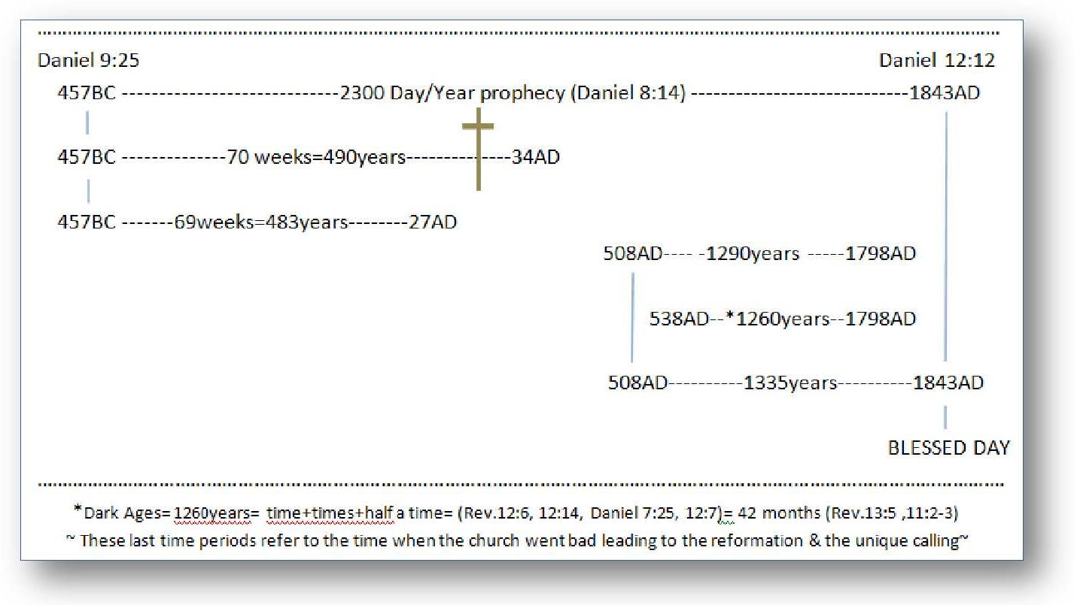
Of the Remnant church
(people)

ROMES CHALLENGE
What does the Papacy have to say about “their right” to kill over 100,000,000 protestants during the dark ages way back their in their beginings of power, “extreemly important” information for protestants;
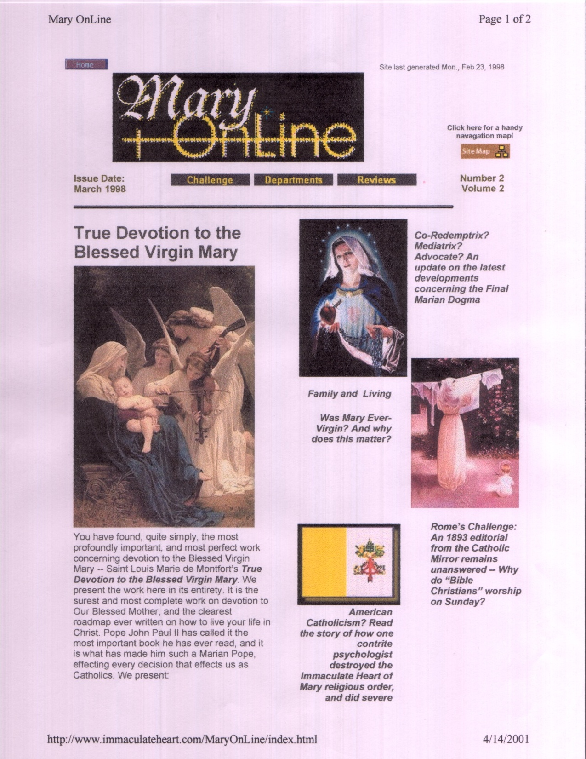
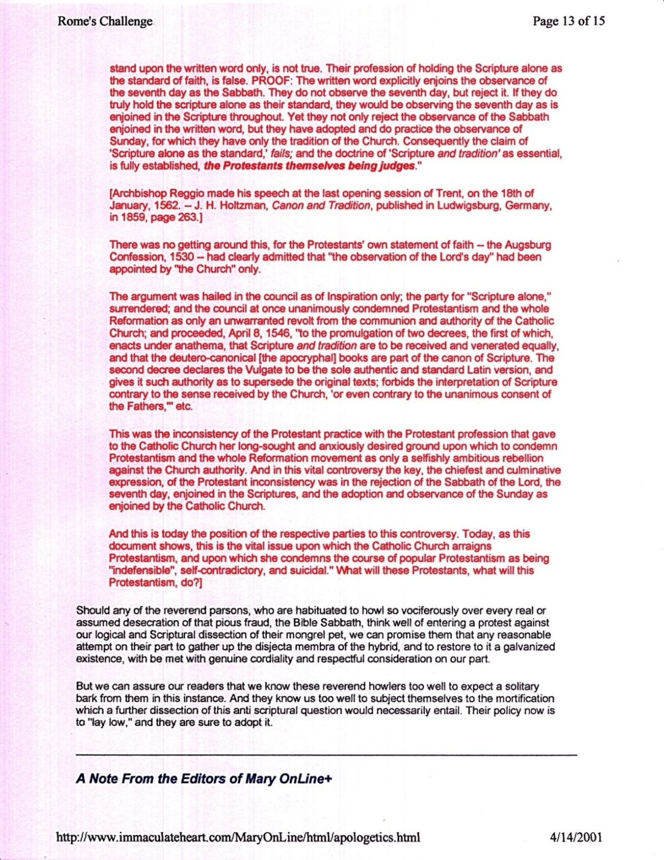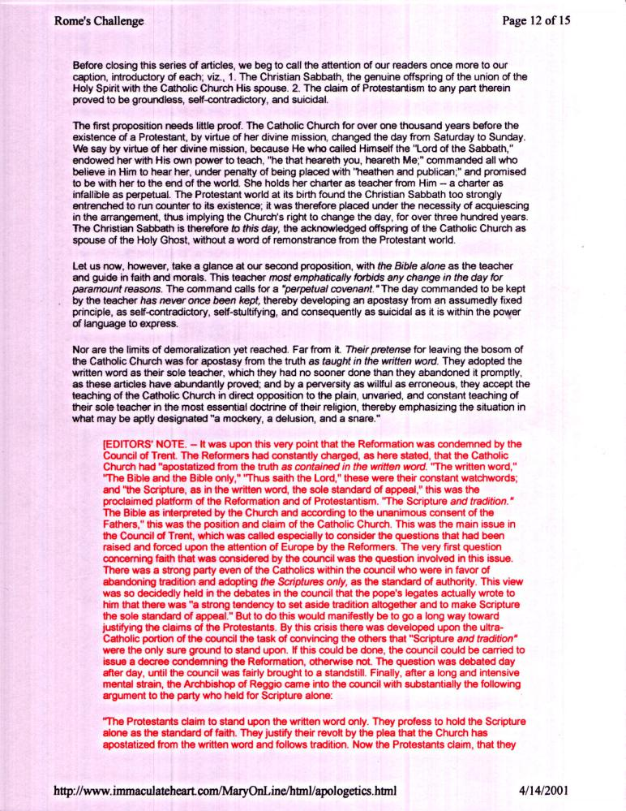

That’s why He said the things He said like; “Let this cup pass”, “why hast thou forsaken me”, but, He knew it had to take place for mankind’s sake, (really for the whole universe) He said; “Nevertheless” thy will be done….
The church, (being the people, see all the books on this site dealing with the “Church”) the church in the first text, represented as a woman in prophecy, (Jeremiah 6:2) is the (pure church) going into the Dark Ages who suffered the persecution of the beast power because she held onto Gods Words. The next text pictures Gods saints (true church) who, having come out of the Dark Ages (and carrying the same Words of God as she went in, being all who didn’t take on the mark of the beast. With a little difference found in both of these churches (people); Both texts picture them “of course” keeping the Commandments of God (big point) but, the first church (people) has the ”Testimony of Jesus” (which Biblically is the “Spirit of Prophecy” Rev. 19:10) and their testimony (Rev 12:11) of what happened to them during that age as we read in the text above, which was “a fulfillment of the prophecies of both Daniel and Revelation”. (See “Do We Really Know Prophecy” this site) The second text pictures the church (people) still carrying (of course) the Commandments of God thru, as it came out of that long prophetic Dark Age (see “Time Chart” appendix) being the church who looked back and saw the Testimony of Jesus in the fulfilling of the prophecies, ( see www.mosescats.com “Yom Kippur”) and we know those prophecies in the New Testament, as well as all the prophecies in the Old Testament complete the “Faith of Jesus” both before He came, and fulfilled those prophecies, and after He left and sent back the prophecies, (“Revelations” see “The Same Message” this site) and in seeing how those prophecies about that Age, did fulfill during that Age, thusly the church of this age (people) are described as having (keeping) the Commandments of God and the Faith of Jesus, as well as Faith in His Testimony. Jesus, being the giver of Prophecy itself which was given to Him by God (Rev.1:1) given for the church (the people) “today as the faith they should have” in keeping (fulfilling) all that God gave for them, for the saving of His saints, us and them, who do what? As have all the pure churches “and people” throughout time even down to our time. Jesus gave us a starting point when He was here; (Matthew 24:11-15) It’s vital in this age of false prophecies and false faith and false testimonies that we know and understand these things or possibly be deceived and lost because we “loved not His truths” nor cares to know them. (II Thessalonians 2:9-12)
It interesting to note (actually tragic) that on the day they dispensed with the “Abba” from Gods worship day (Set forever and ever in the universe, Deut. 7:9, Isaiah 66:22-23, Matthew 5:17-20) and replaced it with the “Sun” (the object of pagan worship forever on earth) at that time when the Papacy’s Counsel of Laodicea met to make the change from the Biblical mandate to tradition, in order to do such a thing they needed a leadership approval it seems, but many of the council members disagreed in the change and held out for maintaining the Bible as pro council. Well we know how that went, and how the persecution against the protestant’s was justified “unless that is they went along with the Papacy’s edict. (See Appendix “Romes Challenge”) 100,000,000 people (a very conservative number) were put to death during the Dark Ages (under the edicts and commands of the Popes who controlled religion for that 1260 days/years (prophetic and literal Rev.12:14-17, Daniel 7:25 see “Time Chart” Appendix) Justifiably killed by the church because they would not uphold tradition over the Bible! Today they freely give up the Bible for tradition, when many of their fathers “in fulfilling prophecy” with their very lives thru persecutions (torture see “Foxes Book of Martyrs” Amazon) and some burnt to death at the stake “for holding on to Gods faith and His laws over mans, and His Sons Testimony (Rev. 19:10) which confirms them.” Does prophecy say this religious powers control will attend the end times? Rev.13:4-17, 14:9-12 see also Convinced” this site for overwhelming evidence that she’s already got her foot in the door and why religion is so dumbed down and will grow more radical in time having done away with Gods moral constitution His 10 (all ten) commandments, and the cycle turns round and round, But, this time it’s the last turn. For prophecy is about to conclude and Revelations, Gods final warnings for the church (people), is about fulfilled. (Rev. 14:6-14, 22:14) Do we stand with God and Jesus or not?
If you notice the same identifications are given for this group more or less BUT, Rev. 21:8 tells you their fate, which; removes the idea that there will be people left alive after Jesus comes (the bases for the previous study on “Christs Kingdom On Earth) which of course leads to the Left behind false doctrines series of the anti-Biblical lies that cause the Bible to contradict itself, and, even if it seems innocent it’s definitely not, for the old saying is true “tell lies so much that we all will eventually believe them”, and discount any arguments against them, whether they are proven false or not, and, it will take a lot to get people to accept that their religion teaches false doctrines, even if they aren’t official ones, but just accepted as religious concepts. I purpose; “test everything one believes against the Bible - because it’s truths are what are going to judge us in the end”, and being flippant is not going to be a viable excuse either, for Paul (the head master of the Gentiles) makes Gods knowledge clear about what He (God) thinks of the truth, and how He will deal with those who don’t “love His truths enough to care about them - enough to change when they see a contradiction for whatever reason” read and weep I know I do. (II Thessa. 2:8-12)

