DECPTIONS how deep is that rabbit hole?
Depth and distance are equal when it comes to eternity; they go on forever and ever “as in time and space”.
If our lives were eternal, then time of course would be of no essence, we could walk this path forever and never reach its end, and it would go on forever.
We however, are trapped in time and thought, never moving, and that picture will never change as long as we live.
The same is true with space.
We could start out into the universe in any direction and we would never reach its end.

The Hubble telescope has done one thing for us if nothing else, it has shown us “just how deep space is, how far stretching it is, well, as far as we can see and remember, we can’t see forever we are mortal!”
Even if we could live forever, when the largest and best telescopes can’t see any further out into the universe, “we still will not be seeing the end”, despite the continuing deceptions of science who have already said they have seen its end, this, to make themselves appear creditable.
Think about it; so what if we could see it’s end, and even prove it some way, then, what’s beyond that and then, what’s beyond that “Infinity”, see it?
No you can’t, and neither can they obviously!
Just suppose we can find God out there and come to the realization “He really did create the universe”, and He said it has an end?
Then, what’s beyond that, and beyond that?
If you really try to think about it, it will drive you crazy.
Those expert astrophysics saying they see the end of anything out there is all part of the lies and deceptions that are buried deep into this rabbit hole of reality, and one I hope to expose in this writing, so that we can see clearly, and hopefully, in time to change our direction for;

No matter what the future may hold
for the last man or woman on earth,
“ours is set” in time and space,
and we can’t change that fact.

We only have so many years to understand what’s next after the inescapable death that awaits us all, and, even if there is something out there, how can we know it’s true or just another deception if we can’t see it, prove it in reality and not theory, even religious theory?
Let’s operate then on that assumption; that there is something out there and we can prove it, without doubt, and if you stick with me, at least for the duration of this study, you will discover; “if that reality, I’m forwarding, is true or hype, fact or fiction, truth or deception as this article, ok?”
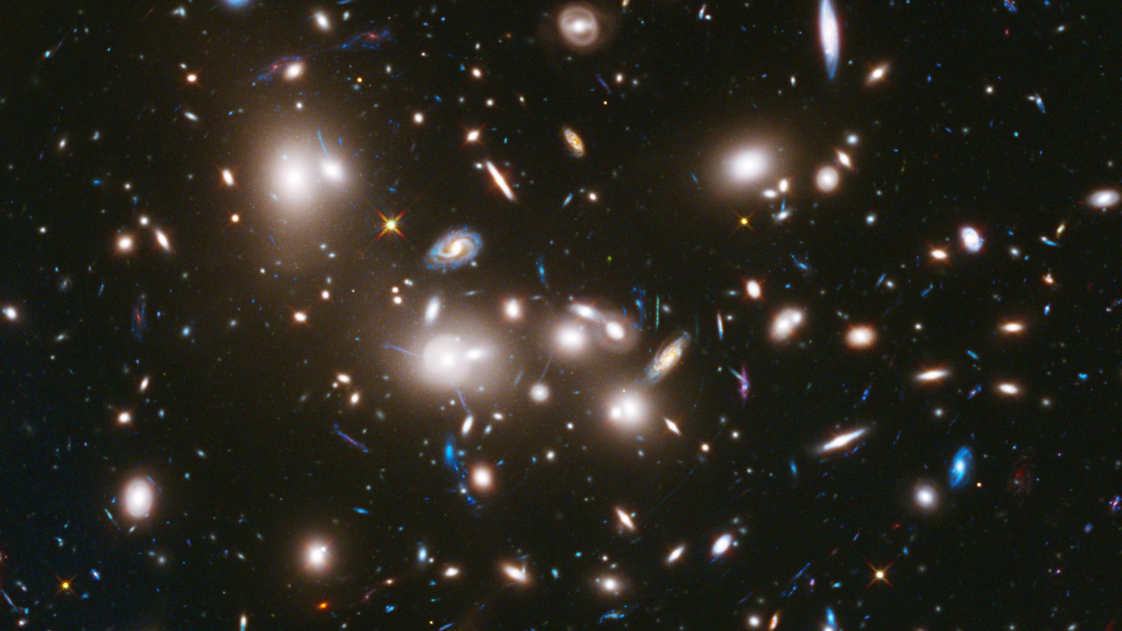
HUBBLES DEEP FIELD VIEW - IN “ONE” DIRECTION
Each of those oblong objects, that Hubble at present can “see” (get it?), are galaxies like our own galaxy, the milky way, each containing billions of stars around a sun (principal star), and yes, possible planets like ours are out there I have no doubt.
“But”, how far out there are these galaxies from earth?
Could we ever get there, as fiction has polluted our minds to think that we can some day?
Oh yes, theory after theory seems to make us think so, “given enough time” they say, but remember; we can’t wait that long to decide if they are true or not, however, this false hope does have a serious effect on us subconsciously, as does religious theory.
What’s not theory though is the fact; that all of these galaxies “do exist” and we can see them clearly.
I love this shot of our Milky Way
A part of our galaxy, called the milky-way, can be seen as in this picture, standing on earth with our naked eye, and we can see this and know that “it exists” out there, and seemingly close by.
Just like with the Hubble telescope, it seems like those other galaxies out there are close, because we can see them, at least as far as the eye can see for now, and there are thousands of them out there in the eternity no doubt and each containing, as I said; “billions of stars around a sun like ours”, it boggles the mind doesn’t it?
How far away do you suppose our galaxy of the milky-way is from earth?
This, my friend is where the rubber meets the preverbal road, fiction meets fact, and the truth supersedes the deceptions;
The closest distance from our earth to just the edge of our own galaxy, the one we can see from earth with our naked eye as in the picture above, possibly beyond the edge of the grouping of stars might be that closest point, just to the edge mind you.
EDGE

That edge is a staggering, incomprehensible distance of “10,000 light years” away.
What’s a light year?
It’s how far light travels in one year, traveling at a staggering 186,000 miles a second, and that’s really, really really fast, seeing we can only go at present 50,000 miles per “hour”, that’s an hour not a second, we can only travel at14 miles per second, big difference, and in a space ship of course, and even that is inconceivable as we travel daily at a mere average 50 miles per hour.
Just to give you a perceptive glimpse of just how far a distance of “10,000 light years and the edge of our own galaxy is”, and how long it would take us to get there at the highest conceivable speed we could ever achieve;
It has taken the space ship Voyger, sent out in 1977 – “2 light hours” to get just past Pluto, being the furthest man has traveled within our “own galaxy”, and, not at the speed of light as in a light years, but in earth years, at our present spaceships speed capacity.
It has taken us forty (40) literal years just to get that far out into the confines of our own galaxy, called interstellar space, almost half a lifetime.
Sure in time we may be able to go faster, but that’s theory, and I’ll give you that, but to think that we can travel vast distances at the speed of light, or even near so, is fiction in the highest order, so forget it and come back to reality and base you hopes and dreams on facts not hype.
To get an idea of how far the edge of our galaxy is, and what it would take to just break free of our own microscopic part in the universe in space and time, notice these charts:
The first chart shows us the relationship of the earth and Pluto so you get an idea of how far we have gone so far (at the time of this writing);
Interstellar Space
< we have traveled Two “light hours” in distance >

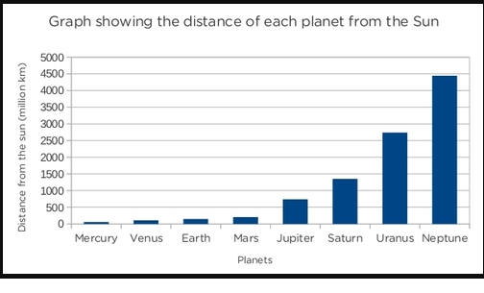
Or as this next chart shows, since they have done away with Pluto as a planet, the distance to Neptune from earth is approximately 4,500,000,000 km.

That’s 4.3 billion Km or “2.7 billion earth miles” to Neptune, and then on past Jupiter to interstellar space another 3.2 billion Km or 2 billion earth miles, making our total trip into outer space 4.7 billion miles from earth+-, and that took us 40 years to accomplish that, at our present rate of speed.
How far then to the edge of our own milky way galaxy, from earth are we, and how long would it take us to get there?
It took us 2 “light hours” to get just past Pluto, but, the edge of our own galaxy is 10,000 “light years” away (closest point) or 10,000yrsx365days in yrx24hours in day= (hold on to your hats) it would take us 87,600,000 light hours to get to the closest edge of our own galaxy.
Ok, let’s figure this out to get an idea just how many earth years it would take us to get there;
We’ve traveled 2 “light hours” in forty years, so let’s see; that’s 87,600,000 light hours (LH) to edge of our galaxy/2x40years = (hold on to your mind) it would take us 77 Million years to get there at just the edge of our galaxy! [Correct me if I’m wrong please].
Even traveling at the highest rate of speed we think we can achieve it would take 67 million years to get there;
(58786253731836077 Miles = I0000-LY/100000 MPH/365/24= YRS)
Get where?
Just to the edge of our galaxy as we can see in the above pictures!
Regardless, we can safely say “not in our life time, no, not in any conceivable lifetime “can we break free of just our own galaxy” Spock!
In fact, just think about this all you who think we can someday travel at the speed of light;
Traveling at the speed of light (which “is” physically impossible except in theory) it would still take us 10,000 years to get there - right?
That’s “Ten thousand years”…..
Please, don’t hand me all those impossible theories we can never prove like folding space, black holes, blink drives etc., why is it we haven’t even been back to our closest heavenly body, the moon, in how many years?
If in fact we even went there, and that’s a legitimate question if you watch the arguments against it?
Why hasn’t anyone else, and why can’t we photograph the stuff we supposedly left there?
So, where are we in this great deception we are under, as far as science is concerned and how has it affected our hopes for our future “in thinking science has our children’s back” when earth melts in the global warming?
The expert astrophysicist’s give us billions of years of theory in describing our future, and their “comrades in deception the evolutionists” give us billions of years of theory describing our past, but none of their theories are sensible, nor can be proven much less even comprehended (think about that), for there was no one back there in our past to record events “past say 6000 years ago+-, and there will be none of us 6000 more years in the future either. Even traveling there and back at light speed with no age accrued, another theory now accepted as a known fact, and that’s a fact?
Evolution is based on pre-historic assumptions and a false calculations of years, based on the age of rocks, “which then date the rocks”, and futuristic assumptions all based on theories which project theories which project more and more theories.
Can’t you see there’s nothing solid there to build anything upon?
So where does that leave us?
Searching for facts based on “creditable history past” and “the future” based on that proven history as well, and we have had that knowledge around for thousands of years, over 6000 to be sure.
True history has shown us, that the faces of mankind we see today, are the same faces we have always seen, in that we are a race that is genetically made after its kind and only by its kind. (See “We look like God” this site)
Still to today, in every plant and animal including mankind, all species that has life, “also has a seed” in it/them to reproduce its like kind, and no crossing of kinds will work! (See my book “The Seeds of Life” on amazon)
So tell me; “how, from the primordial soup did all the diversity of all these like kinds come into being”? All from “one ameba (monera), a single cell organism”? Come on who’s fooling who!
At what point in time did we go, and how, from “one cell to two”, for required copulation take place? And each had to have “had the seed built in” to reproduce, “but” only in like kinds and perfect duplication!

Each with all the same genetic traits to pass on in perfect continuity.
(see my book amazon “Memories”)

All the colors and shapes of life etc., to “naturally” pass them on?

All this diversity and singularity from one original cell in a mud puddle?

This last photo is a typical swarm of flies.

Billions upon billions of them, and everyone is identical to the rest.
Which begs the question; “how many trillions upon trillions upon the quadrillions of flies have spawned over time”?
Some with only a couple of month’s life cycle “from birth to reproduction to death”.
Some actually get only 24 hours to live, pro-create and die, and we know this from our years of observations, and, within these communities “there are no cross kinds?
They all look exactly the same as the one before and the one before, and the one before - infinity!
Of course near Chernobyl (‎Pripyat, Ukrainian SSR, Soviet Union nuclear meltdown), or where the Hulk fell into nuclear waste, who knows what deformations we will see?
Throughout all of time then “we could suppose then,” these billion upon billion of flies reproducing only like kinds, is the same as tracing the billions upon billions of man and woman back to what?
The same as what we have seen every day when we look in a mirror, or as seen in the pictures of the oldest known human sculptures, some possibly even antediluvian.

Back to that graph of the human linage;
Since it requires one of each to reproduce, just like flies, plants, animals (exceptions yes I know) but in the whole of “the kingdom of the living (rocks excluded which they say spawned the first ameba – HA!)” it’s just logical then; we spawned from one of each (man+woman) as the “One God” recorded “in the most ancient/most copied book in/of our history,” where He tells us; they were created by Him “in His image”, (Genesis 1:27) “Like Christ (Messiah)”, a man, but of course history reveals a “God man”, but none the less He was, as we, “the image of God” (John 14:9) the image of God was He, and thus, was our image created in “Their likeness”, He adds, (Genesis 1:26) so there is no doubt what He was saying.

Genesis 1:27 (KJV)
²⁷ So God created man in his own image, in the image of God created he him; male and female created he them…….
²⁶ And God said, Let us make man in our image, after our likeness:
When man was created, as was Eve “over Adams nap” remember, Adam witnessed the fact that Eve was created whole, “not as a prototype or an ameba” that required billions of years of evolutionary generation from one species to the next, going from non-life forms to life forms, but in just a single day was Eve created, and Adam too for that matter, for on the fifth day of creation, according to Gods history book, “man and woman” were created, finishing off the creation of all things, of all elements this planet and our galaxy holds, and, as we have determined “we will never (in this life) go to another galaxy to even compare”, much less, go to much of our own before we self-implode, or, before Gods Son comes back as He has promised, being the author and finisher of our faith, or the Faith of those who believe in His word “and Him as our creator”, and, we are told “His coming will be to gather them alone, and unto whom He will give His reward of eternal life,” (Revelation 22:12 in context) May that be our faith (belief) and the most rational and proven true.
On the fifth day of earths first week man and woman were created “as whole beings in the image and likeness of God” and this is the history of the world and mankind, that has “religiously” been handed down to us and preserved by God, from creations first day to the end of the first week in Eden a once place on earth, and yet, we look to mars with the same ignorance we look to Africa for our beginnings as human beings? How sad and stupid.
Gods Word has been the story of “time itself”, and only in the Word of God will you find the origin of the week, and how on the last day of physical creation on the 6th day, God didn’t stop there in His creations; for He created one more “literal day” to make up that week.
On that 7th day; God created nothing animate but something inanimate; He made a block of time of a whole day (evening to evening) capping off His creation.
He did this obviously so that we (mankind), when each seventh day of the week comes, we will be reminded of our creation “our Creator”, and you look back and mark it down; “it’s only those from Cain ahead that wanted to forget that day”, deny it even to today, as the false churches do today and have changed it from Gods design to their own?
But friend, we can’t ignore it, for it has religiously stood, to Gods people that is, a forever “weekly reminder”, despite Cain’s follower’s rejections, of not only Gods S-Abba-th but His creation, the “literal 7 day creation” itself including the 7th day, telling us where we came from and where we are going or could go.
The Seventh day of each consecutive week, that passes till time ends, has a life of its own as the extra day of creation, the seventh, and was made “By Him” our Lord God “exclusively for His (our) worship day” (Mark 2:27) the Lords day He called it, (Matthew 12:8) and it was called a High S-Abba-th day when it fell on typical S-Abba-th days God set for reason, (John 19:31) and it is the only day with Gods Fatherly name written therein (“ABBA”, Gal.4:6), thus closing out the first week of this worlds creation week.
God created Eve on the 6th literal day also; “so there would be no mistake a day of creation is 24 hours long from sundown to sundown”, back then, as it is now “in like kind” even so, and created that way”. (Genesis 1:31, 2:1-4)
He did it I sometimes think; looking ahead in time (as only He can) knowing the creation of man’s final theories and falsehoods here in the end of time, “deceptions” that would ultimately destroy His creatorship and His perpetual worship day of creation, “that shows/seals/sanctifies our faith in Him.” (Exodus 31:13)
His Sign of the S-Abba-th He gave to mankind which was set by Him at the beginning of time itself ending creations first week. It’s sanctity was carried through all the days by the prophets and kings, was to be kept holy and sacred by His first church/people, then through His testimony, lifestyle/custom and witness He gave personally when He came to this earth, for His second church/people to follow the Fathers will. (Hebrews 10:7, 16)
His doctrine lasted until the second church broke that chain of faith in the 4th century, shortly, in essence right after He left. As the churches that were established in His name began to fall short of true doctrine, marking then a long Dark Age under the influence of the beast power, who dispensed with the Lords doctrine, speaking mainly of the change of 7th day S-Abba-th faith as part of, connected to the creation, for as I said; “I think He “set it in Time and Law” to expose the false religious doctrines “that He knew would rise in the last days” as they will follow after Satan’s/Cain’s “rejection of His ways for their own,” and the final telltale was in their acceptance of the “micro/macro theories saying God used evolution to create”, which is as popular in the Sun-day keeping churches of today, and a direct result of it and the disconnection from creation, lies taking in about 99% of them. (Romans 1:25)
But if Eves one day creation, in the site of Adam, Gods first witness of His creative ability, doesn’t impress you (assuming you believe in God’s Word old and new with no doubt) then; you are aware that He gave us another creation clue, that should end any doubt of Him as our creator, “at least regarding this issue of creation, and that a “creation day is a literal day” not a year or 1000 years or billions of years in that; on “day three” He created the foliage, “BUT” it wasn’t till the next day He created the Sun, moon and stars” - boo ya!
How do you suppose that foliage lived say for a year or 1000 years as some, no, as most religions falsely teach, deceiving their flocks?
Friends; “each of their creation days couldn’t have been literal under their theories then?”
Think about it; how could their lie fit?

Think of the damage this does to the literal week ending in Gods worship day, not to mention no work is allowed to be done on that day or we die, cut off forever? (Exodus 31:13-18)

Unless we deny Gods creation or if we even cast doubts on it aren’t we also casting doubts on God Himself His holy Words and by our testimony teaching others to do so?
Any way you look at it, its effect on them shows us the answer “they have forsaken God” their “re-creator”.
You see, they do this only to appease science or the beast or traditions upheld so long to go back on them would be religious suicide or admitting they have been lying all these years, no it’s a catch twenty two, impossible for them to do now, much less for the author of the theoretical change of Gods Words and commands.
They argue; “to change now would make it impossible to save the heathen world”, and connect themselves back in with the Jews who denied Christ?
That’s the same reasoning the mother used to change Gods S-Abba-th, and to add holiness to the resurrection and the celebration of Easter tradition. (Eggs – Rabbits? Representing fertility as in the heathen rites?) Done simply to appease and save the heathens, and for evolution; to not look week/ignorant in the eyes of the scientific community. It’s all connected, but, it has had an opposite effect if only seen now through Scripture.
They can’t see what they have created as a faith;

that God didn’t have
the power to create
in the way He said

He did, something from nothing as Paul wrote, and, “in 7 Literal days.”
So they read their Bible (or not) with blinded eyes, yet still claiming the Lord as their Savior?
This just doesn’t mix with scripture, and friend scripture actually points those out who believe that way! (Read and weep you claimers but deniers; John 1:1-5, 10-14 The Lord of the S-Abba-th was also Lord of creation as well, and the deliverer of Gods Law to Mankind, etched by His finger on indelible stone through Moses)
No friend, the Bible teaches “a day of creation is a literal day” or you must throw out that book altogether, and listen; this is what “about all religions have concluded today, that Genesis is just a story, an allegory, an account that has been distorted over time but held loosely intact”, and so too, with that, they place the flood in that same respect. (See my book on www.amazon.com search ancion books on the Old
Testament flood reality as inscribed on stones)
In fact, with them the whole Old Testament is out the door, and that’s why we are now called “New Testament” churches today, for you see, you just can’t fit the Biblical accounts “pre-flood at least” into any their scientific scenarios, which they now call the truth, and placed it as such in our children’s school books, as scientific facts, (so called) and this is now the present religious mind set as well.
It’s just that simple, and listen; they all are saying from the least to the greatest; “all you need is Christ and that’s all” and they quote Paul (l Corin. 2:2) thinking he agrees with their non-Biblical beliefs, and, just because of a few misunderstandings “the blind” have taken from Paul’s sayings they have taken “the truth” and turned it into deception. (I Peter 3:15-16)
But Paul saw the future and wrote about it, notice; hitting on our very subject. (Romans 1:18-23)
They still stick with their seeming good philosophy (calling it theology) quoting Paul as having concluded; “all else is unnecessary save faith, so don’t ponder upon works, just accept Christ and your all in” once saved always saved, the rest is debatable and even harmful they teach. (Hebrews 8:11, 9-11 they leave out or actually are blind to its connections with Law/works. Rev. 22:12-14) When the Bible is clear right to the end!
But then I beg to understand what Paul meant in Hebrews 8:11 referring to the New Covenant the churches claim to be under, minus the Law of course.
Biblically “everything written has always evolved around our Savior Christ”, and nothing we have or can do has any merit in its self, “BUT” friend, our profession is witnessed by our testimony which is everything, (mental, physical and spiritual) “reflects our faith”, and if it’s fouled “so is our profession.” So, why do we profess man’s reasoning over Christs, over Gods truth, and, defend it in any way?
Thus I beg again to ask; “why is evolution the way to go” which belittles or actually denies Gods ability to create Eve in one day, or any of the other Dailey creations He claims to have done in His Word” including the S-Abba-th?
Ignoring the even more miraculous things to yet happen.

Or have already happened given to us from Old so that we lose not His present truths that counteract the false;

“He has allowed His Word to be preserved
despite its unpopularity over the many years,
because of its exposure of His religious enemies,
yes, I said religious”

So I ask again; “why has evolution or a micro/macro theory suddenly become the truth?”
Especially when we can observe “real evolution” by the species we have today in all that has life in it?
Which more than proves what God has created through TRUE EVOLUTION OF THE LIFE by the male and female of all species “which have procreated in like kind” since that creation, and done by His Word. (Romans 1:19-20)
God’s WORD; began it all in 4005 BC (Biblical chronology) only 6000+ years ago not billions of years ago? (See www.theuniversalreligion.com the book of same name)
Look around at all the proof;
You can’t reproduce a monkey with a human or vice versa, even if we can share parts, even though we are a very close species genetically speaking, but no more reproducible than a dog with a cat, and I’m sure that would naturally not be possible, like a cat with a mouse, a plant with a man, but of course man derives life from such, not cats and dogs, but cats do eat mice, yes, and man eats plants?
Sure you can cross species with genetic manipulation but it always creates mutations at best if applied, and look at what genetic manipulation has done to the seed bearing plants “it has actually destroyed seed reproduction in those plants”, and all you get is a by-product with some life in it (maybe not even good life) for no one knows the long-long term effects yet if any? Of course they can produce more crops, but at what cost eventually when all the seeds are corrupted?
You can only generate a species “with like kind in all life that has the seed built in”; just as we know it has occurred naturally from the first two parents of all kinds of life!
Oh sure, we may very well soon genetically manipulate the species, as I believe created the dinosaurs in antediluvian times, being one of the reasons God sent the flood to put a stop to it, and of course; we have inner breeding in the “like species” that has given us the huge diversity among “like societies” we see today, however, this is not the same thing as genetics, even though we are dealing in that arena, but the point is; Gods creations are natural, mans are not, and science will never re-create, or even reproduce the same species “outside the womb of creation as God set”, as a “like kind” can and does, and, that’s why God used that powerful terminology of “like kinds, after its kind” throughout His creation of all the species wherein He placed life “to differentiate when things get confused as they are today.” (Genesis 1)
It’s all in the seed transfer and union, and even then we will never understand nor successfully reproduce as I said; “that process outside of the species womb” or the semblance thereof, and when we try as I said, we get genetic deformation in all cases even at the atomic level, it’s that impossible! Despite the lies of the DECPTION, as we have been trying to be god for many years now with the aid of supercomputers but have only succeeded in our minds.
Let just think about it logically;
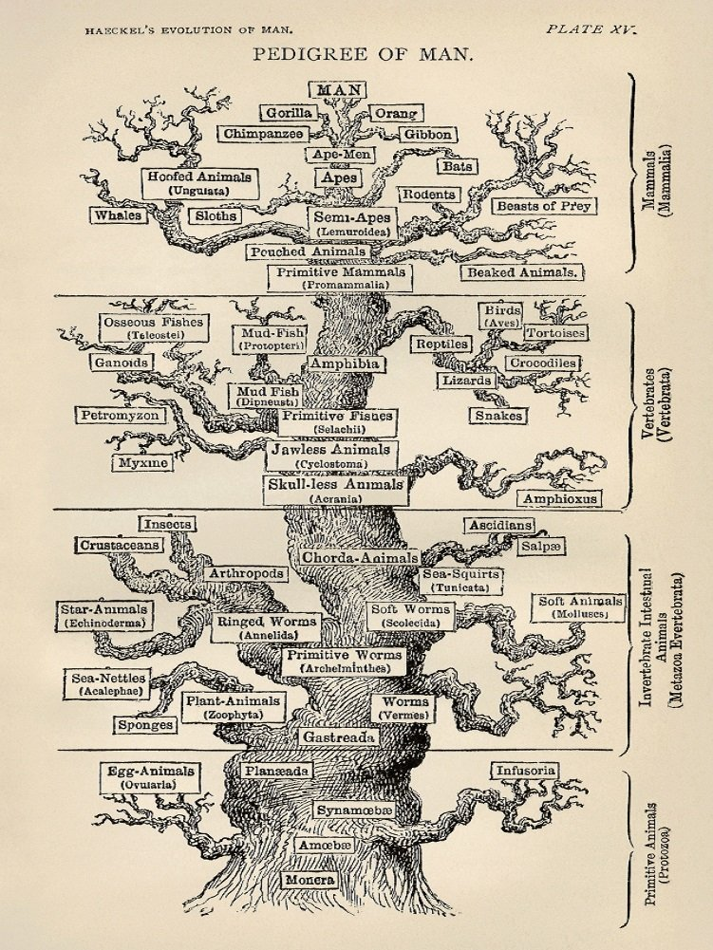
Man’s Logic
Ask you self;
In the theory of mans decent, at what point in the life of the amoebae (Monera), “one” I assume, swimming around in the preverbal soup of evolution, at what point did it decide (with a brain I assume) decide to reproduce?
With what “itself?”
Or at what point did “they now” think to come up on dry land and breathe air instead of water and live?
What about life itself?
Spontaneously creating itself from that soup of billions of years of rain falling on rocks, rocks more kin to cinders as to what the earth would have been like after the biga-banga-booma, you know, that “nuclear degree of a blast” they say that took place creating all life as we know it to be and the heavenly bodies (Stars planets etc.) throughout the universe to its end?
What a long-long-long stretch, all from “a micro dot of dense matter” they say? No bigger than a head of a pencil they say? (Hopefully they’ve refined that schoolbook claim today).
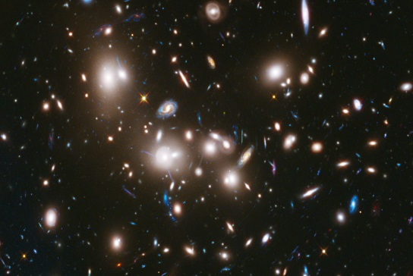
REMEMBER THOSE PICTURES TRILLIONS OF STARS 1000’S OF GALEXIES? THAT’S A LOT OF ROCKS FROM A PIN POINT OF MATTER DON’T YOU THINK?
SOMEBODIES LAUGHING AT YOU FOR BELIEVING SUCH IGNORANCE – NOW THERE’S REAL LIKE KINDS! BIRDS OF A FEATHER FLOCK TOGETHER…

Anyway, from a blast of such intensity like that; all that would have been left regardless, of how much of all matters, they would be rendered “lifeless material”! Burnt to a crisp, spent, and incapable of retaining life! “Much less create it,” and, that includes all the billions of galaxies out there.
But in earths case, being of course the center of the universe, as those bigots like to praise themselves in claiming, from out of that blast came a living planet in the vacuum of space?
That’s not even logical…is it??
Then there’s the present reality of our world “2/3 of which is water???”
Even giving the 12.5 billion years we are told that has transpired since the biga-banga-booma, “in the vacuum of space none the less” from whence came all that water????”
From a nuclear blast?????

The break off mass that they say created the earth at the nucleus of the big bang, once it cooled down, would be more akin to a cinder wherein there’s no life!
What an impossible thing they are teaching our children, who by now all believe their ridiculous scenarios as opposed to creations “truth as recorded” a handed down and logical account of it all, but that’s the myth they say, as they have DECEIVED the children’s children “world-wide”.
Gods account actually “started with water” He placed in the deep, not condensed vapor from nuclear waste (oh yes, and don’t forget radioactive vapor at that) from the cooling of cinders, but, the wise known life came from Gods ability to create life “and sustain it”, in once a perfect balance, from the immeasurable-infinite to the microscopic “did I mention in a delicate balance”.
On Gods earth; all life relies, in one way or the other, upon the other to survive as designed, and yes, all encapsulated in the vacuum of space (within our galaxy) to entrap us “to keep us from letting sin out into the universe”, and all we can do, have done, is use it up, genetically destroy the natural until all seeds of life have been destroyed physically, mentally and spiritually? (See www.amazon.com search “the seeds of life ancion”)
We’ve been manipulating in test tubes, in and out of vacuums, by now, even in the vacuum of space, and from “all the chemistry and science know how we have to date, assisted by mega computers for years now, we still haven’t found the right ingredients to mix for life, much less an “intellectual life” as we have seen from history, and friend; we are degenerating as we evolve, not becoming smarter and smarter from monkey brain to Hawkins brain “where in respect to God” both are equal.
No, we are moving away from Godly intelligence, and from proven facts to scientific ignorance known more as science fiction, “pre-history” based on which no one can prove. They just put billions of years on it because they know that no one comprehends it anyway, and you got a good theory but that’s all it is.
I say you may as well say trillions or zincatillions, it’s all made up and meaningless to life, and, it keeps us from realizing what’s real, and, as far as life is concerned, we’ve got very little of it as well, that puts food on our table 3 times a day.
Are we the only gods in the universe that are self-conceived by thought of an unprovable evolutionary process, or, are we ignorant of the God of the past who was the creator of all life as we know it, from the state of perfection to the preservation of it even in its present degenerated stage, or are we self-made gods heading for complete self-extinction back to the soup state kin to rocks from a nuclear world war?
That’s just the reverse of Evolution so you can’t call it evolution you must call it de-evolution, or evolution to extinction, and that has been the observation in all aspects of human generation, mental, physical and spiritual degeneration throughout time, even in Gods camp both in heaven and on earth.
Where did the spirit of a god etc. come about in the thought process of an ameba or a cave man or even modern man, if there was not always a spirit world in our intellect?
I watched a debate on public TV between a philosopher, a Christian and a Buddhist all doctors, professionals in their fields, and it ended with no answer to that question, so maybe no answer “is the answer”, it has been God all along but they just can’t see it? (John 4:24)
According to the oldest history book there has always been a spirit world as well as a creator of life as we know it, and that knowledge was handed down to us, only, over time we have perverted it, manipulated it, genetically modified it away, swept it under the rug selfishly, and as a result we have lost track with its reality, and its promise of life after death, even when it has proved itself, and documented its proof from word of mouth to the age of documentation and modern intellect. (See www.theuniversalreligion.com “The Dead Sea Scrolls”)
Of course todays intellect have given us Evolutions false science and space science fiction, and all else that has brought down the great nations of the past, mixed with greed, consumption, lies and all the sins against the Ten Commandments including perverted religion, now the logical next step against the creator God is to bow to the gods of their making. (See “Convinced” this site)
While God has seen fit to preserve His Word from the heavens to Creation, to His Revelations sent back from the heavens spoken by God Himself, (Rev 1:1) to inform us of the DECEPTIONS, but, we never listen nor take Him seriously, and thus death is our reward for life.
While life can be our reward for life, but only in Godly circles can this be, as defined by Gods preserved Word Alone “line for line text upon text, (Isaiah 28:10) as it stands alone with no personal interpretation (II Peter 1:20) “save from His words alone”, and we can hold it in our hands today “the key to eternal life”, but, we can only find it down that road……

Should we decide to take it…….

THE PATH OF INTELLECT from the beginning….
When we look around today, say from the news, it’s hard to say we are getting more intellectual, especially when you follow the internet bloggers, you become convinced that intellect has hit rock bottom.
When one looks at religion today it’s hard to tell one from the other, they all persuade themselves they are the religion of God, but on close examination they all follow the beast, (Revelation 18) and it’s only those who actually profess “Gods religion” (Old and New) who can see and expose them as spiritual adulterers.
The greatest spiritual deceptions have come from, what the Bible defines as, the Beast of Daniel and Revelation. Newton identified her, Luther exposed her, France took her off the throne, the USA denied her access early on, but has now made an image to her, (Revelation 13, See “Forgetting to Remember” or “Convinced” this site) and all this, can be easily determined, if one really wants to know Gods last day warnings so we not be DECEIVED, because the Bible foretold us that it would happen, and, not only was this knowledge given years in advance through prophecy as warnings, but by dates and events that have all come true100%.
This is where Gods state of the art of His religion stands, with full exposure, and proven from the pages of His book the Bible, expressly the KJV and only what I use for reference for a reason. (See “What if the Bible is True” this site)
Today’s religions are as good as the milked down versions of the Bible they use, paraphrased and deceptively out of harmony with Gods Word as handed down from eternity, He has preserved miraculously for us to today. Despite the beasts attempt to destroy it, for its exposure of her and her “false worship day” standing as the greatest deviation from God Word we can state, in that God established it on the 7th day of creation as a monument in time, (Search Amazon A Temple of Time Ancion.) and what part on of this writing discussed in detail.
The path of the past history has told us in so many words the longevity of this last day of the creation week, (Deuteronomy 7:9, Matthew 5:17-18) from Old Testament times to New testament times and its mandate has not changed in Gods site, only in man’s blindness, (see “S-Abba-th or Sun-day” this site) and what a “momentous deception” the beast has created causing all christian religions (small c) to follow her, being those who take Gods clear word lightly, and misinterpreting selected passages from Paul’s writings (II Peter 3:15-16) they use to prove their stance, yet, they miss the “whole of scripture” on this subject of truth as Paul warns us here in the fulfilment of this prophecy. (II Thessalonians 2).
This is deception number one in this study including of course the evolution lie that ties right in.
Deception number two has likewise been handed to the protestants by the beast power, and they have now modernized it into a doctrine as a truth (small “t”), but it’s not Biblical, and that deception is; the one of an ever burning Hell where god is punishing man for his sins and will do so forever and ever in pain and eternal suffering.
For one thing; “is this the image of God we have or even want to have?”
Is this the image He has shown us about hell and the afterlife?
If it is I don’t want it!!

LIFE AFTER DEATH -HEAVEN OR HELL?
Have you ever had one of those nights, after you finally fall asleep, the next thing you remember is the alarm and you’re awake?
No dreams, no nightmares, no tossing and turning, just nothing but good old unconscious sleep.
All you remember is; you were awake, then you obviously fell asleep, and the next thing you know is you are awake.
That’s what happens “Biblically” when we die, our thoughts perish, and the next thing we know is we are awakened, either in the first or the second resurrection. (John 5:29)
Jesus talked about this awakening from death, what it was like and when the dead will awake. (John 5:25, 28-29)
This was the Biblical belief in the day when He was here on earth and before He came. (John 11:24)
Speaking of Martha, the sister of Lazarus, of whom were two dearest friends of Jesus, you recall; Lazarus died and when the word got to Jesus, He stated “Lazarus is asleep”, this comparison of sleep as death threw the disciples off, but He quickly told them “Lazarus is dead”. (John 11:11-14)
In fact He said; it’s a good thing I wasn’t there for this gives me an opportunity to tell you about death, resurrection and sleep [I’m paraphrasing]. (John 11:15)
He waited four days before He went to Meet Martha at Lazarus’s grave for two reasons;
One: it was common knowledge in those days that, after four days a person was absolutely dead for sure, and that was why Martha was so upset with Jesus because He hadn’t come before that time “to heal him back to life” as He had done before for others.
Two: He waited till Lazarus was completely dead so that all, including us, might know about the state of the dead who “sleep”, and of the resection to come at the second coming.
As a result of this example of a true resurrection, which the Sadducees rejected, they sought to kill Him and their high priest even perverted the very prophecy that proved He was who He was, and the very year He would come according to that prophecy. (Daniel 9:24)
Point being; when it comes to heaven or hell at death and not at the second coming as Jesus taught, and we can assume Lazarus would have gone to heaven if only for four days. Don’t you think he would have ended the argument as to what happens when a person dies?
But the Bible is silent he never described being in heaven, and of course if hell was his fate Jesus would not have brought him back in the first place.
No friend, in the deliberate use of His friends death He taught us that “death is a sleep” and confirmed what had always been taught in the schools of law; that our thoughts perish, (Psalms 146:4), there’s no remembrance in the grave, (Job 6:5) nor praises in heaven, and friend, if we teach something different than what the Bible makes clear ( and there are many more texts I give in my book) we pervert true and Holy Word of God, and that’s a deception of a great magnitude to do so.
Truly so have the majority of the protestant churches taken the Popes traditions over scripture, over Jesus words, over the Fathers word, even over Paul’s words the Apostle of the Gentiles. (I Corin. 15:51-52 still a mystery to many because of false teachers)
What about then the two resurrections Jesus spoke of that happen at the second coming as Martha pointed out “uncontested by Jesus?” (John 5:25, 28-29, “now is” meant His same voice they were hearing and the result of belief in Him then and then, 11:24)
What about this phrase “the time is coming” Jesus spoke of concerning the grave and the resurrection?
When will the dead in the graves hear His voice? (1 Thessalonians 4:16, 13, Rev. 20:4-6) Also dispelling the lie of a “secrete rapture another deception” which is obviously not what Paul believed and then what did God Himself tell us about that day when time is at hand will be at hand. (Rev.1:1-7, 6:15-16)
Two resurrections:
One: at the second coming when the righteous dead will come forth from the graves, (Rev. 20:9) and one at the end of the 1000 year reign of the saved and when that group who will receive the second death (same type of sleep but this time no awakening) this group will include all those who will receive the second death including; Satan and his evil angles and all who listened to them and not God, and they all will be cast into the lake of fire “just then kindled” (Rev. 20:9) and “Death, Hell, beast false prophets liars sin etc.”, and will be utterly destroyed in that unquenchable fire root and branch forever. (Rev.20:14-15, vs 10)
You say “I got you”, you’re the one telling lies its clear right here and other places where burning forever and ever is mentioned”, “so what are you feeding us?” you say as you mock your false teachers.
The truth of the matter is right there in those two texts what forever and ever means;

Revelation 20:10 King James Version (KJV)
¹⁰ And the devil that deceived them was cast into the lake of fire and brimstone, where the beast and the false prophet are, and shall be tormented day and night for ever and ever.
Seems conclusive without consulting other texts in the Bible of going with the false teachers’ concepts and misinterpretation of scripture in following the beast who came up with this concept.
Now we see the danger in believing death is just an extension of conscious time and awareness, first on earth till death and then second in heavens bliss or in hells torment as opposed to an unconscious sleep till awakened by God or a sleep forever and ever never to be awakened again!
“Death” as defined in the Bible is an unconscious sleep in the grave and that goes for every place it is used such as in the text at hand that answers our dilemma and harmonizes with the rest of scripture as well as our image of a loving, merciful but just God.

Revelation 20:14-15 King James Version (KJV)
¹⁴ And death and hell were cast into the lake of fire. This is the second death.
¹⁵ And whosoever was not found written in the book of life was cast into the lake of fire.

Now Satan, his angles, false prophets and wicked are animate objects that can be burnt instantly or forever and ever, but death, hell are inanimate definitions with no life in them, save what we make them mean.
But the text is conclusive; when all animate and inanimate things are cast into the lake of fire, “just then kindled buy God from heaven” at the end of the 1000 years, it’s called “the second death”.
Meaning once the inextinguishable fire of God (obviously not a normal fire as we conceive fire to destroy even inanimate things) has done its work, they will ever be “forever and ever gone”, burnt up root and branch as another text reveals never to rise again!! (Malachi 4:1)
A sad but happy ending at the end of a dark and long controversy with the results burnt up “not out there or down there somewhere to constantly remind us of our friends and loved ones somewhere burning for eternity just because of poor choices they wouldn’t give up for the truth.
What reality do you choose mans or Gods? (II Thessalonians 2:11)

If this isn’t your churches doctrine then it not a church of God’s word and you have given over to the DECEPTIONS of the beast. (See “Heaven or Hell” this site for a full version)

THE PATH to the future…
OUR PATH
GODS PATH
He still speaks

~MOSESCATS~

APPENDIX

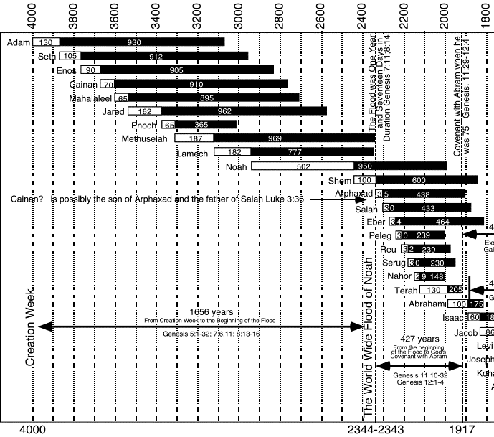

ROMES CHALLENGE
The Sabbath was changed by the Roman Catholic Church in the 4th century at the council of Laodicea, but it wasn’t until the revolution against the Protestants that she converted over the old timers in her religion, who had maintained the Biblical Sabbath as a scriptural mandate, but now forced to accept the Papacy mandates over the Bibles.
As the following suggests, at the council of Trent in the 16th century was when she placed traditions over the Bible as the primary source of truth, and thusly the protestants [protestors then] who chose not to follow her is why, as you will read in this article, why she justified the killing of more than 100,000,000 people (Heretics) being all who would not succumb to her authority in religious matters, and brings up a dilemma, as to why today we see the protestants calling for a unity again with her despite her history, and I must assume their ignorance of it, as well as a literal creation, as well as the 4th commandment of Gods Covenant/will etc., and, the perversion of the prophecy that predicted its change by her, as well as the killing of the saints by her, and actually gives the period of time in which she would do this, (Daniel 7:25) and answers as to why they are blindly following of her in these last days. (See “Convinced” this site, see also the time chart of that period mentioned in this prophecy which can only fit in the time when she was in charge and in control of religion)
This is why the truth about the S-Abba-th of God is/was so important that God made it a “Covenant mandate” of life for His people, and death for all others who worship and follow after the beast of Daniel and revelations. (Rev.14:9-14) What else can one decipher from this end time vision given obviously for us here in the end, who with open eyes see the prophecy fulfilling as we speak, and clearly telling us who worships God and who worships the beast.
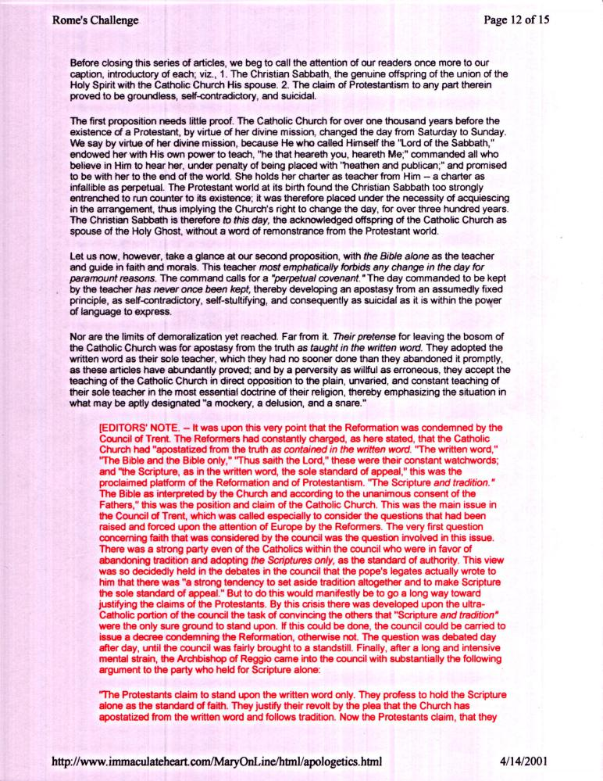
Continued…
TIME CHART
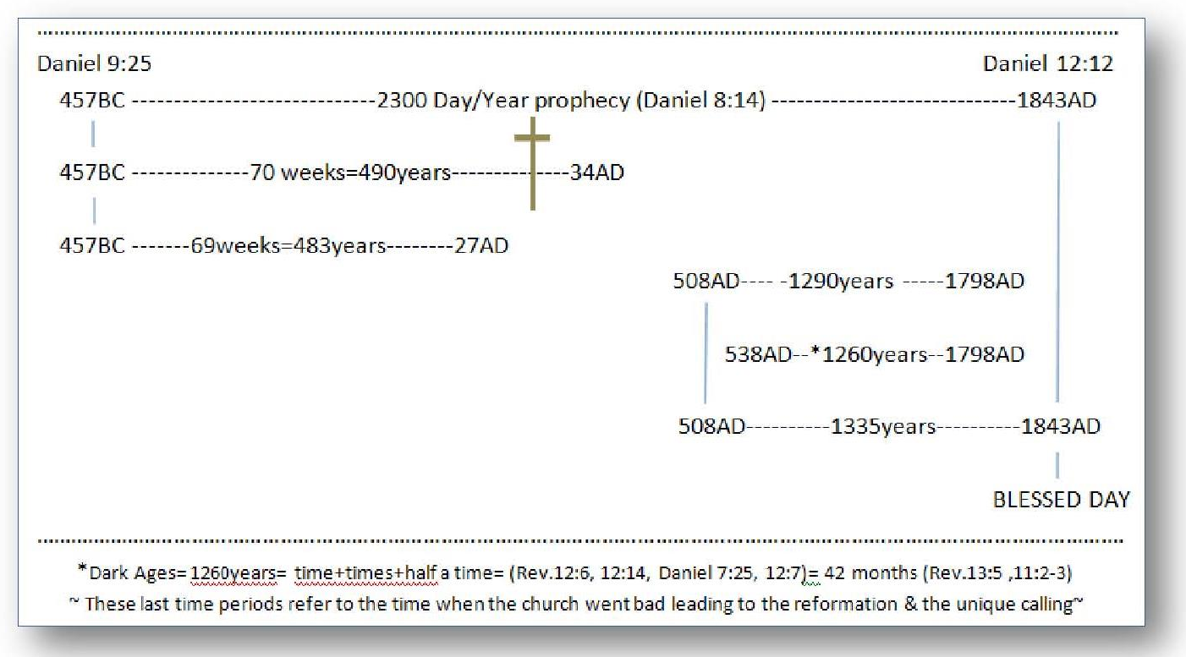
DARK AGE

That’s the space between our planetary space and the edge of our galaxy as the above photo depicts.
When I was researching this; I ask a Japanese astrophysics’ (who I maliciously got an email from) the same question. This man was in charge of the mission of photographing the entire moon’s surface within close proximity. I viewed those photos (they are on line) and it was then I remembered or realized “why I couldn’t see any of the stuff we left there.” I remembered that when I had asked him, about seeing the stuff, he told me I would need to talk to NASSA, “who” had sponsored the mission. Suspicious or what? Telling or not? Why would they hide such an achievement and the proof it would give all those conspiracy theorists as they are called out there including me? Questions….
Called circular reasoning, I say nonsense, “Science” fiction to be added to all their other science fictions. Regardless most all their projections getting more and more complex and far out are not provable any way and never will be, the earth will melt before that!
Sir Isaac Newton, the once considered the first Icon of the scientific age because his theories were and still are provable, said of his intellect and achievements; ‘they came from standing on the shoulders of the great minds of the past”, I say on Gods Truth from the past about our past. What do you say? Or who do you believe in God or man? Your future depends on which.
For years, using super-duper computers that perform equations at light speed and now with unimaginable memory access, has man been trying to disprove what God told them a long time ago “about life and like kinds and no amalgamations which only mutates/corrupts the perfection of life itself,” and to date; they have not been able to prove otherwise nor create even the atomic start of life never will! Oh, but they have already deceived us into thinking they have and have already corrupted mankind’s reception of Gods design for their own, with their string theories and theories upon theories but all mechanical none living!
Not all reproduction is perfect now but when God created it; all were perfect and only sin has degraded that fact, but, when we see the many creatures in like kind and beauty, we get a glimpse of perfection only God could/did achieve. Man’s achievements are pitiful in comparison.
God started with nothing (Hebrews 11:3) and created it all; the earth and the heavens, stars and planets in the void of the deep (Gen. 1:1-2) as in space. and so, we could assume all within our galaxy? This since we know there are unnumbered galaxies out there, and He called them “other worlds with an “s” each time His creation is spoken of. (Heb. 1:1-3) He calls our planet “earth”, thus there are other earths and suns within the other billions of Galaxies out there in the depth of space? We must Realize, because of sin and it’s cancer of death, we will never reach those other galaxies, thus, our creation and all it includes as God spelled it out, was contained within our galaxy this being then “our world” which was placed within the vastness of space. While the other worlds, having already been created as such, are the galaxies we see beyond our own, each containing billons of stars as does ours, and I’m sure other earths not counting heaven, where people also live like us. Created in the image of God? Who knows, but we were, and that’s all we need to know till we have access to those other worlds. Someone said “if we are the only living beings in the universe, what a waste of space that would be”, but we of course know better, for sure, at least we know our God of our likeness is out there and so His son we saw as mankind (John 1:1-14) and was witnessed “by history confirmed” and proved by Gods “prophetic word” that has never failed to prove itself as such. (See “Dead Sea Scrolls” this site for absolute proof of Gods self-proving truths as found in the Bible)
Please get my book on amazon “Animal Stories” a must read, and I’m not saying that for the money but the desire for truth to find its way back into reality and for you to come back to that reality. Look me up and I’ll send you a free copy.
How sad, how “irreverent be” they changed it, and those who promote that change! “Taking Gods name out of the name for the 7th day of the week and added the name of their sun god, of their chosen worship, now known as the beast of Daniel and Revelation. Notice what they substituted His name with; S-“ABBA”-th the Lords day to SUN-day and, not son-day as they have deceived you into thinking/believing. (Exodus 31:13, Mark 2:27-28) (See my book, this site, for a full study on this change and by who, “S-Abba-th to Sunday”. Another must read if you care about your Creator God our Lord who gave His life that we might have right to the tree of life, the one you remember our first parents gave up for “another’s words”, the one who first deceived us in the beginning “to not consult God first and last”, as to His offer of eternal life that’s still being given BUT, only through His way and will, will we be granted that life, and it has to do with worship! (Revelation 12:17-18, 14:7-12, 14)
This is why we are spending so much money, wastefully, trying to find out how it all began, and by making up all those theories, (by the hundreds) making movies and flying off into space to know the answer of biggest of all voids in our lives; to find out “who we are as mankind, where did we come from and where are we going after death, when in fact we already know!” We’ve been handed that knowledge, however, because of Cain’s influence (also handed down) we still search for the answer to our billion dollar question, and billions are being spent to know the answers when they are right in our proverbial face, but since it has the stigma of God attached to it, it’s off limits, and this to our own loss, because only He can, has and still does; offer eternal life for those who will “just believe”.
What are the typical days that Sun-day falls on to be called a high day? Friend they are only linked to pagan holidays like Easter. Truly and historically named after the pagan god “Ishtar” and, that’s why we have eggs and rabbits connected to it as the theme, they are objects of “fertility”. Make no mistake, only God can create a holy religious day, and set is as a worship day! Not man, and not on any other day of the week as they have done throughout history, and friend, the fact is; “only Gods holy worship day is connected to His creation”, and for the reason of; that we not forget Him and chase off after other gods (breaking the first commandment as well as the 4th. Those churches have no power over life and death, as have the false churches and religions claim. Wait! I take that back they do have “the power of sin” to pass death on to those who follow them. Choose His love!
If you go on in this chapters context, make note of another huge deception you have been taught, and that is; the days, months and years Paul was talking about does not include the Creation Sabbath as you have been told. He was speaking of the sacrificial system laws (not the Ten Commandments) and its days, month’s etc. “which met their fulfillment with Christ!” (vs. 4) The Jews in rejecting Christ would not give up those old sacrificial laws, and this was Paul’s struggle to get them to do so, and his writings have thus become a stumbling block to those today, I call them modern Jews who won’t give up their Sun-day for Gods S-Abba-th, and they use Paul’s writings as arguments by falsely interpreting what he means by what he says throughout all of his letters. My I remind you.. (II Peter 3:15-16)
The belief in the theory of evolution (in any form) destroys the creation fact, and makes it a myth in the eyes of its believers, of those who only believe in mans creations and not Gods, and, as is written “to their eternal loss.” (Romans 1:20-25,28,32) Thusly so; does Covenant breaking (vs. 31) by the corruption of the weekly S-Abba-th by throwing it out of “creations reminder,” if only subconsciously disconnecting us from God (Abba) “as our re-creator” in good works, and from the true sanctification that is done by the indwelling Spirit who wants to place Gods laws in us to do His will/works (Hebrews 10:14-16, John 14:15-17) that we might live in His Shekinah presence/Glory, and thusly, “by our Spiritual choice alone” to do His works, we may have right to the tree of live once again. (Rev. 22:14-17) It’s all so clear when our eyes are opened to the truth, but, by us keeping them shut for any reason, can cause deception to set into us “so deep”, that; well, Paul tells us about that kind of personal choice/person. (II Thessalonians 2:10-12)
Exodus 31:13-18; This text may be the most important one of this writing for us to consider, because; it lets us know the importance of the S-Abba-th to “our Lord God”, (Math. 12:8, John 1:1-3,14) not only from the standpoint of creation but of “His will” for us, His people/His “church eternal” (whatever name is on it). Also, this text (Exodus 31:13-18) lets us know of the severity of Covenant breaking (Ten Commandments vs. 15, 18) which is death “by His words not mine.” Now for the importance of this text; “ask yourself; if God demanded death for 7th day S-Abba-th breaking back then, and even carried it out as He showed His first church/people back then, (Numbers 15:30-36) and thusly, through the recorded Word this message given to the first church was then carried (Romans 3:1-2) to the second church and to us now. (I Corin. 10:11) Then think about it: if those people were slain for disobedience to the 7th day S-Abba-th, back then, or anytime for that matter, slain for the disobedience and the breaking of the 4th commandment of the Covenant, and God thought it so important He had the results of that disobedience recorded for posterity, then, how could a just God destroy them back then “but let mankind today get by in breaking the very same commandment? (Matthew 5:17-18- 20) The point is; “He couldn’t (Ezekiel 18:25) and yet treat everybody the same when it comes to sin and salvation (universally!!)”, and my friend; if His ways “are unequal” for all peoples-all souls, then Satan would rise up as He did in heaven and call Gods judgments out as unfair? If he be right then; the law breakers today “join in with him (Satan) every week when they breach Gods Covenant/Statutes/Judgments/Law/all 10 Commandments with impunity and will ultimately die with him.” (unconfessed of course) This is one of the many warnings to the church today scripture gives us; “for willfully (not ignorantly) breaking Gods Covenant of the 10 commandments.” (Matthew 5:17-18- 20, I John 3:4-9, James 2:10-13, Hebrews 10:26-31) What more can He have said to the church through His faithful followers who reported His will for us? To bring the church and us out of darkness, including all who reject His will weekly? (Matthew 7:21, John 5, Psalms 1:1-2, 40:8, Deut. 5:29) Just a taste of what the Word of God teaches on this subject, and He gives us these warnings out of love for our admonition and hope of eternal life, but, many say to me; “you use the same old texts over and over to prove your points”, and I say; “No I don’t, for they are not my points but Gods”, and they never get old to the true follower of God. So we either love or hate His word and His commandments? Love as did David, the root and offspring and our example, or, hate as Cain when we just shut up our hearts and walk away? One last drop of truth on this subject, taken from the wisest man, save Christ, who would ever live; (I Kings 3:12, Ecclesiastes 12:13-14) When will we allow that “Duty and fear” to be in our minds and hearts as Jesus wants to provide under the New Covenant? (Hebrews 10:16) Better yet as Lovers of our Christ; when will we allow that returned love to pass “through us” and back to the one “who gave all that we might live?” (John 14:15) We will be loved. (John 14:23)
See Appendix “Rome’s Challenge”
See TIME CHART Appendix.
Speaking of our Generation starting after He left He said; (Matthew 23:36, 24:34)
Something I forgot to add about the origin of the theory/belief/doctrine and that is it didn’t begin with Darwin. His father or some of his protégées, but in fact with a Roman Catholic priest who lived in the orient and was swayed by their origin concepts, which he then as the church still does integrated it into their doctrine, many years ago so it’s no wonder why they have been teaching evolution in their schools since before the 1950s. (Watch for a book on “Problem Child” for that history)
The mother church brags that she is god of the Sunday worship, and she has also been teaching that form of evolution since the 50’s, exposing her as the beast of Daniel and Revelation, as Sir Isaac Newton pointing to her described her as being although not fully developed in his time or “wholly provable” because; all of the prophecies had not fully fulfilled as yet, marking her as the only religious and politically power to fulfill all the descriptions God gave of her especially in His “timed prophecies”, dates and descriptions that can fit no other, and why the master mind of Newton was allowed to write that about her even having only limited knowledge in his time. But not as today my friend, as we sit on top of nearly all the fulfilled prophecies; that mark her and her protestant converts without any doubts. (See “Convinced” this site, an eye opener) We must of course, allow the Bible to interpret itself and accept no private interpretations as the internet is full of today, where all the false teachers, calling themselves prophets, are destroying Gods clear descriptions of who the beast power was, is and will continue to be, and the marks only she has fulfilled, and He also tells us “what marks a true prophet from as false.” (Isaiah 8:19-20) Goes right along with our subject so far!
The origin for a week of 7 literal days can only be found in the Bible as Gods design. Deny that and we deny God it’s that simple, and He didn’t say the S-Abba-th of the Lord God was on the 1st day as the deceived teach, or the 5th day or every day as the heathen does teach.
The origin of Easter comes from the heathen worship of Ishtar who worshiped the sun, no wonder they named it “Sun”day? Do we help the heathen by telling him or her something God says is sin and death? You tell me at the end of this next week who it is you are testifying for “God or man” in your worship choices. Friend faith is belief not some magic word that has no meaning or work behind it! (Hebrews 11)
They also refer to themselves as “New Covenant” churches in an effort to deny that Gods 10 Commandments have any bounds on people today, especially the forth one. (remember the stick man) and what’s worse they accuse the Law giver as the one who dismantled the Fathers laws into just two basic commandments – GOD FORBID! (Ever heard this doctrine? Matthew 22:36-39 and they stop at verse 39 as they read from their paraphrased versions, and fail to see the next statement Jesus made defining the first. Vs. 40 However in doing this proves their lack of Bible study for truth, because, this statement if used as they use it today in about all of the Sunday churches, as they attempt to eliminate the jot and titles of the 4th commandment, actually in truth contradicts Jesus’ first sermon he gave on the mount, and what He said concerning the Law and prophets, (Matthew 5:17-20) and He goes on to define it further. (II Timothy 3:5,7) Paul gores on…. (II Timothy 3:13-17) Timothy learned salvation from the Old Testament as a child because that’s all they had? Eliminate it and all kinds of confusion will come from scripture being miss-construed by those with an agenda, like the Papacy and her Protestant Sunday converts.
Benjamin Franklin, despite all his great accomplishments, denied the miracles taught in the Bible as his testimony. What’s all he done worth to Gods cause then? Save to cast doubt, and why I pen this writing all to expose such. For in the last days…well lets read it; (II Timothy 3) Keep in mind; all the scripture Timothy had was the Old Testament to learn truth from, so it was with Paul even though his writings were eventually made part of the new Testament, even though Paul wrote some things that have confused modern religion today, especially when it comes to the eternality of the Commandments of God. (the big TEN including the 4th - S-Abba-th) (II Peter 3:15-17) this is his counsel to us, as Peter gives similar warnings of the last days similar to Paul’s counsel to Timothy, being the one thing they agreed upon that would mark our day “and does”. Then there is Christs explicit counsel on that subject of Gods Commandments “longevity that bind mankind to Him”, warnings He gave first off in His earthly ministry in AD27 so that we know His ties to the Old Testament. (Matthew 5:17-20)
The same goes for truth; when its finally corrupted for whatever seemingly good reason, what’s left but lies and deceptions, and that’s why God gave His Laws and Has held His truths from total corruption of the scriptures both Old and new, as He did through the Long Dark Ages, to prevent it from becoming extinct, as it’s going to be in the end! When even the elect (the studied) can be deceived. (Matthew 24:20-24)
We have physically accessed two heavenly bodies to this point and did we find like or just speculation? We see the results of the makeup of distant planets but none are livable, much less reachable (remember) in our lifetime.
I’m thinking of the Dead Sea and the way it was created from a heavenly blast, and the cinders left scattered around tell the story. (See “What If The Bible Is True” this site)
Of course I must mention the alien account for life having been brought here a fabrication they turn to when their science appears unaccountable.
All that man has created “and theorized” is imbalance, and if he doesn’t stop, there will be no life on earth mentally and physically, we will revert back to ape mentality (almost there now) and then a nuclear blast because of nothing to live for, and back to amoebae’ swimming in radioactive soup waiting to rise up again in a billion years?
That’s why we introduce “Ai” into the mix, and billions of years of evolution, thinking that’s what God did? The antediluvians may have been close since they didn’t take the mechanical route like us, but the organic one? That’s just my theory and worth nothing, but, we haft to admit “that side of the flood” does show great past intelligence none can deny, things we can’t figure out nor achieve even today?
I’m editing this in a period of time we have gotten to like no other with the worldwide virus pandemic of 2020 that went across the world in a few weeks, and we are really thinking about life these days and those three meals a day more than ever, as reality meets science fiction.
Actually we are not talking about claiming gods anyway, many so-called gods have come and gone and ask yourself; what did they produce that has survived except stones with their names on them? Stones no one can read much less understand them, BUT, now the One God’s name and history we still have with us today and everyone can understand it, and His image just makes sense over gods with animal/monkey heads. Sure they built monumental structures but they served only themselves, and their worlds are still 3rd world countries, BUT, Gods society handed down the real intellect from creation. At least all that matters, in that our real world is; not of this earth nor came/evolved from it once sin entered, and death prevails, and real history proves it in words that we can understand, and by now we have seen it to compare with all the false history, like, out of Africa what a joke/lie the gullible have bought into. If you can’t see that then you have evolved like all those gods of the past and the grave is your reward. That’s hard to accept I know, it was for me, BUT, it’s as real as you’re going to get, to raise you from the deception you are under, religious or not. Truth requires seeking and accepting once we have found it, reject it and deception will be our end sent by God Himself believe it or not. (II Thess. 2:10-12)
The history of man according to God was religiously passed down from generation to generation. This was the purpose of the weekly 7th day S-Abba-th a reminder of Gods creative ability, of His creation of us despite our sins, thus also of judgment according to the way of eternal life (Deut. 30, 5:12 in context) and why He placed that reminder and asks us to “remember” in His Covenant, but most importantly it’s a reminder of His everlasting love for us, for our sanctification and salvation, and His desire for us to be with Him, (Rev. 14:1-7) and to worship with Him, and that’s why He said “Remember”, so, as I was saying; our history was passed down “religiously”, and friend; that used to make a difference in maintaining its validity, but not today, because we have forgotten just how sure our history is, just think about it; there were only three (3) generations from creation to the flood (See Chart Appendix) thus, the history could not have been perverted since all those kin were loyal to God, see it? Remember too. Adam knew God created Eve thus all that was created! Adams son’s son Enosh overlapped with Noah, making it impossible for the history to have been lost with the story of God’s creation because, it was passed down by word of mouth “within the family” after the likeness of God! (Gen. 5:1-3) Then the greatest of all reminders came; “the flood” that kept that history alive even in non-religious societies to today, despite Cain’s descendant’s perversions and the “wanting to forget” of Gods history. There have always been scoffers, deniers now evolutionists who of course rejected/reject Gods weekly reminder substituting it with their own myths and false worships, (clear up until 1844 AD when God reminded us of His worship) however; all those false religions had no real effect on the “generally accepted” and passed down religion of God. The one thing the Jews did right was maintaining the Word from creation to then! (Romans 3:1-3) But then, of course, came the Messiah came “right on time prophetically”, (Daniel 9:24 see time chart appendix) but the first church had been so perverted and had forgotten the histories and prophecies, thus, in the end He (Messiah) failed in trying to set it back on course. (Matthew 23:37-38) Then after many years of spiritual darkness brought on by the false church, (Beast power) men like Luther, Huss, Knox etc. even Sir Isaac Newton proved that “the Bible, and the Bible only” was the sure Word of God, and prophecy “being the guide lines and final proofs” for the end times. (See “Prophecies the church missed” this site) Today, despite the apathy for the truths of God’s Word, (II Timothy 3:7, 4:4) “Gods people” still pass down these truths as recorded in our history book, Gods history that has obviously been preserved by Him “throughout time”, first by word of mouth from Gods spoken Word “in the beginning”, and by the written Word of God as recorded by His religious followers, and to be shared by us unto all the world? (Rev. 14:6 in context, see also “Watchman” this site)
Actually the Jews were split on death and resurrection. One group believed as Jesus and Martha it happens at the last day, the other sect didn’t believe in the literal end day resurrection in opposition to Christ and His law. Kind of like today when one dies they go to heaven or hell straight off, which is not what Jesus taught, nor is it Biblical and why; this belief is a deception making Jesus and even Paul out to be liars, or at least confusing Bible truth, making the Bible contradict itself. Regardless; it’s a bad foul doctrine of Jews or Gentiles.

