FORGETTING
TO REMEMBER

The other day, amidst the corona virus distancing, as we were approaching the cash register at Lowes I was walking right up to the guy in front of me and my wife grabbed my arm, pulled me back and pointed to the sign on the floor saying “stand here”, you see, I had forgotten about the 6 feet distancing clearance.

This is not what I’m talking about here in “forgetting to remember”.

About the same time my brothers birthday was approaching and I had placed a message on my phone reminding me of that day so I wouldn’t forget it, because, I am always forgetting to remember birthdays, anniversaries, my own head etc.

This is not what I’m talking about here in “forgetting to remember”.

There is something in the Bible, a warning as it were, that should scare us to death, or make us alerted to the way things are today, and then scare us of death! Causing us to make a change in our thought process of remembering, and how we forget to remember in a real sense!

You may be familiar with this verse, and you may not, but it is one we need to not forget to remember;

Genesis 6:5 King James Version (KJV)
⁵ And God saw that the wickedness of man was great in the earth, and that every imagination of the thoughts of his heart was only evil continually.

Someone says; “Well that’s not speaking to me”, and that might be true from their perspective or knowledge, but friend; one day we might just be faced with the facts and discover that “it is true within us even to a lesser degree” than the text portrays, and, we just didn’t know it? (Gen. 4:7) But when we become aware, as we all will because of the unique time we are living, “will we offer Gods type sacrifices” and not as Cain, who refused Gods counsel/will, and when faced with repentance, confession and obedience to Gods commandment, he walked away into continual sin it seems, which is not repenting of it, even when given a last chance?

Do you once think his parents continued to ignore Gods further commandments?

I seriously doubt it after they saw the death sin and deception causes!

You see the day will come, especially here near then end of time, for each of us to receive the “full knowledge of God” and why?

So that we might be able to stand in the shekinah glory that surrounds the Father, our Father in heaven, the glory that will attend His Son at His next coming, but, what we should take from this is; “the knowledge” He has given us over the years of our/mankind’s existence “does have prerequisites” that have to do with “His will” and salvation, and, it has been just lately that I discovered; what His will really is for us who stand on the threshold of that return, well, let’s read about it, and then define it, and then see if our mind is really continually good in His site or continually evil according to our choices, like I say are unique for us today. (Matthew 5:20)

This knowledge comes from a text we all have remembered since we were children, that is those of us who have been privileged to have been taught about God by our parents, for those who haven’t, this may be your point of gaining Godly knowledge for the first time, whatever;

It’s found in a prayer the Lord asks us to pray, and like I said something after 70 years of hearing around religion I just realized the significance of Gods eternal, universal will for the mortal and the immortal;

Matthew 6:9-10 King James Version (KJV)
⁹ After this manner therefore pray ye: Our Father which art in heaven, Hallowed be thy name.
¹⁰ Thy kingdom come, Thy will be done in earth, as it is in heaven.

Do we now get the full significance of this statement?

As we look at christendom today, which, as I have exchanged a capital “C” in not representing Christ with a small “c”, I ask then; “do we see the churches today doing Gods will or not” as we have seen clearly defined by what knowledge we have obtained so far from Gods Word and the few text’s I’ve given already?

Or, do we just go on as if we haven’t received Gods knowledge He so lovingly has given to us through His Son, (John 14:15-29) so that we may be able to stand in His shekinah glory when He comes? (Matthew 7:21)

Do our churches today believe and teach all of Gods Commandments or do they teach those of the Beast and her daughters?

You tell me after we read more of Gods words and the testament of His Son, both while He was on earth and through prophecy;

Matthew 5 King James Version (KJV)

¹⁶ Let your light so shine before men, that they may see your good works, and glorify your Father which is in heaven.
¹⁷ Think not that I am come to destroy the law, or the prophets: I am not come to destroy, but to fulfil.
¹⁸ For verily I say unto you, Till heaven and earth pass, one jot or one tittle shall in no wise pass from the law, till all be fulfilled.
[Hasn’t happened yet right?]
¹⁹ Whosoever therefore shall break one of these least commandments, and shall teach men so, he shall be called the least in the kingdom of heaven: but whosoever shall do and teach them, the same shall be called great in the kingdom of heaven.
²⁰ For I say unto you, That except your righteousness shall exceed the righteousness of the scribes and Pharisees, ye shall in no case enter into the kingdom of heaven.

His message is the same message Moses gave, and Paul. (Deuteronomy 6:25, Hebrews 10:28-31)

God’s prophecy (Rev. 1:1-3) also reminded us what we/the church, will/should look like and are to have that testimony/faith “with and through Jesus”, and we see that picture prophetically described as the church went into the Dark Ages carrying this gospel/same message of which God Had to hide to protect to keep it from being lost. (Dark Age remember with Gods church and message hidden)

Revelation 12 King James Version (KJV)

¹⁷ And the dragon was wroth with the woman, and went to make war with the remnant of her seed, which keep the commandments of God, and have the testimony of Jesus Christ.

When we, as a church/people, came out from that Dark Age, we cam out believing and carrying the same gospel/the same unchangeable message, and having the Testimony/Faith of Jesus, (Matthew 5:18) and would/were to do so up unto His coming. (Clouds Matthew 26:64)

Revelation 14:12-14 King James Version (KJV)
¹² Here is the patience of the saints: here are they that keep the commandments of God, and the faith of Jesus.
¹³ And I heard a voice from heaven saying unto me, Write, Blessed are the dead which die in the Lord from henceforth: Yea, saith the Spirit, that they may rest from their labours; and their works do follow them.
¹⁴ And I looked, and behold a white cloud, and upon the cloud one sat like unto the Son of man, having on his head a golden crown, and in his hand a sharp sickle.

When we (church gone now) prepare to enter into heaven and eternity, will our message/testimony be the same? Will our faithful reward He brings with Him, be the same as the faith that we can have now?

Revelation 22:12-15 King James Version (KJV)
¹² And, behold, I come quickly; and my reward is with me, to give every man according as his work shall be.
¹³ I am Alpha and Omega, the beginning and the end, the first and the last.
¹⁴ Blessed are they that do his commandments, that they may have right to the tree of life, and may enter in through the gates into the city.
¹⁵ For without are dogs, and sorcerers, and whoremongers, and murderers, and idolaters, and whosoever loveth and maketh a lie.

Is this our desire, to hate the lie, and not FORGET TO REMEMBER but remember to not forget?

The definition of the unforgivable sin against Gods Covenant/Commandments (all 10 remember jot/tittle) “is when we REMEMBER TO FORGET” the knowledge God has given us, and because we have chosen to forget and continue in breaching His commandment/s. (James 2:10 in context) We will never ask Him for forgiveness so we will never be forgiven, get it? (knowing better from His Word)

So, my prayer through this message is; we not forget our Father and His will for us as we go forward walking on the edge of eternity….

~mosescats~

Referencing; “The Church”, “Message to the Church”, “Same Message” this site.

APPENDIX

THE SANCTUARY (EARTH AND HEAVEN)
Place of intersession by our High Priest (Hebrews 9:11)

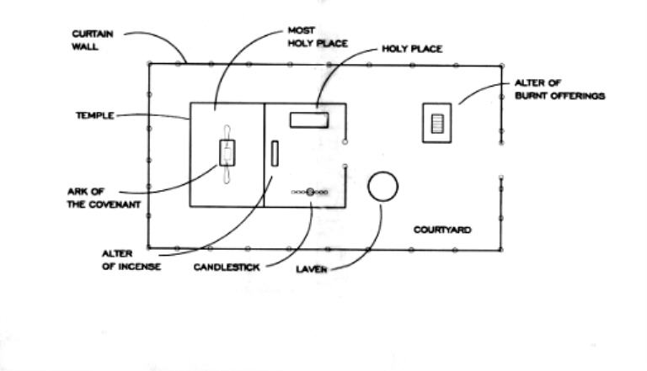

TIME CHART

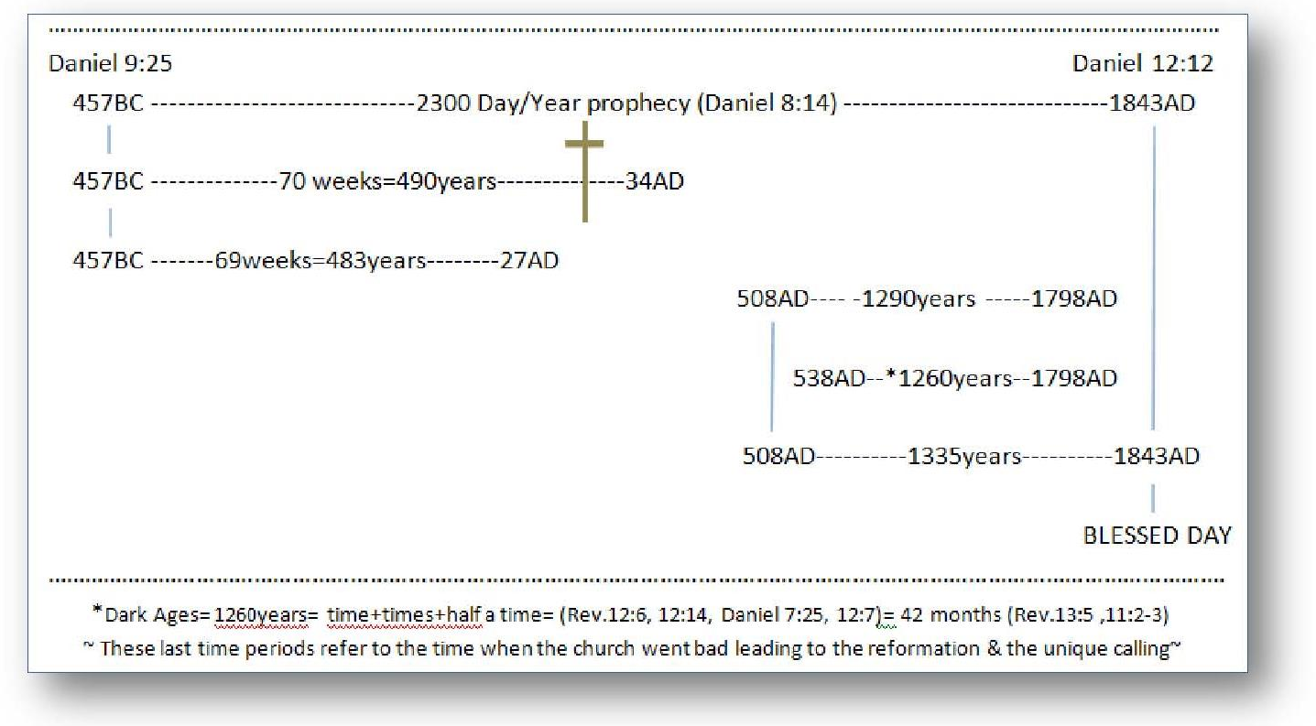

What sin is, just what constitutes sin in Gods site etc. (Daniel 12:4, Isaiah 28:9-10, Hosea 4:6 that’s God warning even a priest…scary Hugh?)
We must understand this Shekinah glory of God, in that sin cannot exist in its presence. Friend this is the glory of God which Jesus will attend at His second coming, the glory that Paul spoke of in II Thessalonians 2 which will of course destroy the beast power but all that clings to him/her, or that ever has clung to all of Satan’s cohorts begging with Lucifer in heaven, and it’s here (in paradise believe it or not) we learn about that Glory; Since sin originated with Lucifer, primarily against Gods law and his government, and Satan challenged Gods right to the throne. (Ezekiel 28:2, 12-15) Gods glory had to be veiled; the Earthly Sanctuary if you remember (See Appendix) was patterned after the heavenly, where John saw Jesus’ intersession for us going on in the holy place Rev. 1:13 in front of the veil in heaven to the “heavens Most holy place” His glory hast to be veiled or that glory would have wiped out Satan and his evil angles before they were expelled from heaven, and his challenge against God would never be able to show itself worth to all the universe, as to whether Gods government and laws were just or not, as to whether Gods will or Satan will was good or evil, and those results would need be played out in the earth, for which he was cast down (Rev. 12:9-10) to prove to us and to the universe his ways over Gods was good or evil. You remember the tree God set before our first parents was the tree of eternal life and the tree of Good and evil. One perpetuated the eternal life of the universe, the other knowledge of evil and good only God knew and mankind didn’t need to know, but, because of Satan’s challenge, the whole of the universe, was watching, which side would mankind choose to follow Gods will and life or the father of evil and death. In which God, knowing the beginning from the end, warned His first two creations the consequences of their/our choice; one would bring life eternal the other death eternal. You see, before the creation of the theater of the universe (earth) had even been set, (Rev. 13:8) our preexistent Lord and Savior offered His life’s Blood as an atonement for mankind should fall to deception again and choose evil over good, and that plan was to become a part of Gods “will and promise” to one day send His son to die for sin, because of sin, because of love. You see, since the glory of God has been shielded from our universe as we read, but one day, that glory will once again shine throughout the universe as it is placed upon our Lord and king, who will come once again as our/a Savior, to those that is who; have forsaken all “even to death”, every sin, and all that is called thereby, that caused us once to be cast forth from the tree of eternal life, and God gives us this warning; that His will and law needs to be accepted by us (Rev. 22:12-16, talking about Gods will and He mentioned “for a reason” David and his desire to have His Fathers law in his heart and mind, Psalms 40:8) as should we, and by His Word He will give us right to partake “with our Lord (we just read)” in that life forever and to enter into heaven and in the new heaven and earth, (Rev. 21:1-8) wherein dwelleth only righteousness and sin cannot exist nor never will again? But wait, what if God allows someone “who will not do His will nor keep His Commandments/statutes on earth today, that we may be sanctified”, (Leviticus 20:8, 21:23, Deut. 5:12 see a connection?) but they were allowed into heaven (somehow hypothetically) to eat of the tree of life in the new heaven and earth, but then one day, say 10,000 years into the future, they decided that maybe Gods will was not the best choice demanding continued worship on S-Abba-th’s (Isaiah 66:22-23) they start thinking any day will do as they once believed? Friend, if God allowed that person in; sin would revive and death, once again, would plague the universe and, well forget it, this won’t happen, and why? Because all who are saved would rather die than to break Gods will or His laws, His commandments (Which simply and lovingly yes maybe harshly save one, just describe what sin is for us Romans 3:20, I John 3:4) and we would never fall to any kind of sin because of His love in dyeing for us and shading His “Saving Blood” for us. (Hebrews 10:25-29) So, sin could never be reborn in us ever, for we already have the knowledge of what good does and what evil does, and our choice will be for God, our Savior and Lord, now and forever! (To God be the Glory)
Something most Christians today do not realize is; when the sacrifices, under the first covenant were being made, the Lord himself came down and attended the Sanctuary there in Israel, and, only on one day of any given year was anyone, even a priest, allowed to enter into the Most holy place of the Sanctuary, where the ark of the Covenant was inside, being the throne where the glory of God would rest. (Typifying the one in heaven Exodus 25:8-9, 40, Hebrews 8:5) Not just any priest but only the High priest could enter in, and on only on that one day of the year, on Yom Kippur, called then “the cleansing of the sanctuary”, that typified the great white judgment day that would take place in heaven beginning (Daniel 12) in 1844 AD (See Time Chart Appendix) and ending when every case including Daniel’s lot had been heard, at the end of the 2300 year prophecy, (Daniel 8:14, 9:23-27) concluding with that great edict by Gabriel (Rev. 22:11-12) marking the end of judgment, “the final judgment”, after all cases had been heard and the rewards set (vs. 12) for every righteous person that had ever lived on earth. This coming judgment was taught to them back there in Israel “in symbolisms”, and they learned the importance of them, and also they knew if anyone entered that Most holy place at any other time other than on Yom Kippur, priest or not, they would be struck dead by that shekinah glory, and, if on that one special day of the year the high priest himself had any unconfessed sin harbored in his soul, he too would be struck dead. So on that very serious day, which was really a day of final judgment for the sinners (confessed and unconfessed of Israel), they knew; they had to have their sins confessed by the end of that day and in the sanctuary for cleansing (final atonement) or they would be cut off not only from Israel but eternally. (It’s the same of us at the close of probation which is at our doorstep) It was so serious, they would tie ropes onto the high priest should he enter with a sin so they could pull him out. That’s how we know sin cannot exist alive in the presence of God, and the need to know what constitutes sin in the eyes of God of whose mercy has boundaries that can’t be crossed. (Rev. 14:9-12) Save that our hearts and minds as David serve His will and laws.

