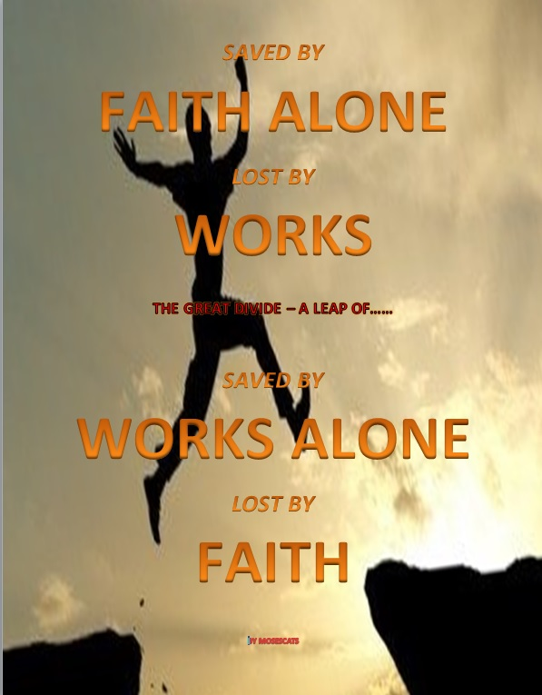

by mosescats

Written especially for
ME
With somethings cutting “us” to the core
so, please beware!

Compiled By
Joseph Ancion © 2017

Faith
When we read the first chapters of the first book of the Bible, we see mankind, although just one – Adam at first, we see that he was introduced to “Faith in God” by the fact that “Eve was created”, something he saw God do with his own eyes.
Faith is belief, that’s what faith is; “believing in God”, not some magical thing that saves you, or some means to the end although, it is “the first step” in the salvation process for, without first believing, we would never take the next more crucial step, in moving then “in Gods direction” regardless.
Remembering of course the experience of that young man who came to Jesus, “in faith” mind you, knowing that He was obviously the Master everyone was talking about, and then; he asked Him the big question everyone wants to know “about salvation” and that is; what does it require of us? (Mathew 19:16-21, 26)
Notice, the Master didn’t give Him a lecture “condemning” his request about works for salvation….in fact, just the opposite, and the Lord didn’t answer him with just two commandments;

Matthew 19 (KJV)

¹⁶ And, behold, one came and said unto him, Good Master, what good thing shall I do, that I may have eternal life?
¹⁷ And he said unto him, Why callest thou me good? there is none good but one, that is, God: but if thou wilt enter into life, keep the commandments.
¹⁸ He saith unto him, Which? Jesus said, Thou shalt do no murder, Thou shalt not commit adultery, Thou shalt not steal, Thou shalt not bear false witness,
¹⁹ Honour thy father and thy mother: and, Thou shalt love thy neighbour as thyself.

²⁰ The young man saith unto him, All these things have I kept from my youth up: what lack I yet?

²¹ Jesus said unto him, If thou wilt be perfect……. come and follow me…….

²⁶ But Jesus beheld them, and said unto them, With men this is impossible; but with God all things are possible.

Let’s discuss then, “the warning”, yes, the warning this encounter gives us today about salvation and, “what it requires according to the Master”, and listen; “it’s something that goes beyond faith and believe, therefore; it needs to be read in context of the whole encounter Jesus had with this young man “for us to get the point of our Saviors warning”, and, it must be seen from all three of the Apostles points of view, and when we do you will notice how; by doing this it builds us a picture “unlike what all the churches are teaching today about faith and works”, bar none it seems.
We’ve already read most of what Matthew recorded, so let’s look at what the others remembered about this encounter;

Luke 10:25-28 (KJV)
²⁵ And, behold, a certain lawyer stood up, and tempted him, saying, Master, what shall I do to inherit eternal life?
²⁶ He said unto him, What is written in the law? how readest thou?
²⁷ And he answering said, Thou shalt love the Lord thy God with all thy heart, and with all thy soul, and with all thy strength, and with all thy mind; and thy neighbour as thyself.
²⁸ And he said unto him, Thou hast answered right: this do, and thou shalt live.

[All the churches teach these “two commandments” as the only means to salvation, BUT, in doing this they eliminate vs. 26 as it relates to the last line, or, worse modify it making the Lords voice of none effect (Matthew 15:3-9) and Him out to be a partial liar “God Forbid!”

They do this by ignoring completely what “He first said” when the young mans asked Him ‘what must I do’. What did He first say of what we are to do?

He first said; “What is written in the Law” (Luke 10 vs. 26 above).

He meant all the LAW not just 2 or 8 or 9 Commandments but all 10, see it? Remember Matthew’s account where he broke it down into 3 or four of the Commandments of the Law?

If you still don’t get it notice as we read another account Matthew had or was He reiterating the same one? But notice particularly vs. 40]

Matthew 22:35-40 (KJV)
³⁵ Then one of them, which was a lawyer, asked him a question, tempting him, and saying,
³⁶ Master, which is the great commandment in the law?
³⁷ Jesus said unto him, Thou shalt love the Lord thy God with all thy heart, and with all thy soul, and with all thy mind.
³⁸ This is the first and great commandment.
³⁹ And the second is like unto it, Thou shalt love thy neighbour as thyself.
⁴⁰ On these two commandments hang all the law and the prophets.

Now notice in the next account recorded by Mark; the Lord quotes out of the Old Testament these very words, that He spoke to Israel when the Law was first written on stone by “the finger of God mind you”, and these, are the 2 commandments (actually principals) that the churches of today have dissolved the 10 Commandment law into. Ignoring completely the bulk of evidence we’ve read by examining all of these passages concerning salvation, and I say contributing to the possible loss of eternal life of their flock.

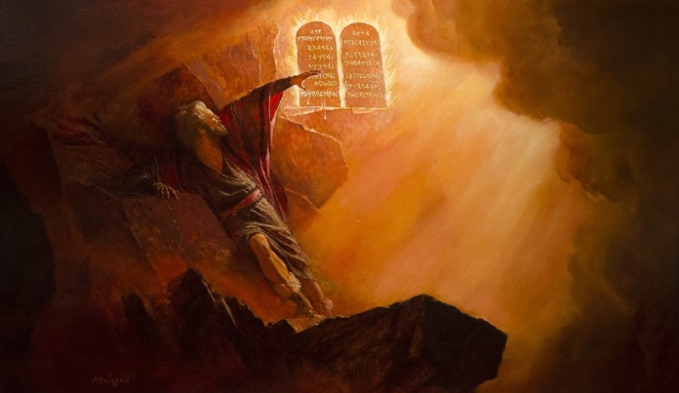

Mark 12:28-34 (KJV)
²⁸ And one of the scribes came, and having heard them reasoning together, and perceiving that he had answered them well, asked him, Which is the first commandment of all?
²⁹ And Jesus answered him, The first of all the commandments is, Hear, O Israel; The Lord our God is one Lord:
³⁰ And thou shalt love the Lord thy God with all thy heart, and with all thy soul, and with all thy mind, and with all thy strength (Deut. 6:4-5): this is the first commandment.
³¹ And the second is like, namely this, Thou shalt love thy neighbour as thyself. (Leviticus 19:18) There is none other commandment greater than these.
³² And the scribe said unto him, Well, Master, thou hast said the truth: for there is one God; and there is none other but he:
³³ And to love him with all the heart, and with all the understanding, and with all the soul, and with all the strength, and to love his neighbour as himself, is more than all whole burnt offerings and sacrifices.
³⁴ And when Jesus saw that he answered discreetly, he said unto him, Thou art not far from the kingdom of God. And no man after that durst ask him any question.

Now Marks account, of what appears to be the young man of Matthew 19, for the answers Jesus gave are the same, but He adds one thing “that seals the Commandments as what we are to do to be saved”, and that is; we can do all of them including the forth and in doing so fulfill the principals there of, of the entire Law both to God and man, reciprocal love it is..

Remember “with God all things are possible”, incidentally Jesus kept our Fathers law without breaking one “by the same power we can have”, more on this as we go.

But notice vs. 21 it’s the proof about how works and faith work!

According to our Lord.

Mark 10:17-21 (KJV)
¹⁷ And when he was gone forth into the way, there came one running, and kneeled to him, and asked him, Good Master, what shall I do that I may inherit eternal life?
¹⁸ And Jesus said unto him, Why callest thou me good? there is none good but one, that is, God.
¹⁹ Thou knowest the commandments, Do not commit adultery, Do not kill, Do not steal, Do not bear false witness, Defraud not, Honour thy father and mother.
²⁰ And he answered and said unto him, Master, all these have I observed from my youth.
²¹ Then Jesus beholding him loved him,

[WHY did He love the man? Who was working his way to heaven by keeping Gods Law- that’s salvation by works? That’s a curse most say and they quote Paul. (Galatians 3:10, 13) But there’s something you don’t know about Paul, that the Holy Spirit made known to Peter. Now I know they were rivals but, if this wasn’t an important fact, especially in todays’ state of the art of religion, God would not have put it in Peters mind, but He obviously did, and for the very reason that we see the churches today using Paul’s words out of context to prove their false doctrines “that make the Bible contradict itself.” (II Peter 3:15-16)]

and said unto him, One thing thou lackest: go thy way, sell whatsoever thou hast, and give to the poor, and thou shalt have treasure in heaven: and come, take up the cross, and follow me.

Incidentally, the “law” Paul was talking about in (Galatians 3:10, 13), that is being used by 99% of the churches to eliminate the S-Abba-th commandment (let’s cut to the chase), that law was the “sacrificial law” Paul was in reference to, it really was Gods (not Moses’) plan of salvation from sin until when? “till Christ came (Galatians 3:19)”, the plan was in graphic form using symbols, i.e. lamb of God, blood of the Lamb etc., and that law was in fact nailed to the cross, “with Christ”, why?
You see the plan of salvation needed two laws as part of the 1st Covenant; one to point out sin and the other to point us to Christ (the symbolic lamb) who was to come one day and die for mankind’s sins (individual not blanket). One law was temporary and the other permanent. One was inside the Ark the other placed on the outside. One represented Gods character required for salvation, the other, His “temporary” plan for mankind’s salvation should they fall to sin.
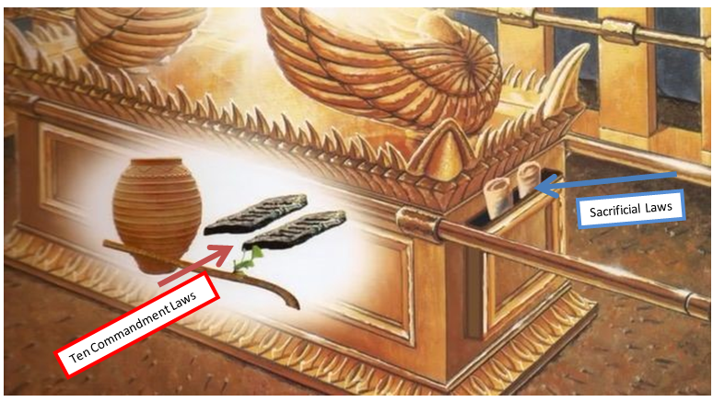
Thus Christ, was the fulfillment of what all those sacrifices represented, and that’s why the veil (60 ft± high) in the earthly sanctuary there in Jerusalem was torn down from top to bottom by invisible hands at His death, “by angles” (Matthew 27:51) marking an end to the sacrifices, because that system of salvation was fulfilled and a new one established with better sacrifices, and that being “our Lord Himself on the cross”, the graphic antitype met the type in reality.
In (Hebrews chapters 8, 9, 10) Paul explains it all, but if still confused go to the Old Testament and read for yourself, (See also www.mosescats.com “Yom Kippur”) however, in (Hebrews 8:7-10) the Lord sums it up for us, and friend, you will notice “the law of God remains in the picture”, but in a more intimate way for “Christ Himself promises” He will put His Laws into us in our minds and on our hearts will He write them, and guess what?
This is actually a quote from the Old Testament compare; (Jerimiah 31:31-33) with Hebrews. So not only will the Christian see how the graphic plan worked but also the new in Christ and the importance of Gods Law working in both.
So this new/old plan was always in the mix (actually always has been Psalms 51:16-17) focusing of course around the death and sacrifice of our Lord and Savior, the Lamb of God through whose blood we are saved, and by His stripes we are healed, how?
We can be healed because He said; “He will personally come into us and write His laws on our minds and hearts, keeping us from sin by their warnings just as David/Adam/Paul received it. (Romans 7:7, 25)
That is, “if we heed them all, and “if, we let Him in to do so?”

Before we tie this all together;
“What about FAITH then?”
We of course already know this about belief in God if we have read the Bible;
James 2:19 (KJV)
¹⁹ Thou believest that there is one God; thou doest well: the devils also believe, and tremble.

Warnings cause us to tremble yes, but I doubt we are that concerned about “belief in God” that we tremble, but there is something else about “belief in God” that does make us uncomfortable, and it’s something that “follows” Faith.
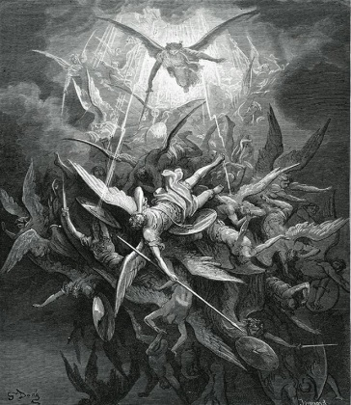
Satan being cast out of heaven

Some have had faith in God for years, Satan possibly for countless years, but there is something that goes beyond faith, and it can keep us out of heaven, it’s true.

Just when did faith in God on this earth begin?

I already mentioned it about Adam, the first human being, who undoubtedly realized full faith in God as his creator, when God put him to sleep, and then, when he woke up “there was Eve, who did not exist before when he named all the living beings, do you see it?”
Each one of us has had similar realizations in our life that confirmed our faith to the same degree, that caused us to not only believe but to know in our hearts and minds “God as our creator, and more importantly we have experienced Him as our re-creator”, and, that’s why we have faith in Him, and follow Him, as He leads us in His ways, ways that the world is blind to, right? (John 14:17)
Adam, when seeing Eve as his help mate the Lord created for Him personally….. now “he had faith”!
Now, he had a firm belief in God as his creator, and he passed it on to his wife, and naturally she had it too, what else would she believe, that is, until she encountered the serpent, possessed by Satan that old red dragon, the deceivers of deceivers, who did what?
Tempted her new “faith”!
Questioning her “belief” in what God had told them, not only about the tempter, but, about the tree of “the knowledge of good and evil”.
He gave them foreknowledge, forewarning as He does all of whom the Father calls. (John 15:14-16) the Lord gave them a warning when He gave them their “only command of obedience against evil and the death it brings”, thus, it was a tree in which they were not to eat of.
But Satan twisted her conception of faith, just as some men do ours today, confusing us into thinking “their way”, instead of Gods, clamming what they have “is the true faith the true enlightenment”.
NOT!
I remember J Swaggart saying on national television, his version of Gods 4th Commandment in that the S-Abba-th of God today is Sunday not Saturday, but I couldn’t believe what he said next and it makes my point here; he said: ‘I can’t prove it with the Bible but the spirit told me so’. Obviously he never read (I John 4:1) and has fallen into Satan’s trap as has about all the world, “as God predicted”. (Revelation 13:3, 17:17-18, 14:8, Daniel 7:24-25 these few verses of the many I could reference (See www.theuniversalreligion.com “S-Abba-th or Sun-day”) predict what the beast has thought to do here in the end, and Swaggart has not only bought into her false prophecy but defends it and deceives himself by listening to a false spirit contradicting the spirit of God, His word and His Covenant)
I wonder where your faith stands, with whom?
We should seek God for answers not man. (Isaiah 8:19-20)
As should have Eve, to start out with “she shouldn’t have been anywhere near that tree”, where the devil tempted her faith, but she was, and he took advantage of her “newly acquired understanding of faith”, questioning “her belief”, by adding to what God had told her, making yes, “a seemingly logical assumption”, one he had used in heaven with great success, and listen, get this all important point; “suddenly she was aware of a new faith”. One I’m sure she undoubtedly later realized; “it was bad faith, a bad choice, a bad work”, it was “disobedience against the works of obedience” that God desired for them, works against His Commandments, against the principals He set for His universe that Satan objected to “in paradise” none the less, but they were set by God in love for all of us to know His Ways which are “the ways of love”. (Romans 13:9-10)
As our creator He knows what is best for us, and anyway, He is the only One who has that right, and we should respect it being one of His creations, as the one who loves us, so much so, He gave His life for us!
Doesn’t that mean anything?
Will we do the same for Him “by giving Him our life to do His good will?” (Matthew 7:21)
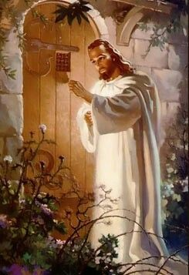
God commanded Adam and Eve to do something, and that something was, that work was;
“Do not eat of the tree of the
knowledge of good and evil
for in the day you do
you will die”

There are consequences for bad works against Gods commandments which are never given in vain nor unnecessary, the results in our first parents case “was death”, and sin, as we know the result, but, in the end “it was their faith that failed in not believing God and believing a lie”, and, bad works followed, they always do - right?
They usually do eventually, the more of God we come to know the more responsible we become, but sometimes it goes the other way around, ask Adam about Cain, his first born, who walked away from the Lord rather than serve Him “His way – Gods way” and not mans, which in his case was himself, of course influenced by Satan who wouldn’t accept Gods way either.
Eve was innocent in the sense that “Adam wasn’t”, he should have continued to have faith in God’s word, and remained obedient, but he too, ate of the tree and both fell to bad works, to sin which lead to death, not only theirs, but the whole world started to die, and eternal life was lost [temporarily of course], taken away, with them being barred from the tree of life, cast out of the garden, and, access to that tree, which will only come back to us should we make it to heaven via Gods Help of course.
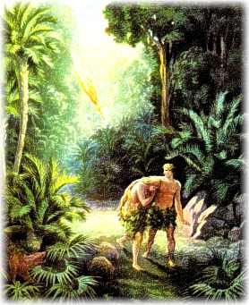
Had our first parents just continued on with good works, when challenged with bad works, better yet, had they just “counseled God first” when their faith was first challenged by the devil, who was; questioning of course the good works God required of them, which was, first and foremost; “to not eat of the forbidden fruit”, listen;
“Had they just counseled God first
they wouldn’t have fallen
for Satan’s deception”
That’s vital counsel for us as well, for our salvation hangs in the same balance. (John 15:5-6) Once saved always saved is a lie for without “the Lord doing the work in us ‘as promised’ working out His good will to do and obey through us, we won’t produce His kind of fruit, make His acceptable kind of sacrifice.
Had our first parents just asked God first “before they ate of the tree”, or had Eve just counseled Adam first, then both of them together go and ask God about this new faith Satan was putting before them; “sin”, would not have entered into the history, at least at that point in time, and possibly never, for we know God has other worlds out there that didn’t fall to sin, only us. (Hebrews 11:3-4)
Today, in this modern world, we are faced with many religious choices, thousands of them actually, all of them out there claiming to know “the faith”, but do they, do we?
Enough for us to know at least “if it’s Gods faith”, or a faith that’s not based on His Will and Word, that being His Word alone and not mans. Or even ours as Cain, one we won’t let go making it “ours by choice in the end?” (Revelation 22:11-12)
One day and not to long from now, due to the state of religion so called, that final decree will go out. And time for change will be cut off. No more pleas for forgiveness will be heard for the Lord has taken off His priestly robes left the heavenly sanctuary and put on His kingly robes to return for His faithful.
Have we, seriously now, “have we counseled God”, through His Word “every time” we are faced with a question of faith or of good works verses bad works, “first”, and not after “we have already eaten of the bad fruit” when it’s too late, or have already become addicted to its taste?
I’ll tell you the answer to that question;
No we don’t, no we haven’t, 99% of us as mankind, and 99% of the time we never counsel God FIRST, second or even ever!
Most never once?
Most just go with what they have been handed, or the most popular, the most convenient, the biggest or the closest church, or just blindly follow the families religion, or even the countries religion, and never once have they really questioned God with what it is they have been handed, what kind of fruit they are consuming, that they think brings life eternal.
Some don’t even want to know the truth, it might cost them something or some work they don’t want to do, and it doesn’t matter if they are works commanded by God or not, they just want to stay with the easy way, the smooth way the comfortable way. (II Timothy 4:3-4, Isaiah 30:8-10)
Many then today, will naturally, or sadly, “unconsciously” fall for the deceptions that “have come into all the religions out there, especially christian ones”, small “c”, save for one.
That one religion is “Gods religion” solely based on His Word, and His word alone, taken point blank with no need of interpretation by any man, despite their credentials of any church or religion;
What we need to do right now, before it’s too late and we become fanatical or ingrained, unmovable, unwilling to change even for God, we need to check them all “against His Word” as we are doing now; every “preacher, priest, rabbi, cleric etc. etc. that enters our life”, but, and this is a big “BUT”;
We can only do this by “first”; knowing “what Gods Word teaches, what the One Gods Word actually is, (See www.theuniversalreligion.com “Dead Sea Scrolls”) and then take “it”, His Word as our faith, and then follow its good works being whatever He Commands or has commanded mankind to do over time”, and those works are “Gods works to salvation”.
(Matthew 5:16, I Timothy 6:17-19, Hebrews 10:24)
Real “Godly” works, not the strapping on of bombs, or confessions to false priests who have no power of forgiveness, or repeating some phrase over and over to some deity or cult, nor worshiping on a day other than Gods, and that’s not the 5th, 4th or the 1st but the 7th of the Law (Mark 2:28 and many more, proverbs 28:9), thusly confessing, trusting, and obeying of course, “the One God” His will, His commandments being His good works as did the Messiah Himself (John 14) to salvation, saving us from the ultimate death we all face, saved or not (the results of works? John 5:29).
Remembering that young man that came “in faith” to the Lord when He was on earth, and that man (representing us in a sense) came to Him because He knew who the Master was by “His works”…..
[which is really the whole purpose of the Bible to establish not only Gods works for Him (Jesus), but, Gods good works were established for us as well “for us to follow” (John 14:10-12)] ….but then as that young man did we “ask Him about salvation, and what works it requires of us?”
It’s the same scenario as if He were here today, doing of course the same “Works as He was doing back then”, and we recognized Him by such, and then, we ask Him the same question as did the young lawyer.
Would His answer be the same Today as back then? (Review; Mathew 19:16-21, 26, Mark 10:17-21)
If His answers are not the same, then we would be divided from them back then in Old Testament times up to Christs time as some falsely teach, under a different religion, and He would be divided “from Himself”!
But we know He is the same yesterday, today and tomorrow, either in heaven or on earth - right? (Hebrews 13:8, Malachi 3:6)

Malachi 3:6 (KJV)
⁶ For I am the Lord, I change not;

No other path is safe my friend, “only Gods”, and He helps us walk it, and yes, it is a straight and narrow path and there are no deviations with His faith and works.
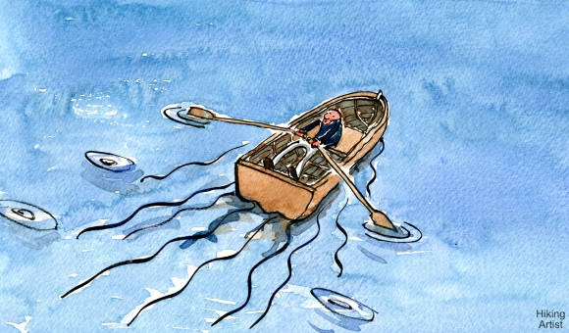
COURSE
GODSS
FAITH
WORKS
It’s like rowing a boat; (one oar “faith” and one “works”) they must be rowed together “at the same time to keep our heading straight”, but when we apply only one oar, either faith or works “we go off course, we swerve to the right or left or go in circles”, we must apply both oars to our lives as we are guided by “His spirit” in the direction He wants us to go.
BUT,
we must test the spirits
to see if it is Gods
“Holy Spirit” speaking,

Right-right?

I John 4: (KJV)
4 Beloved, believe not every spirit, but try the spirits whether they are of God: because many false prophets are gone out into the world.

Adam and Eve both had choices of whose faith, whose works, of obedience they were going to follow, an outsider or Gods.
They chose and outsider.
Will we?
Have we been following the wrong spirit all along and don’t even know it?
The Bible shows us the result of our choices in obedience to God or man. As our weakness as mankind, has been in following Satan from the beginning, as in the beginning, when there were only two of mankind, and that influence has only grown stronger and more refined, and, it begs the question;
“What will Satan’s influence be in the end of time”, when there are billions of people out there speaking and choosing from the many choices, in a time when our listening is dulled to the point we don’t hear the Holy Spirits voice, which has been blocked out by the 1000’s of voices saying; “we have the true religion of God (whatever name for the god they claim)”, what then?
Then, someone else says; “no, we have Gods true religion passed down to us as his earthly representative, we have the truth” and only though our worship can you be saved.

Pope: Only One "True" Church
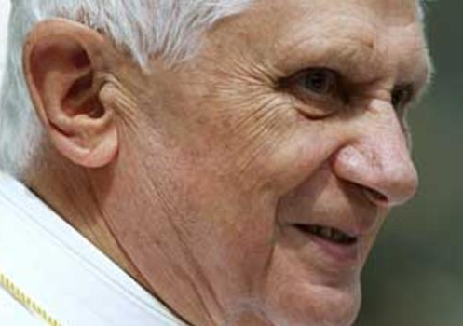
Pope says; “only one true church”
Pope Benedict XVI, St. Peter's Square, June 6, 2007.

Friend, every pastor, every preacher, every TV personality, every Pope and priest that call themselves father, did you know the Pope is called Holy father, bet you didn’t know (Matthew 23:9), all TV evangelists who call themselves reverends, cleric’s, heads of religious states, etc., etc., whoever/whatever religion is saying; “we have the truth and our books prove it”, we are His earthly Holy representative? (II Thessalonians 2:3-4)
I’m saying with this piece “runaway till you check with God!”

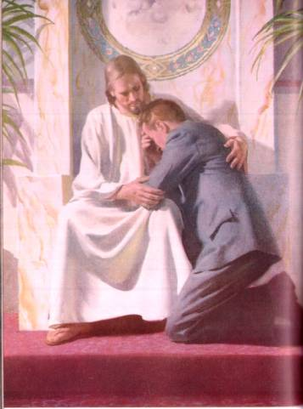

The master, in one of His first religious church services in 27AD, spoke of Isaiah the prophet as, “the bearer of truth” and He quotes Isaiah (Luke 4:10-19).
Then, in His first public sermon (crowd included Jews and Gentiles alike) in the famous sermon on the mount, also in 27AD at the start of His public ministry, He spoke again of the prophets which included of course Isaiah;
Matthew 5:17 (KJV)
¹⁷ Think not that I am come to destroy the law, or the prophets: I am not come to destroy, but to fulfil.

Thus Isaiah’s writings “are valid scripture” for the church the Lord was building “knowing the Jews would soon be rejected” (Matthew 23:37-38) and the predicted Gentiles would be the future church beyond Christs time, as the prophets foretold.
Making the Old Testament, “the prophets and law, “that have been rejected today” by the modern sophisticated churches, but the Old and New of course are “the full gospel” for today.
This according to Jesus, until when?
The next verse tells us;

Matthew 5:17-18 (KJV)
¹⁷ Think not that I am come to destroy the law, or the prophets: I am not come to destroy, but to fulfil.
¹⁸ For verily I say unto you, Till heaven and earth pass, one jot or one tittle shall in no wise pass from the law, till all be fulfilled.

That hasn’t happened yet, so the law and the prophets are valid today as scripture and that includes Isaiah.
I said all this too add to what I said before; the Gospel includes every jot and title meaning every dotting of the “I” and every crossing of the “t” in Gods commandments.
Which commandments?
The one He was quoting from and actually expanding upon their deeper meanings, being “His Father Gods” Commandments what other? (Matthew 5:17-21) The ones we’ve been reading about in all the other verses we read so far “so no surprise, killing, stealing adultery etc. being all 10 including the least one”, but the only one which Has Gods personal Fatherly name in it; S-Abba-th, see it? Actually then making it the greatest “showing us how all the others ought to be taken in love giving and receiving” (John 14:23)
Friend today every one that is teaching; that even the least one of Gods Ten Commandment Covenant has been done away with, or if they have modified it in any way “by even one letter of a word”, I’m saying again; that includes any pastor, every preacher, every priest, every teacher, and of course every Pope “including the first one and that wasn’t Peter, (actually he (Constantine) was the first to modify one of Gods commandments making him and his successors guilty down the line) including every TV evangelist that continues on with that first lie, every cleric who claims Abrahamic roots from whenever, whoever, is sustaining the lie or the change, any change, “they don’t have the truth and their books prove it”, I’m saying again with more fervor “run away” till you check with God, about how He feels - about “His” Word - His Covenant!
You know the one in the “Ark of the Covenant”, the one you had no idea of what it was inside that ark that made it so Holy, and I’ll tell you; “it wasn’t the magic box or the frequency it produced” or some other thing like a modified “two commandment” covenant, the modern deception that Satan has fooled us into thinking or believing, no, “it was the Ten Commandments” that were in that ark that made it so Holy!
The very same ones God said I will not alter, and the savior our Lord confirmed it as we just read, when He said; “think not that I have come to do away with them”, but to live them out, to fulfill them, Mathew 5:17, and He did; every jot and title, and, He didn’t break one His entire life, and listen;
That is why He loved the rich young ruler when He said to Jesus that he had kept the Covenant all his life, (Mark 10:20-21) and think about it, it must have been true for the Lord to love Him, and at that point in that man’s life “he was saved”, by a mutual love because, “they were both fulfilling the Fathers will being His Covenant”, they were both on the same track as it were if only for a fleeting moment.
What changed, who changed, the man once saved or God?
Psalm 89:34 KJV

My covenant will I not break, nor alter the thing that is gone out of my lips. (See also if you dare vs. 30 -32 - Mr. Once saved)

So take heed my friend, don’t just blindly follow the false prophets regardless of who they are and their supposed credentials, or suffer their fate we have already seen clearly.
“Checking with God”, for His commands we are to follow, is our Christian duty, actually mankind’s sole (SOUL) duty (Ecclesiastes 12:12-14 what a shocker), something Adam didn’t do remember, and this includes checking with Gods Word as in “Isaiah’s prophecy and counsel” (Isaiah 8:19-20) Isaiah being one of Gods prophets we discovered, checking with God about His religion is vital, BUT, are we getting the picture yet?
Notice what it is about checking with God before anyone, or rather than anyone despite their claims of seeing and knowing what are God commands, we need to know what He has always commanded, of those in the past who are now dead, to the last man and woman alive just before the second coming, and His Commands are the same for all times in eternity, His universal religion!
Notice what Isaiah was inspired, by the Holy Spirit, to write “quoting the Lords words, to the spirit, to the church, to us to all mankind past present and future”;

Isaiah 8:18-20 (KJV)
¹⁸ Behold, I and the children whom the Lord hath given me are for signs and for wonders in Israel from the Lord of hosts, which dwelleth in mount Zion.
¹⁹ And when they shall say unto you, Seek unto them that have familiar spirits, and unto wizards that peep, and that mutter: should not a people seek unto their God? for the living to the dead?
[Check them out with Gods Word and if…]
²⁰ To the law and to the testimony: if they speak not according to this word, it is because there is no light in them.
Why was this ageless counsel given?
So that we not be deceived by the false religions, and false teachers out there, and that we be prepared to meet our Lord and Savior some day without sin that will surely destroy sin and sinner alike, as well as Satan and all who harbor known sin (II Thessalonians 2:8, I John 3:4-8, Hebrews 10:26-29);
Listen, I’m not just pulling random texts out of a hat to make a point, I’m displaying what the Gospel and the Testimony of Jesus (the faith) actually teaches, has always taught (I John 3:11-12, Revelation 14:6, 12, 14) from Cain to the day we see the Lord coming in the clouds a second time.
From the beginning, actually in heaven from eternity we found out, to the end as our texts imply, and that’s why it’s called “the everlasting Gospel”, everlasting get it?
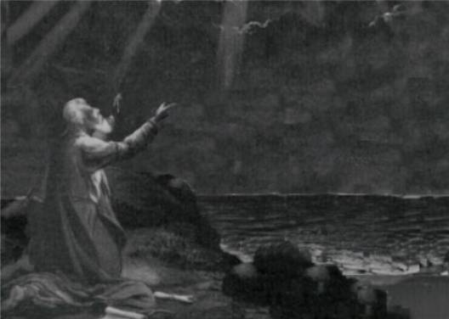
John saw it all and wrote it all down for us!
Friend, the oldest and most published, the most ancient scriptures (see www.theuniversalreligion.com “History is History”, also “Jonah and the Whale”) the most ancient history hands down, is Gods written Word, the Bible.
Proven by all the fulfilled prophecies that it gave hundreds of years in advance “in which all have come true 100% of the time, and, will continue to do so”, (See “Dead Sea Scrolls” same site) and that Bible (God) speaks to us; “something different than all the others books and their authors who speak and who claim to be connected to Him through their scriptures.
They all, including me, especially me – please! - Need to be checked against Gods Word. That’s why I give so many texts and if you noticed they all are linked to Bible Gateway so you can go out and check each one in context.
This reminds me of one of the churches our gospel group sang for; When it came to the preaching they asked us to wait outside because they handled snakes (only in West Virginia!) we didn’t know that going in, anyway, we asked them where in the Bible they got this; they took a text completely out of context where Paul was bitten by a snake and should have died but didn’t, (Acts 28:3-, Mark 16:18) and because Christ had foretold about taking up snakes with no harm, they do it to test their faith.
I say false faith and false works combined, we don’t test God, that’s called presumption, NO, “He tests us”, and snakes may be involved as in Eden, and yes Moses did hold up a rod with a snake on it but that doesn’t mean we should, we should have learned that lesson long ago, because a serpent “is” on the rise today.
Also, in talking about taking texts out of context, there’s the text in (Luke 23:43) where Christ said to the thief on the cross; “today”, you will be with me in paradise. Some churches, in fact about all, have built a whole doctrine of going to heaven directly when you die (looking down on us now the funeral preacher says) and they use that text among a few others as an example of what happens after death.
Problem is, Christ did not go to paradise that day nor even the next, as He rested from His work, of saving the world, on the S-Abba-th, according to the Commandments of God (Exodus 20:8-11, Luke 23:56, 24:1, talk about tests Exodus 16:4 and the S-Abba-th Exodus 16:23, Matthew 12:18), even in death He did not break His Fathers 4th commandment. If this thief text is taken out of context to prove some doctrine that’s not Biblical what about the others they use?
In a minuet I’m going to give you a few texts that show this doctrine is not Biblical, it’s just another example of taking a text out of context, and by the way when the ancient manuscripts were transcribed they had no punctuation and the translators put their own punctuation to them as they compiled the Bible.
That text “to be Biblically sound” about the thief on the cross, should have had a comma “,” after “today” then it would read properly in context to the rest of the Bible.
Christ said “today” I tell you, you will be with me…. “Taking things out of context is one of Satan’s greatest tools, in fact the first one he used on Eve twisting Gods words, and the false churches today have fallen for His deceptions without “checking with God”, and His word alone, His whole un-contradictory words in both “Old and New Testaments for the Truth of any doctrines, creds etc. etc.
Did you ever stop to consider without the Old Testament to check the New Testament against, one could just about destroy most of the Bible as being “contradictory” to itself, and friend they do.
Think about this dilemma;
God had a man stoned for working on the Sabbath (Numbers 15:32-35) but today we can break it by worshiping on another day other than the one in Gods Covenant? God Forbid, remember He said; “I change not!” (Malachi 3:6) Certainly then He wouldn’t do any work on His Fathers Holy day even the saving of souls His primary reason for coming the first time, and what about the second what does He say about the Sabbath in those days? (Matthew 24:20) That may sound petty to you but to God it’s serious, we are talking about Holy things, and to Him His S-Abba-th was made Holy and form eternity to eternity. (Deuteronomy 7:9)
We can see their lack of understanding, and listening to the lying spirit in how they interpret “falsely” Gods scripture, that is, when we seriously take the time to check them out, and if we do we can easily see the errors, and I’ve just dealt with the few we have seen so far “just tipping the iceberg a little” of all the evidence against them that the Bible portrays, “as they misconstrue the word to make themselves appear connected to God”, just as Satan did in the beginning.
BUT, God has placed in His book, as the text we already read states (Isaiah 8:20); “HIS” way to determine whose claims, whose religion, is from Him, and what claims and religions are not, and, all it takes is just reading and thinking about what we learned so far from this first book of the Bible “Genesis”, we just reviewed in short, and then, reading as we are going to do now, the last book of the Bible as cannoned by King James (closest to the original manuscripts), and in doing so, the truth is reveled about “sin, sinners, and those who follow them, religious or not and there are many religious practicing sin and don’t even know it. (Remember what sin is- I John 3:4)
Soon, all that the Bible teaches and requires of the righteous will be revealed (Rev. 22:10-12) and required of those of whom He has called, why?
So that we can stand in the Shekinah glory that will attend the Lord on His return, being the same glory that was in the temple in Israel as they traveled towards the promise land, and if the priest went into the Holy of Holies, wherein dwelt that Shekinah Glory of God, if he went in with any known or willful sin he was struck dead “naturally”!
Because sin “naturally” cannot exist in Gods glory and live, that’s how it has the power to even destroy Satan (II Thessalonians 2:8) and bring him to ashes (not sent to hell either to burn for eternity as the liars claim and the Bible does not teach (Ezekiel 28:18 , Malachi 4:3) another dilemma.
See how easy it is to show what the Bible really teaches, exposing many of the greatest false doctrines that have taken the churches towards eternal loss, or should I say their people, but, not those who want to know the truth as the Lord says we must. (John 3:19-21)
Actually there are a lot of things, 99% of the churches do not teach found in the scriptures, leaving most people in the dark, they won’t teach them so that their doctrines appear to be truth, and most church going people have no idea what God calls sin (I John 3:4-), and as a result they don’t have “the faith our creator God asks us to have, much less the works He demands or commands us to follow”.
It’s just that simple friend, and the remaining portion of the Bible between the first and last books, falls within these set and unchangeable parameters.
Do you get that?
The books of Genesis and Revelation are the Jest of what’s in between these two books “in basic and simple terms”;
The first of Genesis we have already reviewed, and now as we go to revelations last chapter, to see the rest of the story about; sin, sinners, religion and all God tells us about them.
We are going to see it’s all spelled out in these two ends of scripture, the beginning and the end, just what eternal life (salvation) entails both “by faith and by works” as God required and requires still.
Same faith, same works, plain and simple so that the child of God can know the Truth as it was in CHRIST who came as the Father (John 14:9) so we can know Gods desire for us “to love Him”, as He loves us, is ‘His hearts’ desire (John 14:21, John 15:10) always has been. (Deut. 5:29)
Will we walk away as Cain, or as the rich young man to serve the works of another or even ourselves, or, as Satan be cast out of heaven, denied entrance because we won’t serve Gods Covenant, as was His Sons Testimony? (John 14:11)
Time will tell if we will or won’t, because it’s going to be our choice in the end as it has always been, and eternal life is out there for us to “once again” eat of the fruit of immortality and be forever with the one who gave His life for us, why?
That we might live forever and forever with “no chance of sin (or sinner) raising its ugly head of death”, why again?
For “all will have chosen till death do us part” Gods ways over mans (including Satan’s ways of deception), as we, in both camps from the first (John 5:29, Rev. 20:4-5) and the second (Rev. 20:6) resurrections will stand in that day, either in the garden inside the city “wherein dwells the tree of life” or outside the city looking in as the fires of hell “are just then kindled” (Rev. 20:9) to burn away sin and sinners, Covenant breakers who knew the truth, burnt root and branch forever and never to rise again for all will have willfully made their choice, in Adams camp or Cain’s, Covenant (Commandment) keepers to Covenant (Commandment) breakers by choice.
Let’s review what we learned from Genesis before we go on to Revelations for the rest of the prophetic story from God;
In the beginning we learned that faith in God is required for salvation to once again eat of the tree of life “not of the tree of the knowledge of good and evil” being Gods fruits mixed with mans and death results.
Food yes from the forbidden tree, but fruits, if you think about it, Adam and Even didn’t need to know to live forever.
In fact; it was what caused them to fall, see it?
Of course today we are fully aware of this mixed knowledge that tries to destroy our faith so that we fall under all of Satan’s deceptions, but, as we seek to choose Gods truth over the enemies we find that it’s not easy seeing Gods truths for all the deceptions and false doctrines out there today taught by Gods enemies, and through Gods prophetic word we find that “religion has become one of them”. (II Thessalonians 2)
If we so choose then, as did our first parents, to choose something other than Gods truth “without consulting Him first”, then He (God), being a loving and not forceful God (as all of man’s gods have been), He will let us have our own way, but His long suffering may lead, as with Cain and those who have made up their minds they want nothing to do with God, He (God) may even darken their deceptions “because of that final choice for another voice other than His, another work, another worship etc.” (II Thessalonians 2:9-12)
Works we discovered (as we just read), or will discover (in what we are going to read), are paramount to our salvation, and, required mind you today just as in Eden, and our first parents, with death looming over their choice, had they just obeyed Gods command they would not have fallen to the deception, and if we read James’ clear definition of faith and works (James 2) we would know this to be the case.
But if we read counsel like this, warnings like this, but still choose not to follow Gods word “we have chosen some other man’s word over Gods, and as we go to revelation this becomes purely obvious, so take heed to “Gods last words to mankind” addressing those who will be alive then, and the churches which prevail, just before His next coming, listen to our Lords warnings through prophecy.
Don’t be like the Jews who had the faith, who yes, as Paul said had preserved the faith by their commission, (Romans 3:1-2) one of their few good works Israel did do, especially in upholding the Covenant (you know the one they are accused of keeping as works and were supposedly rejected) but the truth is; “they failed to keep it by bad works”, even when the good works was right in their face in the Testimony of Jesus. (Revelation 19:10)
The Messiah who was promised way back there in Genesis, (Genesis 3:15) of whom arrived prophetically in their midst’s “the very year prophecy predicted”, but, they were so steeped in their religious traditions they didn’t recognize their Messiah, their only hope, and friend, they failed not only as a result to fulfill their commission, given them as protectors of the Law (Ten Commandments), (Daniel 9:24) they had Jesus killed!
They didn’t see He was the embodiment, the testimony, of the Law “all ten”, but they were blind and steeped in their traditions, that blindness caused the Lord to reject them, and give the Gospel to the Gentiles. (Romans 2:11-14)
It’s the same today should the prophecy have predicted His coming in our generations time, we wouldn’t recognize him by “our religion and worship practices, traditions and doctrines including the rejection of His law, and possibly kill Him as did the Jews (Rev. 13), well at least kill all those who stand in opposition to their religion as we see is predicted, or what religion will have become in the end, and, this is where Revelations last chapter comes into view.
The Bibles last book - last chapter, talks about the end of the world and the church to whom the revelations’ were given, and what things apply to the church, (Rev. 1:1) and of course the people who make up those churches, religions etc., and what applies to “us”, as to what our religion should look like, and what faith we are to have, and what works we are to keep to display “a reflection of the testimony and Gods law (Ten Commandments/Covenant as did our Savior, or not and reflect mankind and what it will have become in the end.
It’s all spelled out clearly in this last chapter by our loving Lord who wants us to once again have right to the tree of life through His Spirit, His faith and His required “works”.

Works
The last book of the Bible the last chapter, are the Lords final words for us, given to Him by our Father and sent to the church, through the spirit of God, and recorded by the prophet of God “John the beloved”. (Revelation 1:1)
In the last chapter we are going to find all we need to know about; “how God places works as paramount to faith”, and that “faith is specific” and it’s for the last church just prior to the second coming of the Messiah”, and it’s best stated in the Lords words for “us” who are the church, or at least for what “our church” should be.
However, these few texts are pretty specific of just “who it is: that makes up “Gods true church of the last days”, and who His people are that will have access to the fruit of the tree of life for eternity, the access we lost way back there in Genesis, and on the other hand, we see exposed who those are that will not given access to the tree and will remain lost for eternity, and it seems to be all based on what our “works shall be”, and keep in mind it’s the Lord talking here to John – to us.
The underlined texts in the following need no expansion, as far as our works are concerned in our life for salvation, they are self-explanatory, and however I will give other Bible references to support them;

Revelation 22 (KJV)
¹² And, behold, I come quickly; and my reward is with me, to give every man according as his work shall be…..

[Reward of eternal life “immortality”) not given at death “as the false church liars teach” but when is the reward given according to our Lord? We just read it; “at His coming” (Matthew 16:27).

Notice how Paul teaches this same truth unlike what 99% of the churches teach today. (I Corinthians 15:51-58) “Oh what tangled webs we weave, when first practice to deceive”.

This deception is everywhere, even in your church, and, as a result “in your practice?”

Don’t let “the strength of sin” throw you. Think about it in context; how powerful is a lie, when it comes to even spreading what we think is the gospel when it is in fact not? Satan has used lying and adultery, even Gods S-Abba-th against us “now that is power”, Romans 9:29.

THE FRONT SIDE DESCRIBES
GODS CHARACTER

THE BACK SIDE DESCRIBES
UNREPENTANT MANS
CHARACTER

IV

The power of sin on one side of the Law that causes us to fail, and the power of love on the other that keeps us from failing (remember Hebrews 10:16, 24-29) where Paul makes it clearer than I can state it, but more sharply.]

¹³ I am Alpha and Omega, the beginning and the end, the first and the last.
¹⁴ Blessed are they that do his commandments, that they may have right to the tree of life, and may enter in through the gates into the city……

[Who is pictured here? Isn’t this what we have seen all through the time of mankind from Genesis to the end? As to what constitute Gods religion, His eternal Gospel His people, and His church for the last days? (Rev. 14:6-12, 13-14)

¹⁵ For without are dogs, and sorcerers, and whoremongers, and murderers, and idolaters, and whosoever loveth and maketh a lie……

[Who is pictured here? The Lords description of Commandment breakers (of even one of Gods commandments remember - James 2:10) and those who propagate lies like heaven or hell at death, and about an eternal forever and ever hell itself, all lies most churches teach as doctrines believe it or not. Don’t let the “for ever and ever” burning or “eternal fire” lines fool you, as the churches take them as well, out the context of the Bible. Notice how it’s used in context; Matthew 18:8 remember what that Shekinah fire will do to Satan and sinners alike burn them forever and ever or to ashes? (Ezekiel 28:18, Malachi 4:3 ) Revelation 14:11, no ashes, how long do you think the Shekinah fire of God will take to burn flesh? Now Satan a spirit being probably longer - just guessing. Then there’s Jude 1:7, there is no fire still burning in the area of the dead sea where Sodom’s literal ashes lay (See www.theuniversalreligion.com “”What if the Bible is True”!) Can’t you see how these lies “that have evolved into doctrines” can be “extinguished - pun” by searching the Bible to know the Truth?]

¹⁶ I Jesus have sent mine angel to testify unto you these things in the churches. I am the root and the offspring of David, and the bright and morning star.
¹⁷ And the Spirit and the bride say, Come. And let him that heareth say, Come. And let him that is athirst come. And whosoever will, let him take the water of life freely.
¹⁸ For I testify unto every man that heareth the words of the prophecy of this book, If any man shall add unto these things, God shall add unto him the plagues that are written in this book:
¹⁹ And if any man shall take away from the words of the book of this prophecy, God shall take away his part out of the book of life, and out of the holy city, and from the things which are written in this book.

[Prophecy is important to our Lord right?

Of course, it was His testimony (Rev. 19:10), in the life that He lived that life He came to reflect “God our Father” to us mankind, through Works even. (John 14:10-11). So that “we” may also have His Testimony, of all we have read from Genesis to Revelation, (John 14:12-17) and receive the greatest of the “gifts of the Spirit” that we might reflect our Savior, to a dying deceived world out there, this is our commission is it not? (I Corinthians 14:1) He also came to fulfill all the prophecies written about Him confirming the Spirit of Prophecy itself, and I’ll add confirming the Bible as unarguable truth as our history (see www.theuniversalreligion.com “Dead Sea Scrolls”); prophecies like; where He was born (Micah 5:2 penned 703BC Christ came to cross in 31 ½ AD that’s a 734 ½ year old prophecy fulfilled), and how He would die (Daniel 9:25 penned 538BC 568 ½ years in advance of the year of His coming to the cross ending the law of sacrifices as we have already discussed, and so many more I could list, but you get the point I hope. Acts 3:18,19]

²⁰ He which testifieth these things saith, Surely I come quickly.

Amen. Even so, come, Lord Jesus.
²¹ The grace of our Lord Jesus Christ be with you all. Amen.

Who is He which testifieth in this context?

It is the Lord of course, but do you know what His testimony was to be when He came to this earth the first time?

It was in fact “what His life represented through all His predicted fulfillments of those prophecies thereof, it’s like He wrote His own biography in advance then fulfilled it when He came, get it?”

That’s the Testimony of Jesus = the Spirit of prophecy!

Go back and read from Matthew ahead “just His words He spoke in red”, and you will see His mission was to prepare “us” to be like Him and to share His testimony, no, “to have His testimony in us”….starting now….. (Hebrews 10:16) the law is also called the testimony – look those references up yourself sometime, and also explore all the different things the Ten Commandments are referred to i.e. “Law, Testimony, Covenant” etc.

So how does the Bible define what the testimony of Jesus was for us “brethren” who seek for the greatest of Gifts of the Spirit? (I Corinthians 14:1)

Revelation 19 (KJV)

¹⁰ And I fell at his feet to worship him. And he said unto me, See thou do it not: I am thy fellowservant, and of thy brethren that have the testimony of Jesus: worship God: for the testimony of Jesus is the spirit of prophecy.

~mosescats~

What does your “leap” reflect?

By
Mosescat

