The Book of REVELATION
A Study Guide

When we first look at the book of Revelation we notice something right up front, and that is; “it is a book actually written for us down here in the end times, the last generation”, set in motion by the returning of the Messiah back to heaven, and now, He has sent, this last generation, an end time message back to earth “a whole book, authored by His/our Father, containing what?”
Well, let’s read it;
Revelation 1:1 KJV
1 The Revelation of Jesus Christ, which God gave unto him, to shew unto his servants things which must shortly come to pass;
There it is, it’s a book telling us of the things which are shortly to come to pass “post 90 AD” (we live in 2018 AD), since that’s when John, 60 years past the return of Jesus to heaven, penned this book, and notice too, there’s a promise to those who read/study and “keep” the things of this book in mind, and in heart I’ll add knowing the significance of the Lord Gods challenge and promise we will find here;
Revelation 1:3
³ Blessed is he that readeth, and they that hear the words of this prophecy, and keep those things which are written therein: for the time is at hand.
Did you catch His (Gods) endnote there?
For what reason should we make this book a priority here in the end of time?
“For the time is at hand!” He announces
The time for what???
“The time is at hand for what?”
Well, we get the answer to that question at the end of our Lord/Gods book of Revelations “to us here in the end”, notice;
Revelation 22:10-12
¹⁰ And he saith unto me, Seal not the sayings of the prophecy of this book: for the time is at hand.
¹¹ He that is unjust, let him be unjust still: and he which is filthy, let him be filthy still: and he that is righteous, let him be righteous still: and he that is holy, let him be holy still.
¹² And, behold, I come quickly; and my reward is with me, to give every man according as his work shall be.

Well of course He is speaking of His soon return, “the time for His return” is at hand, and notice He is also saying to us “don’t seal this book”, or put it aside in other words, for it contains things that have to do with our salvation, and He refers to the pending judgment; when all cases will have been heard and every decision made for mankind, and then, “time will end” what would delay it right? The return will be eminent then, and notice what He adds at the end of verse 12;
¹² And, behold, I come quickly; and my reward is with me, to give every man according as his work shall be.
That “work” my friend is the preparation for His return and it’s paramount that we need to begin to get ready “personally” as soon as we can, because it’s been how long since He said; “behold I come quickly?”
It’s been nearly 2000 years by now, and listen, it’s past time for His return, do you believe that? And listen; we as humans do not make the changes necessary to meet this coming “if needed”, very fast, if at all. Especially, when it comes to religion, “religious changes”, which might I add “the book of revelation is full of them”, and this is actually the purpose the Lord/God gave it, “for the churches in the end to make changes as we will discover, for they have all turned their backs on Gods plans for them, and they are leading their people astray this very day”.
Real quickly let’s jump back to that part in His book where He describes this apostasy for us, and we find it in this very book “that He asked us to keep/study/ know right up front, and I’ll add learn of these things, learn of this apostasy so that we won’t fall prey to them, the false churches that is, looking as lambs but underneath wolves in sheep’s clothing” believe it or not;
Revelation 17:
¹ And there came one of the seven angels which had the seven vials, and talked with me, saying unto me, Come hither; I will shew unto thee the judgment of the great whore that sitteth upon many waters:
² With whom the kings of the earth have committed fornication, and the inhabitants of the earth have been made drunk with the wine of her fornication.
³ So he carried me away in the spirit into the wilderness: and I saw a woman sit upon a scarlet coloured beast, full of names of blasphemy, having seven heads and ten horns.
⁴ And the woman was arrayed in purple and scarlet colour, and decked with gold and precious stones and pearls, having a golden cup in her hand full of abominations and filthiness of her fornication:
⁵ And upon her forehead was a name written, Mystery, Babylon The Great, The Mother Of Harlots And Abominations Of The Earth.
⁶ And I saw the woman drunken with the blood of the saints, and with the blood of the martyrs of Jesus: and when I saw her, I wondered with great admiration.

Now of course we have little or no idea, for the most part, what He is taking about here, unless of course we have studied it out as the Lord asked us to, right?
Let me give you a clue about prophecy and the Lords use of symbolisms in His descriptions, such as this woman that He just described, it’s a woman who has dealings with the kings of the earth, and has had intoxicating effects on the people of earth and, has even martyred Gods saints, so obviously; we are talking about a power, or in this case as we are going to see, a religion gone bad, “churches/religions gone bad” in that she the mother “has harlot’s that she has corrupted and are following her, working for her” and this includes, or also, she has affected all the inhabitants of the earth in some way or another, thus they are not left out?
You say how do you get all this from this abstract symbolic description the Lord is giving here?
Well of course the quick answer is I’ve studied it out, but it’s in knowing one of the symbolisms that puts this whole text into perspective and this is how the Bible interprets itself, and that so we don’t guess as most preachers and such do today, putting their own spin on God’s Word, and friend, this is what led to the churches apostasy in the first place.
Anyway notice how the Bible symbolizes “the church”, a church as a woman “in prophecy”, and in this next text the Lord is speaking of Jerusalem as the symbolic woman to His prophet;
Jerimiah 6:2
² I have likened the daughter of Zion to a comely and delicate woman.

“But”, you say; “that doesn’t explain the other symbols used that make this understandable”
Of course your right, and this is where we drop back and “start where the Lord wanted us to” in understanding prophecies. He gave us this clue when He was on earth explaining about the end of the world to His disciples and that’s when He asks us to start “in our understanding of end time prophecy” as given in the Bible, which of course in His day was the prophecies in the Old Testament (that’s all they had to learn of God from), and I’m supposing He referred us to that book of the Bible because He knew that He was going to place the book of Revelations in mankind’s hands after He left earth, and He wanted them/us to be prepared to understand the symbolisms and all beforehand.
A big mistake most make when they do decide to study Revelations is; they try to read it as any other New Testament book, like the accounts of the Messiah given by the apostles and disciples, or the letters written to the then established churches, but soon, they discover it’s simply just not written that way, even though; it is an account of the things that would shortly come to pass as the Lord first told us, but it requires the Lords help in understanding it, and this was a built in prerequisite I believe, so that we come to Him for answers to understand rightly His word and to interpret correctly the things which are coming to pass, future things, things written in heavenly symbolisms for the eyes of His servants only;

Revelation 1:1
1 The Revelation of Jesus Christ, which God gave unto him, to shew unto his servants things which must shortly come to pass;
The key thing for us to take from this passage is; “this book was given to “Gods servants”; it is those of whom He tells His secrets to, not the enemy, or those who just passively read scripture to meet some church activity or such, but those who really want to know the truth as it comes from the Lord, and this is how it’s always been since Eden.
Notice Jesus spoke of this relationship between heaven and mankind confirming this;
John 15:15
¹⁵ Henceforth I call you not servants; for the servant knoweth not what his lord doeth: but I have called you friends; for all things that I have heard of my Father I have made known unto you.
¹⁶ Ye have not chosen me, but I have chosen you, and ordained you,

What’s involved in being the Lords servant and friend?
Read chapters 14 and 15 of John and you will see, that is, “if” you place yourself, if we place ourselves as the one He is speaking too there, as He is instructing His disciples (of which we are called right), and if you/we do “as He asks”; then He reveals Himself, and so will/does His Father, and this then opens up the hidden things of this world into our comprehension, and the Prophecies become clear and not hard to understand at all. He says in those two chapters “if you love me and do as I ask in this “Love relationship” I will open your eyes, but, just as assuredly I will shut the eyes of those who don’t care enough to even heed my words.
Notice as you read those two chapters, in essence, if He doesn’t say this to us, and if you do, you will see how the truth really sets us free from “the abomination” that the churches have become in this end time, “just my friend, as the Lord described they will and we just read that in Revelation 17”.
I told you the Lord tells us how to begin to understand prophecy that concerns the end of the world, and, that’s what the book of Revelation is, right, and it contains the things we want to know and understand, right?
He steered us to this as I said when He was on earth, I believe so that when He sent Revelations to John and us, we would already understand how His prophecies work, symbolisms and all.
In the following text Jesus was asked by His disciples about the end of the earth and time, and He told them what it was going to be like when the world was ending, and He compared it to a soon to come event that would happen in their time, one He predicted, of the destruction of Jerusalem in 70 AD, and how they should act then or should have acted then when it came, and that is how He compairs; “last day mankind should act” and be informed, so that when it happens we will be prepared, not as the people in Jerusalem as history tells us, of whom the only saved were the ones who remembered and understood and acted upon His warnings and prophecies and took them to heart they escaped but were few in numbers.
Primarily in this chapter of Matthew, Jesus was speaking to the question of what it will be like in the last days of mankind, so let’s notice an excerpt from that answer “that relates to our question about studying to understand prophecy;”

Matthew 24: KJV
¹¹ And many false prophets shall rise, and shall deceive many.
¹² And because iniquity shall abound, the love of many shall wax cold.
¹³ But he that shall endure unto the end, the same shall be saved.
¹⁴ And this gospel of the kingdom shall be preached in all the world for a witness unto all nations; and then shall the end come.
¹⁵ When ye therefore shall see the abomination of desolation, spoken of by Daniel the prophet, stand in the holy place, (whoso readeth, let him understand:)

There it is! The key to understanding Revelations, and it is “in first understanding Daniel”, and I assume John was inspired to add; “whoever reads this don’t just read it but understand it”.

This is heavens call given to mankind, as we all will face an end time scenario in all generations of women and men who become servant friends to the Most High, because that old red dragon has railed his false churches to seek and destroy all who begin to follow the Lord into battle, the battle of the end of life as we know it, and life as the Lord wants us to know it, and that’s why He has called us to even higher callings we’ve never known before, that is, “If we really love Him” enough to follow Him?

The Book of DANIEL
Perquisite to Revelation

The reason the Book of Daniel was to be our starting point is; it was in the time of Daniel when God first began to speak and have man record prophecies about the future and predictions and some He has even given us time frames that are fixed around historical dates “so that we can figure exactly when they applied and when they were going to fulfill.”
It was in the days of Daniel when the first organized Empires of the earth were forming into their own societies, and they started keeping records too (see “Do We Really Know Prophecy” for details), so too then did God begin to reveal unto Daniel, and subsequently to us, the future prophecies that would affect His people His church, starting with the days of Daniel captive there in the first world Empire of Babylon (605 BC). Were we find Gods predictions contained in an apocalyptic book similar to Revelations.
What we need then to get from Daniels writings, as the source we were referred to by Jesus are the things we are to know and understand, is especially concerning this Abomination of Desolation that will stand in the Holy place where only God can stand, it’s obviously then a religious conundrum one dealing with worship we are going to discover thus, a salvation issue;
The thing that going back to Daniel helps us see is;
“the way God gives prophecy
by the use of symbolisms,
then fulfills His prophecies”
and we will find these symbolisms relate to actual real powers and events that did and will affect Gods people over time, clear to the end of time.
When we see from Daniels book how He does this, we will be able to then interpret the book of Revelations in its use of Biblical symbols and such, and not guess as most do applying their own wisdom over Gods to His Word – God forbid!
Let’s see a quick example of this;
In Daniel chapter 2 as Daniel was being held captive in Babylon “the first world Empire of history “when a single king ruled over the whole then known earth” as God defined the world then (not man) this is a picture He gave and is complete in its symbolisms.
This king had been allowed by God to overthrow His city of Jerusalem in his bid for world conquest, but his power would not last and God showed this king this through a prophecy or vision He gave him telling him of his temporal power.
The king received this vision in a dream but when he awoke he couldn’t remember it, (Daniel 2) and to make a long story short Daniel interpreted it as God gave Him the interpretation and this is what’s important for us to get from this prophecy. ³
The king dreamed of a great image with a head of Gold, breast and arms of silver, belly and thighs of brass and legs of iron, with feet of both iron mixed with clay, and as he watched a great stone made without the hands of man hurled towards the image and break it in pieces and then the king awoke, but did not remember what he had seen but he knew it was important. So he sent for His seers, prophets and magicians to tell him what he dreamed, but of course they couldn’t, and so he issued a death decree on all who claimed to interpret things of this manor and Daniel was among those to die.
Daniel sought God for the interpretation, and he told the king not only what he dreamed but the interpretation thereof.
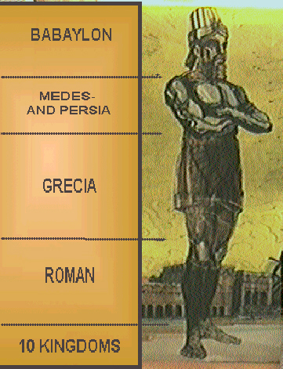
The head of the image “symbolized” the king of Babylon, that golden city of our past, (see www.mosescats.com for the unbelievable details of this world reality), but the kings empire of Babylon would not last it would be overtaken by another World Empire of the Medo/Persians/Egyptians allied together to form the 2nd World Empire of mankind’s history “symbolized” by the silver part of the image.
Thusly each of the four empires were symbolized by the metal on this image, in God telling of the future that would come to pass clear up to the time God as the stone would destroy them all in the end, and set up His kingdom that would last forever.

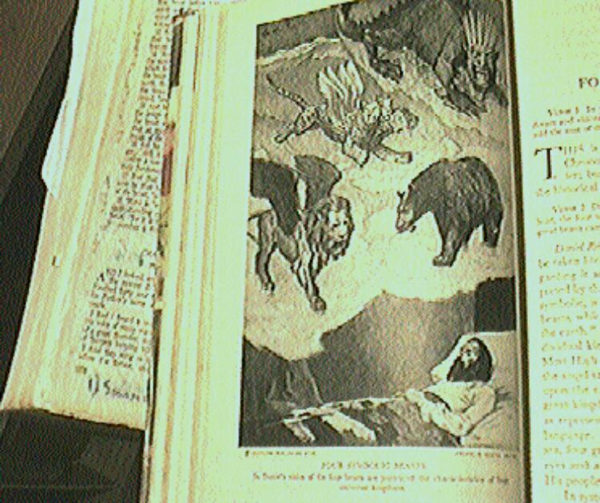

Later Daniel was given a vision of prophecy also containing “symbolisms” but this time instead of equating those four world empires as parts of an image God used animals for representation, such as the first World Empire was symbolized as a Lion with eagles wings, the second Medo/Persia/Egypt as a bear, Grecian the third World Empire of history as a leopard with four wings and the last World Empire of Rome as an iron beast. (Daniel 7:1-7. 17, 20)
Listen now this is important “God only names four beasts each subdoing the previous starting with Babylon (head of gold) ending with the forth and last, let me ask you “who knows more than God or thinks to”, so beware of false prophets/prophecy, and listen He gives the names of the first three in the Bible, (Daniel 8:20-21) history tells us the rest. Notice also verse 13 where the word abomination is mentioned leading up to the abomination of desolation Jesus asked us to learn about.
This prophecy in Danile 7-8 brings us up to Rome the fourth and last World Empire of history (according to God mind you), depicted as the legs of iron on the kings image, but remember it stood on feet made of iron and clay, so what was it Daniel saw that represented that period of future history?
Ten kingdoms would arise after Rome (Daniel 7:23-24) who historically was taken down by ten tribes from the north, it’s all history from reputable sources of course (post 1900 AD) not the internet or at least the majority of the junk that’s out there.
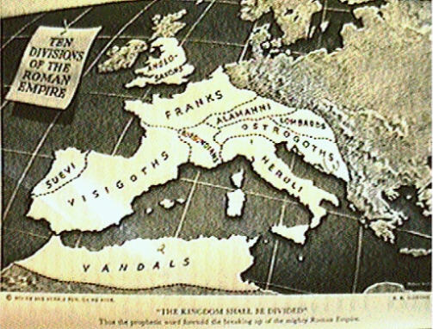
He saw a little horn come up from among those toes, or after the iron beast was destroyed by ten kings in Daniel’s dream. (Daniel 7:8) This little horn representing a power that was to come after the fourth World Empire was destroyed, and it was depicted by God as the one that would led the churches to apostasy and become the abomination of desolation Jesus spoke of, and all this did happen during the Dark Ages that followed Rome and this power would be a religious one as well as political, and rule over Gods people by persecution and would actually blaspheme God in claiming to be like Him, and it would think to change Gods times and Laws, (Daniel 7:24-25) but of course she (the woman “symbolizing” the church) didn’t have that authority over nor from God, but it did have and still has over the churches, as it has led them to apostasy even to today, with her fornicating, intoxicating doctrines and her whoredom’s against the purity of Gods Truth and His image of His true church.
God gave these prophecies in great detail to us way back then, so that there is no doubt what powers on earth meet those symbolisms, and He even gave dates and times for their fulfillment, such as the time that little horn power would rule until she would receive a seemingly deadly wound, from the time of its setting up of power till that wound, would be “according to God a time, times and a half of time”, (Daniel 7:25, Daniel 12:7-9) or as John was shown 1260 days in one place (Rev. 12:14, 6), and as 42 months in another “each describing the same length of time this little horned beast of Daniel and full beast in revelation that would genocide 3 of the ten kingdoms, persecute Gods saints, blaspheme God, think to change His law dealing with time, receive a deadly wound, plus the length of time she would reign” it all adds up.(Rev. 13:5, 6-8)
From the fall of the Roman empire till the seemingly deadly wound would come would be her time of reign, and because we have both Daniel and Revelations prophecies, we can determine when “in fact” this did occur, how long these dates equate to actual historical dates, and thus with just simple deduction, fitting those years between the fall of Rome and say the founding of America, we know this is the only place a length of this time period could be placed into history.
That length determined by the Bible itself, and confirmed by Sir Isaac Newton as 1260 literal years fitting only after the fall the last World Empire of Rome and the institution of America, actually from the time this abomination of desolation power came into Her full reign historically, in 538 AD, when she obtained both political and religious power over the arena of Gods people, until 1798 Ad when she (the prophetic woman church) received the wound exactly as God predicted to the very year, and the rest is history my friend and the message our Lord God wishes us to receive study out and know in that all the world will wonder and worship this beast, religious of course, christian to be exact (small “c”).
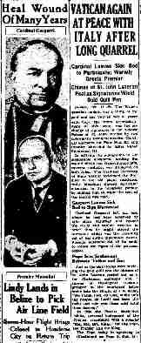
Using the Bible own words….
Once we see all of these fulfillments of prophecies that God gave to Daniel and the accuracy of them in time and history, we are then able to understand the book of Revelations and the use of symbolisms by God and who they apply and to no other power of history, and to then know of our future and what’s in store for us in Satan’s churches deception’s this is the warning with two whole prophetic end time books (Daniel 12:4, 9) given for us to get this message of deception and false religion here when the book of Daniel was to be unsealed and revelation to not be sealed, (Rev. 22:10) why?
“For the time is at hand” and so that the church and its people have time to prepare and so that they will not fall for Satan’s churches last day deceptions which now are overwhelming for those who follow after the beast.
I’ve given a quick overview of the use of prophecy from Daniel so that we can begin then to understand Revelations, but, it would do one well to verify all of this through a personal study of Daniel on our own, setting the stage for fully understanding the book of Revelations, BUT, and this is a big “But”, even having then studied Gods use of symbols there are some things in the last book of the Bible that are yet to fulfill, yet to shed their light to those who love God and want to understand all He has shown us, and listen, if we stay tuned to His truths, separating them from the false prophecies and lies spread by the apostate churches following the beast power of the mother church, we will more than come to understand and see the Bibles interpretation of the dark things yet to be revealed by God as opposed to man’s guesswork.
May we enter this study not only with open minds and hearts to the things of God, but also with a willingness to accept and take them into our minds, hearts and hands (being our life and it’s testimony), because, what good is it to learn of Truth and then turn back to the lies being perpetrated by the abomination of desolation and her harlots that God has fully exposed, should we be willing to see that is and accept.
Here is Paul’s council concerning this very issue we will face and it’s frightening how clear he saw the future even from his time and knowledge;

2 Thessalonians 2 KJV
¹ Now we beseech you, brethren, by the coming of our Lord Jesus Christ, and by our gathering together unto him,
² That ye be not soon shaken in mind, or be troubled, neither by spirit, nor by word, nor by letter as from us, as that the day of Christ is at hand.
³ Let no man deceive you by any means: for that day shall not come, except there come a falling away first, and that man of sin be revealed, the son of perdition;
⁴ Who opposeth and exalteth himself above all that is called God, or that is worshipped; so that he as God sitteth in the temple of God, shewing himself that he is God.
⁵ Remember ye not, that, when I was yet with you, I told you these things?
⁶ And now ye know what withholdeth that he might be revealed in his time.
⁷ For the mystery of iniquity doth already work: only he who now letteth will let, until he be taken out of the way.
⁸ And then shall that Wicked be revealed, whom the Lord shall consume with the spirit of his mouth, and shall destroy with the brightness of his coming:
⁹ Even him, whose coming is after the working of Satan with all power and signs and lying wonders,
¹⁰ And with all deceivableness of unrighteousness in them that perish; because they received not the love of the truth, that they might be saved.
¹¹ And for this cause God shall send them strong delusion, that they should believe a lie:
¹² That they all might be damned who believed not the truth, but had pleasure in unrighteousness.
¹³ But we are bound to give thanks alway to God for you, brethren beloved of the Lord, because God hath from the beginning chosen you to salvation through sanctification of the Spirit and belief of the truth:
¹⁴ Whereunto he called you by our gospel, to the obtaining of the glory of our Lord Jesus Christ.
¹⁵ Therefore, brethren, stand fast, and hold the traditions which ye have been taught, whether by word, or our epistle.
¹⁶ Now our Lord Jesus Christ himself, and God, even our Father, which hath loved us, and hath given us everlasting consolation and good hope through grace,
¹⁷ Comfort your hearts, and stablish you in every good word and work.

What was it God told us about the end?
Revelation 22:10-12
¹⁰ And he saith unto me, Seal not the sayings of the prophecy of this book: for the time is at hand.
¹¹ He that is unjust, let him be unjust still: and he which is filthy, let him be filthy still: and he that is righteous, let him be righteous still: and he that is holy, let him be holy still.
¹² And, behold, I come quickly; and my reward is with me, to give every man according as his work shall be.
¹³ I am Alpha and Omega, the beginning and the end, the first and the last.
¹⁴ Blessed are they that do his commandments, that they may have right to the tree of life, and may enter in through the gates into the city.
¹⁵ For without are dogs, and sorcerers, and whoremongers, and murderers, and idolaters, and whosoever loveth and maketh a lie.
¹⁶ I Jesus have sent mine angel to testify unto you these things in the churches. I am the root and the offspring of David, and the bright and morning star.
¹⁷ And the Spirit and the bride say, Come. And let him that heareth say, Come. And let him that is athirst come. And whosoever will, let him take the water of life freely.
¹⁸ For I testify unto every man that heareth the words of the prophecy of this book, If any man shall add unto these things, God shall add unto him the plagues that are written in this book:
¹⁹ And if any man shall take away from the words of the book of this prophecy, God shall take away his part out of the book of life, and out of the holy city, and from the things which are written in this book.
²⁰ He which testifieth these things saith, Surely I come quickly. Amen. Even so, come, Lord Jesus.
²¹ The grace of our Lord Jesus Christ be with you all. Amen.

I leave you with this last text given in contextual relation to verse 14 above;

Hebrews 10: KJV
³¹ It is a fearful thing to fall into the hands of the living God…..

~mosescats~

This use of symbolisms of course was not a new thing in that in Genesis 3:15 the Messiah was predicted to come and He was symbolized as the seed of a woman, and also the recording of prophecies wasn’t a new thing either; Daniel studied the book of Jeremiah and discovered futuristic prophecies given that would affect him and his future the future of his church the Jews. But what makes the Book of Daniel especially important, and subsequently Revelation are the warnings of future enemies that would affect Gods people spiritually, and thus these two book are essential for our wellbeing against the powers that war against us in all generations, of people that have been called by God to serve him and receive His gift of eternal life.
A day for a year or a time + two times plus ½ a time all = 3 ½ years or 42 months or 1260 literal years. If you know someone more of a numbers man than Newton go with their numbers but remember Newton’s matches Gods and prophecy reveals that this length of time fits perfectly as Gods gave it and to whom it applies what power, so take it up with Him.

