SOCIAL RELIGION
RELIGIOUS SOCIALISM

Secular humanism, as it was called in religious circles, was a direct blow to sound doctrine. (II Timothy 4:1-4)

Then came the doctrineless evangelicals and Pentecostals with their TV shows and missionary outreaches, and born suddenly; Paul’s words to/for Timothy, Titus
and us, were fulfilled. (Timothy 4:3, Titus 1:9, Titus 2:1)

Next, came the beast getting her/his foot in the door of America through this doctrineless society that now makes up most of Protestantism, which, just as soon has fulfilled Gods prophecy in calling them “the daughters of the beast.” (Rev. 17:5)
Who is the beast?
In the 16th century Sir Isaac Newton identified her as the Papacy having studied the prophecies and deciphering the numbers and dates it gives, but, in his time she hadn’t fully fulfilled all of Gods identifying marks as given through prophecy, because, Protestantism hadn’t suffered as yet “all of her vengeance” in that “it was still in its infancy then.” (See Appendix “Newton”)
But, After 1798AD all the religious world knew who she was, and, that Gods prophecy had been fulfilled “in the deadly wounding” of her (The beast) and friend, that wound came “right on time” according to the Biblical reckoning, and now, it was seen by all the main stream religions that had formed to that time. (See Appendix “Samuel Morse”)
History records that in the newly formed USA her power was limited in that she was restricted in her ability to expand her reach and influence as we read in Morse’s book, and more evidence of this can be found in the archives of most magazines of that age i.e. Harpers, Vanity Fair (Manhattan-Based), Library of congress etc.
Soon however, she began to influence the democratic society, and in the time of Abraham Lincoln she made her move “causing a Civil War” according to Lincoln just as she had done in France during her revolution “while remaining in the background”, then and until, she could manipulate herself back into the world’s acceptance. (See Appendix “Wound Healed”)
After 1929 she only needed now to fully promote her traditions, doctrines and the evolutionary views onto Protestantism, and then; with her doctrineless companions and, their lawlessness “and” their Biblical ignorance of their 21st century religion we see today, this then, coupled with the status given him in the world of religion, and eventually the worlds political stage, he/she will finally have them all in her clutches and CONVINCED; she “is”, the religious head of the Christian world and moral leader of the global society. (May 2020 may be the tipping point as she uses catastrophic events through subterfuge to gain her control. Just hid in the bushes and we’ll see.)
Then he/she will begin to unify the “Three Spirits” as God defined them, (Rev. 16:13-15) and when that alliance is fully realized, all the religious world will be hers to control once again, as the protestant heads tend to their Religious Socialism in telling the people just what they want to hear, it will seem to them a good thing. (2 Timothy 4:3-4)
You say wait a minute you’re going too fast and too far, and not connecting all the dots “Biblically and historically” for all of these events you claim to have happened or are going to happen?
Ok, but actually, I’ve already given enough texts and references, but, let’s review what I’ve put out there so far to see just how sound they are according to history, and then I’ll fill in the gaps with facts both historically as well as Biblically, the facts, the prophetic realities, and listen the Prophecies are from God not me.
I’m not stating things that I have come up with, or, am I trying to make the Bible fit my agenda, doctrines or theories as most nominal religions “are doing.”
They simply fit where the Bible fits them, they say what the Bible says, and its Gods words I’m “passing on” not mine.
I’m just trying to put them in a format that only they can fit in, and that goes with all I post here.
Test them against the Bible and the Bible only; (II Timothy 3:16) if they are true then put the Biblical test of faith in them, if not, dispose of them, and, I guess the Bible too, OR, like most make scripture fit your religion better yet, while hiding your head in the sand, BUT, please, let me finish out this study then judge, ok?
First; I gave a fact based on historical evidence (Morse) that most Christian religions have dumbed down, or have completely compromised their once held doctrines, and, the majority of the largest body of claiming christians, (small “c” intestinal) next to the “Roman” Catholics, have dispensed with Biblical doctrines altogether, or fashioned them to unify with the beast, and I told you why?

It is easy to see with eyes open “they (the churches 1st and 2nd) cannot meet those once held views like they once did with Christ at the helm, and the greatest one of all Gods doctrines (Dare I say Godly customs like Luke 4:16) they have dispensed with, and the only one I need to reference is; the “Ten Commandments” (Covenant), and especially the forth, being the one that causes them to dispense with them all. Nailing them to the cross and calling the keeping of them a curse, and compromising them into just two commandments, (Matthew 22:36-39, they forget what He added vs. 40, also Matthew 5:17-18) all by “misinterpreting scriptures”, (both Jesus’ and Paul’s) to suit their traditions “they got from the beast herself”, who, set their worship practice and, even took Gods name out of His “Covenants center commandment”, and, the only one He simply asked them/us to “Remember” in hopeful precipitating love, taking the sting of “Thou shalt not” out from it, but, they have forgotten His custom every week without excuse.

The church/people have forgotten the stance the church’s took against her back then, shortly after 1798 when Gods picture of history was clearly fulfilled with the wounding of the beast, and even up to the mid 1800’s when they signed off on what Samuel Morse had written concerning the beast power, much less have they forgotten the beasts own words and edicts made clear back in her early years (4th century AD) of power. (Rome’s Challenge Appendix)

They even ignored others who came before them who had inside information like Luther, Huss, etc. “their founding fathers”, some of whom were burned at the stake and tortured by her for their defiance of the beast powers demands, and as far as inside information is concerned about her, she was the real reason for the civil war Lincoln made known with his death for those who know the truth, and they still hide the truth from their own eyes even when it stare’s them in the face of reality/facts. (See www.mosescats.com “Lincoln”)

Next I talked about who the beast is according to the Words of God and the “marks” He gave that described her throughout time among all the beasts who, have operated against Him and His people/church. (See www.mosescats.com “The Last World Empire” that goes into detail of those marks)

She alone fits all those marks historically, and another big one is the time she was to rule according to God “1260 years”, (See “Time Chart” Appendix) a time period WHICH can only fit; between the fall of Rome and the wounding. There’s no other place that length of time can be placed in time and past history, and another big Mark is her genocide of the three nations completely out of existence during her rise to power. (Daniel 7:8, 20, 24) History tells us friend who it was that did this “no arguments.”

I mentioned Sir Isaac Newton, the numbers man, and once the Icon of the scientific age, who; if anyone could put doubt on the prophecies of scripture, and who they pointed to in prophetic time and history, it would have been him, but, he wrote a book on the things that were revealed to him, “even though those books hadn’t completely fulfilled to a conclusive picture without some doubts”, in fact, the book of Daniel was a closed book until after 1798AD, (Daniel 12:4, 9-12) and I’ve concluded unless on knows and understands the book of Daniel they would have a hard time understanding Revelations, especially prior to 1844 Ad and that really still goes for today as well.

So, those up until Newton, the putting together of the puzzle pieces did not give them a full and undeniable picture of who the beast power was, is and will be of Daniel, and even Revelations which John compiled in 96AD, many years before the prophecies would meet their fulfillment, and we read neither Daniel nor John understood fully as did Newton, BUT today; we stand on nearly all the facts and fulfillments given through prophecy, and friend; there is only one power alive and at work yet today that fits all the marks God gave “to a tee”, and that’s a fact to accept or reject.

The story of Samuel Morse, the man who invented the Morse Code, a man as well-known as was Newton, also wrote a book under a pseudo name “Brutus” for fear of reprisal, was also a friend and advisor to Lincoln, along with the once priest of the Roman Catholic church, who as Luther began to put the puzzle pieces together, both of them told Lincoln of the threat on his life from Rome by the beast, and, she got her wish of course with Lincoln and eventually through her Jesuits and “believe it or not democrats” loyal to her if her power only, and willing to do her biding as well, (1850-1888AD) and little by little she would strengthen her stand in America, which was once boycotted by those who knew why they had escaped from the old country under her rule of persecution, another of the marks God gave to identify her. Daniel 7:8, 20-21, 25, Revelation 17:6, 13:3-9)

The 1888 bid was an attempt to strengthen “by law” Her day of worship, this attempt to change times and law was referenced in prophecy by God, another mark, (Daniel 7:25) among all the other references to her worship and ours. (Revelation 13:8, 12-17) Obviously this law will be passed in our future to wart off global warming or to appease god in fighting off viruses, natural disasters etc. etc. whatever, but really only to get her control once again, which she obviously will, and at the end, and unless we acknowledge her direct and infallible connection to god, and of course worship her way as during the dark ages, well, you just read what God said (He/she with the help of apostate Protestantism) He/She will cause her united religious and political deceived (worldwide through superstition) feel compelled to do anything “to quieten the Abbas faithful once again” who will be deemed responsible for our woes. This is not conspiracy but Biblical facts that “will” take place, just hid in the bushes and see post may 2020, God is always 100% accurate!

I referred to the “Three Spirits” found in Revelation.

Revelation 16:13 King James Version (KJV)
¹³ And I saw three unclean spirits like frogs come out of the mouth of the dragon, and out of the mouth of the beast, and out of the mouth of the false prophet.

This now is her only obstacle going forward in time, and that is to unite all of religion under her banner of loyalty and influence, under her mark, then she will, under the influence and power of the great red dragon, once again, rule the whole world as she did during the Dark Ages.

When speaking of those times she did so much damage to Gods religion “He had to hide his truth and people” from her power, BUT, today the information highway keeps this from happening at least to soon anyway, however, near the end; those that are loyal to God, His will, His Covenant, His Abba worship will fall prey to her damaging religion, and even though she will once again attack them; first with hardship and then next with death once again, (Rev. 13:15-17) God will once again (Rev. 12:11-12, 17) add His protection, through the patience of the saints, who love not their life unto death, when she will be exposed for who she is “by their very testimony and their stance for God Abba’s Covenant, a truth that cannot be denied”, this then, will then be the separation between the lambs from the goats “spiritually”, BUT, unfortunately all those who were under her spell will not wake up, because; what the real followers of God stand for doesn’t even make sense to them (John 14:15-17, 21-24) and, they will join in with her as do the so called religious democrats who accept what that party stands for; “things that God will never accept and you know what I’m talking about”, but, if you don’t you still have time to find out and change sides, whatever that means to you.

Concerning the three spirits; this is what this latest act of the Papacy is all about, to unknowingly bring in the end time fulfillments of Prophecy, and that is; to unite all religions with her for the good of mankind, and, she has already laid the foundation for this act (“Convinced”) and will attempt to fully instigate it possibly beginning on May 20, 2020 to take in the whole religious worlds heads politically/socially, and Religiously/spiritually. (Protestantism, Catholics and Spiritualism)

Once she has them under her control things will return as they were in the Dark Ages, and God revealed that to us many, many years ago, but we just couldn’t see it with blinded eyes, (Matthew 24, John 14:15-17) even though He made it clear where we could find the truth, “a starting point as it were” (Matthew 24:15) but, we never follow up on it, nor then can we see the signs clearly before us of where we are heading.

This is why I write of the things I have discovered, since I followed the Saviors advise and listened to Him and not man, as I pray you will at least pick my mind at least once to get the full story and not just half, for salvation requires a full faith, and only as we have faith (Justification) can God changes us from deception to acceptation, and that’s a work of a lifetime (Sanctification) and only through those steps taken “in order” can we receive God’s gift of glorification, and yes; works have no part in what only the blood can do. (See my book “Faith verses Works” this site)

(Step 1) is simply belief yet my friend, Faith/belief is a work in itself on our part. A work that leads to even greater works, (John 14:11-18) and these greater works we can/will take only after we have taken Step 1.

(Step 2) Can and will be done by/through us “if” in turn we are willing to take it, that we might, and can be saved as Jesus was saved into the Glory of God.

That last verse; (John 14:11-18) should give us hope, as does Gods last words for us (Rev. 21:1-7), and lead us to the side of our God, because Social Religion or Religious Socialism takes us in the other direction siding with the world, and gets us nowhere in Gods site who judges us by His doctrines, His customs and His Spirit not mans, or the lack there of….

~mosescats~

APPENDIX

NEWTONS BOOK
Sir Isaac Newton the “Numbers man”, who, if there was ever anyone who could put doubts on the Scriptures it was him, and, if anyone could decipher the “time frames” given in Scriptures prophecies, it would have been him, right?
Newton lived in a time when the book of Daniel was still a closed book, (Daniel 12:4, 8-14) so his insights as far as religious history is concerned, must have been from God, as were given to men like Martin Luther, Wycliffe, Huss etc. all these men knew who the beast power was as given in the Bibles descriptions, even though Daniels book wasn’t to be opened (I suppose to the common man) till after the beast received her deadly wound (Rev. 13:3) which came in 1798 AD, after which then, with the Pope off his throne, then the books were (opened) available now for all the world to see who Gods enemies will be till the end of time, and so that we can see His message to us “clearly” and without argument. So the two books Newton expanded upon Daniel and Revelation were then, and still now are a “complete confirmation looking back and then ahead prophetically to the end” of who it was going to be prophetically against God, and who was going to be with Him and keep His Covenant and receive the Testimony of Jesus to give to the world (Rev. 14:6-14) which is the Spirit of prophecy. (Rev, 19:10, Isaiah 8:15-20)
The two books remain open today, but the light is fading as the message is once again being subdued (not taught for the exposure of just who it really is they follow, nor do they even care to know) and if they honestly care to know “the prophecies have been so perverted by deception” that; no one will know when the pope stands up and receives his full power once again, and is perceived by the protestants as an angel of light, they won’t know that behind the scenes of scripture his power was given to him by the great red dragon, as he continues to tout the same deceptions that have always plagued the church, who are my friend, the people. (See a study on this “The People are the Church”, this site)

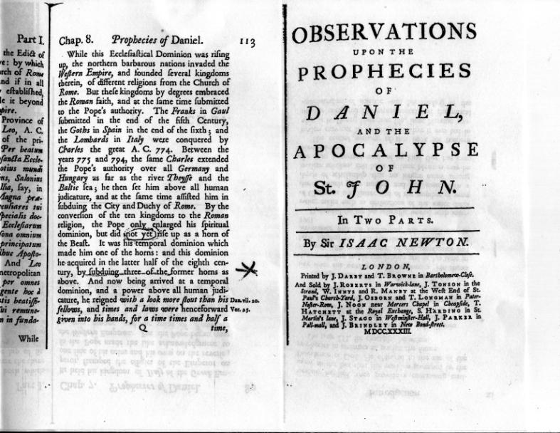

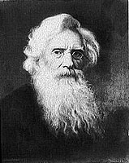
Samuel Morse
Notice what Samuel Morse the inventor of Morse Code
said about what the Protestants thought of the Papacy
in his book written under the sudo name BRUTUS;

Books in the times that this one was published were throughly researched by the publishers.
Not like today when so much fiction is on the shelves there is little room for books that have any real value, especially when it comes to religion.
Have you been to a book store lately, not a used book store but the kind like in malls etc.?
It’s hard to find even a Bible much less a non fiction rack if there is even one at all.
It’s a sign of the times more than just intentional however, because there is no demand for such anymore, or very little making it not worth the rack space.
Been to a record shop recentally, or I should say a music store, since records are about gone as well?
What dominates but “rap”, which in my opinion is not music at all, BUT, it is whats popular, “God forbid”, and about anyone can do it. All you need to do is talk dirty and fill the lines with sex and violence etc. and you got a hit, and this influence has filtered into about all artists works, leaving no room for decent music that has some value to society, and; we wonder why things are so bad nowdays, and our kids are lost in a world of fantasy and fiction and have no intrest in religion or even history.
Speaking of history; they are thinking about taking it out of the schools….Wow…. and putting more books on evolution, and of course human rights, abortion and homosexuality etc. I assume?
Notice date

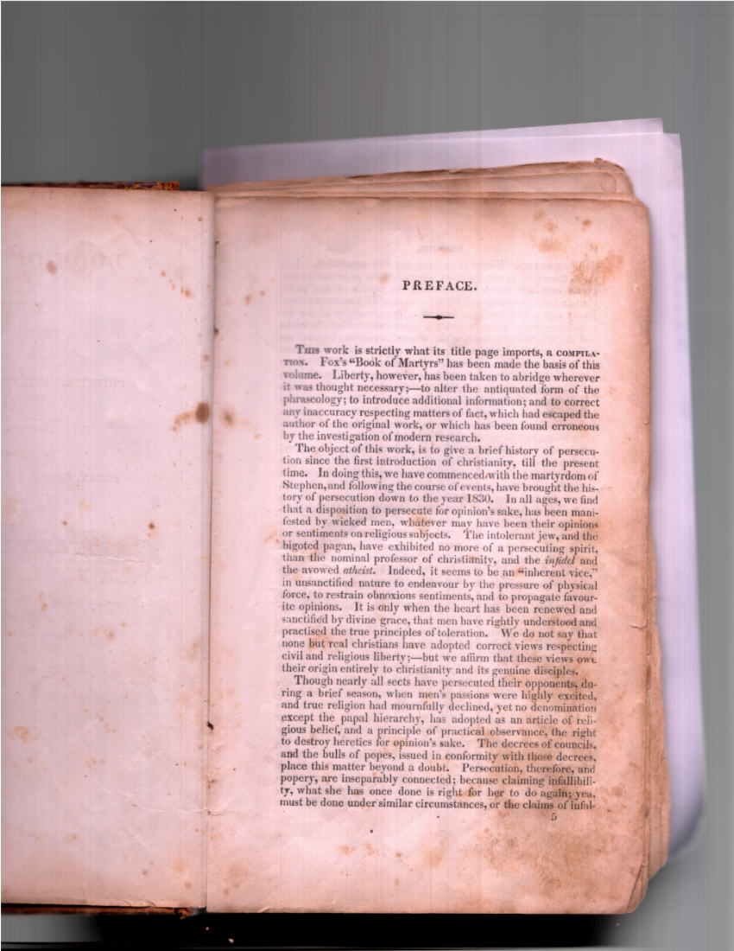

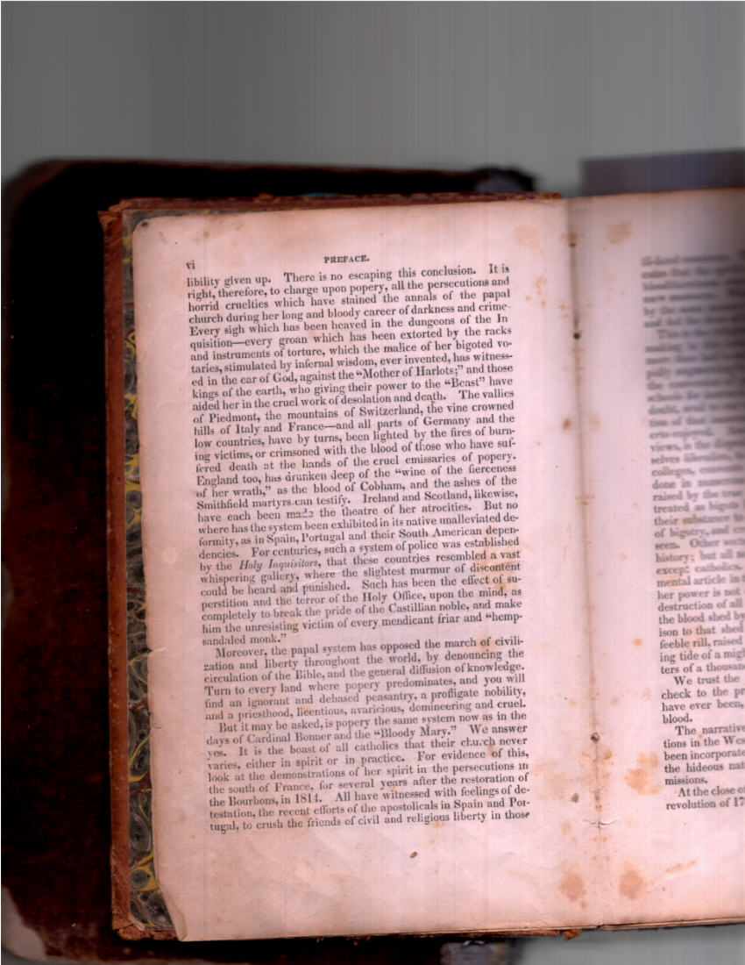

Statement and signed letter acknowledging this book was factual and that the major religions at that time agreed:
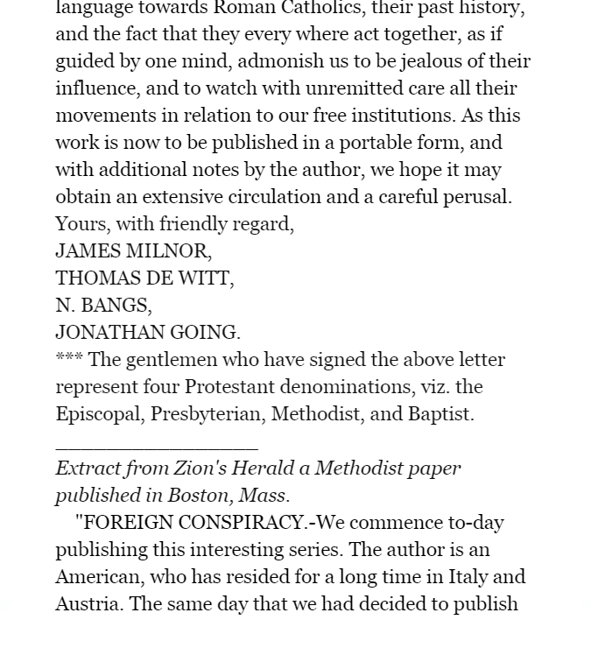
This clip shows what religions supported Morse’s claims taken from an Amazon clip of the above book (“look inside” their book for the list, and you might be surprised considering the pictures of them today or will be soon when it comes to religion. (Rev. 13:3).
WOUND HEALED
The Mother church was reinstated in France after they saw that banning religion altogether was a big mistake, yet they made another mistake in putting back into power the very culprit that influenced the revolution in the first place.
The wound didn’t become fully healed until 1929 as follows, and notice the newspapers caption and “how it reads is very significant!”
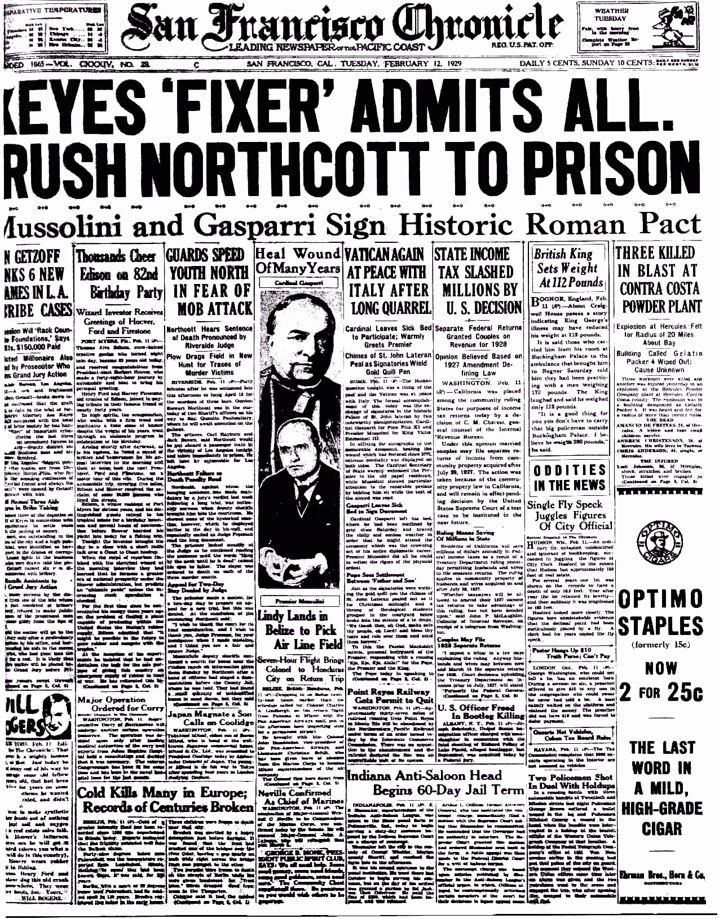
Odd way for the newspaper to title this historical event isn’t it?
Or, was it for future proof of the accuracy of Gods prophecy? See more on this here.
But the wound healed just as God proclaimed in the “Scripture of Truth” right?
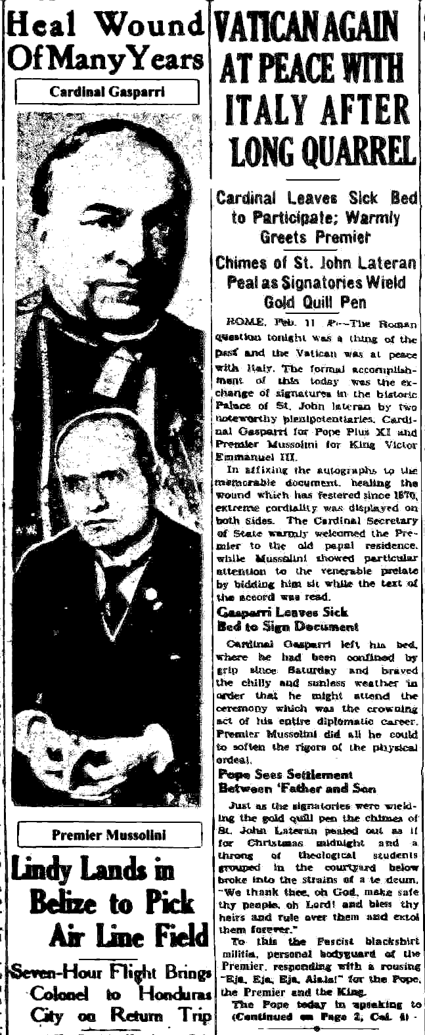

Using the Bibles very words!!
Mussolini pardoning the Papacy;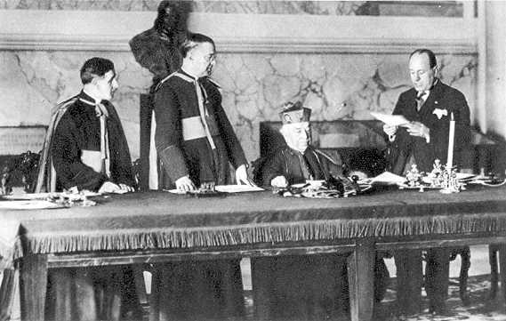
Mussolini pardoning the Papasy for Frances actions, and who was Mussolini? Hitlers right hand man? Makes you wonder who’s connected to who…or don’t we already know. This signing healed the wound and notice the pompous look on the Pope setting as the king he will become.
One things is for sure as a result of this study we are a whole lot more knowledgable now than we were before. What we do with it only God can forsee, but always remember “He can” (see that is).
“Covet Prophecy” Paul said, and now we know why – don’t we?

POPES AUTHORITY/PROTESTANT COMPROMISE

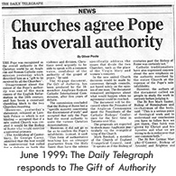

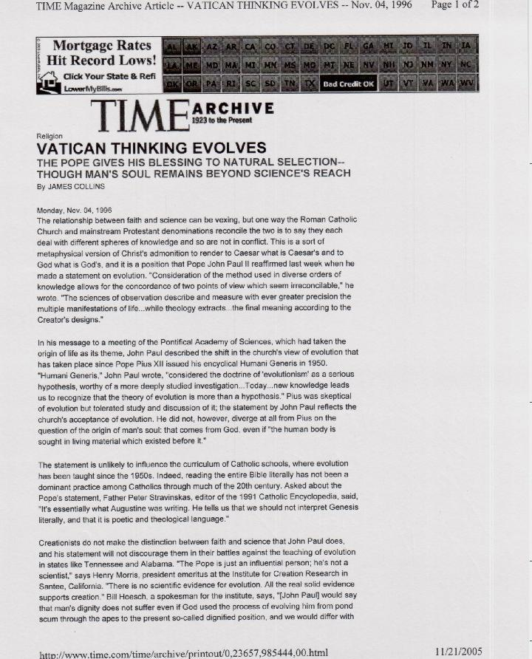
POPE ON EVOLUTION
1996
When I first began looking into how far the spread of this acceptance by all religions today has gone. I contacted the lady in the forefront of the adoption of this as far as Protestantism was concerned. She told me unarguably “all of them” (talking mainstream and of course evangelicals) have accepted that God used evolution in some form or another (i.e. Micro/Macro) in creation, despite the Bibles clear context and language?

Genesis 1:26-27 (KJV)
²⁶ And God said, Let us make man in our image, after our likeness: and let them have dominion over the fish of the sea, and over the fowl of the air, and over the cattle, and over all the earth, and over every creeping thing that creepeth upon the earth.
²⁷ So God created man in his own image, in the image of God created he him; male and female created he them.

I think that is emphatic enough!

I’m sure He was looking forward to our time as did Paul;

Romans 1:18-23 King James Version (KJV)
¹⁸ For the wrath of God is revealed from heaven against all ungodliness and unrighteousness of men, who hold the truth in unrighteousness;
¹⁹ Because that which may be known of God is manifest in them; for God hath shewed it unto them.
²⁰ For the invisible things of him from the creation of the world are clearly seen, being understood by the things that are made, even his eternal power and Godhead; so that they are without excuse:
²¹ Because that, when they knew God, they glorified him not as God, neither were thankful; but became vain in their imaginations, and their foolish heart was darkened.
²² Professing themselves to be wise, they became fools,
²³ And changed the glory of the uncorruptible God into an image made like to corruptible man, and to birds, and fourfooted beasts, and creeping things.
FIFTY YEARS IN THE CHURCH OF ROME

In short; this book, compiled by a former priest in the mother church, speaks of how Lincoln won a law suit between him and the church making Lincoln, who was his lawyer before he became president, become her arch enemy, and he tells of the warnings that she was out to get him from his inside information, as well as the very same warnings Samuel Morse who was in Rome had also overheard.

My book on Lincoln goes into extreme detail that makes it the undeniable truth with his accounts and Lincoln’s own acknowledgment of his possible fate, coupled with the surrounding evidence leading up to his assa-sin-ation, leaves no doubt of these truths, BUT, getting anyone to take it from the halls of Conspiracy theory to facts is impossible, but, hopefully you can see it’s just another “Big mark” against her, or is it? You decide.

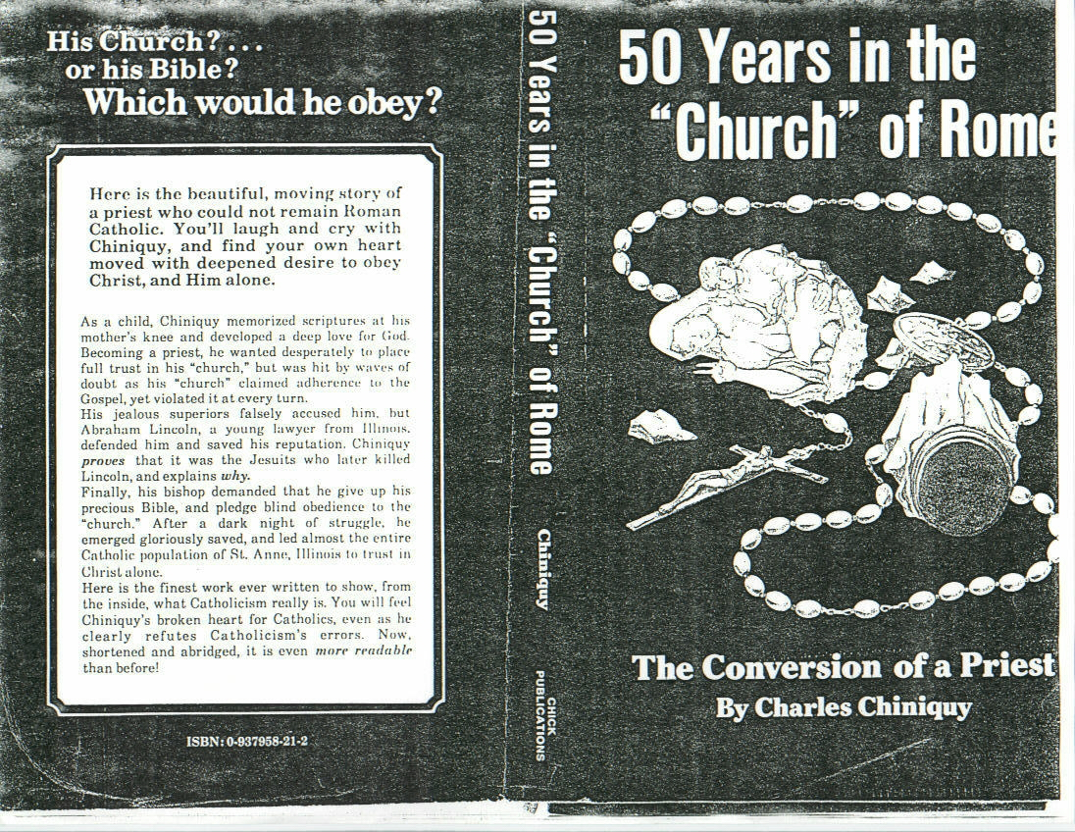
MARK

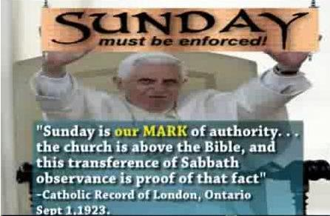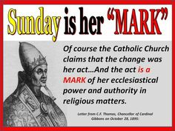
Someone said well that was stated a long time ago, but, they don’t know that once a pope makes an edict like this it can’t be reversed or they would break their “infallible” link from Peter ahead, which, by the way infallibility is still their claim remember “Rome’s Challenge” below.

It is amazing to me how she has fooled herself in using this term to describe her authority to alter Gods Covenant, but then again, she isn’t worried that people, even religious people up to their masters of divinity, will fit the puzzle pieces of prophecy together to know about the real Mark “the real God of authority” gave her, as the one who would think to change times and laws, of course, no one save God could change (Psalms 89:34) His Covenant sealed by the blood of Jesus. (Hebrews 10:19 in context) So, she would think to change times and laws. (Daniel 7:24-25) In the end though, the whole world of religion will accept her authority without question, and even the nonreligious will abide by her wisdom so called and power of influence. (See “Convinced” this site)

What does the Papacy have to say about “their right” to kill over 100,000,000 protestants during the dark ages way back their in their beginings of power;
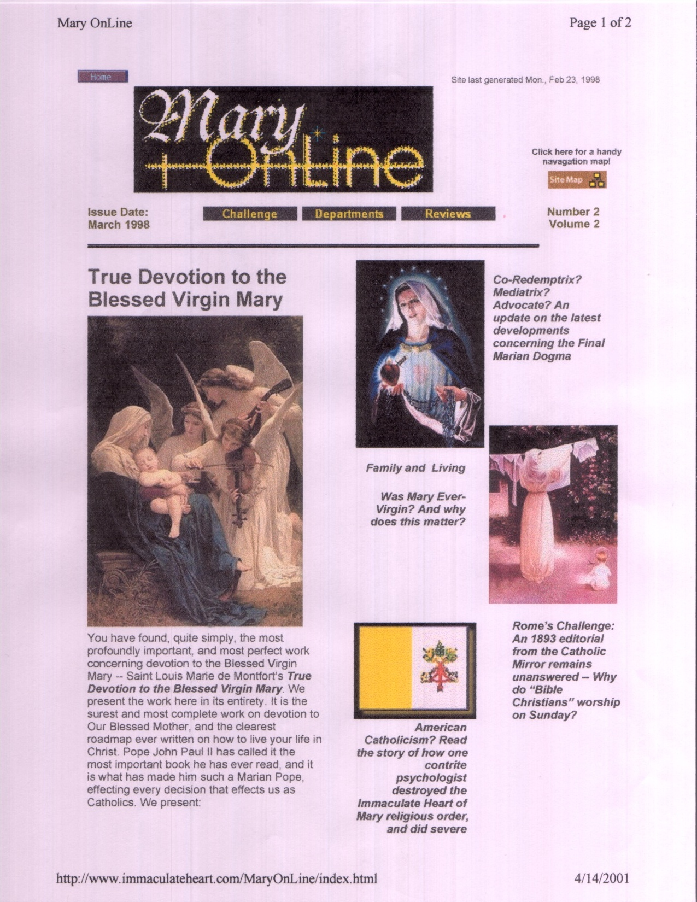
PAGES 12, 13
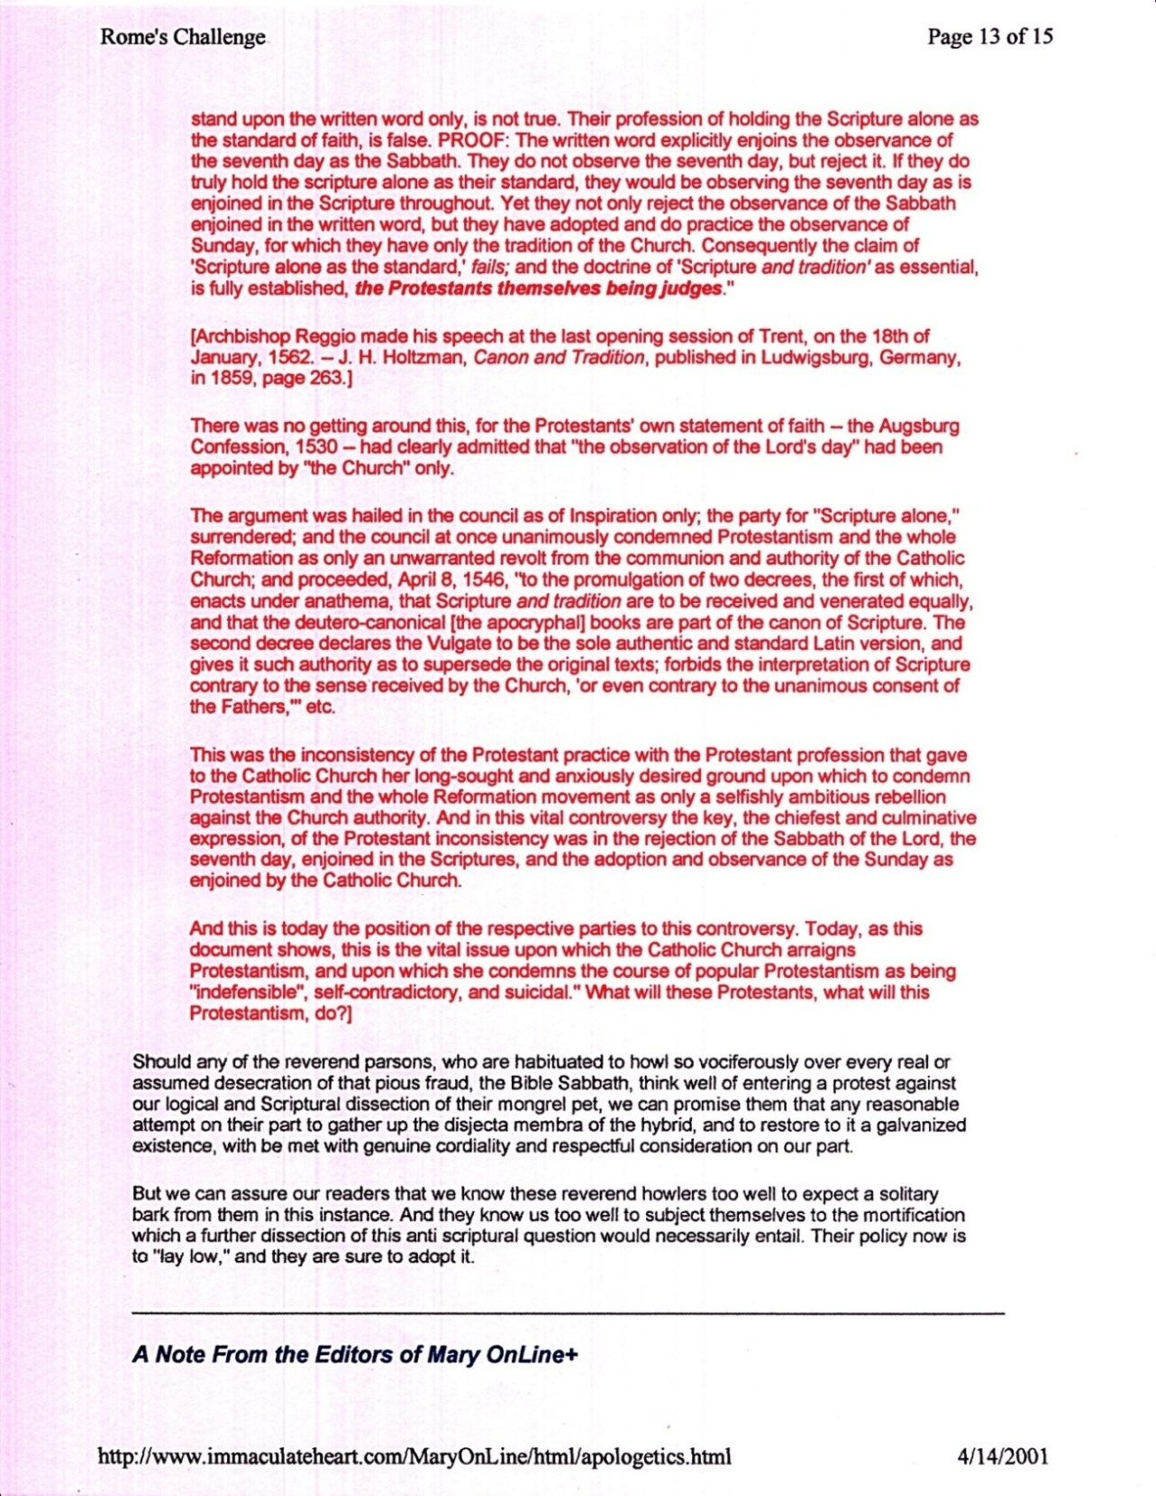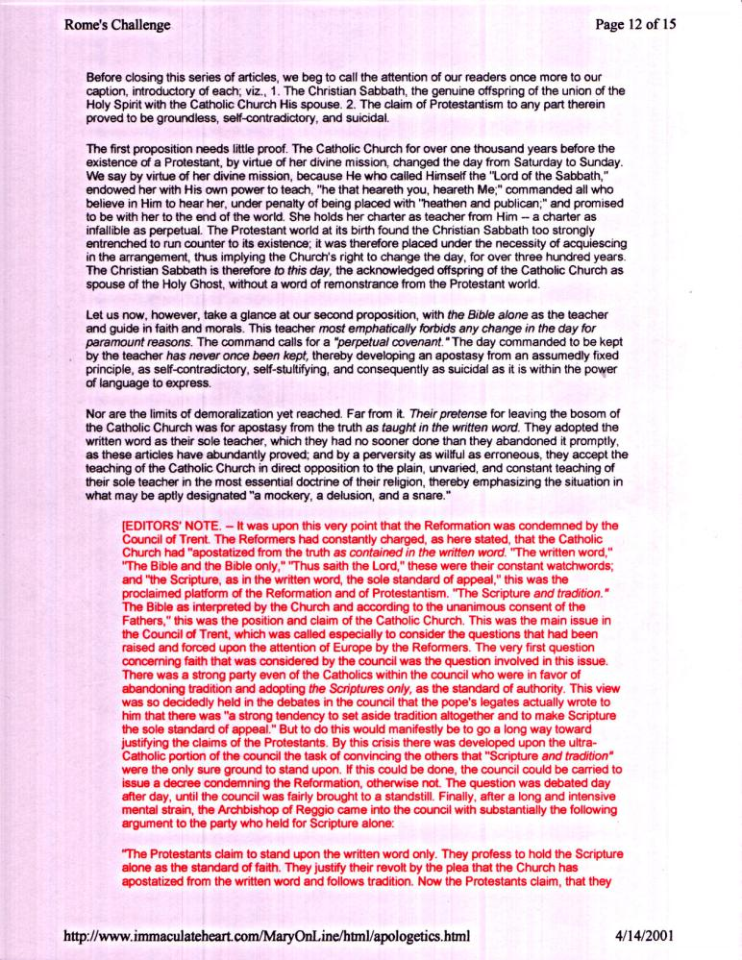

What does the Papacy say about the chage of the Sabbath? 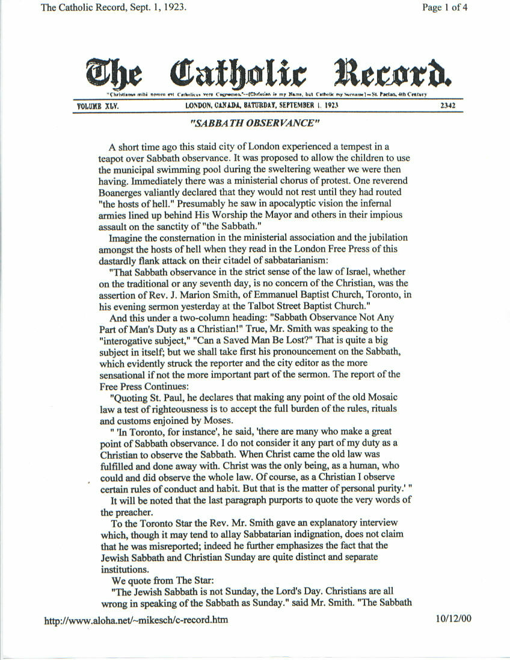

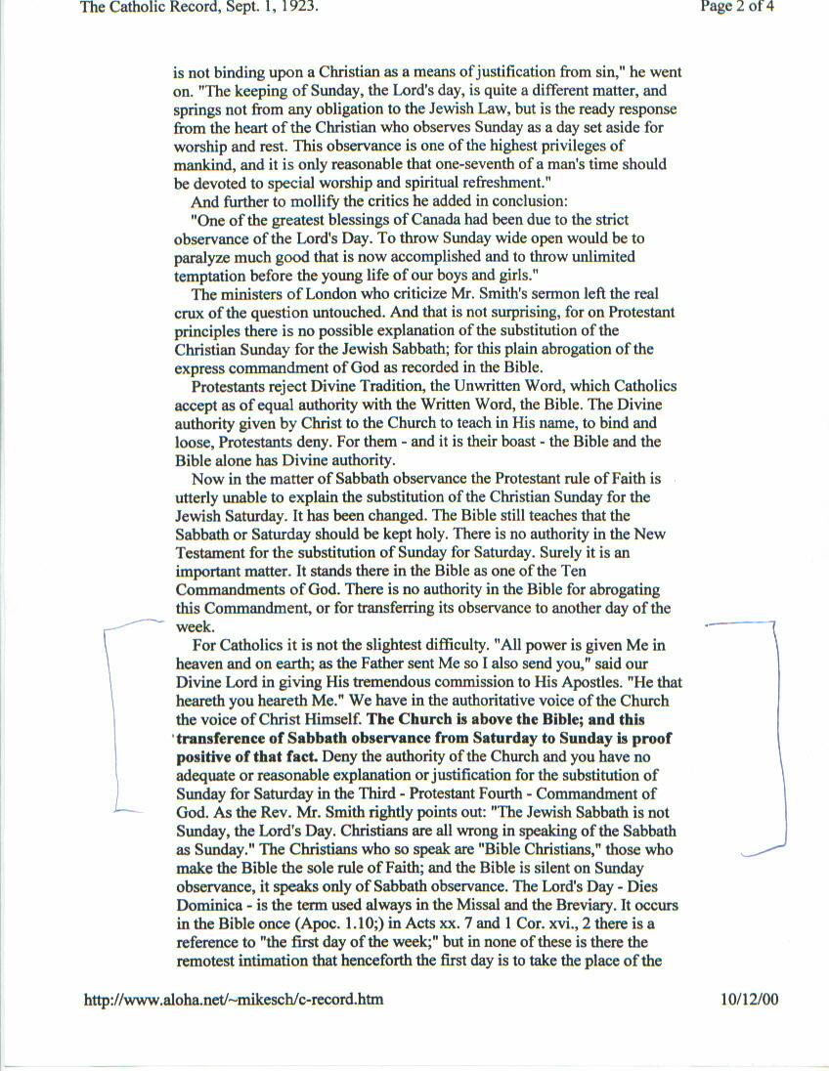

See www.mosescats.com “French Revolution” compilations from “the Great Controversy” White.
See “CONVINCED” book this site.
When the Pope died in 2005, Billy Graham said in a statement; “Pope John Paul II was unquestionably the most influential voice for morality and peace in the world during the last 100 years…” See Appendix “Popes Authority”
The fullness of the three spirits (three major religions of the world? I’ll let you surmise) will not come to fruition until the end of world and the second coming as text refers, but, all the individual decisions of the people (churches, synagogues, temples etc. of all the religions of the world) will have been made by then, by all of those who group in with the beast, and according to prophecy, who have been sealed/marked by them, a change of mind will be impossible for them then. Even when she is exposed as having led them into eternal loss and their eyes are finally opened, but, it’s too late then to change. That’s why God is warning us now of her power to deceive, so we will not follow her and her unified religious world into eternal loss.
The second church Christ appointed, under the guidance of the 12 Apostles/Disciples, being the churches they set up throughout Mesopotamia, but we know they had problems, we know that when we read Paul’s writings and, each time he returned back to check on them from time to time tells that story. (Even God reminded us in Revelations) But, as time went on they grew further and further away from Christs example, testimony and message, (See Same Message this site) these being the prime things God commissioned His people with in preparing the church for His second coming, and warning them of the prophetic things that would come against them, in Satan’s attempt to thwart Gods plan for mankind’s salvation. (See “The Church” and “Message to the Church” this site)
I love the arguments and attempts to justify their breaching of Gods Covenant by saying; well, the synagogues were the only place of worship so that’s what He used, but, they forget the time when Paul wanted to worship and no synagogues were available, and the “day” He chose to do so as the example for the Gentiles, as was His custom obviously was “as well”. (Acts 16:13) It would have been prudent for Paul at that point to have instigated a change of Gods Covenant then to the Gentiles, with a change of venues and a change coming of Gods Law, but He didn’t, it wasn’t even in his mind to do so. (Romans 7:25) thus, he even brought them in, teaching and praying on Gods created worship day, our custom , (Acts 13:42) and Gods unchangeable custom.
Most of Paul’s writings have been misinterpreted today, through not only paraphrased versions of the Bible but by Biblical ignorance as Peter was inspired to write. I believe as a warning of such. (II Peter 3:15-16)
Forgetting all the protestant arguments and why they have forgotten to remember, or have chosen to do so despite the clear Biblical truths from Gods past, (Exodus 20:8-10, Deut. 5:12, Leviticus 19:30, Leviticus 23:3, Exodus 31:13, Mark 2:27-28) and they have forgotten even Jesus’s plea to them in; “if you love me”. (John 14:15) Just ask yourself; “if it doesn’t matter what day one worships on, (misinterpreting Paul’s meaning in Colossians 2:16, II Peter 3:15-16) If any day will do then “Why not choose Gods worship day? You remember the extra day He made at creation. (another reason to forget it, it defies their new evolutionary ideas-beast influenced) A day He set in time itself long before there was even a church, or sin for that matter? Satan of course wants you to go with his day not Gods, and God made that act of the beast “one of His warnings” of what that power would do someday long before she did it and the religious world bought into it. (Daniel 7:25-26) The picture is clear what is what, and who is who when it comes to worshiping God or the Beast, and so are His warnings His judgments. (Rev. 14:9-12)
See “Foxes Book of Martyrs”.
See Appendix for excerpts from the book “Fifty years in the Church of Rome” more in the “Lincoln” reference.
Yes, one has to fit the puzzle pieces together to get to the truth but, it’s out there for all honest Christians who are searching for the truth to discover. Yet, who takes the time to search for the pearl of great price nowadays? They just cater to the traditions of their religion and don’t make waves, “it’s easier that way” and really, they say; “what difference does it make”, forgetting that the Ten Commandments is the Covenant that will judge them in the end. (James 2:12 in context) They forget, or have never considered; while they are alive the door to repentance is still open, it’s the only time they can either keep it or break it, it’s that black and white, but, they have been deceived by what the beasts influenced religions has to offer today, keeping the truths from them that point them out as sinners against Gods law. (I John 3:4) But they forget God is watching them, waiting with all the power of heaven to do good through them, and for them to change, so that He doesn’t have to strengthen their delusions and deceptions sealing then in their own chosen demise despite His warnings, (II Thessalonians 2:8-12) and, it all focuses around truth! So wake up if you see yourself in this group of those who believe mans lies “who will not have any right to the tree of life” less they recommit themselves while there is still time. (Rev. 22:14-15) God says this, not me, But, “I believe”.
He didn’t get all the pieces but he got enough to know who the beast was and would be. (See Appendix)
Don’t get me wrong Jill, (as today I learned you are down on your back as I’m editing this piece) I’m still a registered Democrat, but, since Obama, who I voted for, moved towards their old ways (in reverse) and towards SOCIALISM, I’ve stepped up my allegiance for other more eligible candidates, yet, I know the SOP says it will be the Republicans who bring forward the last events, however, as it stands today; I can’t agree with most of the Democratic moral standings and behaviors, not meaning to Trump the issue, just giving my opinion to get it off my chest.
See “Mark” Appendix.
When the Latter Rain, the same as the former Rain, will once again be heralded around the world for the last time; “through the same prophecies”, the gospel, of the unchanged “Same Message” (This site) is given “Loudly”, then will the end come. So, as we see these events unfold (See “Convinced”) we must take heed and think of former times when we felt a Godly closeness in our minds and hearts, and seek His loving protection and caring once again, from those predicted end time events.
Religions that claim to be from Abrahamic descent but have not the faith and obedience to Gods Covenant that proves their real spirit and enlightenment. (Isaiah 8:19-20) The remaining religions will just follow what seems to be for the good of mankind not knowing, why they are following, is really the preamble of the last plagues that God will send to seal up His people and bring things to a close, (Rev. 7:3) but first His warnings, and now they may be His last for us here with the end of time at our doorstep!
Newton was the founder of higher mathematics, optics, an inventor, religious scholar and predecessor of Einstein.
In Matthew 24 Jesus gave us a glimpse of what the end times would be like, but also, He referred us to the past Vs. 15) and warned us to know and understand these things we are studying about prophecy, and that He gave this message back then to Daniel and then again to John and subsequently to us (Revelations) as warnings for our preparation for the end times. When; even the elect vs. 24 could be deceived, and how deceptions and false prophets will try to sway us from the truth and how the beast will in the end deceive all the world, of religion in particular, and Paul tells us that God Himself will let us have our own ways and beliefs and even enforce the deception since it’s our final choice and they never will accept the truth. (II Thessalonians 2)
Rev. 19:10.
For a larger picture of those unbelievable times very few hav e seen BUT should see. (See www.mosescats.com “Lincoln”)

