THE CHURCH
An historical perspective and study….

INTRODUCTION

Before one can know about the house of God on earth called the church, mosque, parish, sanctuary, synagogue, temple, tabernacle etc. etc. they must first know about ”Gods church” from conception to today, and that taken only from the oldest source of Godly information “the Bible only”, that is, to fully understand the mission that the church has been given, and then, and only then, will we know the whole story.

Knowing historical church founders and figures, organizational trials and errors, different authors opinions, Greek etc. plays little into the picture if we don’t first see the reason why the church, any church, was called by God, and then, what makes the “one” church God has called unique among all the others in context of the 1000’s of denominations out there, and yes, we need to see this on an historical level, and a universal level as well.

But also, and possibly more important, we need to see this in relation to “religion in general”, and that means, baring none humanity has come up with relative to Gods; helping us then to understand and accept, that there could only have been “one church of God” –“at any given time” throughout history, including today, thusly, only “one can stand alone” that was called by Gods commission, or, “God would be divided”, do you see that? Which we know He cannot be to be a just, unchangeable single minded God as He has shown us He is, thus, it’s “His commission” for the church that makes the ultimate difference.

Of course for God to commission a church doesn’t make that church, or any church for that matter, “the ends to the means” as we witnessed in Israel, Gods first church as it were.

It was only when His church, in “all its ages”, fulfilled His will, “Gods will for mankind - and for mankind”, did it (does it the church) then become special, unique, and; since it’s people who make up a church, unless they become special “individually as well as collectively (we are talking committed here not perfection)”, but unless that church, no matter what it’s called, no matter what its mission or commission was, unless they/the church commits to the Will of God “it too will fail in the end – “as the church” “as the people”, “as the people as the church”.

Each time Paul came back to a church, there in the Holy land times, the ones that he had established, what was their condition?

Degraded, compromised- etc.

We see also heavens analysis of the church (being the people), over the ages past Pentecost, in the messages to the churches the Lord gave in Revelation, named after those Paul and the others established, symbolizing and prophetically reflecting the ages of the churches to come. Thereby we see their condition both good and bad, from “the Lord Gods point of view”, and we see specifically too; “their call in Gods desires for them to fulfill His will”, and ours as well.

GO TO STUDY (1)

THE CHURCH

To know the history of the church, any church, and miss its direct implications to our personal call from God united with others who share that same call, we must come to understand that; “we individually and corporately” must follow up on that call, and only then, the church will fulfill its purpose, and so then will we;

Defining the statement:

Matthew 22:
¹⁴ For many are called, but few are chosen.

Is it Gods fault that we are not chosen, as a church as a people?

Think about it….

I labor on this point because we could spend a whole year on this subject and end up with just a history lesson, but miss the underlying purpose for this study and that is; “how it relates to us” as Gods chosen, called personally by Him as the above text alludes.

This then is the challenge for us to discover the answers - “ourselves” - to this question, and when we have, it is then, and only then, we will see the true church of Gods calling, its mission, and our place in it.

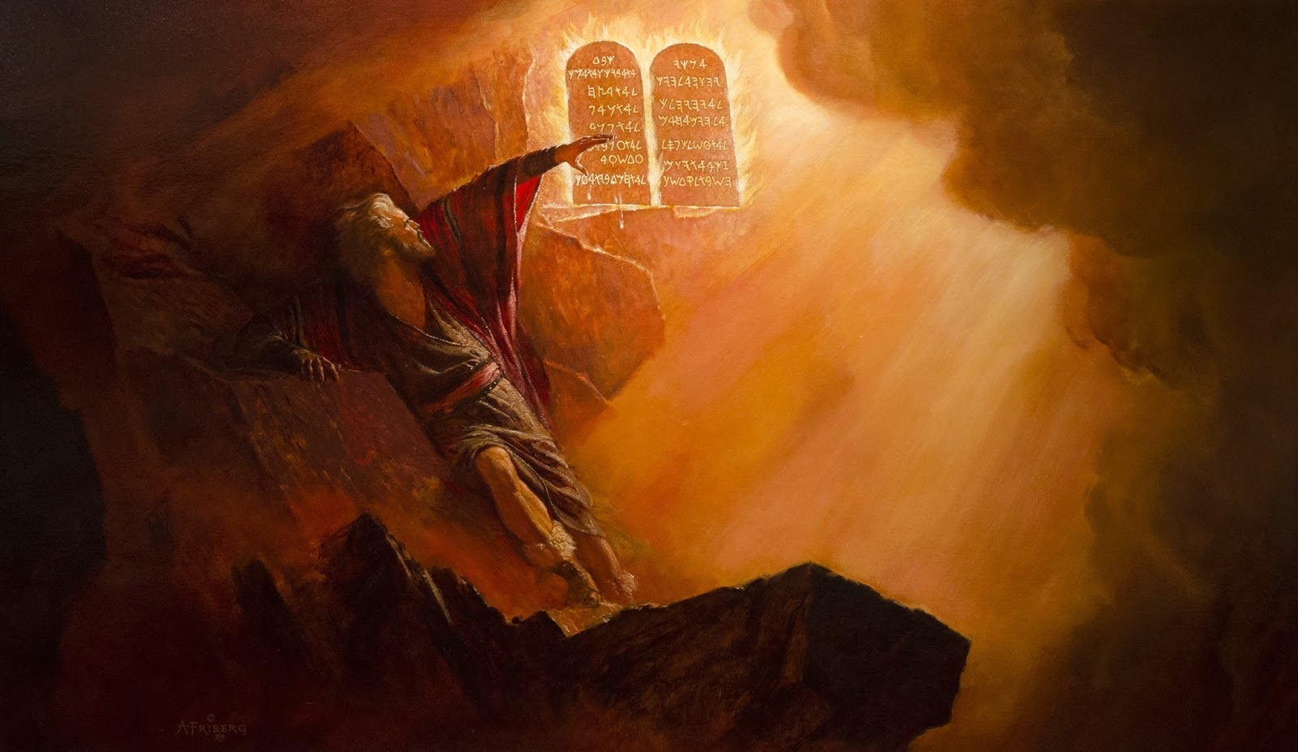

FIRST CHURCH - PERSPECTIVE ONE

When God called “His first church”, as it were, out of Egypt and made His Covenant clear and binding on two tables of stone. The people united under His call for a moment in time, and mostly because of having seen the evidence of His awesome reality, the many miracles and plagues that only the “One God” could have accomplished to gain their release from Egypt.

So at the base of Mount Sini; “who could have blamed them for believing and accepting His commands, “in the heat of the moment” from “the literal fire of God’s presence created there on the mountain top”, a site that would be enough to cause anyone to come to reality, at least for a moment, as it did Israel.
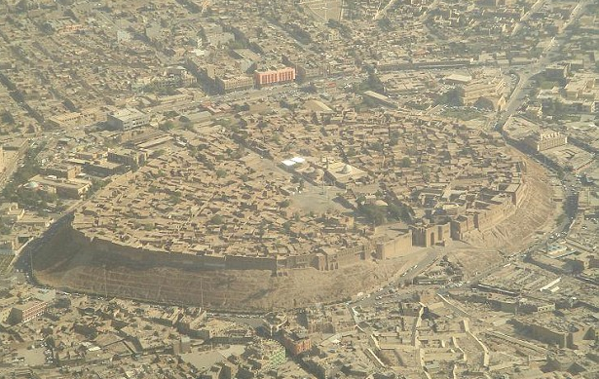
ANCIENT NINVEVH AS IT STILL STANDS TODAY… if ISIS hasn’t destroyed it that is?

Just as Jonah’s Nineveh, that ancient city who woke up one day to “Gods reality”, with the realization that “the One God, of their history past, who sent the greatest of all of the events of their history “the flood”, was now at their doorstep and calling on them.

They remembered the famous tall “tower of Babel” God destroyed shortly after the flood, so they obviously went to their library where their history was inscribed on stones and parchments telling of the realities of their past, and there they found the account of the cities of Sodom and Gomorrah; that world famous event that the “One God utterly destroyed with fire from heaven”, and now, He was singling Nineveh out, singling it’s people out.

So, finding themselves under “the threat of annihilation” the people, including the king of that ancient city, searched out “the records of their recorded past”, finding, maybe rediscovering, all those accounts of Gods dealings in the past, and obviously then they took the threat as real, because, they all united themselves together for God and restrained His wrath. Just as Israel did some 700 years previously (1450BC) when all of them claiming to “commit” to Gods will for them under the fires of Sini, so did the city of Nineveh (750BC), and, that ancient city (unless ISIS has completely destroyed it) is still on the map today, some 2800 years later from Jonah’s time, same walls, same city, documented by Gods word as well as the contemporaneous authors as “a witness, as examples of the reality of the God of Creation?”

So it was, the people of Israel promised obedience to His will when God spoke those words from the mount, maybe out of fear as Nineveh, maybe not.

Let’s analyze Israel’s conundrum for a minuet;

The children (people-church) of Israel weren’t being threatened by destruction like Nineveh, and, the God who gave them their freedom from Egyptian bondage, was only requiring of them “Ten simple things” that they had to do, which were a different form of life or death by His word and promise. (Deut. 30:19) So they may have rationalized; that all of those ten were really logical and seemingly easy to do, so, why wouldn’t anyone conclude and say; “sure Father I will do your will”?

Of course then, that’s how they responded?

Notice;

Exodus 19:
¹In the third month, when the children of Israel were gone forth out of the land of Egypt, the same day came they into the wilderness of Sinai.
² For they were departed from Rephidim, and were come to the desert of Sinai, and had pitched in the wilderness; and there Israel camped before the mount.
³ And Moses went up unto God, and the Lord called unto him out of the mountain, saying, Thus shalt thou say to the house of Jacob, and tell the children of Israel;
⁴ Ye have seen what I did unto the Egyptians, and how I bare you on eagles' wings, and brought you unto myself.
⁵ Now therefore, if ye will obey my voice indeed, and keep my covenant, then ye shall be a peculiar treasure unto me above all people: for all the earth is mine:
⁶ And ye shall be unto me a kingdom of priests, and an holy nation. These are the words which thou shalt speak unto the children of Israel.
⁷ And Moses came and called for the elders of the people, and laid before their faces all these words which the Lord commanded him.
⁸ And all the people answered together, and said, All that the Lord hath spoken we will do. And Moses returned the words of the people unto the Lord.
⁹ And the Lord said unto Moses, Lo, I come unto thee in a thick cloud, that the people may hear when I speak with thee, and believe thee for ever.

How long did God hope their promise would last?

“Wasn’t it that they would believe Him– for ever?”

Don’t you think that God looking ahead knew how long that pledge would last, and don’t you think that He knew their hearts, and that it was fear that drove their promise to live for Him?

The fear of the Lord is clean right?

As a motive used by God, but, not any man who does not have that prerogative of course, as some have used in the past?

We need to discuss and study this from His word.

GO TO STUDY (2)

FIRST CHURCH - PERSPECTIVE TWO

The experience of God speaking from the fires on Mount at Sini, was one I’m sure the church passed down forever, as were the events of the flood, Sodom and Gomorrah etc. (See www.theuniversalreligion.com “But-What if the Bible is True”)
CREATION TABLETS FLOOD TABLETS SODOM & GOMORRAH
All of these same type of records were known to Nineveh in those days. On stones, now only found in the back rooms of the national libraries, hardly even known to exist, even by the clergy much less their churches.

Yes, I’m sure account of those acts of God in mankind’s behalf were passed down for many generations, oh wait, till now!

(See www.theuniversalreligion.com “Dead Sea Scrolls” for Biblical conformation)

Will we pass them on, or, aren’t these things important enough that we; as most nominal churches today say, openly if not in their hierarchy; “those things are just myths and have been proven so by science, and they were only made up stories, allegories to arouse our “fear” (man’s use of the word).

Sure, kind of like the doctrine of “Hell” was invented, for purposes of fear during the Dark Ages to force people to invest in the mother churches demands under terms of life or death “literally” in torture chambers or after death for release from purgatory, but, were not like the real fears “God established” being denied today of death in breaching His Covenant.

Their “made up fears” are the wrong kind of fears that God has nothing to do with, and “their religious creeds” are the real myths, and not even kin in any way to His purposes in showing those examples of the past for “our benefit”, and certainly not to arouse some kind of irrational response, “for all of His (Gods) acts are positive are they not?”

GO TO STUDY (3)

OBIEDIENCE AND THE CHURCH

Exodus 19:
⁴ Ye have seen what I did unto the Egyptians, and how I bare you on eagles' wings, and brought you unto myself.
⁵ Now therefore, if ye will obey my voice indeed, and keep my covenant, then ye shall be a peculiar treasure unto me above all people: for all the earth is mine: ⁶ And ye shall be unto me a kingdom of priests, and an holy nation. These are the words which thou shalt speak unto the children of Israel.
⁷ And Moses came and called for the elders of the people, and laid before their faces all these words which the Lord commanded him.
⁸ And all the people answered together, and said, All that the Lord hath spoken we will do. And Moses returned the words of the people unto the Lord. ⁹ And the Lord said unto Moses, Lo, I come unto thee in a thick cloud, that the people may hear when I speak with thee, and believe thee for ever.

What did verse 5 above say?

“If ye will obey my voice indeed, and keep my covenant”, then, what?

Then, “ye shall be a peculiar treasure unto me above all people”:

This is a message directly to the church in all ages, as well as us individually, just as it was for those back then, being the up and coming “first church” of God.

Verse 8 tells us what the response of the people was, when God Spoke those words to Moses on the mount “as He was etching them in stone”, and we read that He spoke them aloud (vs. 9) so they could hear Him and know it was Him speaking, and even afterword, when Moses reiterated the Covenant to the people, what was their continued response again?

“All that the Lord hath spoken we will do”

This brings us to the first church that was started their at the base of the Mount, called by God, trained in Gods will thru His commands, led by God, given the wisdom and knowledge of God thru His Covenant, being the same church who was commissioned by God “to usher in the promised Messiah”, “in a time and year predicted by God” (Daniel 9:24), but when He came to earth what had happened to the church?

They were not prepared, not ready, and worse, they had been deceived by their leaders and false prophecy.

They didn’t even recognize the “living Covenant” standing before them (the Covenant is also called a testimony Exodus 25:16, which of course was Gods Ten Commandments being lived out, (Romans 2:13-14, 8:4, John 14:10-11) being the Testimony of its fulfillment through the Messiah, and as a result they killed him (John 10:31-33-), and thus they were rejected by God, “as Gods church and people”(Matthew 23:37-38);

Matthew 23:
³⁴ Wherefore, behold, I send unto you prophets, and wise men, and scribes: and some of them ye shall kill and crucify; and some of them shall ye scourge in your synagogues, and persecute them from city to city:
³⁵ That upon you may come all the righteous blood shed upon the earth, from the blood of righteous Abel unto the blood of Zacharias son of Barachias, whom ye slew between the temple and the altar.
³⁶ Verily I say unto you, All these things shall come upon this generation.
³⁷ O Jerusalem, Jerusalem, thou that killest the prophets, and stonest them which are sent unto thee, how often would I have gathered thy children together, even as a hen gathereth her chickens under her wings, and ye would not!
³⁸ Behold, your house is left unto you desolate.

Rejected despite His desire for the church and the people following it, “they did not do what they said they would do” as a people, as a church, way back there in their beginnings at Sini, and then, even when reminded through the prophecy in Daniels time as he pleaded for his people knowing their condition and what it should be, (Daniel 9) as he was more than aware of the churches condition having seen Gods city destroyed for lack of doing, and now he was a refuge in a foreign city captive.

Notice Daniels plea to God, and Gods response, as well as His commission for the church heretofore, when their captivity ended and Gods church restored to usher in the Messiah, as well as Gods demands “being the same as He gave Israel”, notice;

Daniel 9:
¹⁰ Neither have we obeyed the voice of the Lord our God, to walk in his laws, which he set before us by his servants the prophets……
²¹ Yea, whiles I was speaking in prayer, even the man Gabriel, whom I had seen in the vision at the beginning, being caused to fly swiftly, touched me about the time of the evening oblation.
²² And he informed me, and talked with me, and said, O Daniel, I am now come forth to give thee skill and understanding.
²³ At the beginning of thy supplications the commandment came forth, and I am come to shew thee; for thou art greatly beloved: therefore understand the matter,
and consider the vision.[Daniel 8:13-14]
²⁴ Seventy weeks are determined upon thy people and upon thy holy city, to finish the transgression,[I John 3:4-7, I John 2:1-7, I John 3:1-4] and to make an end of sins, and to make reconciliation for iniquity, and to bring in everlasting righteousness, and to seal up the vision and prophecy, and to anoint the most Holy.

Did Gods Covenant, being His Ten Commandments, the ones in the “Ark of the Covenant” the tables of stone, which were, and still are the Covenant Christ lived out without breaking one (His Testimony), and then He sealed for all time the Covenant with His blood in death.

“Did that Covenant fail” as the churches out there now unanimously today claim?

Or did the people, who made up the church - fail?

Hebrews 8:
⁸ For finding fault with them, he saith, Behold, the days come, saith the Lord, when I will make a new covenant with the house of Israel and with the house of Judah:
⁹ Not according to the covenant that I made with their fathers in the day when I took them by the hand to lead them out of the land of Egypt; because they continued not in my covenant, and I regarded them not, saith the Lord.
¹⁰ For this is the covenant that I will make with the house of Israel after those days, saith the Lord; I will put my laws into their mind, and write them in their hearts: and I will be to them a God, and they shall be to me a people:
¹¹ And they shall not teach every man his neighbour, and every man his brother, saying, Know the Lord: for all shall know me, from the least to the greatest.

Hebrews 9:13-24, 10:9-10, ¹⁵ Whereof the Holy Ghost also is a witness to us: for after that he had said before,
¹⁶ This is the covenant that I will make with them after those days, saith the Lord, I will put my laws into their hearts, and in their minds will I write them;

All this was known through prophecy from back in Isaiah and Jeremiah’s time, so we must ask; “how did the first church miss it, and doubly so, how does the church/churches miss it today?”

GO TO STUDY (4)

FIRST CHURCH - RETROSPECTIVE:

God looked ahead and knew that His church would continue to fail even after seeing those graphic examples sealed by the sacrifices; the chief of which “the one that represented His Sons death by the shed blood in their behalf, all so they could get the picture” of how it all was working in accordance to His (Gods) plan of salvation, for mankind.

But they didn’t get the connection, the symbolisms, and they not only failed to fulfill the first Covenant when they said “anything you say we will do” but “then didn’t”, and, they took the next obvious step, they went one step further and killed the Covenant bearer.

So God said ok, now that the Savior has come as predicted “as the one and only acceptable sacrifice for sin by His blood”, and by His death the Law has been sealed, and my Covenant, the church has “outwardly” failed to keep, because of their weakness over the power of sin.

I’m now going to make it even more personal with them, now that the Son has gone back to heaven, and now for the second church He has raised while on earth;

I myself He says; “through the power of the Holy Spirit”, I will personally place those Laws in their minds and hearts will I write them, so it will be easier for them to obey me and sin no more, and as John said; this is nothing new, in context (I John 3:4-11) …this is the same message ye heard from the beginning…., but now, it will be applied in a new way; since the ultimate example of this has been given (seen) thru the Sons life, and it has been seen as “the true relationship with the Father”, (which many in the past have had incidentally David etc. Psalms 40:8), but now, we “Christians - we followers of Christ” can share “this new Covenant” relationship personally with God and of course also through the church.

But! and this is the Big BUT, “the terms” of this “New Covenant relationship” are still valid today; “the Law” being the Testimony/Covenant/Ten Commandments, and friend, we are talking about the same law “the churches ‘today’ reject” yet, and get this now; while “all claiming to be under the New Covenant but, not under the law?” Isn’t this then “a rejection of the Savior as well?” (Romans 3:19)

Meaning the rejection of the Ten Commandments they claim not to be under, and this mainly because of “the fourth mandate (4th commandment)”, the least of the commandments (Matthew 5:19-20) it’s the only law that doesn’t even begin with a thou shalt not, “as if said in love (John 14:15-17)”, But they reject it all by breaking even the least (James 2:10), and, “in so doing”, not even realizing that they are breaking the New Covenant they claim to be keeping in their disobedience, and worse, if even possible and really is worse, they are “rejecting the Holy Spirit” who is trying to place Gods law in their hearts and minds, (Hebrews 8:10-12). Sin is iniquity, and rejection of the Holy Spirit is or can be the unforgivable sin. (Matthew 12:32)

Just as the first church “killed the Savior by their breaking of the Law of God” and replacing it with their own, (John 19:7) todays church is doing the same thing, by perverting and taking Gods name “Abba” out of Gods S-Abba-th worship day, and adding “Sun” to theirs, the object of all pagan religious worship since Cain.

So, by breaking the Law of God they are just the same as killing him as well, “because sin which is extreme Iniquity against God, as well as transgression or the breaking of His law, I John 3:4) and it requires blood for remittance, always has (Hebrews 9:22 the context Leviticus 17:11), and not just any blood “but the Saviors blood is required for atonement”, and that includes breaking any one of Gods Law (James 2:10-).

This puts a different perspective on this next text because; blatantly rejecting Gods forth Commandment is what willful sin is Biblically”, that is, knowing we are doing it but going ahead and doing it, and not just once in innocence, but weekly, premeditated and knowing better, despite Gods warnings galore throughout the whole Bible!

Hebrews 10:
²⁶ For if we sin wilfully [I John 3:4 remember] after that we have received the knowledge of the truth, there remaineth no more sacrifice for sins……

[He will not sacrifice Himself and shed His Holy blood for blatant willful sinners is the point, so what’s their reward?]

²⁷ But a certain fearful looking for of judgment and fiery indignation, which shall devour the adversaries……

[Message from the beginning to the church remember (I John 3:11) and listen; God cannot cast the judgment of death on them, as He did throughout history, and yet, let “today’s willful sinners pass”-no way! (Ezekiel 3:16-20)

For He is the same forever and ever and that’s what makes Him a fair and just God treating all of His creation the same under the same Laws of righteousness (Romans 3)] in all times!

²⁸ He that despised Moses' law died without mercy under two or three witnesses:…….

[Paul’s talking to the second church here, so this applies not only for the first church but for any church, anyone in any age, and friend, the unpopular truth is; “the more we know the more we are accountable for”, and today, we have got it all spelled out plainly “Gods Will for mankind” in both the Old and New “Testaments”, and; just because we haven’t read it is no excuse, and why?

Are we not claiming Christians and yet never read nor study His Word, words, to know who the next verse applies and when it will apply in our life to us?

Sure, Paul is talking about willful sinners, but, at some point in our life if we take Gods Word lightly we could be considered such, because truth “is” progressive “the more we learn the more we are responsible for”, and really “it’s others”, and not just ourselves, we are responsible for as well; Our call to duty is to get the message’s out to “all of them”, the warnings out to the whole world (Ezekiel 33:6-20, 20:11-20), and listen, the text we are reading above is “a warning that Paul is giving to all who take any scripture lightly because why?

We are all sinners, (I John 1:8-10) and, especially those who ignore willful sinning and go on and break Gods Covenant as if they can remain a Christian in doing so, and they say the following strong text doesn’t apply to them?]

²⁹ Of how much sorer punishment, suppose ye, shall he be thought worthy, who hath trodden under foot the Son of God, and hath counted the blood of the covenant, wherewith he was sanctified, an unholy thing, and hath done despite unto the Spirit of grace?
³⁰ For we know him that hath said, Vengeance belongeth unto me, I will recompense, saith the Lord. And again, The Lord shall judge his people.
³¹ It is a fearful thing to fall into the hands of the living God.

Is then; the church today “still failing to meet its calling”, despite the fear Ezekiel had first and then Paul is warning them/us with, a warning that is meant for their/our change, and being only one of the many warnings “they have also ignored”.

So the question we must ask ourselves is; “are we following after them” their church and not God, or worse ignoring God as did the first church?

GO TO STUDY (5)

The SECOND CHURCH – Submerging into the Dark Ages

Here is where we turn to prophecy for answers;

The second church, of whom the Messiah was the cornerstone, was built upon the same promises and Covenant as given to the first. (Matthew 5:14-20-)

Given through the many prophecies that confirmed them, “by their fulfillments”, fulfillments the prophets themselves would not see for they were, in most cases, way off in their future.

John saw this second church “in advance” as to what it was to be like, as described in the early chapters of Revelations, those messages sent back to the church by our Lord from our Father.

But as those prophecies compound, from chapter one, into further chapters of the Revelations, and, as we see those Prophecies “fulfilled” one by one, it becomes clear to anyone “who will take the time to do so”, we can see clearly; “what Gods church was to look like” as it faced its first great challenge, “the Dark Ages”.

Since the churches today have lost sight of Gods Covenant, they have also lost sight of His prophecies (Proverbs 29:18, 28:9 what is God trying to tell us?), and naturally they lost their sight “by perverting them” (the prophecies and law) which of course takes away Gods vision and worse we just read.

By doing this; the church doesn’t even realize her darkness, through her own deceptions and some God may have added. (II Thessalonians 2:11)

“We too, in our coming age, as the church, as the people called of God, we too are facing another Dark Age (Matthew 24:21), “Darker” than the one before, when, “even the elect, who have the knowledge of God, could be deceived away from the truth”, or “out of physical fear” switch sides when faced with death (Revelation 13:15), worst case, speaking of our time in the last days.

This was not the case for the true followers of God however; of the early second church during the first Dark Ages; “when they were faced with death”, during those long years (538-1798AD), the period to come as God predicted in 96AD to John, and even further back in Daniels time (605BC); John however recorded of those in that age; “how they would overcome fear (remember this was going to happen in Johns future); they would overcome sin and Satan and the fear of dying for God’s Word, even when faced with the loss of their life, by holding on to….…well let’s read it, it’s that important;

Revelation 12:
¹⁰ And I heard a loud voice saying in heaven, Now is come salvation, and strength, and the kingdom of our God, and the power of his Christ: for the accuser of our brethren is cast down, which accused them before our God day and night.
¹¹ And they overcame him by the blood of the Lamb, and by the word of their testimony; and they loved not their lives unto the death.

Does this sound vaguely familiar, and in any way, blood -Testimony?

The Lamb was slain (blood shed); for “His testimony in upholding, obeying, (whatever you want to call it, and He defined it best in John 14: as “works”), His testimony was “in living Gods Law to perfection for our example”, by living Gods Commandments (Covenant - Testimony)”.

The church (the people) of the dark ages believed the same way, they lived the same way (to their ability that is), and they not only gave their own blood “which of course was worthless” yet, “it counted in Gods site, right?”

Because of their testimony then; He hid them from their enemies, so that; “that testimony of Jesus”, being like Jesus, would not be wiped out. Thus, of course, this type obedience counts in Gods site, the Lords site, “as do the works of His WILL for all mankind”, past, present and future.

The fact is, God tells us of those who follow His Will even “by Works!” (Rev. 22:12-14), they are obviously worth rewarding to Him.

That true church, during that first Dark Age, maintained that testimony as a people, as a church, until such a time when God had to hide His “special people (church)” in the mountains.

Why?

History tells us, they were hidden away from “a persecuting power, a religion believe it or not”, the one that held power over “religion and politics” in those days, its history for the looking.

A persecuting church, that had gone wrong, just as did the Jews who as well sought to hush and end the Word of God by killing those prophetic messages and their bearers (Matthew 23:37).

This second false church in turn wanted to kill the message because they pointed straight at her (the church is represented by a woman “in prophecy” by the way Jeremiah 6:2), so she attempted to kill the message by burning Bible’s, and “men alike” (Read Foxes Martyr’s sometime of just a few of the 100’s of millions killed for staying true to Gods Covenant and testimony) and she obviously did so “as the prophecy said she would, its history.”

History that the Pope can’t deny, but today since the church has come in the news about the forever abuse of kids, she “is trying to play the worse stuff down by apologizing” knowing she’s guilty, and yet; her Popes still claim “infallibility back to Peter?” (Proof here in an article, and read carefully “their strategically used phrases, especially primacy vs. infallibility” - Chk thesaurus)

The world of religion however is buying into it, believe it or not, despite Gods feelings and predictions for and about her, that they are ignorant of. But for her, as with Satan, “it’s obviously too late for apologizes, “because” she is predicted to return to her old ways when she regains her power back, with the help none the less from “apostate Protestantism”. (Revelation 13)

Remember we are talking churches here!

The Dark Age she created was just a glimpse of her power, “Our Dark Age” will be worse when she regains her power, so wake up! (Matthew 24:21)

What did this prophetic church (true woman) of the first Dark Age John was shown, the one that God protected in the mountains, how was it described by the Lord; what did it look like?

Revelation 12:
¹⁶ And the earth helped the woman, and the earth opened her mouth, and swallowed up the flood which the dragon cast out of his mouth.
¹⁷ And the dragon was wroth with the woman, and went to make war with the remnant of her seed, which keep the commandments of God, and have the testimony of Jesus Christ.

Including the 4th one….

What a surprise!

Does this now begin to sound familiar; is it connected to all we’ve seen so far?

When talking about the churches?

Notice that the True church, as it was going into the Dark ages, had fulfilled what “the first church hadn’t”, in accepting “the testimony of Jesus into their lives (hearts and minds) even unto death, just as had Gods Son, in “living His Fathers testimony” (defined by His Commandments the ones He wants under the new Covenant to place in our hearts and minds remember), thus, they too “could be called sons of God”, (I John 3:1-7) because they appear like Him, they are like Him vs. 2 - get it – BIG point?

This church was of course keeping the Covenant, Gods will, the Ten Commandments (“now sealed by blood” Hebrews 9:16-17), and under the penalty of “literal (martyrdom) Death” just as His Son, not like the first church that eventually even forsake Gods will and even instituted His death, “under their law not Gods of course (John 19:7). They obviously had no “vision” despite their misguided loyalty to Gods Laws “both Sacrificial and Moral” (Mark 7:5-9 even of the Sabbaths sanctity and its Authors intent 2:23-28).

They were so blinded by deception they didn’t even recognize “the Law giver Himself” by His works alone (John 14:11 in context), much less Him as their Messiah, the very “One” standing right in front of them, “who was fulfilling by His testimony those very “precepts” they claimed to hold onto, “in vain” of course (Mark 7:7 in context), and they were blinded to the fact that He was fulfilling the prophecies, “the very one they lost sight of, by so doing”.

Had the church in charge during the Dark Ages “accepted the Covenant (Commandments) and not perverted them”, and, had they upheld the prophecies “then called the testimony of Jesus (Rev. 19:10)”, they would have seen what the Lord was trying to show them, warn them, through Daniel and John and they would not have gone the way of the Beast”, but then, maybe “she did” see the warnings and hoped no one else would by keeping the Bible to herself and interpreting her way and not Gods? Maybe that’s why she wanted to burn all the Bibles and men who knew the truth about her being described in and by “the Spirit of prophecy?”

Revelation 19:
⁹ And he saith unto me, Write, Blessed are they which are called unto the marriage supper of the Lamb. And he saith unto me, These are the true sayings of God.
¹⁰ And I fell at his feet to worship him. And he said unto me, See thou do it not: I am thy fellowservant, and of thy brethren that have the testimony of Jesus: worship God: for the testimony of Jesus is the spirit of prophecy.

The remnant church however, that went into hiding, carried the messages of prophecy which included the Testimony of Christ “and” the keeping of all of Gods Commandments (Covenant) “of course”. We just read it in Rev. 12:16-17 above (compare the two texts and it is clear).

GO TO STUDY (6)

The SECOND CHURCH – Emerging from the Dark Ages

So we saw the second church, “Submerging” into that long dark period of 1260 years, carrying the Gospel of God, being; “the testimony of Jesus and the Commandments of God”, and we saw the church “hidden by God” to keep the Truth from being extinguished by the false church. A church none the less who was “bound to destroy its testimony”, under the influence of the dragon, and, “this future events time frame 1260 years” was given to us in prophecy so we would know the exact place it would have in history, “and did” have in history. (we are going to see a Time Chart in a minuet).

This remnant church was then to “emerge” at the end of that time long period “carrying the same gospel” of the hidden church, an important point, and “that same Gospel” would then be carried by the emerging church “into all the world to the end of time”, as a last call for mankind “to know and follow the WILL of God” as given to His prophets. Given so that mankind could come back into the righteousness required to live forever, and listen, God leaves no room to argue that this is true (Rev 22:14); when He identifies His last day church and people; “the Remnant of the Remnant” in those last days right before His second coming in the clouds;

Revelation 14:
¹² Here is the patience of the saints: here are they that keep the commandments of God, and the faith of Jesus.
¹³ And I heard a voice from heaven saying unto me, Write, Blessed are the dead which die in the Lord from henceforth: Yea, saith the Spirit, that they may rest from their labours; and their works do follow them.

[What’s the next thing John is shown?]
¹⁴ And I looked, and behold a white cloud, and upon the cloud one sat like unto the Son of man

Does this in any way sound familiar?

Is it connecting us with a “constant theme for the church and the people who make it up”, being the remnant church right before the second coming of the Son of man in the clouds, and to what it’s “calling and commission was and is, and has always been for Gods churches?

Remember the first churches calling (Daniel 9), and, in so many terms, it’s the same for all the churches and people who want to follow God, its logical and most important it’s the Truth.

Satan was successful in keeping the first church from fulfilling its calling and commission, and so has he been successful in keeping the second churches calling and commission a failure, and thusly in following Satan’s doctrines, they have Failed at the very roots by putting a “nominal value” on Gods Commandments, “which are the terms of righteousness” (Romans 10:5,16), causing then the church to fail, as well as its people, in the things we have obviously seen that are important to God “or”, get this now, or “He wouldn’t have made this the theme or call for all His churches and the people that make them up”;

The first churches call, Daniels church - the Jews, actually Gods church;

Daniel 9:
²⁴ Seventy weeks are determined upon thy people and upon thy holy city,

[First church was to do what?]

to finish the transgression, and to make an end of sins, and to make reconciliation for iniquity, and to bring in everlasting righteousness,

[All done under the osmosis of the Covenant-Commandments, and having a knowledge of prophecy (to play their part), and of course by accepting the testimony of Jesus as the anointed, the Most Holy. All “ear marks” of the church or, supposed to be anyway]

and to seal up the vision and prophecy, and to anoint the most Holy.

Satan has tried, and will continue to try, to shut up this message of the “Eternal Gospel” its meaning and demands, of which it’s call is still the same today, as it has always called, and will be so until time has ended, when it has done its job in calling all who will hear unto the remnant church, and then, “what would keep Him from coming back?”

Prophecy told us when this last day remnant church would come into being, it would necessarily learn of the prophecies, accept the Spirit of prophecy, and thusly this would be it’s commission “to spread the foreknowledge prophecy gives”, and too, this church would learn of Gods will for His church “in keeping the testimony and faith of Jesus” (Remember Rev. 19:10), and obeying “the Ten Commandments of God” including the reinstatement of the S-Abba-th, as was done in the early stages of the first church of Israel; “as a test you recall” of their obedience (Exodus 16:4, Deut. 8:2,6,16), this was to be a continual test “even in their latter days” (Deut. 7:9 same as forever) ( thus modern Israel is the church the New Covenant was given), those who are to receive the new Covenant are still called Israel notice; (Hebrews 8:8-11) and is to be their main theme (vs. 11).

Somehow the church today, to remain popular, or at least they think so anyway, to remain popular with the nominal churches main doctrines, they are joining in and overemphasizing and speaking only pleasant things, saying only Jesus, Jesus, Jesus as the text alludes; thus they have walked away from their main theme, their main calling. (Matthew 7:21-23)

GO TO STUDY (7)

CHURCH OF THE TESTIMONY born

So, when would this church of the testimony, of the Commandments, emerge from the Dark Ages, and when was this Dark Ages to end prophetically?

This is so simple to know, even a high school student given the right motivation could determine this from scripture alone as did Sir Isaac Newton who remember, had much less knowledge to learn from in his time in that the prophecies hadn’t all fulfilled in his time, but as you saw, it does take a little bit of an introduction to discover who Gods church was “in the beginning of its emergence from the dark ages, and what it has expanded to today, and it’s commission of carrying Gods last call of the three angles of Revelation (Rev. 14:6-12) into all the world.

But before we get to that; we must see how this “graph of the time prophecies” pins all this down in history as God said they would fall; as describe through prophecy (the spirit of prophecy the emerging church would have) and also describing the events leading up to what God predicted as a “blessed day” by His calling, (Daniel 12:8-12) when His church would be able to once again “without the persecution and deceptions” hindering His last call for mankind so long, but then at the coming of the blessed day; the call of the Gospel as John saw going into all the world could now go forward, and then the end of the world would come.

Revelation 14
⁶ And I saw another angel fly in the midst of heaven, having the everlasting gospel to preach unto them that dwell on the earth, and to every nation, and kindred, and tongue, and people, ⁷ Saying with a loud voice, Fear God, and give glory to him; for the hour of his judgment is come: and worship him that made heaven, and earth, and the sea, and the fountains of waters.

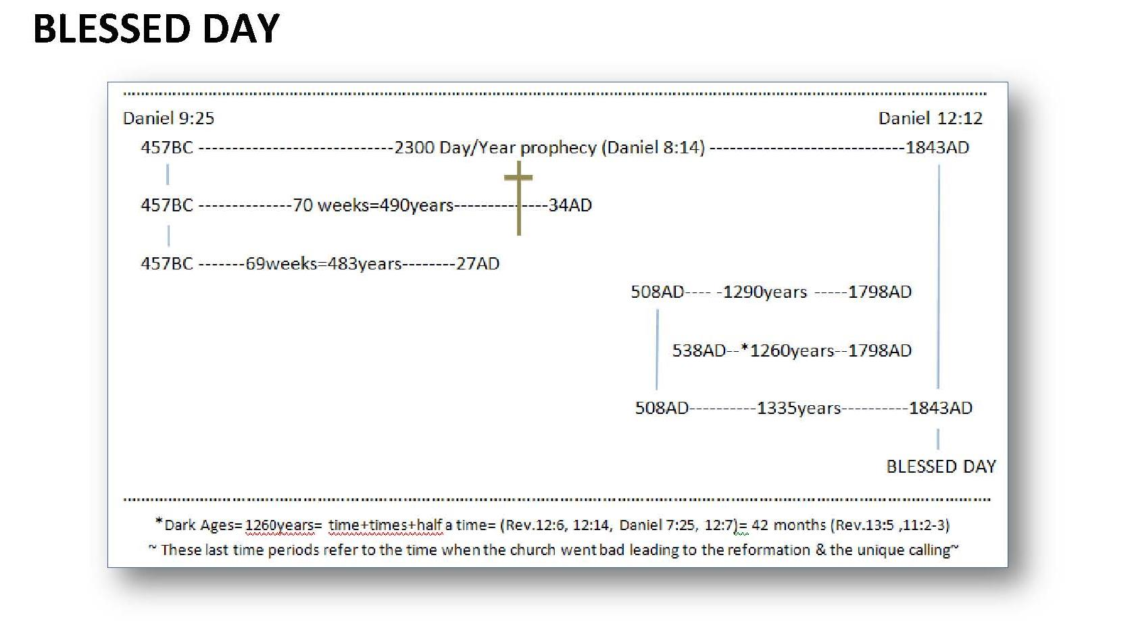
As you see the first church could have had this prophetic knowledge (Recorded by John in 96AD the same as first recorded by Daniel in 605BC) but they rejected it when they rejected the Messiah, who, even gave them a hint in speaking of the last days on earth (Matthew 24:3-4) and what the church should be, and what it was to look forward to as the last day church (people).

Matthew 24:
¹⁴ And this gospel of the kingdom shall be preached in all the world for a witness unto all nations; and then shall the end come.
¹⁵ When ye therefore shall see the abomination of desolation, spoken of by Daniel the prophet, stand in the holy place, (whoso readeth, let him understand:)

But they didn’t get the picture, and the church He established while on earth soon fell then into darkness, but, the true church (people) that was protected by God, of course to preserve the Gospel, only, and get this now, “would remerge on prophetic time” (1843-44AD), and this remnant of the remnant church “would listen to Gods prophecies, search them out and know them”, for what this knowledge was to tell the world; and that was “who Gods enemies would be and how deception would take the church at large and turn it against Gods Commandments through deception and thus reject the testimony”, this was what she “should have had as her testimony as the church at large today”, as Gods last day saints, but few there be that follow.

Unfortunately now, to date, too much water has passed over that dam, and should Christ come today, just as He did in the days of the first church, todays church wouldn’t even recognize Him, and just as surreally not only would they not recognize Him but seek kill Him, just as surreally “as they have killed His testimony and His Commandments (Covenant) thru perversion”, and friend, “Just as God predicted way back then when He first gave His prophecies to Daniel” (605BC);

Daniel 7:
²⁵ And he shall speak great words against the most High, and shall wear out the saints of the most High, and think to change times and laws: and they shall be given into his hand until a time and times and the dividing of time.
²⁶ But the judgment shall sit, and they shall take away his dominion, to consume and to destroy it unto the end.

They will think to destroy “times and laws” and “persecute God saints” in attempt to extinguish their testimony, the testimony of God and His Son; “that points directly to them as false”, and eventually, their darkness and lack of Godly light will lead us to that dark period of time (vs. 25 = 1260 years), and to a day in our time after that period has past, and it will be “even darker than the one past at its end (Matthew 24:20-22).

When the judgment that began in 1843AD will call for every mans case that has ever lived before the heavenly throne, every man and woman who have made his or her decision for or against God, after which, will the last day plagues fall (Rev. 15,16,17,18,19,20) and the real fears will once again punish man, and as I’ve stated Hells fire will be kindled at the end of ends, and that will be their relief, from the torture in their mind that will come because of the eternal loss realized by the lost. But, for those who “know the fear of God” they will not be afraid in those times, for His angles will encamp about them that “fear” Him and He will deliver them!

Psalm 34 (KJV)
⁷ The angel of the Lord encampeth round about them that fear him, and delivereth them.
⁸ O taste and see that the Lord is good: blessed is the man that trusteth in him.
⁹ O fear the Lord, ye his saints: for there is no want to them that fear him.

This is a promise! (In context)

GO TO STUDY (8)

THE CHART DEFINED - The history of the church discovered

In 457BC the first church was given their freedom from Babylonian bondage according to the prophecy, their city of Jerusalem and temple was rebuilt according to prophecy, and remained the temple of God until the Messiah came as the anointed in 27AD according to prophecy, but He was rejected and killed by the first church causing its rejection as the church of God according to prophecy, and the Gospel went to the second church of the Gentiles, however, that church, as did the first one, fell to Satan’s deceptions and, in her rise to power in 508-538AD, as predicted by prophecy, for 1260 years she reigned as the enemy of God yet, she regarded herself as Gods church according to prophecy, but, in 1798AD she was temporarily removed from her throne according to prophecy, giving rise to the remnant church being the last day church who would keep the commandments of God, in particularly the S-Abba-th, and would have the testimony and faith of Jesus the Messiah, according to prophecy, and thus have “the spirit of Prophecy” being it’s commission and call of God to carry that Gospel into all the world, according to prophecy “The three angles messages - mankind’s final message”. (Rev. 14:6-14)

Begging then the question;

What church emerged in 1843AD to learn of Gods prophecy, and who would carry His Gospel commission into the whole world as a last day message and all this “according to prophecy”?

History tells us friend, there is no guessing, and listen; it could have been any one of the established denominations (churches) that had already organized themselves as Christian churches in that time of the mid-18th century.

But, they rejected Gods call to know and understand prophecy (Matthew 24:14) and His commission for the church as outlined in the message He sent from heaven after His departure John recorded in (96AD).

Thus that call was given to the most unlikely of individuals at first (See further study at end of this study), but then to date has arisen as the remnant church (people) which “keep the commandments of God - all of them including the S-Abba-th”, and have “the testimony of Jesus” which is “the spirit of prophecy”; it’s understanding and it’s messages as “interpreted by “the Bible and the Bible only” that has been rejected by the false church (See appendix “Rome’s challenge”) and her converted protestant churches and replaced by their traditions mainly from the Dark ages “which have no Biblical bases”.

GO TO STUDY (9)

~End or BEGINNING~

FURTHER STUDY (Taken from www.mosescats.com) (Extra credit if you turn in a two page synopsis “in your own words” of the following as it relates to the above.)

The following is the history of how it all came down to the church, and what we can be a part of today; “the remnant of the seed of the pure woman”, the pure Church of (Rev. 12, and not the impure “ones” of (Rev. 17:5):

The following is an excerpt from www.mosescats.com....

Yom Kippur
“what is it – really?”
( Discussing today’s misinterpretation of Daniel chapter 9 )
In 1843, around the first days of fall, a small group of people, which would represent nearly every protestant denomination across the world, waited and watched the sky for Christ's return, much like they have done several times since.
This group, back there in the eighteen hundreds, had come to call themselves Adventists, meaning; "those who are waiting for the coming of Christ". They rallied under the leadership of a Mr. William Miller, a self-appointed evangelist in his time. Back then you must realize, it did not require a master of divinity to preach, you were just "called" as they said, by the Holy Spirit. If only today people were so in tuned with the same Spirit, as opposed to occupation compromise would not have crept in?

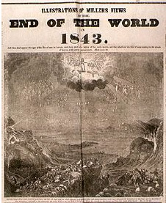
TAKEN FROM A MAGIZINE OF THE DAY

As the faithful watchers waited, the day of the predicted event came, and passed, without Christ's appearing.
“Why hadn't He come”?
Where had they figured wrong? The Bible seemed so clear, the prophecy so concise, what had happened?
So, back they went to the scriptures to search deeper for the reasons much like the Bereans did checking out what Paul was telling them.

(Acts 17:10-11)
And the brethren immediately sent away Paul and Silas by night unto Berea :
who coming thither went into the synagogue of the Jews.
These were more noble than those in Thessalonica,
in that they received the word with all readiness of mind,
and searched the scriptures daily, whether those things were so.
You see, it all started when William Miller discovered an obscure prophecy given to Daniel in 605BC. [1 See footnotes] It was a prophecy given by God to the Jewish nation, His chosen people, and His church for the time period (and given to “us” in this time period as we will see).
This prophecy dealt with "the Cleansing of the Sanctuary"[2].
As Miller studied the Bible, along with the historical documentation, he came to discover that the "Cleansing of the Sanctuary" was a yearly event in the Jewish tradition [3] which of course was still being celebrated in Jewish communities even in his day as “Yom Kippur”.
It seems odd now, looking back on it, that he would not have been naturally aware of this holiday as we are today. But you must remember books were few and far between then, and there was no radio, TV, magazines, and the calendars were generic, mostly farmer’s almanac types dealing with planting rather than cultural holidays etc. Here is a calander 15 years into the future of this writing.

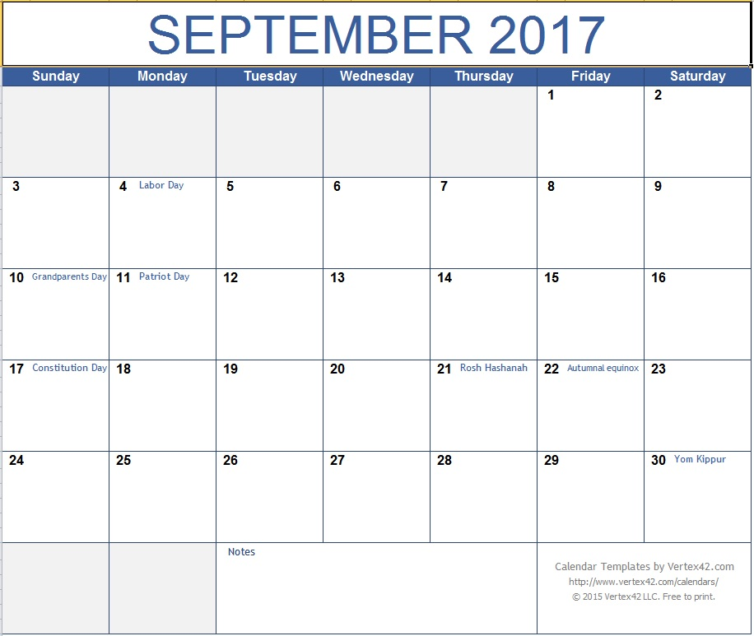
SEE BOOK OF CALENDARS AND COVERT HEBREW TO GREGORIAN DATES FOR ANY GIVEN YEAR - LIKE EASTER

[1] Miller was just one in a long line of men including Sir Isaac Newton who had discovered this ancient prophecy and expounded upon it over 100 years before, and also Martin Luther over a hundred years before that.

[2] Called “Yom Kippur” today.

[3] Leviticus 27:26-29; This was a day of reconciliation, heart searching, and a day of actual final judgment for Gods people. Leviticus 16:1-34, gives the establishment of this statute, “by God” mind you. In Hebrews chapters 8, 9&10 Paul describes what this means and how it relates to the Christians under the “New Covenant” made by God so miss understood today.

In our age of knowledge of course, on the information highways, we have heard of this ceremony of old, called “Yom Kippur”, because it is marked on about every calendar published. Today most of the world does not call it “the Cleansing of the Sanctuary” as it was originally called, however, among the Jewish nations this custom has roots stretching back long before Millers time, even long before Daniel's time, in fact; all the way back to Moses' time [4], when the institution was first invented, and it was created by "God" not Moses as some would have us believe.
So, it was the discovery and study of this prophecy, and its stretching forth into Millers own age where it appeared to reach its fulfillment, that called it to his attention. This then is why the longest of time prophecies [5] in the Bible, became the initial cruxes of this newly formed Advent movement, with “no name” to this point.
As Miller and his converts studied the history surrounding this Typical Event [6], they discovered that God, the author of Prophecies, when He called His chosen nation out of Egyptian bondage, he had actually set a time, in prophecy, for their release, and it came to pass right as He had said it would, right on time. They also discovered that other Prophecies also were “set around time" as well, including this one about the Cleansing of the Sanctuary.
To get the same impression or the picture they received as they studied this subject in Millers time, we must re-create these events of history in our minds as well. Possibly because we do not know what the Prophecy is all about. But most likely, as in Millers time, we today, despite the awareness that exists in this age of information, we too have lost sight of most all of "biblically" [7] interpreted Prophecy [8] though none other than the “false Prophecy” all the biblical writers warned us about.
Isn't it true today that everybody and his brothers uncle is an interpreter of Prophecy? Why, this one Prophecy alone, has been so broken up into pieces [9], and applied to so many events past and future, and has been so falsely interpreted, by so called teachers of Prophecy, that it hardly resembles the Bibles own interpretation [10] of a typical event symbolizing the anti-typical event.
The "history", surrounding this Prophecy; about the Cleansing of the Sanctuary, we will see has been ignored, and this is why the entire predicted event has been pushed off in the future, and I mean our future believe it or not (as seen above), and what is so amazing about preachers doing this, is the fact that the Bible is as clear as a crystal of how this Prophecy has already been fulfilled, and it happened right there in Millers time believe it or not and we will see this in a moment.
[4] All the way back in 1450BC that’s 3450 years ago and the celebration of this event has been preserved since then, compromised yes, but preserved.

[5] This is the longest prophecy connected to time and events found in the Bible. See Sir Isaac Newton’s "studies in Daniel" or search this site.

[6] Tpyocal as opposed to “antitypical which is the event or thing that foreshadowed the typical.

[7-8] Remember what I always stress; it is the Bible and the Bible only that can interpret prophecy. That is allowing the Bible to interpret itself, see II Peter 1:19-21.

[9] Ever herd of “seven years” as part of a prophecy? Like “Left Behind” or “Late Great Planet Earth” or…Well forget it; it’s a part of this prophecy and cannot be separated from it, and it’s the only place that you find seven years mentioned in prophecy. So if you cannot separate it from this one then the others are false. I deal with this more…

[10] This thing about the Bible interpreting itself is a "principal" that must be applied if we are to know the truths surrounding any prophecy. We could all have our opinions but God says no to personal interpretation of prophecy. The Jews are a prime example of missing the first coming of Jesus, we may be the second if we do not heed Jesus’ warning in Mathew 2

You see, history is a source that stands on its own it happened and God recorded it or inspired His Prophets to write it down. Therefore history to the serious Bible student cannot be dismissed, even if we would like for it to be (such as the holocaust, or the events of the dark ages, or the reality of Christ Jesus. Some dismiss about anything that is against their civil rights or humanistic beliefs or religious beliefs (know anybody like that?). But history friends, needs no defense, it stands on its own two feet and needs no proving except to authenticate it. Events such as the story of Moses and the Exodus, why nothing is so set in time and history, but there are some who desire to put these stories in the category of myth? In fact there's a whole world of agnostics out there and it is growing, and what is even scarier than that is, these are the teachers of the subsequent generations.
So to set the stage in truth for those who love truth [11], lets recreate the history of this Prophecy and the events both before and after Daniel's time so we can get the picture, and listen this won’t will not be hard; nearly everyone who has seen the Ten Commandments movie, recalls the story of when the time of the children of Israel's release was about to come, Moses, an Egyptian citizen, and a Israel transplant into that nation, was called by God to lead Gods people out of Egypt and into the promise land of cannon. There was even an old song, very popular years ago, written about it; a spiritual; "go down Moses and let my people go". This is so ingrained in our history one must ignore it so that it will appear to go away in order to get rid of it.
Undoubtedly we should remember the tremendous miracles that surrounded the Exodus, as well as the plagues, and the parting of the Red Sea. We may even recall the institution of another event sacred to the Jews, called the "Passover" still celebrated today and marked on every modern calendar. I wonder why, we’re not a Jewish nation?
As you realize the Passover (a Typical Event) commemorated the "deliverance" of the people of God from the grips of the Pharaoh who had them bound in Egyptian slavery. You may recall too, they had to sacrifice the symbolic lamb the night before the big day, typifying the Lords (Anti-Typical) blood, which assures deliverance (from the bondage of sin ultimately). This of course was to be a symbolic event (Typical) mind you, and if you don't know; the event this institution symbolized, or pointed to, it was that day way out there in man’s future when Christ would come as the lamb of deliverance, to deliver his people from the grips of sin, and assure them regained immortality at the close of this event by his coming for complete deliverance.
The cross is called the "Anti-Typical Event", that the "Typical Event", being the first Passover, pointed towards but had they not been taken out of Egypt the deliverance process would not have been complete, it was "symbolic" of both of these great events of history that happened right on time exactly as God predicted . These biblical terms are important for us to understand as we look at the Prophecies that surround time and history (see footnote 6).

[11] What is truth someone said; “only as far as the eye can see”. Now that may have been the norm at the time that was stated, but today; “we can see farther and farther, into the unknown and into the known, so whatever has been recorded from the past (trusted sources of course) and not pre-history (get the significance of that term?) confirmed history yes can be truth as the world can accept it, but to the Christian it must come from Gods Word alone, and let everything be judged by it not vice versa, and that applies to everything, and friend the Bible is exhaustive search it out for Truth it’s easy today for we sit on top of it all with the internet at our disposal, but don’t forget don’t trust it compare it to Gods Word (KJV)

As Miller and his associates studied these Prophecies and learned these terms; the one thing they found most interesting was; this Anti-Typical event, being the slaying of the Lamb of God (Jesus’ crucifixion), took place right on time in history; right according to Daniel's prophecy, the Prophecy we are about to study of the Cleansing of the Sanctuary; and it happened exactly as the Bible predicted, hundreds of years before, “in the very year 30 1/2 AD” [12].
In that very year, tradition would be fulfilled, as foreshadowed by the slaying of the lamb the night before the Egyptian deliverance. That holy day was keep sacred throughout all Israeli history, right up until the day Jesus, the Anti-Typical Lamb, was crucified [13]. This was accomplished on Friday, the day before the traditional "Passover day" there in Israel. Thus fulfilling the symbolism's of the original Passover instituted way back there in Egypt. Only this time it was not the symbolic lamb slain but the Son of God.
I linger on this Typical and Anti-Typical stuff because this is important for us to understand as we study Prophetic interpretation, for the larger portion of Prophecy was given in shadows and symbolisms, and we must see how God represents things, as things that represent things that will come. Such as the lambs slain all those years, up until the cross, only represented the Lamb of God who was to come one day and shed His all Atoning Blood, once and for all, for the plan of salvation [14].
Bear with me now and you will not be confused, I promise, as we see how God operates and most important how he interprets all of His Prophecies, and especially this, one dealing with Yom Kippur, of which we are going to study.
Let’s go on with the story of the Exodus as we set the stage;
You recall, how when the children of Israel reached Mount Sinai, in their trek towards Cannon. God brought the procession to a halt at the mountain base. And there he had them set up camp. Then, as you recall, he called Moses up into the mountain to give him instructions.
In these daily rituals, as well as at the "Day of Atonement" or the "Cleansing of the Sanctuary" (on Yom Kippur), man was to gain a graphic image of Gods plan of removing sin, both corporately and individually, and how it worked for their redemption from the plague of death. A plague which had been upon mankind since the fall of Adam and Eve, apparently shortly after the first week of creation.

[12] This Anti-typical event was a part of the 2300 year prophecy in Daniel 9 where he saw the cutting off of the messiah in the midst of the prophetic week. Exactly 3 and one half years from his anointing (baptism) there in the river Jordan. You've heard about seven years used in some future prophetic scenario? Well forget it you can't pull it out of this time fixed prophecy and apply it to anything else but what God intended to mean. This is the only place in the Bible where you will find a seven year prophetic statement. And it deals with the time of the Anti-typical Passover where the Anti-typical Lamb was slain for them and for us as well. This in itself confirms the very date in which the crucifixion was to take place, and did take place, right according to prophecy, just as the Bible describes and "not" on Wednesday.

[13] Daniel 9:26, 27 The Messiah was cut off by crucifixion and the sacrifices ended for He was the Anti-typical Lamb.

[14] Hebrews 9:11-12.
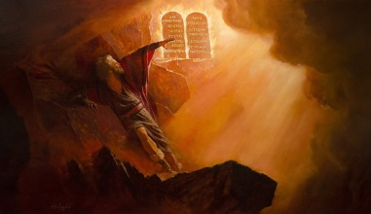The Lord gave him plans for this Temple that would duplicate the pattern of the Heavenly Sanctuary [15]. He also told Moses something that should interest us very much, and that was He wanted him to build Him a place where He could dwell among His people as He worked out their Salvation.
Of course you remember He gave him the tables of stone with the Ten Commandments written on them. But, what you may not realize, the Lord also gave him a command, from that same mountain top, to build Him a temple, a Sanctuary. (A Sanctuary, incidentally, that would require "Cleansing").
Through this temple and the workings within, He would show them His plan of Salvation. A plan of which God had provided for them; by the volunteering of His Son, who had chosen Himself, to give His life as a payment for sin, a plan laid out long before the world was created [16]. This plan then would provide a way of escape from the death penalty of sin for all mankind born into sin from Adam on.
It was in this Temple, or Sanctuary, that Israel would realize Atonement for their sins. You can read about it in the book of Leviticus; about all of the various duties of the priests, and also the duties of "the people themselves" in the plan of salvation, a principal we lost sight of in this faith only so-called religion [17].
The Lord wanted man not only to see what he was doing for them, but he wanted them to understand their part in this plan as well [18].

[15] Exodus 25:40

[16] I Peter 1:18-20, John 1:29, Rev. 5.

[17] See James chapter 2.

[18] The sinners part was to bring the lamb confess his or her sins over it representing their part in the sin and then with a knife they had to slit the throat of the lamb representing what their sin did to the lamb of God who would come and shed His blood in their behalf of that sin making then atonement for it, but, they were to leave and not sin any more or they would need to repeat the process again. All this was to remind them of the magnitude of sin and what it causes in hopes that they would not repeat it or continue to sin. This earthly process was symbolic of what the true (anti-typical) Lamb of God would do when He came to earth and die for all accumulated sins from Adam to the last. Today since the Lamb has already come and shed His blood for us we need only confess and repent and not repeat the sin or sins under this new Covenant we need not bring the Lamb and only in our prayers is this process of salvation accomplished, but, if we take our easier process lightly Paul lets us know the result in Hebrews 10:26-29. Sin still means death and each and every one as in Israel needs atoned and the process is the same by faith they took the Lamb by faith we ask for the Lamb to forgives us in a sense it’s always been symbolic for those who didn’t see the Messiah come but had faith and for us who have seen the Messiah come yet we too must have faith. But faith without works being the works of the plan of salvations requirements for us or them faith in the Lamb must be followed up by works as the process requires, physical lamb for them spiritual lamb for us.

This temple that Moses built was a portable thing that they carried with them on their journey those forty years in the wilderness. It was the figure of the temple eventually built once they settled in Jerusalem [19] many years later.
It had three stages or compartments.
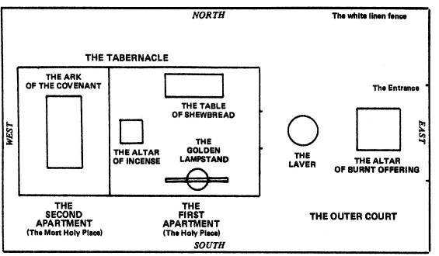
SANCTUARY
The courtyard was contained within a surrounding a high curtain wall. Inside was a rectangular building with two compartments. The holy place was veiled from the most holy place called also the Holy of Holies. This inner sanctum represented the very presence of God. This was the place where the lord worked out the plan of salvation for them. Believe it or not he actually came down and inhabited this holy space. And dwelt in the Holy of Holies in this rude temple made of wood and animal skins. At night the people could see the Shekinah glory of the Lord there in the temple built by the hands of man.

[19] Remember our scripture; in that it was also a figure of the temple in heaven.
[20] Yom Kippur or the cleansing of the sanctuary was the end of the Jewish year in that all sins must have been confessed and in the temple by the end of that day to be atoned for or forgiven. It was truly a day of judgment when the record of the sins that had accumulated in the earthly sanctuary were sent to the heavenly sanctuary and thus the earthly one was cleansed till the next years sins were accumulated.

Into this presence no man, not even the high priest of Israel could enter. Except for only one time each year. And that was on the "Day of Atonement", the day of the "Cleansing of the Sanctuary", "Yom Kippur".
This was the highest of all the days in Israel [20]. It was a day of judgment actually for Gods people living back there. It was to be accomplished each year just like clockwork on a specific day of every calendar year.
The accuracy of this "timed event" is witnessed by the setting of it, in all the time records throughout history. Despite the changes from one calendar [21] to another, we have established equations between all of these calendars throughout history that help us establish this day with absolute accuracy even to today. Just take a look at the calendar on your wall, and you will see all the equitable dates listed; such; as Rosh Hashanah, Passover, so too "Yom Kippur".
This highest day of every year as I said, it was also day of reckoning for Gods people, a day of heart and soul searching. The reason is; if the individual’s sins had not been confessed and atoned for by the end of the day and transferred into the sanctuary, they were lost forever, cut off from salvation. So it was a solemn day, a day not to be taken lightly, set as a high Sabbath [22], even to this day and time, which you will soon see..
This annual event was called the cleansing of the sanctuary. It was this event Daniel had described in the 9th chapter of the book of Daniel that William Miller picked up on.
Unfortunately though, in his interpreting of this prophecy, he did not know all of the things we know today surrounding this event, he didn't know this at first anyway; he thought, as well as his followers, the Cleansing of the Sanctuary meant, the end time event of the second coming, where the fires of destruction would "cleanse" the earth of sin. You see the earth was conceived by them to represent the sanctuary.
Thus this misinterpretation [23] was applied, by them, to this longest of the time prophecies of the Bible. A prophecy that stretched from the going forth of the command to restore and build the

[20] Yom Kippur or the cleansing of the sanctuary was the end of the Jewish year in that all sins must have been confessed and in the temple by the end of that day to be atoned for or forgiven. It was truly a day of judgment when the record of the sins that had accumulated in the earthly sanctuary were sent to the heavenly sanctuary and thus the earthly one was cleansed till the next years sins were accumulated.

[21] The Gregorian calendar is our form of time keeping today. It is a modified version created by Julius Caesar in 47BC But in the 1500’s Pope Gregory modified leap year to make our calendar the most accurate of all time keeping instruments, in perfect tune with the solar system. The book of calendars in every library shows one how to equate our calendar with most all other time keeping instruments in the world. We have not lost tract of time, at least as far back as Jesus’ time, even back as far as Daniels! Leaving Jewish history with its prophetic time references exact in their relation to our times and seasons.

[22] John 19:31.

[23] Showing us how important it is we let the Bible explain prophecy rather than our own guesses no matter how sure we might be of them. See II Peter 1:20

temple which had been destroyed by Nebuchadnezzar the king of Babylon [24] unto the coming of the Messiah the Prince (when he began his ministry). It stretches then on past this time of his baptism, past the crucifixion, and the stoning of Stephen clear up to the year of 1843AD So naturally it caught the attention of people in that time frame where Miller was living [25].
This reckoning of the prophecy of the cleansing of the sanctuary was not first made by Miller and those of his time, but had been determined by many in the past including Sir Isaac Newton, Martin Luther, Abraham Lincoln and other biblical scholars and historians who wrote about prophecies throughout the ages. Unfortunately the Jews hadn't studied this one particular prophecy or they could have known for sure who Jesus was and the very year of his baptism and crucifixion.
Miller and his followers thus set, the date of Christ return to Cleanse the Sanctuary, and might I add with all sincerity, and with honest hearts and minds it appeared to be according to the Bible to them. Of course nothing happened, so they returned to their reckoning to determine what was wrong with their calculations.
They realized suddenly, that when going from, or calculating from, BC time to AD time, there is no year "0". So to account for this you must add one year to any crossing dates. It was clear now they were simply off by "one year". The fever pitched again for another bitter disappointment that awaited them on the next Yom Kippur the following year.
After this new date came and passed the creditability of William Miller was washed. Most gave up on this date setting thing which had caused quite a stir anyway among the ranks of religion, who quoted scripture saying no man knows the day nor the hour of Christ's return, which is true, and bylarge portion of his followers returned to their nominalde nominations.

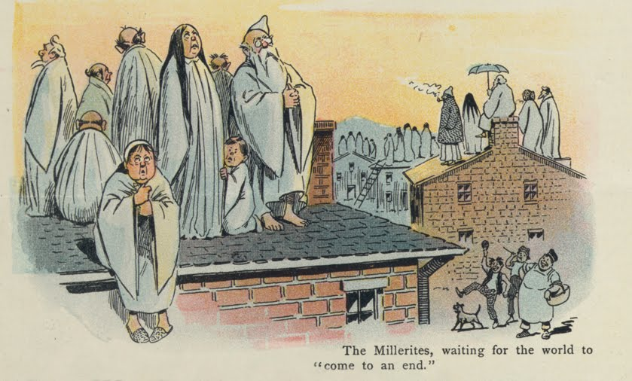
CARTOON FROM THE TIME POKING FUN
But God designed the disappointment seeking sincere followers…
The bases for His remnant church of prophecy

[24] Daniel 9:25.

[25] It also caught the attention of some even before Miller such as Sir Isaac Newton.

Miller however and those who had studied this thing, knew the accuracy of this date, according to prophetic interpretation, as it is applied to history and the calendar. They felt there was no other way to interpret it. What was wrong? An event was to take place in that very year none could deny this. So what was the meaning then of this prophetic vision? What was this event supposed to be?
They came back to the Bible with more intensity than ever to seek an understanding through prayer and supplications much like Daniel did. And the answer did come just like it did for Daniel.
They discovered that Yom Kippur was not only an annual traditional Jewish event, but was also a symbolic event as well. An event symbolizing the time Christ was to enter into the Holy of Hollies in the heavenly sanctuary in heaven (of which the earthly was but a pattern). He was to enter in to this compartment to begin the Cleansing of the Sanctuary, not the earthly as did the high priests throughout history up until Christ but the heavenly sanctuary was to be cleansed also.
His entry into this apartment commenced the Anti-typical Day of Judgment, the Anti-typical Cleansing of the Sanctuary in heaven. Meaning that the final events had come to the pages of time itself, events that Daniel was told to shut up in the vision, for it was not for many days. In that day (post 1843-44AD) when he would stand in his lot? [26] Meaning the day Judgment would begin of course, thus this was the sum of his visions and the intent of this prophecy.
As Miller and his associates studied deeper, they saw that soon every case would come before the heavenly court. And the High (Anti-typical) priest (Christ himself) would one day then finish his work, which was begun at Calvary. They could visualize how Christ's work would begin with the first case of the first deceased person who died "in Christ" (Abel I assume), and then His (Christ’s) work would logically terminate with the last case of the last person still alive just prior to the end of time.
Then, at that time, at the close of the Judgment process (the Close of Probation), at the end of the Anti-typical Day of Atonement, just as in Israel, but now in heaven, Christ would take off His priestly robes because every case had been presented before the Judgment seat of God, and when that Anti-typical day was through Jesus would put on His kingly robes, and then, and only then, would it be time for Him to come back to this earth and gather the harvest of the redeemed. [27]
"No man knowth the day nor the hour", something they ignored in their excitement there in 1843. Now rang clearly true. Miller and his Millwrights were wrong in the event, but were “not wrong” in the timeliness of the event for in 1843-44 the great Anti-typical Judgment Day began “in heaven” as predicted by God through His prophet Daniel.
As a result of being wrong in the interpretation of the event of this prophecy, the Millerites met with bitter disappointment. However out of this came a thorough knowledge of the truth.

[26] Daniel 12:13.

[27] Remember He comes with His reward -see Rev. 22:11, 12, and He comes at the “close of probation” thus, every case has been herd (important point) of which many estranged doctrines (mainly the 7 years ones) have attempted to destroy; such as; left behinds, the doctrine of life after death, purgatory, heaven directly after death, eternal burning hell going on now etc.

A new light as it were, one of which Daniel did not have but a vision of, but was told to wait until that blessed event took place [28]. And this was a vision of the great Anti-typical Day of Atonement.
At some point in time friends, we must face the facts, the final hours of this last (Anti-typical) “Yom Kippur” will take place in heaven, closing time itself for eternity.
Will the end of the prophetic Anti-typical day, coincide with the Typical day as set in our time? Only God knows, but in solemn self-observation we should not take lightly the hour in which we live.
The last day events according to the prophecies are happening in rapid succession. The Abomination of Desolation [29] is at this very moment moving in the high places as spoken of by Christ himself in Matthew 24. Where He refers to the very book of Daniel wherein contained are these very prophetical events. Of these things he says "let everyone who has an ear understand", will we? Should we? Do we? The winds of strife friends, that have been held back so long, are now beginning to breeze upon us.
If only we would see the times and seasons, and bare our hearts and minds towards the Lord, who is the Author and Finisher of our faith. Our Lord, who was that symbolic lamb, slain as it were before the foundations of the earth [30]. These things then would be opened up to our minds and hearts, and it is in these very personal places "in us", where Satan wants to place his mark (see Revelation 14:9), but so it is in these same very places, God wishes to place His marks (see Deut.6, Hebrews 8:7-12). And the differentiation of these two groups, who have let one or the other mark them, God or Satan; is seen clearly in Revelation 14:6-12, as the “Adventists” stand this time "for real" just prior to His return.
"Blessed" the Bible ends in Revelations last book of Jesus' last call, "blessed-happy" is he who has “right to the tree of life" and who, by Gods power, is able to keep His Commandments (Rev. 22:14).
As we conclude this little study, of the real meaning of Yom Kippur, it comes clearly to this; In Revelation 14:6 John describes the gospel that we are to be taking to all the world in these end times. This gospel is to most defiantly include the knowledge of these things we have just brought forth. For John said in verse 7 of this chapter of Revelation; "for the hour of His Judgment 'is' come". God realized for all who would read and understand this prophecy, shut up to Daniel and even John, the event of the Cleansing of the Sanctuary would already "have come" or would have already begun (post 1843AD) as we read and learn of it.

[28] Daniel 12:12, 13.

[29] Something Jesus warns us to know about in Mathew 24:15. And described to Daniel as a power that would come up after the breaking up of the Roman Empire in 476AD and would do terrible things including subdue (genocide) three of the seven kingdoms which divided the old Roman Empire. The identification of this Beast Power as it is called is simply finding out who did this. History gives us the answer it was the power of the Papacy, the “Little Horn” of Daniel 7:7-8,23-25, and also the beast described in Revelation 13:1-5. The two time periods described, 1260 years and forty two months, are equal (see “Abomination of Desolation” coming next month) and fit exactly to the period this power ruled over Gods people, with the worst persecutions Christianity has ever known. From 538AD to 1798 the Papacy fulfilled every description God gave of her. Up until the time of the “deadly wound” when a French general pulled the Pope off the throne and swore never again would such a power reign. God of course says the deadly wound would heal, and all the world would wonder after this power. As we look at the state of the art of religion today we see the explicit fulfillment of these prophecies.

Can we say for sure we know which of the two sides, described in the remaining of this vision, we are on?
Will verse 14 of (Revelation 14) be an event we will welcome or will it find us unprepared, surprised?
May God give us strength to find the truths that will set us free is my prayer.
Please go on to study the Abomination of Desolation with me for further revelations. (See www.mosescats.com )

~mosescats~

STUDIES

STUDIES (1)
Compare the actual church letters Paul wrote, to those in revelations the Lord spoke about, the churches of the same name.

Class discussion: Prepare at least one comparison” if called upon”.

STUDY (2)
What drives us at times, and how long have the promises we made to God lasted, and why?

Search all the Psalms for the fear perspective, and its connections to the Big Ten (Covenant) that was in the ark called what? “The Ark of the Covenant” and the two tablets of stone were inside that box of Gods design, or sacred Ark as it was called.

Q. What were the other items in the Ark with the commandments of God?

Q. What’s in this Fear of the Lord?

(We will do this one together here as an example)

We will make a list by searching the Bible and its use of “fear” to see if it is in fact “clean” from Gods perspective;

- Psalm 19:9 King James Version (KJV)
The fear of the Lord is clean, enduring for ever: thejudgments of the Lord are true and righteous altogether
.
- Psalm 22:23
Ye that fear the Lord, praise him; all ye the seed ofJacob, glorify him; and fear him, all ye the seed of Israel.

- Psalm 25:14
The secret of the Lord is with them that fear him; and he will shew them his covenant.

- Psalm 27:1
The Lord is my light and my salvation; whom shall I fear? the Lord is the strength of my life; of whom shall I be afraid?

- Psalm 33:8
Let all the earth fear the Lord: let all the inhabitants of the world stand in awe of him.

- Psalm 33:18
Behold, the eye of the Lord is upon them that fear him, upon them that hope in his mercy;

- Psalm 34:7
The angel of the Lord encampeth round about them that fear him, and delivereth them.

- Psalm 96:9
O worship the Lord in the beauty of holiness: fear before him, all the earth.

- Psalm 103:17
But the mercy of the Lord is from everlasting to everlasting upon them that fear him, and his righteousness unto children's children;

- Psalm 111:10
The fear of the Lord is the beginning of wisdom: a good understanding have all they that do his commandments: his praise endureth for ever.

Let’s now make that list of all the positive points that directly point to the churches need for this kind of fear, and that need for ourselves as well;
What can we conclude “the fear of the Lord” is from the above texts;
(Example for future subject lists)
- Clean
- His Judgments true and righteous.
- We are the seed of Abraham as much as Israel.
- God will show us His secretes and Covenant - for information or doing?
- He is our light and salvation, our strength of life so there’s no fear in fear?
- This is a message for all the earth not just David or Israel but the church!
- He sees those who fear Him, big point!
- His angles will protect us who fear, bigger point, remember fear is “clean”
- Worship and fear, towards Him are interconnected.
  - He will deliver us who fear, His mercy and righteousness can be ours and our children forever right?
  - Fear is the beginning of wisdom, of understanding “if we keep His Covenant?” - A prerequisite none the less?

STUDY (3)

Q. What other church doctrines like “Hell” were created especially for provoking responses during the dark ages and since?

I’ll mention a few
- Like mandatory church attendance or hells fire and damnation, loyalty to Pope or same and he will command it be done now, proof of power to make her traditions supersede scripture, her worship day over Gods, even for church wealth (mandatory rituals and penance) or hell?
- ………………….
Q. How do they compare to Gods true, reasonable and loving provocations, verses, the false churches creations?
1. ………………….

STUDY (4)

Q. In what ways is the church failing today by the same ways and reasons the church has always failed?
1. …………………..

STUDY (5)

That was a lot there to take in and not see our inner selves, but, we are talking about the church primarily, and yet, as I know personally that things like this remind me of my condition, “it’s hard not to think of ourselves when studying these topics.

Please don’t let this come across to you as a wiping, but let’s simply just “store this in our memory (and hearts) “for the day that it might apply to us”, and listen, that day will come as it has with all sinners who can’t help themselves under the power of over now “6 thousand years of sins influence, the day will come it’s inevitable “when the Holy Spirit warns us (John 14:26) that we have fallen off the path (small way or big way), even lost the path that “down deep” we all want to stay on”, and then, take courage; “through the power of the indwelling spirit (Covenant) we will remember Paul’s warnings, as God gives, and why?

He gives them because He loves us and wants us to become like Him and able to live without “willful sin”, but more live “willfully live without sin” (get that BIG-BIG point?) now get this; willfully live “as did our Savior, and by the same warnings, which applied also to Him, right?”

Q. What then was the churches calling that took over after the first one failed? The one called the Gentiles, being the second church of Gods establishment and calling.
A. ……………………

Q. Was their commission the same as the first church?

A. …………………..

Q. How does all of this relate then to the Seventh Day Adventist church and its history (Punch line of study) its commission, its duty, its unique message no one else can give, no other religion worldwide from 1844AD ahead to the end?

A. …………………

Glad you asked, but before we go on, see if you can answer those questions first from what we have seen so far from Gods Word.

STUDY (6)

Compare the ways the submerging church was spiritually the same as the emerging church, and in what ways is this obvious by Gods descriptions.

Q. Is this emerging church todays church as well?
A. ……………….

Q. What then should it look like spiritually?

A. ……………….

STUDY (7)

What then is the “main theme the church is to broadcast to the world in the end”, and how does that relate to Jesus’s testimony from Eden to the cross – to the end? (Hebrews 8:10-11)

Q. What do these laws, that are to be in us, have in common “in relation to the gospel – the judgment – eternity?” (Hint Revelation 14:1-6)

A. ………………..

Q. Does the Lord promote perfection or “no fault” by intention, or is there a difference?

A. ………………..

Q. How does this all really put “Christ” front and center by the very virtue of the churches (our) testimony, despite “Hebrews 8:11” above?

A. ………………..

STUDY (8)

Q. In what ways can we claim this promise now, in our fears for relief no matter what?

A. …………………

Q. Hasn’t He given us a multitude of examples of His deliverance in all ways?

A. …………………

Q. Is it then we need only to grab hold of their relevance to us?

A. …………………

STUDY (9)

Can you see how all of this fits into all we have seen so far “in relation to our subject”?

Q. If so in what ways?

A. …………………

~END~

APPENDIX

GEORGE SMITH ARCHEOLOGIST:

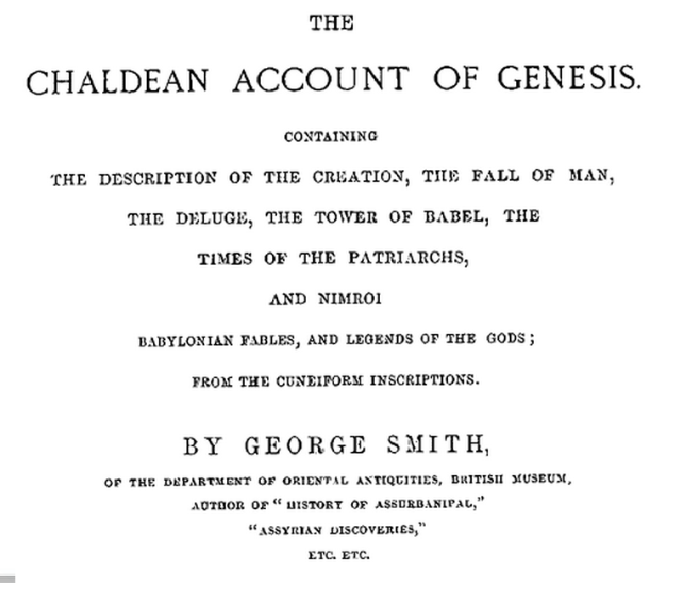

This book is “on line” at amazon, as well as many others telling of the ancient discoveries made in the most ancient lands of mankind, records made by nonreligious (so to speak) men, events the Bible tells us about; not only the major events of history; the flood (deluge), tower of Babel, Sodom and Gomorrah inside the book .

ROMES CHALLENGE, the reason for the reformations demise in their own words….

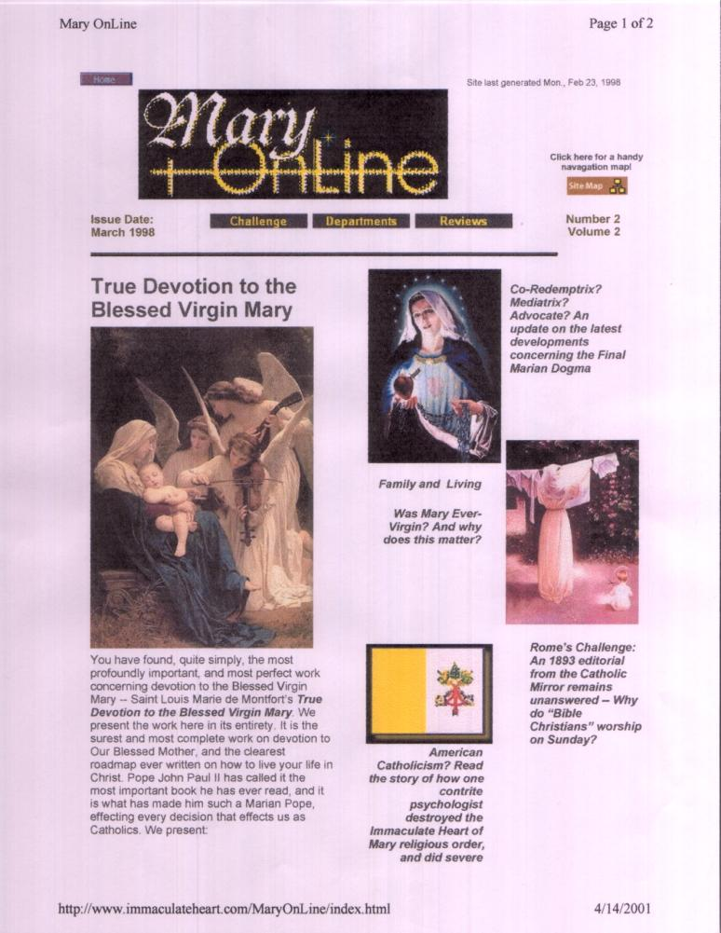
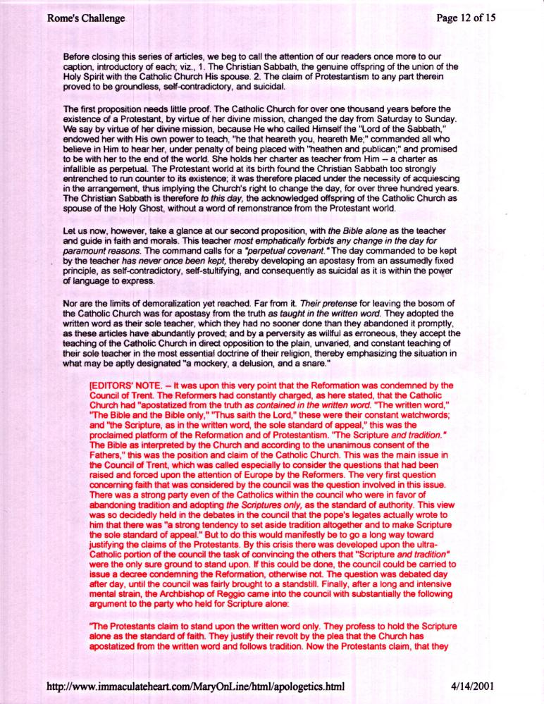

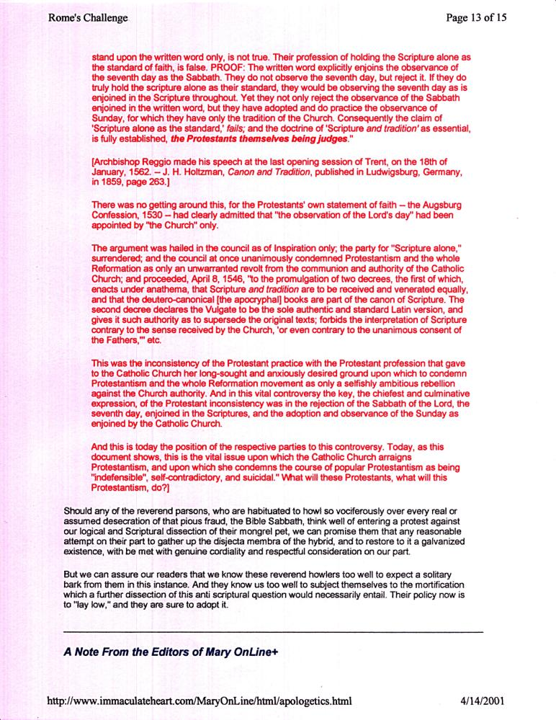
This website was removed shortly after I posted it on www.mosescats.com in 2001

THE CHURCH
A historical perspective

BY
MOSESCATS
2015©

Even though I have put a Hyperlink on referenced texts to make it easy, please get out your Bible and look them up and even underline them. Input = output and familiarity with the Bible is “becoming familiar with your God” and that’s why it’s called the “Word” - His Word.
The oldest known source for God is the Bible which has prophetically proved itself to be so. (See “Dead Sea Scrolls”)
For the duration of this study, and based on all the evidence shown on this site, Gods church is derived from the Genesis as found in the Bible only.
A land that’s not so Holy now.
Jonah 1:1-, (Search www.amazon.com “Jonah and the Whale\ancion” for details, See also www.theuniversalreligion.com “What if the Bible is True”)..
Nineveh from that day forward became known as the religious center of the world, whose name ironically denotes a fish?
See Appendix for excerpt from “George Smith” book of his archeological findings of past contemporary (non-religious) discoveries on stone.
See also www.mosescats.com “Watchman” for the gruesome details kin to today’s Isis jihad, but worse (Warning not for the faint of heart).
See statements by Pope Innocent iii, infallibility claimed up until 1870-71 by Vatican counsel, but later they backed off and try to date to rephrase what they once claimed, I wonder why. The original Great Controversy was even revised in 1911 to not offend? See Liberty of conscience GC Chapter 35. Even if only infallible in Edicts and not personally doesn’t “Sunday (1st) as Sabbath (7th)” a change in the “sealed” Covenant defy even that? Get real!
Look at an encyclopedic Bible center column for Ezra chapter 7, and the actual decree is vs. 12-13 .
Emperor Justinian I of the rag tag “holding onto some parts of the late Roman empire” gave the Roman Catholic Church religious rule over the territory held by Him, but in 538 she was given political rule as her power had risen to that degree. These dates fit the prophecy of Daniel as our chart displays 508AD to 1798AD = 1290years her religious reign set up, 538AD to 1798AD = 1260years her full reign. Daniel 12:11-13, 1798 her reign taken away temporally.
In 1798 French general Berthier under Napoleon pulled the Pope off His thrown for all the atrocities of the church, and swore there would never be another Pope, of course he didn’t know the prophecies which spoke of her come back into power over Gods people again and those same persecutions to death will resume, this time the USA apostate protestants will join in (Revelation 13:11-17)
In 1843AD the 2300 year prophecy (Daniel 8:14), being the longest time prophecy in the Bible, ended from its tart in 457BC with the decree we read in Ezra 7.
See Appendix “Romes Challenge”.

