The MESSAGE to the CHURCH
Based on; “The People are the Church”

The Bible is not only the history of mankind, their creation, life and fate, it is also, and might I say; “most importantly, Gods message to the church” please keep that in mind.
Now while it’s true; there was no real church of God, per say, till the children of Israel (Jacob’s descendants) were gathered at the foot of Mt. Sinai back there in the exodus from bondage in Egypt, when the church was properly established “under a Covenant with God” (please keep that in mind as well), but before that; “Gods people were His church” and really, just like today and forever; “no people- no church”, get it? (Keep this thought too)
So, we are the church, “The people are the church”, but friend, all churches can’t be Gods church, just like all people can’t be Gods people!
How is that?
“How can two (or three) walk together if they don’t agree, remember that text? (Amos 3:1-3, 7)
Isn’t that text implying that God is speaking of Himself as one and His people as two?
In this case it was His first church He was addressing, His chosen church, and His chosen people from all the earth!
It was His family that He was reprimanding for not following what they knew they were to do under the Covenant, which were/are His instructions for mankind/the church. (This is obvious from the previous chapter vs. 4)
You see, from the very beginning; all of Gods instructions for mankind were to be, and were, established thru Adams race and through all who subscribed to His plan, and His instructions were made plain through all the prophets, (as the previous texts told us if you read the context) yes, from the beginning His instructions were clearly understood by all of His chosen, who choose of course to follow Him; from Adams time to Noah, through to Abraham then to Isaac “Jacobs father” and down to Moses the deliver, but, up to that point there was no church proper.
It wasn’t until then, when the Jewish/Egyptian ruler (Moses) was chosen by God to deliver the release of His people from bondage (in bondage for not following His instructions might I add), and they began their 40 year journey to the promise land, and that was when God organized His first church.
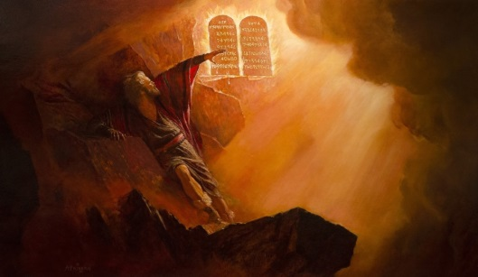
That was when He spoke His instructions “Himself with His own voice” out of the fires, and then He even wrote them down with His own finger on tables of indelible stone, the things “from His heart” He gave them, all the rules of heaven, “yes Rules & Commands”, (Exodus, Deut. ) and not just for the first church but all that fall under that 1000 generations of time, He has given us (mankind/you/me) these things “for our hearts and minds” did He give them to US;
“His loving knowledge
of what it takes to live
eternally as He does -
in universal righteousness”
as should all of His people/churches He has called want to live, BUT; that’s not the way Satan’s church and his people from Cain ahead think, and do of course, because he, the serpent, that great red dragon has turned them away from Gods instructions for eternal life, being the father of “unrighteousness”, he has led them into sin and transgressions, Just my friend, as he did the angles in heaven, (I John 3:4, 7-8, 10) when he Lucifer, once an angle of light, turned them against, Gods ways, His Laws governing immortality, turning them against His will for them, and now; we the people of earth and the last day churches have fallen for his deceptions once again and against Gods will in disobedience to His Covenant in following the Beast of Daniel and Revelation!

HOW IT STARTED
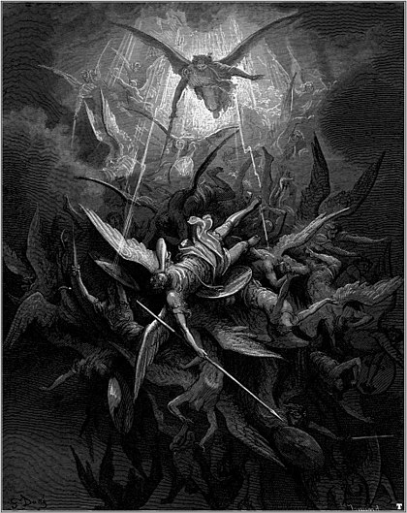
Rev. 12:7-9
The conflict that began in heaven, transferred to this earth, caused us to fall into sin, to killing etc., which led us to the first destruction of mankind which “evolved into fully and willfully embracing evil through amalgamation, (Gen. 6:5-6) and even after Gods one time great example of the results of sin, (the flood) of what sin causes by its creeping compromises, breeding themselves into the hearts of man and finally into Gods “first church” causing it to forget His Covenant, leading them unbelievably (Gods chosen people/church) to commit the fatal act of killing their Messiah “under a religious guise of deception”, [even having been forewarned by prophecy (Daniel 9:28) and, according to those same prophecies given (to us) by God;] leading to the second church, (our church) under the same guise and deception; (Matthew 27:37-38) to the killing of Gods saints (Dark Ages by her the beast/and in the end by her daughters as well according to prophecy), how can this be?
Because; “her deceptions” have led, once again, to the destroying of Gods instructions of “His Covenant”, and that; if only by one transgression, as in the beginning, when there was only one commandment.
So in the end it will also be true; for in destroying one we have killed (broken) them all, (James 2:10) and just as surely have we killed the testimony of Jesus, so required “for the sanctifying of man’s souls”, and, just as the first church we have killed the prophets that have brought us His Truths. Destroying those wedded twins of the Bible; the Testimony (Prophecy) and the Law (Covenant). (Leviticus 20:6-8, Isaiah 8:19-20, Deuteronomy 5:12, 29-33, Exodus 31:13, Hebrews 13:8,12, 10:29, John 17:19, 17, 1 Thessalonians 5:18-24, 1 Peter 3:15, Hebrews 9)

SO IT BEGINS
and so will it end…
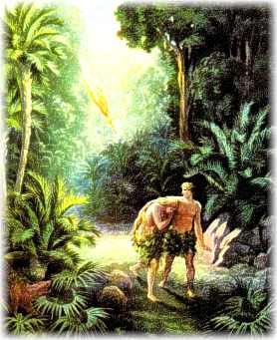
Back there in the beginning of this earth, in just “one act (not 10) of disobedience against Gods instructions/Commandment (just one remember) lead to the first transgression” (I John 3:11-12) “it was then we gave up Gods will for another’s will (Satan’s) back there in Eden”, and this has led to all our mortal weaknesses and deceptions from that point on, and how much more so after 6000+ years?
Some people look back and say; “that it was unfair of God to do such for just one act of disobedience”, and friend that was Satan’s claim before his fall; that God was unfair, Cain obviously thought that too as he walked away from God rather than repent confess and obey, Ishmael bred a whole race on antichrist, even Israel Isaac’s descendants made the same claim against Gods Covenant and (Malachi 3:13-14, 18) “400 years before the promise of the year of the Messiah given to Daniel, (Daniel 9:24-25) that first church and people were from Gods prophetical guidance, as Malachi was the last prophet to give Gods council”, and it was right after he (Malachi in 430BC) gave Gods stinging words to the church; the church and and the people were cut off from heaven, left on their own for the next 400 years, until the prophetic year of the Messiah’s appearance (27AD), and during that time of silence they lost sight of their promised Savior and what would be His Testimony despite all the prophecies that they ignored during the preceding years before that 400 years of darkness, and when He did come (right on prophetic time in history) they didn’t even recognize Him nor the prophetic year in which they were living, (Luke 4:19 in context) even though He made it clear.
This darkness has returned today in Gods second church, so it began so will it end.
“Despite the recorded history and all the examples of failure’s from the past, as well as the prophecies of the future they are fulfilling unaware, because, they as Israel Gods first church, have again forgotten those terms of the Covenant, Gods (requirements/instructions/commands), prerequisites for His first coming, (Daniel 9:24) which are the same prerequisites for His second coming, (Why would they be any different? Same Lord of old, came Christ same Messiah?) And they have even forgotten that He gave those prerequisites “for their/our preparedness”, so they would recognize His Son “pre and post Calvary”, and the price “He had to pay” to be able to forgive sin, being the sins that still prevail to today! (1 John 3:4-11, James 2:10-13 even the least so called Matthew 5:17-20, Rev. 22:14-15, 18-19)
All this obviously tells me that the church today; still as the Jews, have not seen as yet “the magnitude of sin” through Gods eyes, despite the many examples given in scripture, (1 Corinthians 10:11 in context) or my friend, they wouldn’t question Gods instructions anymore, His law, His ordinances of His Commandments/Covenant He gave that we; if kept of course (all ten not just nine & especially the 4th) that we “might live free of sin and death forever”, by His power naturally there is no argument about that, or do we, as yesterday’s church/people; simply just do not wish to sacrifice all for our Lord? Even for eternity, and would rather live in a world of sin forever, and guess what?
Those who accept this kind of religion will live as such for their few short years on this earth till they die, and it is a death without hope, (Deut. 30:15-19) as He warned them back then, when He gave His first church His knowledge, and really friend, as it has always been. (Jerimiah 8, Matthew 5:19-20, 17-18)
Today He is calling His second church out of the spiritual darkness, that, He predicted will come! (Matthew 24:3-5, 21-24)
“We too of the remnant church/people near the end, (Rev. 12:17, 14:12-14) will have the same hope less that is; we let God save us from the sin of death; that naturally occurs while transgression against His commandments is alive and breading in us as a cancer, even one cell of it! (I John 1:8, James 2:10)
This is why God needed to build a church, so that people would have the hope that only a God fearing wholly obedient people (not perfect of course) can offer their neighbors. (Malachi 3:16-18, I John 3)
I stress this fact; that it’s only a “Bible only” believing and following and teaching church God wants”, one not following the traditions of all the churches that have separated themselves from God; the Jews first and now the Gentiles, it is only the now called remnant end time, last days church/people who follow the Bible and the Bible only, keeping and doing the Commandments of God and have the Testimony and faith of Jesus our Lord “both before His birth and after His first coming”, showing us how to live all the ways that God has led His people by, from Adam to the last on this earth that will make heaven (Rev. 12:, 14:, 22) you look it up.

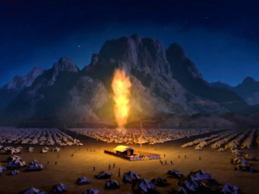
TH2 FIRST CHURCH at the base of Mount Sinai Exodus 25:8
Attended by the awesome presence of our Lord God

When the children of “Israel” as God named His first church, not Jews nor Muslims, but “Israel” being a mixed multitude that came out of Egypt, which He could have labeled Gentiles at that point, but they were soon to become the first church of the Lord of the S-Abba-th, (God the Son Matthew 12:8, Luke 6:5 John 1:1-5, 9-14) the creator of all life as we know it, and who promised to come and die that all men might live, and who gave His church their traveling orders from heaven for the assurance of their inheritance into the promise land. (Deut. 6) Upheld it by His life, and then reaffirmed it from heaven again to us. (Rev. 1:1-5, 22:16-21)
We too are marching towards a promised land and our marching orders are just the same as the first church, and, our Messiah is the very same one and of whose commandments and testimony we too are to follow, why? “To be granted entry through the gates into heaven and regain access to the tree of eternal life, and that’s His promises to His church, but not the churches who have strayed away from His Covenants; back then and “especially those today”, less that is; they can regain His mercy by fulfilling His desires for His church/people, being the same desire throughout the ages, for His people? (Deut. 5:29, Isaiah 8:16-20, Rev. 12:17, 14:12, 22:14)
This has been the same message given from the beginning. (I John 3:11 in context) because God “hast too”, and does, treat everybody the same; from heaven to earth to the new earth and forever, and that’s what makes Him our God in truth and mercy for a thousand generations. (Which is the same as saying forever, right? (Deut. 7:9)
This was the mandate for the first church waiting on the first arrival of the Messiah, (Daniel 9:14) and our mandate as well, as we have already read in the closing lines of the last testimony of Jesus given to Him by God the Father to the last church, (Rev. 22:12-14) and one 99.9% of the claiming Christian churches today cannot claim to be doing, because they fall short as did the first church of the Jews which now enter our prophetic picture and “The message to the church”.
The Jews as we call them (Israel) were Gods “prophetic church” (people were the church) from the Exodus clear up until the arrival of the acceptable year of our Lord, (Luke 4:19, 21) the appointed day (of the Messiah and Savior “fulfilling a part of the longest time prophecy given in Scripture”, (Daniel 8, 9 27AD) which stretched all the way into our time. (1844AD See chart attached)
But the Jews loosing site of this prophecy, actually perverting it, (John 11:47-53) mistook the very Messiah they were promised and waiting on, the one “they now wanted to kill”, not recognizing Him because as I repeat; “they ignored their probations mandate (Daniel 9:24) and were too steeped in unrighteousness, idolatry and transgression” while appearing to be Gods church, yet they became the ultimate “Commandment breakers”, while claiming to follow all Gods laws under His first Covenant with their traditions? (Hebrews 8:9-10, 10:14-16, 26-29)
The churches today, being the second church God, through Jesus (the Cornerstone), raised is equality as guilty for the same reasons in having broken Gods Commandments (even the least Matthew 5:17) and just assuredly are killing Jesus’s testimony as did the Jews, because they haven’t fulfilled the things the first church was to fulfill (Daniel 9:24) and are guilty of not doing in Gods will and Commandments (if only one) under the “first Covenant waiting on the first coming of the Messiah”, (Matthew 14:8-9, Mark 7:7-10) and being the Same probationary requirements under the “new Covenant (Hebrews 8:9-10) for the church/people again waiting on the return of the Messiah once again”, but this time it’s different;
This time He comes to issue in eternity and the universal righteousness that we will enjoy in heaven, and that righteousness exists because “all who are saved have freely accepted Gods will and ways and have the testimony of Jesus (the knowledge of the spirit given prophecy) and who keep/do all of Gods Commandments” as they are pictured in the end, (Rev.14:12) and really friend, His faithful have always been ideally pictured by God throughout all time as we have known it and the Bible exhibits. (Deut. 5:29, John 1:12-13, Romans 16:25, John 14, I John 3) All this; through the power of God to do and help us become acceptable.
Does this describe the churches of today and the people that make them up, your church, my church?

THE MESSAGE
The book of Revelation was given to us by God through Jesus and the holy Spirit then to John to give the churches, (Rev. 1:1-4, 22:16-21) and Revelations message was not just the first church or the seven mentioned, but to all churches bar none to the last, and to us people who make them up, all those that He is calling, through this last book; being His last call, calling us out from among those which have rejected Him and His Father, His messages, instructions and prophecies, given to mankind from Adam, through all the prophets and kings, but down the line they have largely been ignored by them even to today. Just as were the prophecies given to the first church telling them exactly when their long awaited Messiah and Savior was to come on the pages of time, and that failure lead to the weaknesses of the early second church and why God spelled out their instructions, achievements and failures as examples to warn the churches beyond the seven mentioned and to us personally.
Failures we saw beginning in Paul’s time, in the Gentile churches he had to constantly rebuke every time he was away for a while. These same failures especially in the church leaders, after Paul and all the apostils were gone, eventually then led to the “mothers churches failures”, causing her to became the great whore church and the mother of harlots, predicted to happen, by God of course, so we could trace the progression of compromises/evil risings, especially in the church, (Rev. 17:1-5) and listen; “those harlot daughters described are the Protestant recruits who have adapted her doctrines”, so today or one day soon, all of them combined, will fully become the propagators of all the foul doctrines and false spirits upon the earth that are against Gods religion “as God has already predicted”. Thus, sadly causing all the people who make up those churches, those “who follow her that is” (the predicted Beast of Daniel and Revelation) to be lost, and as verse 6 of the last text says this unity will lead once again to persecution against those people that stay loyal to Gods Covenant, and worse yet; causing those who worship Her knowing better as lost with her, having not only ignored Gods warnings but have actually changed His commandments rather than keep them, to their eternal loss.
“Come out of her” is Gods warning, (Rev. 18:1-4) because her people will face the Savior once again, but this time “under different circumstances, as did the first church, not as Savior but as judge of her unfaithful (Rev.14:6-12, 13-14) as well as His faithful of course, begging the question; “in which group will we fall?”
God is waiting still while time lasts for our decision, as He always has, to welcome us back into His fold, His ark of safety, before the clouds open up at His coming; (Rev. 14:14) judgment having already been set, (Rev. 14:7) the rewards determined for each of us, (Rev. 14:13, 22:12) from Adam to the last, and now has come the time for that reward of life eternal life to be given, and access once again to the tree of life (Rev. 22:14) we so easily gave up in the beginning, and that eternity awaits for those who gained victory over the beast and her worship, (Rev. 15:2) who will live in the presence of the Lord of Sabbath, (Isaiah 66:22-23 , Rev. 21:1-7) where in dwelleth, Truth, Justice and Mercy forever and ever.
My prayer is that we fall to Gods side before sin has so impaired our judgement that deception has set in, and so ingrained that we have become unworthy of eternal life, and eternal death is our reward for our works.

Revelation 22 King James Version (KJV)
22 And he shewed me a pure river of water of life, clear as crystal, proceeding out of the throne of God and of the Lamb.
² In the midst of the street of it, and on either side of the river, was there the tree of life, which bare twelve manner of fruits, and yielded her fruit every month: and the leaves of the tree were for the healing of the nations.
³ And there shall be no more curse: but the throne of God and of the Lamb shall be in it; and his servants shall serve him:
⁴ And they shall see his face; and his name shall be in their foreheads.
⁵ And there shall be no night there; and they need no candle, neither light of the sun; for the Lord God giveth them light: and they shall reign for ever and ever.
⁶ And he said unto me, These sayings are faithful and true: and the Lord God of the holy prophets sent his angel to shew unto his servants the things which must shortly be done.
⁷ Behold, I come quickly: blessed is he that keepeth the sayings of the prophecy of this book.
⁸ And I John saw these things, and heard them. And when I had heard and seen, I fell down to worship before the feet of the angel which shewed me these things.
⁹ Then saith he unto me, See thou do it not: for I am thy fellowservant, and of thy brethren the prophets, and of them which keep the sayings of this book: worship God.
¹⁰ And he saith unto me, Seal not the sayings of the prophecy of this book: for the time is at hand.
¹¹ He that is unjust, let him be unjust still: and he which is filthy, let him be filthy still: and he that is righteous, let him be righteous still: and he that is holy, let him be holy still.
¹² And, behold, I come quickly; and my reward is with me, to give every man according as his work shall be.
¹³ I am Alpha and Omega, the beginning and the end, the first and the last.
¹⁴ Blessed are they that do his commandments, that they may have right to the tree of life, and may enter in through the gates into the city.
¹⁵ For without are dogs, and sorcerers, and whoremongers, and murderers, and idolaters, and whosoever loveth and maketh a lie.
¹⁶ I Jesus have sent mine angel to testify unto you these things in the churches. I am the root and the offspring of David, and the bright and morning star.
¹⁷ And the Spirit and the bride say, Come. And let him that heareth say, Come. And let him that is athirst come. And whosoever will, let him take the water of life freely.
¹⁸ For I testify unto every man that heareth the words of the prophecy of this book, If any man shall add unto these things, God shall add unto him the plagues that are written in this book:
¹⁹ And if any man shall take away from the words of the book of this prophecy, God shall take away his part out of the book of life, and out of the holy city, and from the things which are written in this book.
²⁰ He which testifieth these things saith, Surely I come quickly. Amen. Even so, come, Lord Jesus.
²¹ The grace of our Lord Jesus Christ be with you all. Amen.

~mosescats~

ATTACHMENT:
TIME CHART
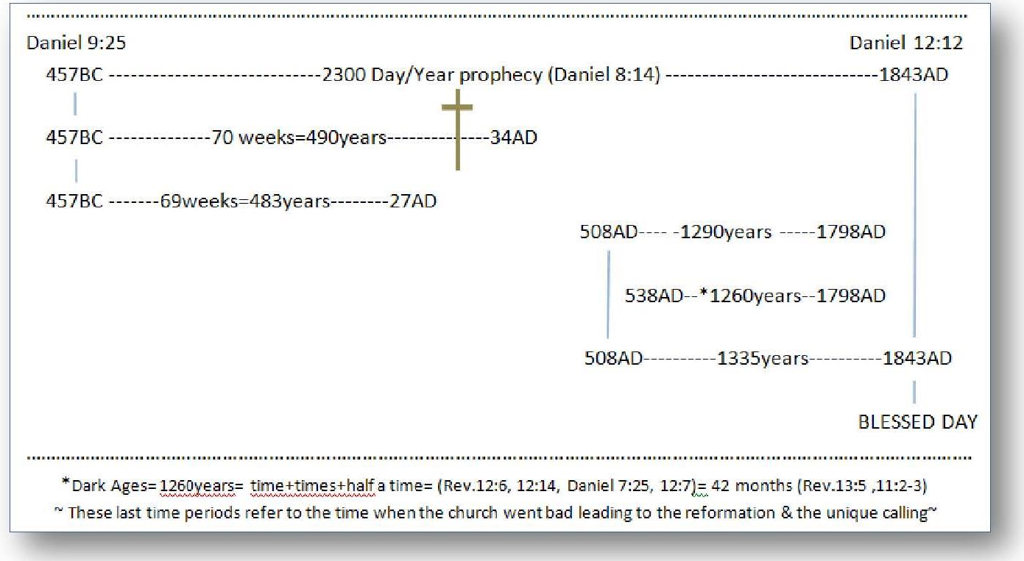

Isaac not Ishmael was Gods choice, Biblically speaking, for one reason; he kept Gods Covenant. Look around at all of the world’s religions “who claim the God of Abraham as their creator”, and you tell me which one to this day keeps all of Gods 10 commandments if only by faith. It’s easy to see why then the claiming christian churches (small “c” intentional) have fallen too evolution of any form, because, it conveniently separates them from Gods history that binds them to a literal creation of the 7th day of the first week, which is the central point of Gods (1000 generation) perpetual Covenant, they just can’t justify by their choice. (Romans 2:11-13) RU1?
I must interject here; their journey was delayed 40 years because of their reluctance to follow Gods instructions, before and after they made up the first church. This weakness of not following Gods instructions, Commands and Covenant goes back to the first act of disobedience and the first sin by “our” first parents, and as we know; this inherited weakness has plagued mankind down the line till today! We of our own choice must overcome this weakness as Gods people/church “through His power He offers us”, BUT, we must accept it as our gift of life, as our way of life, as did our Savior, we must accept our Fathers instructions for life now and forever. (John 14, Deut 30:19) “If you love me” He adds to this choice….
See also “The Sanctuary” a follow up study on Gods church.
That’s like saying forever; for a thousand generations of mankind, church or no church, of God’s people, that’s how long? 40x1000= 40, 000 years will His Covenant (the Ten Commandments/Covenant) be enforce. The Messiah then comes along and defines, and re-enforces for us how long He says (to a mixed multitude in His first public sermon at the beginning of His official ministry, see “time prophecies” this site) just how long Gods law will last; (Matthew 5:17-18) (all of them incidentally - every dotting of the “i” and crossing of the “t” that makes up the Ten), therefore every word including the 7th day as set “in time” will be enforced by God, it’s that important to Him and should be for us as His people as His church? Please understand the significance of this!
To the person who says I’m just stringing texts together to make my point; read each one in context, and really my friend they are not my words but Gods given that you and me can know His will and be able to stand in the cleansing fires of hell on that last day where no sin will remain alive nor the harbors thereof. Those texts only seem to be disconnected because the deception has blinded your eyes.
Jesus said in John 14 that He and His Father through the Holy Spirit would help us love Him through obedience to His commandments, so I ask; “which one of the Covenant requirements will He let us do away with as the church/people?” Murder? Heaven forbid no! Lying? Adultery? Other voices another’s will other than Gods? Idol worship even in the church? No absolutely not! So which one can we eliminate re-write or change its context? Surely not the one that has His name attached to it as our Father Creator, His/our Lords S-Abba-th to reflect the SUN the object of heathen worship forever? You tell me, but please get my point before you say; “yes I accept that change “, as most do today worldwide, and yet still claim to be worshiping the God of Abraham, they think by the power of the Holy Spirit? Paul says no! (Hebrews 10:26-29, 30-31) Absolutely not, in fact just the opposite! So who is it that’s really giving you power, power to do who’s will? What Spirit, certainly not Gods which is trying to supply us the power we need to serve a living God, how did Paul put it? (Vs. 31) But who fears today under the deception? My prayer for even myself is; that it’s not a deception Gods has allowed us to be comfortable under, (2 Thessalonians 2:11 in context) for remember; the deceived do not know they are deceived or they wouldn’t be, because most today read the above verses and think they do not refer to them. Is that deception or not, you tell me? I do know our only hope comes from a thorough search of God’s Word for the answers while looking nowhere else, no other word!
Check out this example; When He our Lord called the first church out of darkness, His first test of obedience was His Sabbath worship to see if they would follow Him their creator and live as His chosen. (Exodus 16:4, 22-23), The Bible gives an example of how important this one command is to God, (Numbers 15:30-35) do you really think the same judgment will not be applied today? If so, you are like Israel we read above in Malachi, and as He told Cain; The serpent is always at the door with his deceptions, (Genesis 4:7), as He told His church through His prophets, (Ezekiel 18:20-32) and as He warned the Jews their leaders are wolves in white clothing, (Matthew 7:15) and as He has warned us through prophecy “come out of the false churches my people. (Rev. 18:4) Are we listening, do we hear with deaf ears as the first church/people, and then just walk away as Cain’s race?
Led by the Lord of course, but also Japheth’s descendants. (See “The Universal Religion” this site for proof)
See “Convinced” this site for more than enough proof.
If only “by law” enforcing her doctrines and traditions under penalty of death, (Rev. 13:15) as she once did, (Daniel 7:25, Rev. 13:4-9) once she gets her foot in the door of this last and once God fearing nation. You say that could never happen, but you forget the power of evil in just removing God Covenant reminder from the sight of man (court house, all public properties, in schools!) because it offends the evil ones who are against religion, the anti-christs and all the false religions as God has defined them to be. All, my friend, easily distinguished from the people/church God has described that will be His remnant people/church in the end, as opposed to those who don’t want to follow Him, His ways, His laws that govern eternal life, His chosen. (Rev. 22:14-15)
In the end my friend the Truth of this message, (not from me but from Gods Word) will be known by everyone of whom the Lord God has called, leaving all who choose to continue to follow the beast and her worship, over Gods He placed in His Covenant, and in so doing is the willful sin Paul spoke of in (Hebrews 10:16-29) causing them to do “despite unto the Spirit of Grace” and a rejection of the Savior who shed His blood that we might overcome sin, (I John 3:1-11) and that is the result of rejecting His Law/Covenant when we see the Truth. Think about it; if the Law will be what judges us for life or death, (James 2:10-12) and if keeping it is what gives us our right to enter into heaven, (Rev, 22:14) do you once think God is not going to show us this truth that; “He wants to place into our minds and hearts” if we but let Him! Didn’t we just read what Paul said to the Hebrews of the first church, having now become members of the second church Paul was counseling, who should have already known this truth about willful sin? If however; we will not let Him, our Lord, place His laws in us through the promised Holy Spirit – John 14:15-18) if we will not let Him come in and place His 10 Commandment Law in our minds and hearts (all Ten James just told us) then; we will be denied entry in heaven as a result, of willfully ignoring or blatantly breaking His Covenant/Law/Commandments, which we know “He paid such a high price to fulfill for us, and His offering wasn’t just a blanket for all people/church but for you and me personally.” What does your mind and heart say to Him right now? Do we really love Him that much? (John 14:15, Deut. 5:29, I John 3:11, 16) Q. “Do we love our neighbor enough, to want His testimony living in us that they might see the Message God has given the church here in the end, or not?”
Death eternal! Not the eternal death as the Beast teaches, will the reward of the lost be; eternal death is absolutely not “eternal torture in the fires of hell” as the God of S-Abba-th would judge? “God forbid” He is a God of Love? Come on now does that even make sense that our God would do that? That sounds like the beast; “obey me or get tortured”, at least she was forced by nature to let them die, but; in telling her “eternal punishment lie” she is really stating her wishful intentions as god on earth, she claims to be, but without the power to be so and make her threats real. No, that’s one of the great deceptions she has scared people with for centuries and now you with, to deceive you into her camp or into her daughters religion that teaches the same lie, no difference. Being just one of the many doctrines we must “also overcome”, and that; through Gods word, which only can we trust “not the church and her promises” which she can’t keep “standing on the outside of the gate where she already stands!” (Rev. 22:15) That is Gods fearful scare and as John was shown. Paul put it the same way (Hebrews 10:31) as he is identifying the two groups as did John. (Hebrews 10:26-31, Rev. 22:14-15) One group is pictured as following the truth the other the lie. Where we stand now may very well tell us where we will stand then. Please take Gods warnings of love to heart, and stand with Him on His promises to those who will serve Him “now and forever!”

