The TESTIMONY of JESUS
What is it really?

It might surprise you to know that our Lord Jesus told us what His Testimony was and still is, and we find that in a book compiled by John the beloved, but, when we read the opening lines of this book we discover it was actually a book authored by God Himself and then given to Jesus, who gave it to the angles, who then gave it to John to compile for us.

That calls immediate attention to this book does it not?

If not, you had better ask yourself “why”, for the days are short and the hour is late.

anyway;

This book contains “the last message to mankind” sent from heaven for us, all of us, as the end time people, as the last church, primarily given for earth “to prepare for the soon return of our Savior”, (Rev. 1:1-3, 22:16-20) and listen;

As Daniels prophetic book was closed until the time of the end, (Daniel 12:4) this book as well, could not have been “fully” understood until near the end of time, our time, as the prophecies unfolded and the “time was at hand”, as you noticed, if, you read those two texts taken from the last book in the Bible last page.

Placed last for a reason in a sense that;

If you got nothing from the whole of the Bible “which laid the groundwork for the Eternal Gospel” starting from Genesis to Jude, and even though Jude wrote his book some 30 years prior to Johns, it was placed next to last before Revelations because it seems to sum up the Gospel in essence if you read it you will see, but, you will see this more clearly, once you have studied this last book in depth, that “the eternal Gospel has been capped off by Revelation no doubt.” (Rev. 14:6)

John saw this message being given in his future, given to the end time people by the 3 angles, sent from God and the Lord remember, and it’s a message, if none other, that you should at least take very seriously as “the Gospels summation” found there in the last written words from our Father to those of us in this last generation of the church.

The church that was established by the Messiah (The prophetic Corner Stone Matthew 21:42), and really friend, if you think about it, talking about the church set up by Him, if you really search it out; “nothing positive happened from the time that Messiahs church, was perverted early on in the 3rd century AD, till near the end of the 17th century.

It’s true and that’s why that period is called “the Dark Ages”, and why was it called that?

Because it was “Spiritually Dark” for the most part, well over 1000 years!

So technically speaking; the last – “really last” generation “who would benefit from this last book, through the fulfilled prophecies it brings forward “is us”, because, most of those prophecies were fulfilled during that spiritually Dark Age, and too; their full understanding wasn’t really possible until essentially the 18th century (the 1800’s), around the time when the last stronghold for the Gospel was founded and the darkness lifted, and this was all predicted by God. (Daniel 12:9-10)

It wasn’t until then “The Christian Gospel” could once again do its’ work in a land where freedom for religion and “freedom from religion” was established in a new world, and not influenced nor controlled by decades of false worship, false religions and religious persecution, and that place being “the Isles of the Gentiles”, from Britain (Isle) and then to America (an isle in respect).

That progression was even foretold in Genesis through the linage of Japheth, search it out and you’ll see its true, and of course “history proves it to be”. (See Appendix “Sons of Noah” and the dispersal of the tongues)

How long this Christian stronghold lasts, is how much time this generation has to prepare worldwide, and it’s slipping away piece by piece every day, and has been for a long time by now.

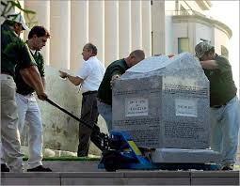
All religious artifacts are in jeopardy now days, starting with the Ten Commandments here in “America”??

It is here then, this last book of Revelations we can read and even study in historical depth with understanding, if we are wise (as Daniel just told us vs. 10) here in this land of freedom of the conscience if we throw out traditions and false doctrines that have kept the church dark even to this day by the same religion that founded them, and in so doing, it’s here in this last book of Scripture heavens last warnings that we find; “as stated by God” mind you, telling us, through the Lord, through the angle to John, “what the testimony of Jesus” really is, notice;

Revelation 19:10 King James Version (KJV)
¹⁰ And I fell at his feet to worship him. And he said unto me, See thou do it not: I am thy fellowservant, and of thy brethren that have the testimony of Jesus: worship God: for the testimony of Jesus is the spirit of prophecy.

Did you notice also, that those who are of the brethren are also fellow servants?

Of whom we too have been called to be, should we choose, and for us as did John, we discover, we can be friends as well, (John 15:15) even sons and daughters. (I John 3:1-2)

That is, if we desire this testimony and “the gift of prophecy” this books message brings forward, to and for us, and this is something we should choose, Paul says; as “the most desired gift” from the same Spirit as Jesus had, the same Spirit who sends to us these prophecies which are the Testimony of Jesus to us, get it? (I Corinthians)

We should also have, or should take on then, however you want to say it, “the testimony of Jesus” ourselves! As did Paul, as did John, Abraham, Moses etc. who, get this now; are “just” (a double positive), men and women like us who are called to pass this testimony down, including all those who took it to themselves in all the ages; “the testimony of the Lord”, of whom we know preexisted before coming to this earth, One who was involved in its creation, and the One who is involved in all aspects of mankind’s lives, especially our religious lives, of whom, did the witnesses of the “Old Testament”, get it “Testament”, of whom, did the faithful witnesses inscribe, and handed down that witness (making it the prophetic/gospel), until the day the “Testimony” came in the flesh. (Hebrews 11, 12)

The “One” who came as Promised, to fulfill that prophecy and “testify” of the Father for our example in righteousness, the righteousness as inscribed in the “New Testament”, through His life witness and testament.

The Lord who not only created us (John 1:1-8) but will re-create us in His likeness, “His image” of righteousness that we know from “His Testament”, having seen Him, and it is Him that wants to create in us “His Testimony” (Hebrews 10:15-16) “if” we will let Him, this is; the New Covenant!

Thus friend, the Testimony of Jesus has been defined for us from creation, when there was just two of us who walked and talked with the Lord personally, and then His Testimony was defined more clearly through the ages to the flood (by His followers e.g. Enoch, Methuselah and Noah who also walked or talked with God), and then, after the flood His Testimony was shown even more personally through Abraham who exemplified for us what following God really means e.g. “Isaac”, in sacrificing and giving all, or at least being willing to do so.

Then, His Testimony was given to Moses the Intellectual Egyptian/Jew; who learned of Him through trials and errors as do we; even denied, you remember “the first promise land” but not the second, for He was so close to the Lord, angles were sent to raise him from the dead and, he was taken to heaven as you recall. (Jude 1:9)

But His Testimony was most clearly given to His first church, the one He formed at Sinai, when the Lord wrote down His character for mankind to live by, “His testimony” on tables of stone, and He spoke them clearly in the ears of the first church from the fires of Sini. (Exodus 25:16, 21-22)

Then He had Moses place those stone tablets, with His inscribed Testimony on them, in the Ark of the Covenant, for that Covenant, and the ark that held it; represented His very essence and presence in judgment yet mercy and love for His creations? (Revelation 11:19 , Psalms 33:4-15)

He gave not only to His first church, (Exodus 25:16, 21-22 did you notice He called the Covenant the “testimony” vs. 16) He not only gave these testimonies, as His Laws, to His first church but, they are also for us. So that we, individually as well as the church, may become like Him and His Father in righteousness (John 14:9-31), and have that testimony inside us, in our minds hearts and hands (works), actually that’s the New Covenant we’ve learned-right? (Hebrews 8:7-11)

I’m getting ahead of myself, but, this was what Israel was to do themselves, but as the Lord said “they didn’t” thus, they were the cause of it having fault, not the Covenant itself “God made” mind you!

To think this, as 99% of modern religion is being taught, is to think that God creates failure - God forbid! (Hebrews 8:9).

We are going to read more on this all important thing for us to get straight, but, for us who see the Truth, as we just read; “the Lord will work His Laws out through us if, “if” we will simply just let Him, despite the false teachers, and allowing Him to do so will make failure “impossible”! Unless that is we follow the world of false religion and reject His “Testimony=Covenant=Commandments=Laws” we now know, and understand, are all the same thing when it comes to salvation.

Think about this; if we think God made a defective first Covenant, and we reject His Covenant laws as a result, which we saw are also the second Covenant, then we will never let Him put His laws, being His testament His Covenant the Ten Commandments (all the same) in us!

If we fall to Satan’s deception out there and reject these, then in essence “we are rejecting the Lord” who wants to place them in us, so, we will not fail as did Israel, and be rejected as were they, and remember, this rejection is what led to them even killing Him because they didn’t even recognize Him as the testimony “they were to usher in” (Daniel 9:24), much less that He reflected what their Testimony should have been, but was not, and they were given ample time (483 years) to have let the testimony change them into what God requires of those He loves and has called to be like Him, and more important to reflect Him to a deceived world, it’s no different now than it was back then. (They had ample time for preparation and were forewarned through prophecy, but they did not and would not, and killed their only hope for salvation as a church as a people. Daniel 9:24, Matthew 23:37-38)

We kill Him just the same today by rejecting Him in wanting to place in us His testimony as did Israel, and in doing so, we reject the Holy Spirit as well, and that’s why Paul wrote what he did about willful rejection of Gods knowledge given through His laws to us. (Hebrews 10:28-29)

Because of deception, ignorance and willful rejection, this is the message the churches today will never hear, and as I said, we will see this more clearly as we go on, and listen; “this is the main purpose of this study” in helping us see how “the Testimony of Jesus” was composed for His followers in all ages! (Deut. 6:1-9, 17)

Did you notice in that last reference, how again we see; His testimonies= His testament= the testimony of Jesus do you see it yet? There are a lot of semantics in scripture as we see, words used synonymously with each other, that are, or mean, or explain the same thing. Such as the symbolisms, God uses in prophecy, for things meaning the same thing e.g. “a woman in prophecy is a church”, a purer one (Rev. 12:1) or a false one like a whore in Rev. 19:2)

This was the first churches challenge, (See the book “The Church” this site) as were all those who were privileged to walk with Him in His testimony both in the Old and New Testaments (Hebrews 11:5), like those who walked and talked with Him personally, as the Apostils and disciples, and even those as Paul; once an enemy but who then having discovered the Truth, as we are now, who then had a personal faith based on his spiritual relationship with the Savior, even, after having been responsible for persecuting Him and His saints. (Acts 22:7)

Showing us how wrong we can be in believing the lies out there in the churches, making us not only a false representative of the testimony of Jesus before the world but, leading others to deception and possible rejection by the Father himself. (II Thessalonians 2:1-12)

We as Paul, no matter what religion has led us into, we too can accept His challenge and follow His testimony, should we desire to do so, if not, who are we really following, whose testimony are we a testament of?

The Testimony of Jesus, as we have seen in the lives of the apostles, was not all peace, love, and Kumbaya, but comes with challenges, even for the Savior Himself, thus, with much endurance, hardship, trials, sacrifices and even death they were tried, to become like the Father, and to dwell with Him through the spirit on this earth and in heaven someday, “Face to face”, having overcome of course those challenges with His help “in them, in us” and through His blood. (Revelation 12:10-11)

Isn’t this our desire?

If so, then we need to see from “the Testimony of Jesus”, which is, as we discovered, “was and is the Spirit of Prophecy”, we need to see however, just what it takes to become the sons and daughter of God, and to see Him as He really is, to be like Him, (I John 3:1-2) and listen; as I’ve said, you might just be fooled as to what it took Him to be like His Father, and what it will take us to be true followers, as all the above has described, as the many who came before us “seeking such”.

“Really” following the Lord, might not be what you have thought it was or was told by those who really don’t want to follow Him “all the way”, and listen, it’s more than just faith and grace even for Jesus; (Rev. 2:7,26, 3:21, 21:7)

Going on in (I John 3:2-11) we see things the nominal churches don’t teach, and, the scriptures throughout speak not only of those who follow, but, those who do not choose to follow Jesus fully; (John 14:15-17, Rev. 22:14-16) His testimony is defined here in this prophecy when it says “He testifies” John records, notice “I Jesus..Testify…” vs. 16, semantics right?

¹⁶ I Jesus have sent mine angel to testify unto you these things in the churches. I am the root and the offspring of David, and the bright and morning star.

If you read on in that chapter you’ll see the day of His coming back is obviously at hand, especially as we look around and see the world becoming as Sodom and Gomorrah once again, homosexual priests and all; (Romans 9:29, Jude vs. 7, Matthew 11:24) we are seeing the world today as it was in the days of Noah, (Hebrews 11:7) as in the days described by the Savior in our future. (Matthew 24:37), (Hebrews 3:7-15)

Tomorrow may be too late, for us to start taking on the Testimony of Jesus; time is against us on every turn; whether old age or accidental death, we all face just a few years to prepare, and it takes us a long time to make up our minds, and sometimes friend, “change is not what we are willing to do” especially when it comes to religion, but make no excuses, the day of the Lord will come as a thief in the night when we least expect it, (I Thessalonians 5:1-20,21-28, II Peter 3:10) when that great edict is given in heaven (Rev. 22:10-12) that marks the end of time for preparation, and then then Holy Spirit will no longer strive (Genesis 6:3, Matthew 24:37) with us for a decision, and whatever that decision may be then “will be set”, and the Spirit will be lifted at His coming, and He will gather all who allowed Him to become His saints. (2 Thessalonians 1:10-12 notice testimony)

Saints we are called to be, “if”, we allow Him here in the end of days, to place His Testimony in us. (Jerimiah 31:31-34

Paul repeats this scripture for both the new and the old Converts to Christianity in front of him but it’s recorded for us as well, all who were henceforth being called into Gods house, because they and we are grafted into Israel. That’s why the New Covenant Paul speaks about is for the house of Israel, or we could say “church” instead of the house of Israel and Judah, because we are, as they were, called unto God individually as well as the church.

Paul’s writing to our church today, to us as followers called to a higher calling; Hebrews 10:15-16

John saw the fulfillment of this calling in those who make up Gods church those who stayed loyal to the Testimony, notice “testimony as the faith” Rev. 12:11, Rev. 12:14, 14:12, 22:14-16) and they counted His blood as their only hope of life eternal with Him. Not as the world, who as the Jews didn’t even recognize Him, but we will. (I John 3:2) For we will be like Him (not perfect of course) but striving through His indwelling Spirit to be like Him and not the world, especially the church of the world, having the Beasts testimony and not Jesus’. (Rev. 22:12-14)

But we, after having overcome, through Him and “by Him working in us”, we will have right as He promises; to enter into the heavenly gates wherein dwells the tree of life and forever be with Him, our Lord and Savior sent from God for us, and certainly, should we be the only thief on the cross who had faith in who He was and is we will be assured salvation just the same.

But listen, you once saved always saved saying it’s by faith alone (including you Venden’ites) get this; “Had that thief come down from the cross alive, and had second thoughts or turned back to his old faith, his old ways, his fate would have been different” even having been promised heaven, and something else; he didn’t go to heaven that day nor did Jesus, who, even after resting over the S-Abba-th day, from His works of saving us, he didn’t go till that “high Sabbath” had passed, on the first day of the week “Sunday”, and we read “only Jesus went to heaven not the thief, and according to historical descriptions of Roman crucifixions, that thief who only had his legs broken, probably didn’t die till several days later and was buried.
“Saved - yes” there on the cross by faith, but, as everyone mortal, he with us, including Paul will only receive immortality (living after death) “at the last trump and not before, when Christ comes.” (I Corinthians 15:52-53)

Or we may as well throw out Paul’s fabrications from scripture, but friend, the Bible is clear when we receive life eternal even if we had only this one text, and Jesus’ promise in His last words of when He gives His rewards of eternal life. (Rev. 22:12)

So please Keep this in mind at the next funeral you attend when your preacher preaches a person into heaven, and say they are looking down on us weeping etc. etc., and you will see how he treats the scriptures “with truth or error”, you might just be fooled, as he is, and friend you may have an excuse because you depend on him for truth, but he has seen the truth and chooses to follow tradition instead, and as Paul wrote in II Thessalonians 2:10-11 we’ve already read, his fate is sealed, yours is not, mine is not yet?

May this little piece help us see who Jesus really was and is, as “His testimony” has shown us; through “the Spirit of Prophecy”.

~mosescats~

THE SPIRIT OF PROPHECY
Which is still the Testimony of Jesus….

Way back there in the Genesis was the prophecy given, that one day, the Messiah would come to die for the sin problem our First parents fell to through deception.

This was the first “prophecy” given, that “testified of our Savior”, in a promise He Himself made; (Genesis 3:15) That He would come someday and deliver them from the enemy.

Can you see it?

Right there in the beginning of our story, which was beginning to unfold, we have the first connection of the “Testimony and prophecy?”

Adam and Eve saw it I’m sure, and I’m also sure that this was “their testimony” from hence forth to the world, of Gods promise (prophecy).

The next Testimony of the Lord, of big significance, was in His dealing with sin and because of sin; “was the prediction (prophecy) of a pending flood”, and Noah believed and preached for 120 years Gods warning (testimony), but, how many had faith, much less entered the ark?

“One” it seems, (Genesis 7:1) implying to me when He said “You only”, the others were just tied to his apron strings as it were, but none the less they were saved.

One was tied, but not to Noah’s testimony, but to another’s, and sin “too soon” began to raise its ugly head once again, but God; by confusing the tongues, (languages-is what tongues really are in the Bible and not gibberish- God forbid 1 Corinthians 14:1-6) thus, by confusing the tongues God delayed the effect of “the passing on of sin”.

At least till now with the information highway heading us towards, a one language scenario again “1’s and 0’s”, in our intellectual society, and I say intellectual in a very broad sense, intellectual at least in man’s ways, in man’s images and the most popular of those images are “not Gods” sorry to say. Whether innocent or hard core, their results are the same are they not? Be careful of your answer.

Noah prophesied; that a day would come when the world would be destroyed, and that; was the Lords testimony given to him, and Noah’s time was just like Jesus’s time when He came the first time; He testified, prophesied, in comparison; that there was coming a day in our future like no other time has been before, a day in the end that would be even spiritually darker than in Noah’s day, darker even as in the “Dark Ages” rightly called, however, this coming age Jesus predicted will be a period darker than it has ever been or will be (Matthew 24:11-13, 21-22) and, unless we are prepared mentally and spiritually we will not make it, and we will give in to the image of sin and its coat tails/tales, whatever they may be, and in some things religious, some have already given in, even in their worship practices. (Rev. 14:9 He’s talking worship here and religion naturally is included)

But that’s another prophecy we will get to, but, let’s continue to look at more of the predicted testimonies of Jesus;

“I Jesus, testify of these things” He always says”, so, we are talking about things He testified and gave through prophecies, and all of His words are prophetic in some sense of the word.

The prophecies of God were always given through the Lord, then to the angles and then to the prophets through all the ages leading up to His first appearance. (See “Prophecies the Church Missed” this site, John 14:10-11, 24)

They (God-Jesus-angle-prophets) even gave prophecies concerning the Messiah, so when He did come there would be no misunderstanding about who He was as we just read.

Of course the Jews, His first church, didn’t recognize Him when He came bearing that “Testimony”, despite the fact that He showed them His character many years before “written on tablets of stone” (John 14:21) at Sinai, and just as Jesus was instructing His disciples here, was exactly how He instructed His first church concerning His commandments and His testimonies back then (this is an important connection to get); “they were instructed to take them into their hearts and minds and lives” (Deut. 6:1-9), so that when He came they and their sons and daughters were so familiar with them that they would automatically recognize Him, and this by His Fathers testimony He had in Him, “by His works alone” none the less. (John 14:11)

The Jews however lost touch with this “spirit of prophecy given them” (Deut. 6:1-2) and didn’t see “this testimony of Jesus” being lived out right in front of their face.

The church today, the people, are just as guilty (and blind might I add) by claiming; “the Ten Commandments of the Father and the Lord (the Covenant none the less) were dissolved into just two commandments”, but, if you noticed in that last verse, way back then in Israel to the first church, those same words Jesus used back then are the same words He used when He came, the words they say He used to change the Ten Commandments into just two?

Why would He do this?

Get this now; “if He did, He would be doing away with the S-Abba-th commandment the one they especially want to get rid of” as well as 6 others.

Which ones I can’t imagine, just to prove a contrived doctrine, in which about all the churches have bought into, it’s false of course, and the reason is right there in John 14:17, 23-26, and friend, it’s actually a rejection of the Holy Spirit none the less as we can see, who’s trying to place in them/us Gods Testimony - His Character so we will know Him as He is! Not as the world and false churches present Him to be but as God has presented Him (Son) to be, and us to be as well.

Please notice: this is important in what the Covenant, being the Ten Commandments should mean to the church Old and New and us; (Deut. 6:4-6) that’s the old wording, now compare the wording with what is claimed to be the new Covenant commandments (Matthew 22:35-40) and realize, these supposed “New Covenant commandments” are simply the “principals” upon which the ONE Covenant “all Ten” precepts “Old and New” are based upon, those same principals!

Did you notice the wording He used; “on these two” “hang all the law and the prophets”, the ones (prophets) who testified of the prophecies, who have testified of these principals throughout time, “including Jesus Himself”, and for mankind to become and testify of such to a dying and lost religious world. (Isaiah 8:20)

I could actually stop with this text alone which makes the point I’m trying to make, but there is so much more proof yet to learn of.

So you can see, should see, obviously must see by now, how this all ties together with the Testimony of Jesus, the one He gave before He came, and the one He gave when He was among us, and then, even after He left He sent us this same “principled Covenant message” and a glimpse of His future people and church, showing us that our testimony should be as His, as He and His Fathers have always wanted it to be in us, (Rev. 22:8-14) and it’s a promise, they will come into us and help us keep them, “all 10” of them not just two! (John 14:21-23) The two fulfilled will be the result of all ten in us; we will love God and obey His will as David (Psalms 40:8)

This is the most important aspect of this study on the Testimony of Jesus and how it applies to us His church even today, those last four verses in context says it all.

Here’s how it was in the days of the first church, and may I add again; just as it is today because of the blindness to the Testimony of Jesus and why, and listen; we are talking church leaders who are the most guilty leading the people to blindness “because they are blind today to the knowledge of the principals of God, (John 14:17, Isaiah 8:20) why? Because they have chosen to be by their faith and their works which are contraire to Gods.

Here is how it was in the days of the Messiah;

Three Kings came from the east to the head of the church of God seeking the promised Messiah, telling this, “claiming to be man of God”, that they had studied the ancient prophecies, and that it was the appointed time for the Messiah to come, and He was to be born a king of the Jews, and they had come to worship Him.

Herod, the reigning head of the church in Judea, a Rome’s man politically and spiritually, immediately called His man in charge of the prophecies and was told, yes, this is part of a prophecy of old.

Herod not asking for a complete study of the prophecy or if it was really a true revelation or not, he simply ignored it as the church leaders do today, because of its possible repercussions of course, Herod remembering what the three wise men had said (Matthew 2:2) called for all new born babies to be killed to protect his political position.

Destroy the messenger and destroy the message that became the churches modes operando hence. Get rid of the threat before it becomes one “despite the truth”, in spite of the prophecies, ignoring the promised testimony of the Messiah to come.

Like I said, it’s no different on this side of the fulfilled prophecy, get this;

In the Dark Ages when the Pope, the head of the christian church then, (small “c”) who also was “directly appointed” by Rome the fourth World Empire (the fourth beast of Daniel 7), appointed as was Herod, to control the church for the empire”, and acting just the same; in that when the Popes priests got too familiar with the Scriptures, and began to see
through those same prophecies that the wise men from the east studied, and then seeing that the prophecy pointed to their very church head as “the Beast of Daniel and Revelation; blaspheming God, persecuting His people, changing His worship of the “law” commanding a specific “time” of Gods worship. (Daniel 7:25, Revelation 13, 14)

The Pope called for these men, and all who subscribed to them to be killed as heretic’s, to protect his political position as did Herod, despite the prophecies and the testimony of Jesus that confirmed them, thinking himself above them and even above God himself, at least as far as earths concerned. (Daniel 7:23-26, Daniel 11:32-37) Thus fulfilling prophecy, to the tee mind you.

Today, following after the mother church (Roman Catholicism) in her traditions and worship day, 99% of the Christian claiming churches, having lost site of the Spirit of Prophecy, as did Herod’s Jews being Gods first church, and as a result, they do not even recognize who it is they are really worshiping, and above all they can’t see the Testimony of Jesus as the author of the 7th day worship as set at creation and as a central point of the Covenant of God and mankind’s relationship with Him, as mentioned in that last text, and they can’t see the most important fact that the Covenant is the very thing that is going to judge them, (James 2:10) and further more; that’s why they have placed on the law books of the land, a land which has come to be the only place where Christianity can function unabated, at least to date, they have placed their law under this same beast powers influence, making them the image of the beast, (Rev. 13:12,17, 14:9,7) who, along with the beast they have passed a law that restricts work on “their worship day” under penalty of fines and imprisonment, and eventually death according to prophecy, (Rev. 13:5-9, 15) and those laws my friend are just waiting to be executed as “Sunday Blue Laws” (do yourself a favor look this one up).

Just hid in the bushes and watch for its re-emergence, because, just as it was once the churches earliest laws, “when heretic’s by the millions were killed for not accepting Her day or simply working on that day”, so too, will it be in our future near the end. Take heed as the verse 9 above warned.

This one day of no work sounds like a not so bad thing on the surface as Clinton, Graham and most protestant heads agreed If only to slow the pace of life down and have time for god, worship and doing good, and of course uninhibited holiday exercises and all their dressings, sounds convincing doesn’t it?

Will you vote for it?

But what about the poor guy who has to work three jobs, on all the Biblical work days set by God (Exodus 20:10, 31:13, Hebrews 4) to survive, and who keeps His 7th day S-Abba-th holy according to the Covenant, who needs to work that 1st day of the week, and can’t afford to miss two days out of his work week to get by?

Now you see why those who still keep and do Gods Ten Commandments are considered to be following a cult, and they go on to say; “after all those laws were nailed to the cross and now only two laws are binding to man under the new covenant, and if those infidels really loved mankind they would accept the traditions of the churches, and if not, so be their fanatical fate, and after all, how can everyone else be wrong and only them right”, they add.

Showing that they have lost site of the Prophecies and the Testimony Jesus gave, and left as their example and the answer, thus, they go on satisfied they are doing Gods will. (Matthew 7:2-21, 22-24) just as did Paul, ignoring the testimony, who also lost site of the prophecies “or, get this, he would have known who Jesus was” as one of the intellectual chief leaders of the church of the day.

Can’t we see, in the history of the church; (See “The Church” this site) don’t we see “when the church loses site of the Spirit of Prophecy they destroy the testimony of Jesus and don’t even recognize His connection to the Father”, and they loose site “that only through Him can we even see the Father and have eternal life.” (John 14:6-15, 16-28)

Just as assuredly todays church as did the first church, kill their only hope one physically the other spiritually, and why?

Because they didn’t/don’t recognize “The Testimony” Jesus was giving.

So as it is today I repeat; the second church has also not only forgotten His Testimony, even His 7th day S-Abba-th, destroying then the Testimony of Jesus, Spiritually, even Paul’s testimony and why?

Because they have lost site of “The Spirit of Prophecy”, they don’t and won’t accept the Testimony of Jesus as John described, and, this is why Paul stressed the gift of prophecy as our greatest sought after gift, (I Corinthians) even over teaching and preaching and all the other gifts, and now we can see why they can’t understand, how it is true; “that the Testimony of Jesus is the spirit of Prophecy”? (Revelation 19:10)

If don’t see it yet, please stay tuned as we go deeper into this subject, as if we really need to!

The first church misinterpreted the prophecy about the birth place of Jesus (Micah 5:2) because they were blind to the prophecies, when they are so clear, as was His birth place the Kings of the orient saw and found in prophetic time.

Clear even in giving the very year He would began His ministry, in 27 AD (Daniel 9:24), it even told of the length of His ministry (Daniel 9:26 70 weeks – 69 weeks leaves one week or 7 days (or prophetic years) and after 3 ½ years exactly of ministry Jesus was crucified in the midst of that week (in 30 ½ AD) He would be cut off by death but not for Himself (because He had no sin, He did it for us), cut short by His crucifixion just as the prophecy told, and then the prophecy tells of the very year the passing off of the gospel commission to His second church the Gentiles, at the end of that 70th week (in 34 AD), by Gods rejection of the first church, who of course rejected Him rather than follow His preparatory commands given in that prophecy, and the time to prepare, and had “they not lost the gift of prophecy” they could have known the very year of the Messiah, all this from Daniels visions of chapters 8-9 of the 2300 day prophecy. (See Appendix “Time Charts”)

But let us stop here, and read about these things as they unfolded through prophecy and the fulfillment thereof by “the Testimony of Jesus” in person, which is our subject. in seeing how His whole life was a testament, prophetically foretold, and then given as a testament for us, and then, as we see the fulfillment of those future prophecies He gave us, both while here and those He sent back from heaven after He left, we will have confidence in His Testimonies and surety of the word of God and His ability to not only see the future but predict it as well for us, and listen; they are so important to us that he spent most of His ministry telling of them, and then He had John write a whole book capping off the Holy Scriptures, all for us, the end time church, the end time people.

The book of Daniel, as the book of Revelation, are the recorded accounts of Prophecies given to them by God, speaking of future things that would, and still do, affect Gods people, Gods church.

Daniel was shown the very year the Messiah was to be baptized and begin His ministry testifying the fact that He was the Messiah who was to come, and that He had come right on time, according to prophecy, in a specific time and history. (Luke 4:16-19, 20-21)

All though the reference He gave from Isaiah, about the acceptable year of the Lord, that was to come according to Gods plan, would be witnessed on the Day of Passover in a given year, and that would prove He was the promised Lamb of God.

The Jews should have been waiting on Him every “Passover”, every year that passed, but they lost touch with the prophecies, not to mention the symbolisms, and when that Passover came they were not even looking for Him despite His claims of having come in the acceptable year and that He was the one Isaiah’s prophecies was pointing to.

However they had no excuse when the time finally was due, for through the prophecy given to Daniel the very year for His arrival was given.

Let’s look at that prophecy for it has something to tell us about “our time“ here in the distant future from Daniel’s time, and concerning that sacrifice made for the atonement of our sins as well as the worlds;

Daniel 9: (KJV)
²⁴ Seventy weeks are determined upon thy people and upon thy holy city, to finish the transgression, and to make an end of sins, and to make reconciliation for iniquity, and to bring in everlasting righteousness, and to seal up the vision and prophecy, and to anoint the most Holy.

Here we see not only the first churches challenge, their prerequisites for ushering in the Messiah, we see the prophecy about His appearing on the stage of history to be anointed to spread the gospel by His ministry “His testimony”, and that very year of this event is given in symbolic terms “days for years”, and friends, Jesus knew of this prophecy and He knew it was the year for this prophecy to be fulfilled by Him, for His Father, of whom He was called to testify of and for. (John 14)

Notice what He (Jesus) said in His first sermon, after His baptism in 27 AD and after the wilderness test, when He spoke at His home churches worship service on the next S-Abba-th to occur, notice what He said;

Luke 4: (KJV)
4 And Jesus being full of the Holy Ghost returned from Jordan, and was led by the Spirit into the wilderness…….

¹³ And when the devil had ended all the temptation, he departed from him for a season.
¹⁴ And Jesus returned in the power of the Spirit into Galilee ……….

¹⁶ And he came to Nazareth, where he had been brought up: and, as his custom was, he went into the synagogue on the sabbath day, and stood up for to read.
¹⁷ And there was delivered unto him the book of the prophet Esaias. And when he had opened the book, he found the place where it was written,
¹⁸ The Spirit of the Lord is upon me, because he hath anointed me to preach the gospel to the poor; he hath sent me to heal the brokenhearted, to preach deliverance to the captives, and recovering of sight to the blind, to set at liberty them that are bruised,
¹⁹ To preach the acceptable year of the Lord.
²⁰ And he closed the book, and he gave it again to the minister, and sat down. And the eyes of all them that were in the synagogue were fastened on him.
²¹ And he began to say unto them, This day is this scripture fulfilled in your ears.

You see that very year was the acceptable one predicted (prophesied) in Daniels time (605BC) over 600 years previously, and as you can see Jesus knew His testimony through the spirit (of prophecy) had begun “in that very year! (27 AD)

We are going to look more closely at that prophecy Daniel was given , first lets notice what His testimony was to be according to Him;

His testimony was to include He said;
Preaching the Gospel
Heal the brokenhearted (this is a spiritual healing)
Preach deliverance to the captives (of sin obviously)
Recovering of sight to the blind physically (but more important their spiritual blindness?)
Liberty from the bruises of sin. (Physical liberation from sin through His blood and spiritual sanctification – a purging of sin by His power)

If you look at his purpose in coming, throughout the record of His life, you can’t miss the fact that He was “fulfilling His Testimony” – given by “prophecy” through the power of the “Holy Spirit” for us as His church.

It’s all for us friend; including the Gospel, and given for us to fulfill these very things in us through “our testimony” before the world, and through “prophecy”, John actually saw that happening in his future, by those who accept and put on “the Lords testimony” (John 14:12,23) the one He gives us, to put into our hearts, minds and actions (life style), and those who do this have accepted what the Holy Spirit has revealed unto them as we see in “the three angles messages”, (Rev. 14:6-14) and they have accepted the not only His testimony but the Spirit of Prophecy, as prophecy portrayed by John, being fulfilled in us who live just prior to the second coming.

Notice too they have received the Testimony of Jesus and the commandments into their hearts as requested by Jesus in John 14 we just read. This is what separates them from the world of confused religion and false doctrines, they rely on Gods will and not any mans or church.

We therefore, as Jesus, are called to have the same testimony He had being “the Testimony of Jesus” and that being “the Spirit of Prophecy”, to know, understand and pass this gospel on, for the saving of souls from the decadence and deceptions of sin which have penetrated even the church.

These three angles messages speak of past history unto our future history, and this, my friend is the testimony of Jesus which is the Spirit of Prophecy for us, and through us, for to prepare us for the end of time.

Read as if it’s important for us to understand, because; “it is to God” and that’s why He gave it to us!

Here is what led prophetically to the three angles messages in Revelation 14, in a review of Prophecy given first to Daniel and then enlarged in understanding to John, for to give to the remnant (last) church;

The prophecy given to Daniel spoke of our time here in the end and it goes beyond the Testimony of Jesus we read in, Daniel 9:24 to a time when the last church and people will face the darkest period of time to come, when deception has gripped even the churches save only the remnant church (the last of the true churches of God) which keeps the commandments of God and have the testimony of Jesus. (Rev. 12:17, 14:12)

Listen;

I’m not just pulling texts out of scripture to prove my points, but to paint a picture Jesus wants us to see, and to know and understand it’s “that important to Him”, and why it is He referred us back to the book of Daniel when He was describing our time, and what it was going to be like in the end of time, with all the deceptions, the false shepherds, and the compromised churches etc. (Matthew 24:1-15) All compromising us away from the Lords Words and warnings His Father and He gave for us.

This is the importance of “prophecy” as Jesus testified, as did all the prophets He sent us. (Rev. 22:6)

So let’s go back and read that prophecy about the coming Messiah, and now, we see how it applies to our time, and see also “how it is we fit into it, as a people, as a church;”

Daniel 8 (KJV)
8 In the third year of the reign of king Belshazzar a vision appeared unto me, even unto me Daniel, after that which appeared unto me at the first.
² And I saw in a vision; and it came to pass, when I saw, that I was at Shushan in the palace, which is in the province of Elam; and I saw in a vision, and I was by the river of Ulai………..
¹³ Then I heard one saint speaking, and another saint said unto that certain saint which spake, How long shall be the vision concerning the daily sacrifice, and the transgression of desolation, to give both the sanctuary and the host to be trodden under foot?
¹⁴ And he said unto me, Unto two thousand and three hundred days; then shall the sanctuary be cleansed……….

Daniel 9 (KJV)
………….²⁰And whiles I was speaking, and praying, and confessing my sin and the sin of my people Israel, and presenting my supplication before the Lord my God for the holy mountain of my God;
²¹ Yea, whiles I was speaking in prayer, even the man Gabriel, whom I had seen in the vision at the beginning, being caused to fly swiftly, touched me about the time of the evening oblation.
²² And he informed me, and talked with me, and said, O Daniel, I am now come forth to give thee skill and understanding.
²³ At the beginning of thy supplications the commandment came forth, and I am come to shew thee; for thou art greatly beloved: therefore understand the matter, and consider the vision.
²⁴ Seventy weeks are determined upon thy people and upon thy holy city, to finish the transgression, and to make an end of sins, and to make reconciliation for iniquity, and to bring in everlasting righteousness, and to seal up the vision and prophecy, and to anoint the most Holy.
²⁵ Know therefore and understand, that from the going forth of the commandment to restore and to build Jerusalem unto the Messiah the Prince shall be seven weeks, and threescore and two weeks: the street shall be built again, and the wall, even in troublous times.
²⁶ And after threescore and two weeks shall Messiah be cut off, but not for himself: and the people of the prince that shall come shall destroy the city and the sanctuary; and the end thereof shall be with a flood, and unto the end of the war desolations are determined.
²⁷ And he shall confirm the covenant with many for one week: and in the midst of the week he shall cause the sacrifice and the oblation to cease, and for the overspreading of abominations he shall make it desolate, even until the consummation, and that determined shall be poured upon the desolate.

APPENDIX
SONS OF NOAH

Genesis 9:19, 10:1,5 (KJV)
These are the three sons of Noah: and of them was the whole earth overspread………
………Now these are the generations of the sons of Noah, Shem, Ham, and Japheth: and unto them were sons born after the flood………..
Speaking of Japheth’s linage;
…….⁵ By these were the isles of the Gentiles divided in their lands; every one after his tongue, after their families, in their nations.
The Isles of
BRITAIN
AMERICA
Notice the General dispersal of Japheth’s generations.
Their path led to the Isles of the Gentiles, which has become the last harbor for the Gospel “His” tongue, while the others spread forth carrying “their” own tongues, so, is this not prophetic in a sense? “His” tongue, being the Mother tongue as the “Word?”, which is spoken by the tongue? Synonymous right?
You tell me?
According to my Arabic literate friend - yes! (See “The Universal Religion” book for more details on this important discovery, well I think it is anyway, whether Mr. C.A. thinks it’s not preach ‘able or not, and it certainly didn’t spawn from Africa that was Hams domain! Check it out it’s that important.)
ENCYCLOPEDIC BIBLE - CENTER COLUMN

Notice the date in the center column for this decree, and then read the very decree itself vs. 21-23 in this chapter, marking the beginning of “the 2300 Prophetic year prophecy” as we discovered; from the command to go forth and build up the walls… (Daniel 9:25) One of the most archeologically confirmed dates in history and the Bible, and listen you can’t take any part of this prophecy out of it chronological order and apply it to some future 7 years of secrete rapture’ism, those are Satan’s images he’s trying to put in the minds of the innocent, but, one day all will be exposed and remember we don’t change our religious views on the fly and some never! That day might be today for you like it was me once and it’s taken me 20 years to get it straight (from the Bible of course).

Notice also why Ezra was leading this undertaking and why, vs. 10…
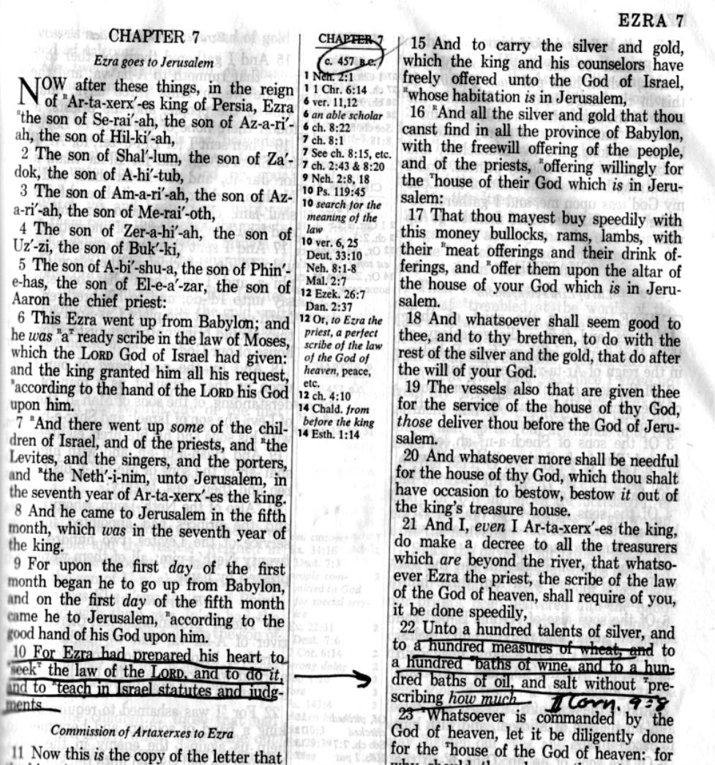

TIME CHARTS

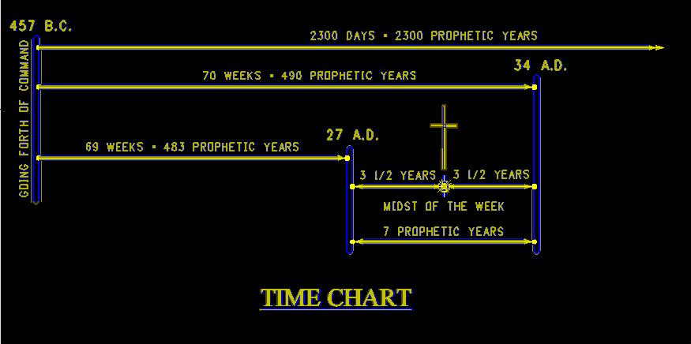

When going from BC age to AD age, since there was no year “0” you must add one year to your calculations; thus 490 (probationary period given the Jews to make ready for the coming Messiah) – 457 BC (year prophecy began see Bible excerpt below), and then, since we are counting the years backwards from BC To AD it takes you beyond the year “0” and 33 years past (490-457=33), but then we must add the 1 year = 34 AD that marked the year when the Jews killed the first martyr Stephen, and Paul was holding his garments in full support of the killing, as he was obviously in support of the killing of the Messiah? However the Jews had already been rejected by the Messiah (Matthew 23:37-38), and it was Paul who would eventually lead the new church of the Gentiles, thus a fixed part of the prophecy 34 AD the turning point, as was the crucifixion in 30 ½ AD as well as the baptism of Jesus in 27 AD.

But the prophecy had more time given as our next chart shows;

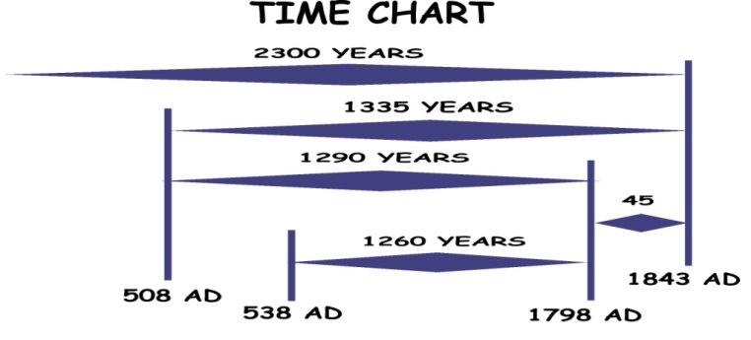
2300 (length of prophecy in prophetic years) – 457 BC (when prophecy began) = 1843 AD without adding the year as shown on chart, but, we must add a year remember thus 1844 AD marked the fulfillment of this longest of time prophecies given in Scripture.

[The other dates shown on this chart are part of other prophecies we will not discuss in this study but available in other studies on this site.]

Not seeing this “adding of a year in reckoning time from BC to AD” was how William Miller miss-interpreted this prophecy when he proclaimed in 1843 AD the second coming of Christ, who didn’t come of course, so learning of this I year application he proclaimed 1844 AD as the time of His coming, of course it didn’t happen again. (See www.mosescats.com “Yom Kippur”)

Why do you suppose God allowed him to make such a blundering error in the days of the protestant awakening having the beast wounded and temporally out of commission, and not able to control protestant America especially?

The answer is; God needed people who would search deeply into His scripture for answers, something the Jews, nor the second church to follow, was willing to do, as He (The Lord) was preparing a people on this side of the Dark Ages to build His remnant (last days) church, one who would stay faithful to the church the Lord raised on the other side of the Dark Ages while on earth, not the one the Beast of Daniel and Revelation poisoned as predicted.

Miller and those who followed his lead saw this poisoning of the beast through prophecy, but came to make a fatal error as it were, but, as the result of making this error on Millers part and those who stayed with Him who searched deeper into the Holy Scriptures, God, raised a people, a church, that would share His prophecies with the world that had warnings about the future of His people, to prepare “all the world” for the second coming that John was shown, who saw prophetically “not only the Gospel going into all the world but a description of the remnant people church that would be proclaiming it”. (Revelation 14:12-14) John was shown the end time people just before the 2nd coming remember.

After the error of the interpretation of this longest prophecy was made, and then understood truthfully, as the date marking when this remnant church would be called into existence, “by this very prophecy in 1844 AD”, in which year there we quite a few protestant churches in existence at that time, but, none took on the call of the prophecy (and still to today eject or ignore it mind you or worse pervert it with false prophecy – left behinds etc.), and it was those back then who, as we read described to John they would be, those that proclaim the “Testimony of Jesus, and those who keep the Covenant (as Jesus) “The Commandments of God”, including giving up Sunday for His S-Abba-th, and like I said; only a few were willing to do so back then in Millers time, and fewer even today, but, it was those who accepted His Word, His Covenant naturally (Romans 2:1-15/Hebrews 10:13-39 Paul is addressing all of us beyond Calvary) those of whom would make up His remnant church people (not perfect but striving to do Gods will through the understanding of His Word alone.

The question is “are we willing to do the same?”, if so, we can then be counted in the description given by Jesus in His last message for the end time church/people, who He described and gave them a blessing/promise.

Revelation 22 (KJV)
¹⁴ Blessed are they that do his commandments, that they may have right to the tree of life, and may enter in through the gates into the city.

The “Faith of Jesus” we discovered is the same as “The testimony of Jesus” and the Commandments are the Covenant.

I pray this little study leads us to make a firm decision to follow God His son and the Holy Spirit who want to come into our lives, we discovered, and place in us the Covenant of everlasting life and help us keep it!

~END~

NOTES:

King James of England (16th century) was the first to really challenge the church in charge of the religious Christian world during that Dark Age, and he did so by compiling the KJV English Bible, and in combination with the printing press “ beginning the opening of the gospel to the deprived and spiritually dark common people, thus, the Christian gospel started on an Isle (England) but it didn’t reach its full potential, until the Beast was wounded of course, but with the settling of the Isle of America, which in it’s infancy “rejected any part with Roman Catholicism in this protestant land! God of course foretold this, in a sense, of this progression of the gospel way back in Eden believe it or not, and as we look back we see it unfolded just as He said unto the Isles of the Gentiles.
This is an example of how when a man dies, any man, and falls into that sleep of death waiting the resurrection, as was Moses. One of few exceptions of having been prematurely raised from the sleep of death as defined in scripture. (I Corinthians 15:52) Lazarus was another, and listen; He told no tale of what heaven was like and that he was disappointed Jesus brought him back to earth “but forth” from the stinking grave, only to die again and wait in sleep again until the trumpet of the Lord sounds and the dead “in Christ” - having His Testimony - will be raised at His second coming as Paul clearly states. Despite the Roman Catholic false doctrine of the immortal soul and heaven or hell at death. (I Corin. 15:51-54, I Thessalonians 4:13-18) Don’t let “bring with Him” fool you friend, Paul means bring them up from the grave as was Jesus, or the next statements make no sense, and think about it; if this is interpreted wrong, makes what Paul told the Corinthians false, as people are today, just as back then they were confused and ignorant, for the Jews were split on the resurrection, and today “it’s still a mystery and people are still ignorant when the Bible is so clear. Don’t get caught up in the false doctrines out there, check all you hear with a full search of scripture as we are doing now, don’t be fooled of given to deception (II Thessalonians 2.)
In the 1970’s the Episcopal Church in my home town allowed homosexual priests? It might surprise you to know how many denominations out there today allow homosexual clergy. In the basement of that church back then it was more than coincidental that you could buy all the drugs you wanted, that is how is how I found out, what’s that tell you? The state of the art of religion is even worse today but more cunning as wolves in sheep’s clothing, and friend, most of them know better or will before then end and that’s the Grace part in telling them their errors, faith comes when we make the decision to turn away from the errors and towards Jesus’ Truths, and accept His testimony over theirs. We cannot remain divided for ever and a time is against us I repeat.
Can you imagine being in heaven after you die, looking down on people on earth say; seeing your children who decided not to follow God and spit at Him? What kind of life would that be knowing there is nothing you can do for them? (The other Lazarus story) Heaven would be a tearful place not a place where every tear is wiped after death has been thrown into hells fire never to be no more (Rev. 20:14) in that “New heaven and earth”. Any other belief would be making God out to be a liar, God forbid! We only get the reward of eternal life at the second coming not before my friend and you mark down His words and take His words over your deceived preacher, church. (Rev. 21)
The Middle Ages 5th to 17th century religiously speaking were dark.
In 508 AD because the Roman Catholic church had become so powerful in defeating the allied tribes that had taken Rome down in 476 AD, the head of what was left of the rag tag Roman Empire, appointed the Pope as the only church, political move of course. But it was in 538 AD the Pope was appointed not only over religion but also politics as well and became fully the beast as God described in prophecy and “right on prophetic time” mind you. (see charts Appendix) All the Protestant heads knew of this prophecy and fully subscribed to it clear up until the end of the Dark Ages when Napoleons general threw the Pope off his throne. But again, it wasn’t too long after that, that the protestant churches began to forget the mothers churches persecutions and 95 deviations Martin Luther had described the church was in Biblical conflict over, not to mention the false doctrines she had created to get money to built her empire and power over the people, and just 100 years later in 1888 AD the protestant church of America sought to establish her (the beast) worship day as a “Sunday Blue Law”, in this country mind you of religious freedom, and the rest is history. With 99% of the world of religion today bowing down to her by being with her in so doing, including independents like Graham, Swaggert and all in between. Run as fast as you can from them or fall to their deceptions, and listen this may get pointed but; I’m simply paraphrasing the many warnings of scripture concerning the beast and her worship. (Rev. 14:8-11) and this is an end time warning for the next thing John sees happening in that future prophecy, is the second coming. (vs. 14) Thus friend this is our last warning from God-Jesus-angle-John-kjv-us concerning religion. Accept it or we may as well shut the Bible up for all the good it’s going to do us (by taking away that part of the prophecy (Rev. 22:18-19) If we can’t heed Jesus last day warning messages found in Revelation “for us end time people”, what more can heaven say? You tell me…

