WATCHMAN on the wall
Continuing studies on Prophecy…..

If we never could conclude anything from prophecy, then, “why was it given?”
Better said; if your religion, claiming to be a Christian church, which of course was given the prophecies according to Revelations last day, last churches gospel. (Rev. 22:16)
Saying then; If, your church, any church, can’t see the purpose of a prophecy and the end fulfillment thereof, then; shouldn’t we as Christians look for a religion that “can and has found conclusions for most all prophecy given in scripture?”
Especially those prophecies that, have already met their fulfillment, “the Bible gave and interpreted them ITSELF?”
You tell me what makes sense?
There are a lot of religions out there some even claiming to have the gift of prophecy even putting it in their religions name, but the truth is, that we are going to see, very few actually have the gift, and, the reason I can say this without any doubt, is; their interpretations are their own in most cases, and that defies scripture as do a lot of their doctrines as well.
Some don’t even try to find the truth they just leave it for you to decide, and I’m going to show you just how dangerous that may be to our salvation, but first, let me give you an example of leaving the congregation in the dark when it comes to seeming contradictions brought on by, well, you decide;
I remember a fellow once, a Nazarene, when we were discussing the second coming and how it was going to happen. He told me his church gives you all the choices, pre, post millennial rapture, even secrete rapture etc. etc. and lets you decide?
Now I don’t know if that is the official denominational stance or not but it was in a published Sunday school pamphlet, and when reading it I thought to myself what good is that when it comes to discovering the truth of the matter, any matter that is.
So I said in my heart I’m never going to let these type things go unsolved, and always search for the truth no matter how long it takes, and I still hold to that principal and, God has never let me down on any subject the world of religion has thrown at me.
It may take me a while but, eventually I’ll post it, on one of my sites of the conclusions I’ve discovered from the Bible and the Bible only plus history “confirmed”, and test me against this not some PHD, MD, VD or such, only God’s Word is the final answer for the Truth not any religion of mans design.
Fulfilled prophecy my friend; “is our history! For claiming Christians anyway” and that according to God. (Look at my book on www.Amazon.com Search: History is History ancion)
The same goes for all of God’s word that has been proven and fulfilled, the Bible is not divided on this subject, nor any subject for that matter, and all it takes is a prayerful study and the willingness to accept the truth when one discovers it, and then not reject it or be passive about it just because it cuts across our path, or our “religion”, never once ever stopping to consider what does God say, “above” your religion in whose hands you’ve put your life?

Prove all things
and hold fast to
that which is right

Somehow that principal has gotten lost in the mix, when it used to be that people (even publishers), at least tried to prove their religion or what’s being presented as religious truth, to see if it was the same as Gods.
Not today, they are too far away from the truths, so they just throw away firm Biblical doctrine and any doctrinal differences as if they just don’t exist, and yes; for the worthy cause of unity, peace and faith, is their claim.
BUT whose faith, under whose unity, and listen, there will never be peace as long as transgression exists, and let me remind you “it still does my friend, even in the church, your church?” (I John 3:4 in context) (See “The Universal Religion” this site)
Let me ask you a serious question about the church, any church; “if just one doctrine, or one prophecy for that matter, is out of line with the clear unadulterated scripture, tell me, could that church or religion be of God?”
God is not divided nor is His Word, what He set in days of old as commands or the actions He took against sin and its progression “still hold true today”, or He would not be the Just judge we know Him to be, only that is: “as we hold His word undivided ourselves.”
Take for instance what Isaiah said through the inspiration of the Holy Spirit about prophets and prophecy. You know the Esaias Jesus referenced in His first home town sermon after having begun His ministry there in Nazareth? (Luke 4:16-19)
Would He have endorsed Isaiah as a prophet “if” Isaiah spoke his own interpretations of God’s word given to him?
Of course not!
Peter even knew the difference between Gods interpretation of the prophecies given to His prophets, and that only through them (as recorded - historically) can we correctly interpret prophecy, and also, “we can know those that are giving all those false prophecies out there are false teachers, preachers and religions.”
How can we know who they are that are deceiving us if we don’t first know the truth to compare their claims to?
Peter and Isaiah agree “it’s only those who rightly divide God’s Word” that can rightly explain prophecy to us, and that by using God’s Word as their interpreter, nothing else, save fulfilled prophetic history confirmed, and “beware of internet confirmations” always check them out with God’s Word and a reliable source that follows that same principal.
Even some religious sites are not in line with the Bible and I’m talking the big ones, (See “Prophecies the Church Missed” this site) and, you may as well forget all the mired of small ones holding all kinds of strange doctrines.
Who is it then that have the gift of prophecy (Paul calls the greatest gift save charity? I Corin. 12:1, 14:1) But aside from Paul’s conclusion, (I Corin 14:39) there are two texts from God’s Word that tells us who it is that can have the gift of prophecy, and, it’s not those who talk in tongues today, please?
One text telling us who it is that we should seek for interpretation of prophecy and what it is that separates them from the false prophets;

Isaiah 8:19-20 King James Version (KJV)
¹⁹ And when they shall say unto you, Seek unto them that have familiar spirits, and unto wizards that peep, and that mutter: should not a people seek unto their God? for the living to the dead?
²⁰ To the law and to the testimony: if they speak not according to this word, it is because there is no light in them.

The other text tells us how we are to interpret prophecy assuming we have passed the test of the first text as people of God and not the false prophets, false religions, false churches, false speaking people out the in abundance today counting in the thousands, of different voices all saying contradictory things about prophecy, even about God’s word, especially about Gods doctrines, and absolutely/to rejection of His Commandments, those He set for all mankind not just the prophets or Jews, but all! From Adam (search it out) from the first to the last, and friend you will find conclusively we are all under the same judgments and mercies, provided that is, we follow God’s Word and not some mans, no matter His degrees or cunnings or apparent knowledge of scripture, when on the surface it’s very easy to know who it is he really follows and speaks for, if only by these two texts alone.

2 Peter 1:19-21 King James Version (KJV)
¹⁹ We have also a more sure word of prophecy; whereunto ye do well that ye take heed, as unto a light that shineth in a dark place, until the day dawn, and the day star arise in your hearts:
²⁰ Knowing this first, that no prophecy of the scripture is of any private interpretation.
²¹ For the prophecy came not in old time by the will of man: but holy men of God spake as they were moved by the Holy Ghost.

Remember what I said about God not changing His commandments, His laws, His conditions of judgments that He gave first to Adam and Eve, who of course, listened to another interpretation of God’s Word “leading to sin and death”, and then after that rejection, we see His first church who also followed other doctrines other than what He gave them, other laws and commandments leading them to break the one on killing and they justified “taking the life of their only Hope”, then The Lord having rejected His first church, the one “He led mind you”, (I Corin 10:4) the one He constantly tried His best before He to change to their ways, despite the fact He kept them in a tight net group “by bloodline”, they still went against Him, and even though they did bring the commandments (being the Covenant oracles) ahead to pass on to the Gentiles, (Romans 3:1-3) they didn’t keep it righteously!
Thus, before He left earth He established the second church of the Gentiles, who of course quickly followed in the footsteps of Israel and forsake all that God and Jesus left for them, “being the Everlasting Gospel” to take to the end time people, and we see the story of that church gone bad throughout that 1260 prophetic year Dark Age, when that church killed not only Gods people but His Word (it even tried to destroy it as it did the bearers thereof) and even worse perverted Gods doctrines and prophecies, but!
At the prophetic end of that Dark Age in 1843-4 AD, (See Appendix “Time Chart”) right according to the longest of timed prophecies God gave to Daniel, when a new church (a remnant people/church) was to arise, and this is why Christ referred us back to that prophecy, for this vital knowledge. (Matthew 24:15)
Knowledge He give to the church and to us “in Advance”, given before He went back so we could know and identify this power to come, representing itself as the true church but, not Gods.
It was then at the end of that age a remnant church was raised, a people well defined by God’s Word, (Rev. 12:17) and carrying the true faith, of the testimony of Jesus and the prophets, (Matthew 5:17) and, that remnant church would hold sacred Gods Covenant to the end, as we see by just a couple of texts, given to us as prophecies, as well as, showing us what Gods church would look like after those days, and what it would keep and teach to the end.
Rev. 12 tells us about this remnant church as it was formed by Jesus as it went into the dark ages and hidden by God from the false churches persecutions influenced by the great red dragon.
Rev. 14 tells us about that remnant church that came out of hiding during the dark ages and it would then spread the Gospel to the ends of the earth, being, the same Gospel as described above, the Gospel the world churches hate and want eliminated again, as the Jews, as the Dark Age church, and as the majority of the end time churches, who will one day unite to do so again, as we are told in Rev. 13.
How this all played out is no mystery, it’s now history playing out as we speak! (See “Convinced” this site “a must” if you are serious it is prophecy fulfilling right before our eyes)
Truths about the church, the remnant and the false ones, that we can easily establish from real events that prove these prophecies true, from, as I said real events that tell us just who it is today among religious circles who “correctly interpret prophecy”.
Correctly interpreting prophecy using of course Gods Holy Word to do so, by comparing His Word to how the prophecies have fulfilled, and, they have my friend just as God gave them.
Including that “longest of time prophecies” being the 2300 day/years that ended in 1844 AD (see Sir Isaac Newton’s determinations Appendix, See also “Time Chart”) a prophecy that is fixed in time and history and cannot be misinterpreted (even though it has) because of the prediction of the very year the Messiah would come (and He did right on time AD 27 preached for 3 ½ years and was then cut off right according to prophecy) and this prophecy ended in the days that the remnant people, I’m speaking of, were raised.
Raised specifically to tell of Gods past, present and future prophecies, and what it is “He demands of His church, His people and His religion”, and, it’s all based on the above texts that need no interpretation, but can be taken directly from God’s Word “which can’t be misinterpreted, only denied”, or not understood by those religions that teach something different, and now; I’ll tell you how this all came to us, those of us who really want to follow God as He has lead His people here in the last days, and does lead them, and will lead them to the promised land, but, it’s not the land the present churches think they are bound, because they have been deceived by the false prophets. (II Thess. 2:3-12)
I’m talking about those churches who are rallying behind the worship of the Beast, “just as God said”, (Daniel/Rev) and they won’t listen to God, because they can’t turn back to God for they’ve gone too far away.
I pray this little study will bring you back to God’s Word and His Word alone as the means to life.
(Deut. 30:19) His Words still ring out today “the same way through His Covenant” which includes S-Abba-th worship not the beasts-day worship, and yes those are just days but it’s who we are worshiping, whose ways that counts, Gods or mans!
Choose life not death was Gods plea to His first church and really for Adam and Eve our first parents, (Two trees to choose from) and this is of course His same plan for those of us who will be alive when He comes. (Rev. 22:10-15)
Every word in Gods “last words, in His last book was passed down to us. Notice who authored that book and who passed down to us from heaven. (Rev. 1:1)
His final words are obviously for the “last day remnant people, churches, and religions”, and these words are clear and unarguable, and can be taken without need of interpretation, that is, if we are of those who meet and accept them as did the prophets of old. Who don’t try and second guess God, in all that is contained in the above references. Every thing written in Gods book are all taken from God’s Word for us all, past, present, future and you? (John 14:9-12-end)
I asked myself; why is it the churches today cannot see these simple and obvious warnings from Gods will?
I discovered they will not accept it “for obvious reasons”, and the reason they will not make Gods words clear to the public today is; “they have separated themselves from Gods Eternal Gospel” despite the fact that it was given to them through the prophecies, (Rev. 14:6-12) being that gospel John saw going to the end time world, given by the remnant church people/religion kindled way back there in 1844AD, and, really so too were all the prophets from Adam to John separated off in Gods camp (even at times from His church Israel), but, those nominal churches to today guess and speculate, and divide, and wrongfully interpret prophecy for their own advantage, or through ignorance, “and so do those who willfully accept and project their words”, and not Gods, who’s word the prophets esteemed, clearly distinguishing them, and all that followed from the world of religion out there. (Isaiah 8:19-20)
All these nominal churches have one thing in common; they have first rejected the few texts I’ve given above, thinking they don’t apply to them, despite the fact that what God spoke and commanded was “not for any given time and people”, but they are simply the very things His kingdom is built upon. Those very things remember Satan (in paradise mind you) rebelled against, “as do the churches today”!
So, it’s no wonder they are rallying around the beast (See “CONVINCED” this site) and have taken on His “mark of worship”, and, according to God are deceived. (II Thessalonians 2:1-5
Reading about this man of sin it’s as if Paul is speaking to us today about the beast, and listen, those who have been deceived in the end, as Paul prophecies, “God Himself will enforce their delusion”. (vs. 11-12 in above text)
Meaning friend, they will be outside the gates of Heaven as they are well described as liars and lost, under the worst punishment found given by God in scripture given in the site of Jesus non the less. (Rev. 14:9-11)
Even worse than the man who was simply just picking up sticks on Gods S-Abba-th day, ignoring Gods command, and “by Gods own direction” he was stoned to death, and we still ask why? (Numbers 15:32-35)
Think about it, if anyone is saved “in” their sins (harboring any sin unconfessed) and keeping it to themselves, any unconfessed sin, (Sin is defined by God I John 3:4) and, if that unconfessed, unrepentant sinner would somehow make it to heaven, as if it were possible to hid their rejection of Gods S-Abba-th from God, but let’s say hypothetically they did this by claiming to follow His day rather than man’s, day of the sun (Sun-day) but, it was just for show and they really didn’t believe it in their heart, yet they were allowed into heaven.
How long do you think it would it be until they become the new Lucifer and start the sin problem all over again?
This cannot be, and in reality nothing can be hidden by God, but my friend, this is why God gave His terms of eternal life to His church, His Covenant that exposes and points out sin, and by them there is no doubt “what God equates as sin”, and listen, until we, as want to be followers of God, get this clear within our hearts and minds “and in our life application” (including S-Abba-th reverence) “of our own free will and would die rather than break any ties with Gods will for us, “can we” be allowed eternal life, or, sin could eventually find a way into the newly cleansed universe.
Friend, it’s just not going to happen, and as we look back at all the seemingly terrible things God had to do to protect His universe, as the stick man or the people given over to the beasts worship, or all the horrible things God had/has to do, in destroying the progression of sin, from taking over our lives and that includes everyone from the first to the last, including His churches, in establishing a righteous people, based on His terms of righteousness that have always ruled the universe and will continue to do so, and friend; all who truly follow Him can be a part of His universe, but make no mistake,
those without His will
operating in their life
through His power to
save, will be lost
and that power to save we do not have of ourselves, (and that’s how that phrase fits) and the Bible is perfectly clear “those who reject His will” (Psalms 25:14, 40:8) will meet their eternal end, willfully knowing better by holding onto sin, even after having the fore knowledge by way of the Covenant, (Hebrews 10:26-29) including all its complexities as His S-Abba-th, will find themselves without the eternal city of God, while those as God described will have right to the tree of life eternal. (Rev. 22:14-15 a clear picture of this) and, their reward came only by the grace (which is the power of God to save) working in them.
The distinction is clear through scripture, BUT, your church thinks its own doctrines and prophecies are the way, and the old question (Deut. 30:19) comes to you right now; “why would you choose death over life”?
This is the age old “hearts cry of even the One God”, (Deut. 5:29) and the bases of the One universal religion, the one and only religion of our Lord God.
You say to me; “who are you telling me your interpretation of scripture is the right one?”
I’m not I’m just pointing out scripture your church is afraid of, I’m no different than you “a lost sinner” as are we all, (Galatians 3:22 “in context”) and I have my own battle over sin, but, as the gospel is our schoolteacher, and as those who are willing to be taught, as were all the prophets kings etc., we seek (I hope) to know His word and will (Psalms 25:14, 40:8) “for all of us of the Old and New testaments”, and we of those not only want to know prophecy and how to discover its real interpretations, but we want to know what God desires of those who He has given such insight too, as well as all the Gospel Old and New that He has given us, so that we might realize our obligation to our fellow man.
Especially when I see him come under the attack of the enemy!
So I’ll leave you with this thought, and to why I’m writing all that I have over the last 40 years of Bible study, and why I titled this study as such;
“Watchman on the Wall”

We “are” modern Israel and please, remember what I said about how God treats everyone in every age the same, under the same commands, and I just told you why, so that we take this seriously and into our life as gospel, well, “isn’t it?” for we my friend today stand as “Watchman and Watchwomen have you, on the wall of Gods Truths in a real war over souls”.
How serious will we take the next warning from God through His prophet?

Ezekiel 33 (KJV)
33 Again the word of the Lord came unto me, saying,
² Son of man, speak to the children of thy people, and say unto them, When I bring the sword upon a land, if the people of the land take a man of their coasts, and set him for their watchman:
³ If when he seeth the sword come upon the land, he blow the trumpet, and warn the people;
⁴ Then whosoever heareth the sound of the trumpet, and taketh not warning; if the sword come, and take him away, his blood shall be upon his own head.
⁵ He heard the sound of the trumpet, and took not warning; his blood shall be upon him. But he that taketh warning shall deliver his soul.
⁶ But if the watchman see the sword come, and blow not the trumpet, and the people be not warned; if the sword come, and take any person from among them, he is taken away in his iniquity; but his blood will I require at the watchman's hand.
⁷ So thou, O son of man, I have set thee a watchman unto the house of Israel; therefore thou shalt hear the word at my mouth, and warn them from me.

[This yes, is a word to Israel, Gods first church of course, and while that’s true, it could be said to today’s church as well! For the principal is the same, and remember what Jesus said addressing the church to come? (Matthew 5:16-20)

In the rest of the chapter as far as we have read here; this is our Lord God’s word to us, (really the Lord right “the Rock” (I Corin 10:4) that led the first church/people) and we are reading what God is saying to mankind not just those back then, and really that’s the whole point of all scripture isn’t it? For, what God said to Adam and Eve, He says to the last person on earth, speaking to them/to us through “His Word alone”, and every week get this straight for we are watchers on the wall, every week He and His Son asks us to remember, (John 14:15, Deut. 5:29) and we “must” pass this on to our fellow man of what we have learned of “Him” and of the eternal rest He offers. (Hebrews 4)]

⁸ When I say unto the wicked, O wicked man, thou shalt surely die; if thou dost not speak to warn the wicked from his way, that wicked man shall die in his iniquity; but his blood will I require at thine hand.
⁹ Nevertheless, if thou warn the wicked of his way to turn from it; if he do not turn from his way, he shall die in his iniquity; but thou hast delivered thy soul.
¹⁰ Therefore, O thou son of man, speak unto the house of Israel; Thus ye speak, saying, If our transgressions and our sins be upon us, and we pine away in them, how should we then live?
¹¹ Say unto them, As I live, saith the Lord God, I have no pleasure in the death of the wicked; but that the wicked turn from his way and live: turn ye, turn ye from your evil ways; for why will ye die, O house of Israel?
¹² Therefore, thou son of man, say unto the children of thy people, The righteousness of the righteous shall not deliver him in the day of his transgression: as for the wickedness of the wicked, he shall not fall thereby in the day that he turneth from his wickedness; neither shall the righteous be able to live for his righteousness in the day that he sinneth.
¹³ When I shall say to the righteous, that he shall surely live; if he trust to his own righteousness, and commit iniquity, all his righteousnesses shall not be remembered; but for his iniquity that he hath committed, he shall die for it.
¹⁴ Again, when I say unto the wicked, Thou shalt surely die; if he turn from his sin, and do that which is lawful and right;
¹⁵ If the wicked restore the pledge, give again that he had robbed, walk in the statutes of life, without committing iniquity; he shall surely live, he shall not die.
¹⁶ None of his sins that he hath committed shall be mentioned unto him: he hath done that which is lawful and right; he shall surely live.
¹⁷ Yet the children of thy people say, The way of the Lord is not equal: but as for them, their way is not equal.
¹⁸ When the righteous turneth from his righteousness, and committeth iniquity, he shall even die thereby.
¹⁹ But if the wicked turn from his wickedness, and do that which is lawful and right, he shall live thereby.
²⁰ Yet ye say, The way of the Lord is not equal. O ye house of Israel, I will judge you every one after his ways.

Mosescats….

APPENDIX

SIR ISSAC NEWTON

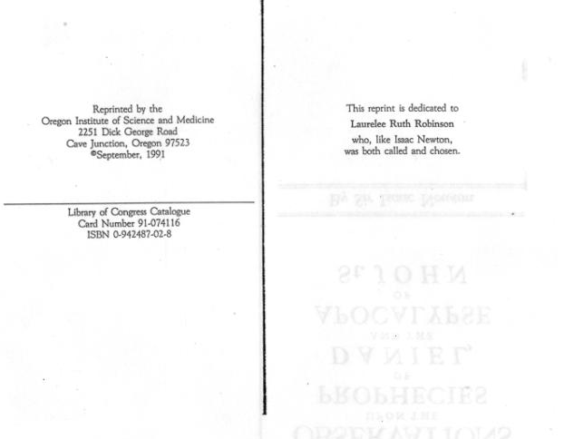
Newton, once known as the premiere Icon of the scientific age (pre 1960), that is, before science put other men on the pedestal like Einstein, Darwin, Stephen H. even Carl S., what a joke beyond Albert E., but, talking about jokes, equating three of a kind, here are the pop culture icons today, just to show you how far we have degenerated. What losers in Gods site and no personal judgment involved;

Newton however was a man of integrity (despite the rumors falsely contrived) a man who figured real things out, complex things, like who the Beast of Daniel and Revelation is, and would be once all prophecy had fulfilled, and who it was God revealed that power to be, and, Newton knew “Gods revelations” had and would came true 100%, including all the other prophecies concerning Himself and His Son, those prophecies we need to know, the ones that are hidden from the Covenant breaking world. (See “DEAD SEA SCROLS” this site, proof positive of this)

Thus was the Remnant church (the third church of God) raised, with this commission and calling, marking them as Gods saints and not of the Beasts marking. (Rev. 14:6-12) This is the final prophetic look of those who will stand for God in the days just before the 2nd coming, which John saw after he was told what we just read. (Rev. 14:13-14)

Thus time is short to get this right, as I’ve said, and nothing short of this will be acceptable, as the Marking of the beast is happening as we speak, and we now have entered into the last phases of prophecy.

SIR ISSAC NEWTONS BOOK
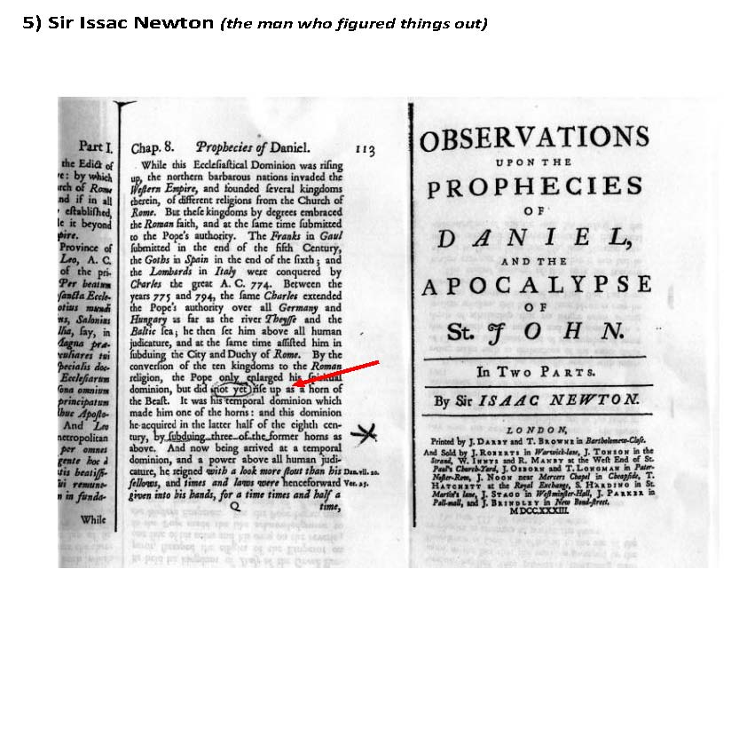

However relating to this subject; Newton discovered, among the very few even today, something the Bible itself gave as clues in deciphering “prophetic time periods”. (Numbers 14:33-34, Ezekiel 4:4-6) Newton discovered, that in interpreting prophecy, one must use the Bibles reckoning of “a day equaling a year (in prophecy only)” so the 2300 day prophecy in Daniel 8:14 is actually 2300 literal years, and the 1260 days in Revelation 12:6 being 1260 literal years, or, as Rev. 12:14 same chapter same description thus the same time period, and is the same time period God gave to Daniel, thus the same use of a “time, times and a half a time” covering the same period in future history, linking as Newton wrote both Old and New Testament prophecy together, a period he Newton lived in, with the prophecy ending some 65 years after the introduction of his book on Daniel and Revelation painting a picture God, the Lord and the Holy Spirit (Rev. 1:1) wants us to know, they are actually warning us to know, so that we know who’s side is Gods, and which side isn’t, as is the purpose of most all I expand upon.

This principal of interpreting prophecy using the Bible and the Bible only to do so (II Peter 1:19-21) ) is vital in getting it as God intended, and then you will discover that all the puzzle pieces fit tightly together as history has shown us “it does” and the future is easily discernable.

Get this wrong and we fall to all the deceptions surrounding Biblical prophecy, and Paul let us know the outcome. (II Thessalonians 2)

TIME CHART
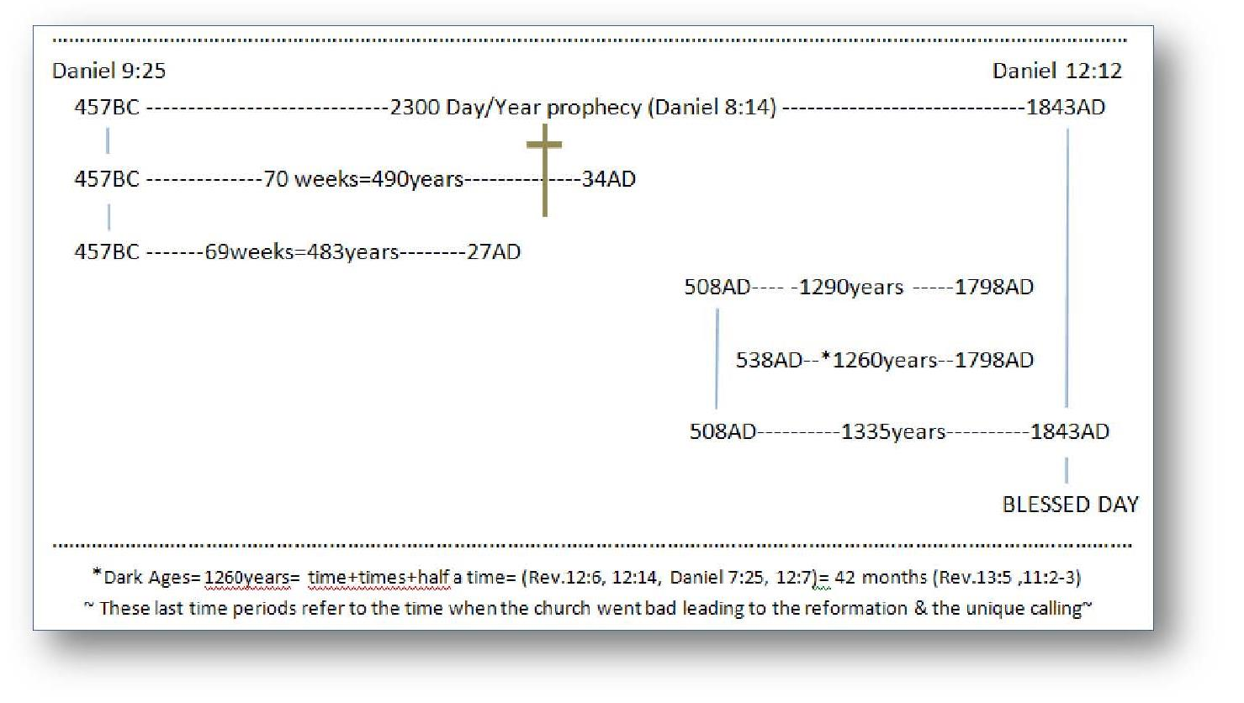

MILLERITES

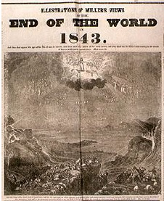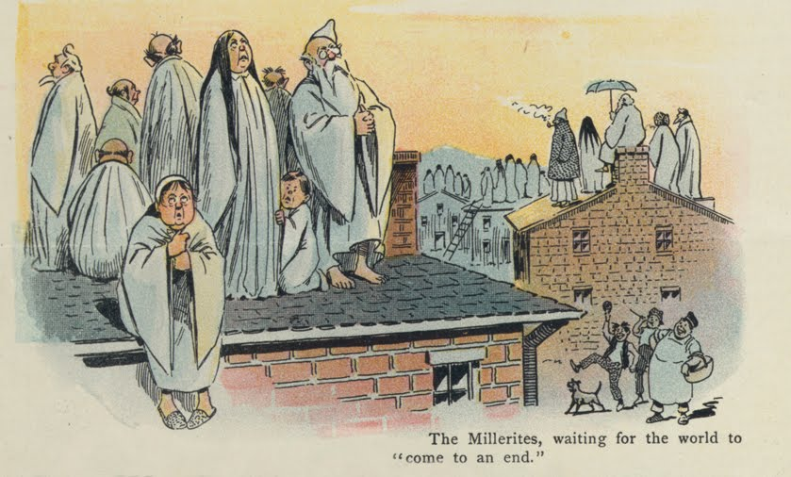
NEWS PAPER CLIP PUBLIC OPINION

(See www.mosescats.com “Yom Kippur” for the whole story and how God used their disappointment to raise a people who wanted the greatest gift Paul spoke of (I Corin. 14:1) to know and understand prophecy from God’s word, and to preach it to the end as well as live it, and this only by Gods power to do so of course!)

I want to interject something here; about people saying all prophecies have double meanings or multiple fulfillments, this “can be” a dangerous sidestep, and I have come to believe we should allow God to reveal that to us individually and not make a doctrine out of them, one that can take the importance of the initial intended fulfillment away or at least make it seem unimportant or detached. An example of this is seen in a prophecy the Lord gave commonly misunderstood or miss interpreted, in which, I’ll leave you to work out the truth as it is found using all scripture. (Matthew 24:3, 15 vs 16, 41) Another big, non-prophetic one but used as such; (Galatians 3:13). The point is, if we try hard enough we can make the scriptures prove about anything even snake handling. Even justified killing (of heretics once again) as predicted, that will come to those who hold the scriptures sacred with something’s binding from Old to New. (Rev. 12:17, 14:12-14, 13:15,18) (See “Convinced” for details)
However I will add; After the Dark Ages ended prophetically (Daniel 8:14, 9:24-27 Luke 4:19 Matthew 24:15, 3-14) at the end of the longest time prophecy given in Scripture (2300 years), a remnant people were rekindled carrying the same “eternal Gospel” that went into that dark age (Rev. 12:6, 14, 17) where they were hidden away in the mountains by God to emerge at the end of that age (Rev. 14:6, 9, 12, 14) carrying the same message of God they when in with. (See THE CHURCH this site) It’s all prophetic and not a mystery or subject to interpretation, it’s self-evident. (Rev. 19:10 the same Spirit of Christ the world hates so will it hate those who have it in the end, just as it was in His day, and in the Dark Ages, so will it be in the end “the remnant times”) find that last day people group and you will get as close to the truth as you can get (and I’m not speaking cultish when I say that, how can it be when you just read it in Gods Word?). But beware, it’s the false religions that are being led by the spirit of “cultish hierocracy” as always; as was Christ accused by them even in His day you recall (John 19:7 this is the same claim they call cultish today that identifies those churches as false by accusing those who try to follow the Everlasting Gospel as cults, works are a curse etc.) It’s all spelled out in prophecy clear and unarguable, but, not understood by those with a different spirit leading them, so, who is the cult in the end? You tell me…
The reason is the Bible depends on the Bible. [I’m suggesting the only study Bible everyone should use is the KJV] When it comes to any subject the Bible is the final word, and, the only reason the Bible appears to have contradictions is usually; “the person claiming this”; either has a vendetta against God’s Word or they haven’t taken the time, “with an open mind and heart” in trying to see, prove or show that there is no error, and the Bible if taken as God’s Word has the answer, but, I have to admit that Paul seems to contradict himself a lot, “seems too” I say as that Galatian’s reference above. Paul no doubt is dangerous to the unknowledgeable and in searching for that conclusion the Bible even tells us his writings are thusly used, (II Peter 3:15-17) and, we see the evidence in all the contradicting doctrines out there leading someday, as in Christs day, for the false churches to kill all who are accused as having doctrines that disagree with theirs. When it comes to seeming contradictions, yes, there may be typographical mistake or translation mix ups that seem to make things disagree or imply error. But a thorough study of the Word from Genesis to Revelation (open mind, heart, prayer and no bigotry) on any subject that seems to contradict and you will find the error is not with God but with man, Adam, especially Cain to last.”
I mean misinterpreted, the “out of context” usage of texts, even by paraphrasing scripture as most of the Bibles being used today have been, volumes called the bible (small “b”) having been translated by men who think they have that liberty, a liberty which only belongs to God, or those He has ordained to “transcribe” the ancient texts, (pre 1900 AD not including the Vulgate!), which is a big difference than personally translating (not transcribing) scripture from their own point of view to fit their religious views, or their religions doctrines. The use of Paul’s writings, as I said earlier, is a prime example of the miss use, the misinterpretation of scripture, coming from a lack of knowledge of Gods eternal Word “Old and New.” (II Peter 3:15-17) The misunderstanding or willful miss use of Paul’s writings have led to many false doctrines being established, know the truth or remain guilty of spreading false doctrines yourself. (See “Convinced” for proof) Study to show yourself approved says the Bible, (II Timothy 2:15, 3:13-17) rightly dividing the Word and using it to counter errors as I’m bring forward here.
A deceived person doesn’t know they are deceived or they wouldn’t be deceived. (1 Timothy 2:14, 2 Timothy 3:13, Romans 7:11, Romans 7:7) We know for sure Paul was deceived don’t we. But, his eyes were opened to the truth and Gods law against sin even though he had been schooled in the law and the prophets? Deception distorts our conception of God’s law even, or Paul would not have been deceived on who Christ was, much less Stephens testimony given right before he was stoned to death. (Acts 6:8, 7:57-58) Read all of Acts 7 especially (verses 51-53) to get the picture of where Paul’s mind was, where his loyalty laid. (vs. 54) When we read in the prophecy Rev. 13:15 is it then so hard to believe this same rejection, condemnation, even actions by the “claiming religious” none the less, is going to be in the future against those who rightly divide Gods law from mans? The same reasons then will incite those future accusers, and it’s because Gods chosen are keeping His commandments, His S-Abba-th particularly?? How can we think otherwise when we see how Paul, the intellectual Paul slew all those Christians before he discovered the truth? I sometimes think, if Paul was incapable of knowing the truth and was deceived what chance do I have, save God reveals the truth to me opening my eyes heart, and mind to His Law and not mans? (Hebrews 10:16-) Think about it.
Tongues as referenced in scripture is the ability to speak languages you never learned, unknown to you, thus unknown tongue, and doing so you are allowing God to speak through you, but, according to Paul not without an interpreter or it’s a show just to make people think you are from God. (Always remember Isiah 8:20 and you will be safe)
I’ll give you a big conclusive clue; (Deut. 7:9) do you know how long that is? 1000x40 years=40,000 years, some texts have a generation at 100 years, either way it’s obvious for those of us living in time our time, Jesus told us conclusively how long Gods Covenant was to be enforce, He was actually updating what He told Moses to write. (Matthew 5:17-18) It will be enforce till time ends as we count time, and we know the world is not going to last 40,000 years, when in the past 150 we have about destroyed it, along with religion as God established it to be.
In the days that the 2300 year prophecy fulfilled there were only a few Protestant Christian churches including the mother church of course, but, since this prophecy, as well as the others, were given by God to expose the mother church as the beast (Newton) the remnant people would necessarily come out of the protestant churches. Not to diminish the various priests that did come out of the mother, but they were killed by her for heresy remember, and had long since left their commissions to the protestant churches “they founded.” So the gift of prophecy; to rightly interpret prophecy “using the Bible only and proven history”, to expose the powers that were and would come to try to destroy Gods Eternal Gospel after 1844AD, was open for any one of the established churches. However, they had reached a point where they thought they knew it all as well as did their founding fathers, and had settled into their various doctrines to the point that they felt no need of prophecy, which yes, had gotten a bad name from the Millerites. (See Appendix) A group of self-appointed (at first) who had predicted Christ would come in 1843-44 by incorrectly interpreting the 2300 year prophecy. So the major protestant religions backed off from prophecy altogether, or began to distort the interpretations thereof, thus the remnant people, who came out of the Millerite movement, sought with all their heart to correctly understand the 2300 year prophecy and where they went wrong, and then, to correctly apply it to the history (both contemporary and religious) leaving of course the interpretation solely based on God’s word alone, and, as a result became the remnant people, who had come out of the major religions of those times. It could have been anybody (big point) but the gift of prophecy and correctly interpreting prophecy, using God’s Word alone (and fulfilled history of course) became eventually “the remnant church of prophecy”, and since they have been rejected by the second church “naturally” as were those of the first church who rejected the prophecy giver Himself, (Matthew 23:37-38) and thus; the rejection by heaven of any church hence who perverted prophecy as Jesus made clear in His last words to this generation. (Rev. 22:6-19) With warnings (Matthew 24:1-15 being one about the end of time-our time) and prophecies throughout time, He made it clear the importance of the gift of prophecy knowing learning and spreading their warnings from the past to the future, but, most importantly not adding or subtracting from them by self-interpreting them. Thus the importance of this study! (See my sister site www.mosescats.com “Yom Kippur” for details on the MIllerites)
See “Convinced” this site to see those churches today following after the beast just as God said. (Rev. 13)
The next thing John sees after defining who Gods saints are, (Vs. 12-14) or at least it tells us clearly what they will believe at the second coming! So this obviously is a message and warning for the end time people, churches, religions etc., most of “Whom have separated themselves from Gods commandments,” including His 7th day S-Abba-th number 4 of the 10 commandments Jesus had faith in. (John 14) Who’s commandments are they? Who represents God? (Vs. 12 us?) Jesus testified with His life (and in keeping them He was going against the church of His day “who killed Him” despite the Law) because He kept (John 19:7) those things required by Gods will, for mankind, and “by keeping them as our example.” (Rev. 22:16-20) Thus we can only conclude, “if” we really love our God as did Jesus, we will keep His law, and not like the offenders, transgressors, who break and not keep, Gods law being His Covenant, or breach any precept of the Commandments “He gave as the eternal Gospel of old and new”. (Matthew 5:17-20, James 2:10-12) Those deniers, Covenant breakers will be denied access into heaven! (Rev. 22:15) How else can you explain all these messages from God? The point is you can’t, and the only choice most make is to “separate themselves” from that group of Gods saints, and go with the false churches and their saints “so called”, who blaspheme God as well as His true followers! Just search you tube for what the deniers think of Gods 7th day S-Abba-th keepers, it says it all, and helps us understand what the prophecy tells us about our future, in that the beast and those churches and religions that bind themselves to her by uniting with the mother church, and what they will do. (Rev. 13:7-9, 15 Revelation 13 precludes Rev. 14 that describes their enemy who will someday suffer persecution once again, just as they did in the past by her hand. (Daniel 7: 8, 20-21, 24-26) See also Appendix “Rome’s Challenge” for proof of her actions in the past and against who she has especially marked for persecution, and who she will mark again “with help from the protestants who quit protesting”, and, who join her in her pursuit against Gods last day saints “that deny her sun-day worship” in favor of Gods S-“Abba”th. (See “Convinced” this site) Friend it’s already happening, what she couldn’t do in the 1888 U.S. congress, to pass and enforce a Sun-day blue law, (which is still on the book mind you) soon she will get her laws passed and eventually Rev. 13 will be fulfilled, for Gods prophecies are never wrong!
Gods will as David described it as the Covenant His commandments including His created by Him S-Abba-th is not just for us but His universe. We have got to see this truth in one of the most prayed prayers known to man, taught to us by the Master Himself; (Matthew 6:9-10 (KJV) ⁹ After this manner therefore pray ye: Our Father which art in heaven, Hallowed be thy name. ¹⁰ Thy kingdom come, Thy will be done in earth, as it is in heaven.) This is the eternal gospel of the universe!
Of whom the “New Covenant” is given, (Hebrews 8:7-11) and why did the first Covenant fail? You missed the significance of Vs. 9) we are grafted into Israel of course (Romans 11) and not through Abrahams bloodline, but, by the Blood of our Savior, and we are just as guilty of not following Gods commands as were they. Will we then keep His Covenant “all of it”? This remains to be seen doesn’t it, and yes, I am always beating the same drum in hopes that we get into Gods rhythm, and for me “stay there”?
Not all Daniel wrote I accept, but, since his determinations in how to interpret prophecy is actually Biblical, as well as his determinations of who the beast power was and would continue to be, and then adding to that his creditably as a man of numbers, is all one needs “to give confirmation of reckoning dates and times given in prophecy. What is so amazing is; in his time the book of Daniel was actually closed until 1798AD (Daniel 12:4, 7. 9. 11-13 see time chart below) but, obviously God gave Newton this wisdom for proof and understanding of prophecy, if only for those of us like the Millerites (see below) who really want to know and understand His Words and His exposure of the powers fighting against Him and His people throughout the ages!

