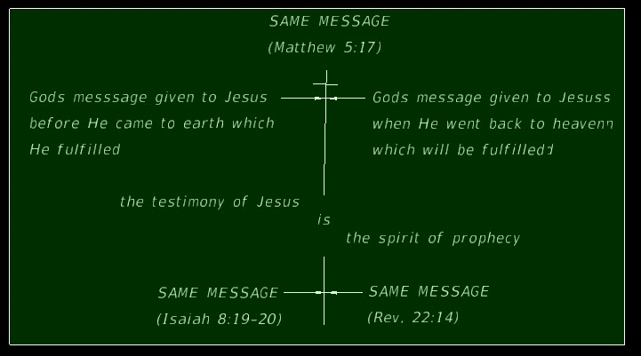
12:17
Early one morning this image came to me; as I have been trying to expand on what is one of today’s biggest needs in the world of religion at the state of its art, and that is; “a reconnect to Gods eternal message” John saw going to all the world just before the second coming, being the eternal gospel, meaning it has to have existed before eternity as we know it to be and will never end since its eternal.
What else can one make of this statement given to John by the Holy Spirit given to Him by Jesus given to Him by God?
You tell me?

Revelation 14:6, 14 (KJV)
⁶ And I saw another angel fly in the midst of heaven, having the everlasting gospel to preach unto them that dwell on the earth, and to every nation, and kindred, and tongue, and people………¹⁴ And I looked, and behold a white cloud, and upon the cloud one sat like unto the Son of man, having on his head a golden crown, and in his hand a sharp sickle.

The message that fits then between those two passages; is what this study of “The Same Message” is getting too, and since it’s a last day message from God “it must contain what we need to know in these “end times” as a church as a people called by God.
This follows the series on prophecy I have been expanding on lately, of the things that we need to know according to Revelations (Rev. 22:8-12, 6-7) the last Words God sent down to us as recorded by His prophet John the beloved, for the churches which were to follow the Christian lead. (Rev, 1:1-4)
The following study takes its lead from the principal God gave His prophet Isaiah on what we are to follow as our guide when it comes to prophecy and the eternal gospel or anything else anyone might come to us with in the name of religion, being those who claim to come in the name of God and His Son or the Spirit that speaks to us through the Words of the Bible and the Bible only as our source and what the man of God must be that claims such light as we have been given…..

THE STUDY

GODS MESSAGE GIVEN TO JESUS GODS MESSAGE TO JESUS WHEN HE
BEFORE HE CAME TO THIS EARTH WENT BACK TO HEAVEN AND WHICH
IN WHICH HE FULFILLED -BEING; HE HAS GIVEN US TO FULFILL-BEING;

~ THE TESTIMONY OF JESUS “IS” THE SPIRIT OF PROPHECY~

SAME MESSAGE SAME MESSAGE
(ISAIAH 8:19-20) (Rev. 12:17, 14:6-7, 14, 19:10)

God gave the same message in olden times “defining His people back then” who would make up His church, just as He “defines them to be today” and, they have one thing in common did you see it, do you understand it?
God gave His Law (10 Commandments) to His chosen people who were to make up His first church, (Deut. 7:9) and as you can see it was to be a perpetual Covenant to last throughout all the generations of His People/church and not just the Jews or Israel but throughout “time”, as He established in creation His S-Abba-th set “in time itself” so did He His whole law. (Exodus 31:13) His law is as eternal as His gospel as we will see.
Israel, of whom, was delivered out of Egyptian bondage, was “His first church” and, I say that for a reason, and that reason is; there was no Sanctuary built (as it were) before the one He had Moses build there in the desert. (Exodus 25:8) A Place where His chosen could find salvation offered to them by the lambs sacrifice, “physically” at first, (Gal. 3:19, Hebrew 9:1-14) but ultimately “spiritually” by the blood of His Son as Paul explains the two Covenants.
Of course we know mankind’s salvation was not through the sacrifice of a physical lamb beast, no more than it is by works, but only through the promised Messiah who was to come and shed His own blood for mankind’s atonement “from the death of sin”, we have known this from the beginning as was promised to our first parents. (Gen. 3:15, 4:4, Heb. 10:4-5)

Hebrews 12:24 King James Version (KJV)
²⁴ And to Jesus the mediator of the new covenant, and to the blood of sprinkling, that speaketh better things than that of Abel.

All those years, from Abel’s offering ahead to the sacrificial system, that God put in place for His first church, those lamb sacrifices were symbolic pointing to the Messiah (John 1:29) who would come some day and shed His blood for mankind/church, and seal up the Covenant/Law by His blood, (Romans 5:9, Ephesians 2:13) and establish the testimony He had given to mankind for all those years “in advance concerning mankind’s salvation”, as they were given by the prophets to the first church. (Matthew 5:17, 23:34-37)
He came fulfilling Isaiah’s prophecy, (Isaiah 8:13-20) by His first words to a mixed multitude there in His first earthly sermon on the mount:

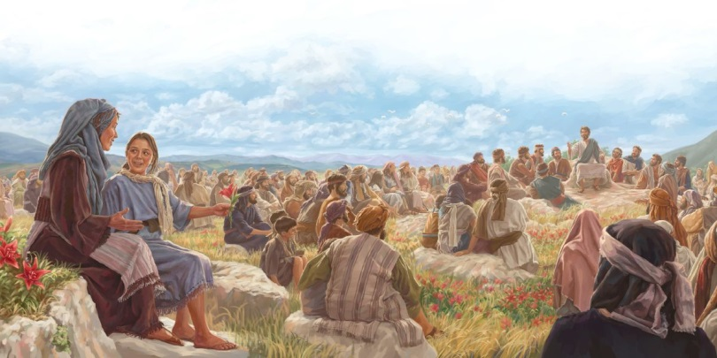

What was it Isaiah prophesied of old about men, even the Lord, and anyone claiming (thinking) to be following God in all things?

Isaiah 8 (KJV)
20 To the law and to the testimony: if they speak not according to this word, it is because there is no light in them.

That’s the very same thing Jesus said and what He came to prove by His testimony and life that He was from God? “Those very claims” He witnessed, “He gave the very SAME MESSAGE! He had given Isaiah before so that we would recognize Him when He came. (Luke 4:16-21)
He held up what Isaiah taught because it was Him giving him as well as all the prophets words to say and why right at first He made it clear about the Law of God the 10 Commandments men so easily write off today as a curse none the less. Why then, did He say the things He said if not true and relative to our salvation as well as Him being also judged by the Father?

Matthew 5 (KJV)
17 Think not that I am come to destroy the law, or the prophets: I am not come to destroy, but to fulfil.

Certainly He came to fulfill both laws, one to live out to perfection “as we know He did”, and the other as the Lamb of God the sacrifice for all who obey.
He came fulfilling all that was predicted about Him and to spell out Gods will for mankind, thus, proving He was the one of whom all those sacrifices pointed, BUT, the first church did not see it, and they crucified Him “breaking Gods Covenant and cutting themselves off from their roots, and they still search for their Messiah.”
But we too as they, will be fooled by the second church gone bad (protestant churches) falsely prophesying (predicting) that a new temple will be built and the sacrifices resumed, it will be then that all churches will have cut themselves off from“ the Law (Psalms 40:8) and the “Testimony” (Rev. 19:10) the very things that were given to enlighten the church they have cast aside, or modified for their own doctrines , laws and traditions to be upheld over Gods? The very things that cut off the first church from God is plain to see do they do, despite all the scriptures they pervert to worship their own ways as has all of mankind done since Cain who was the first to walk away from God over the same issues. (I John 3)
What about this second church gone bad, having also separated themselves from the law and the prophets and really from the “real Savior” they claim to follow, who as we read, came to fulfill Gods will (Law) and fulfill the testimony given by the prophets as a Son of God?
Where does this lead one who is searching for a people/church that desires to follow God by Keeping His Law as was shown us by the testimony and faith Jesus exemplified, and, “what was to frame His second church?” (Matthew 5 message calling the public, John 14 message calling His disciples)
For this picture “from scripture” which tells us: “that the message given to the first church” is the same message given to “the second church”, being the whole point of this study?
We need to refer to the prophecies then given to the second church that were sent back from heaven for the “end time/remnant church/people.” (Rev 1:1)
This same message of end time prophecies given to Jesus (for His testimony Rev 22:16) were given to Him by God Himself (must be important) for Him to send them down to the churches, particularly to the remnant church/people, so these last messages (revealing’s) need to be known before the 2nd coming in clouds by the church of whom Jesus (the corner stoned) sent them down to us (since we are the remnant Rev 1:1-3, 7) through the same "Spirit of Prophecy" which is the Testimony of Jesus (Rev. 19:10) being the same testimony He gave to the prophets (i.e. Daniel in details) but to all from Eden ahead He gave the same prophesies/message/Gospel to the first church/people all those from Adam ahead “that were willing to fulfill and pass on the message of the Lord”, His testimony before coming to this earth and after He went back to heaven. (Isaiah 8:20, Rev, 19:10) sent to us by the same spirit as back then, and now, they are the same last words with all the details for salvation from the beast and Satan’s influence over the earth. Especially to us the last day people/church since we sit on top of all prophecies having seen their fulfillments one by one to now the last message to be received from God out of heaven, and are the same bases of the message “the pure second/faithful remnant/last church are to give to the world.”
That church/people He described to Daniel in detail, He gave to John for us to see just what would comprise that last end time church people;

Revelation 14 King James Version (KJV)
14 And I looked, and, lo, a Lamb stood on the mount Sion, and with him an hundred forty and four thousand, having his Father's name written in their foreheads.
² And I heard a voice from heaven, as the voice of many waters, and as the voice of a great thunder: and I heard the voice of harpers harping with their harps:
³ And they sung as it were a new song before the throne, and before the four beasts, and the elders: and no man could learn that song but the hundred and forty and four thousand, which were redeemed from the earth.
⁴ These are they which were not defiled with women; for they are virgins. These are they which follow the Lamb whithersoever he goeth. These were redeemed from among men, being the firstfruits unto God and to the Lamb.
⁵ And in their mouth was found no guile: for they are without fault before the throne of God.

[By and thru the Grace (power) of God given to all who love Him (John 14) and who will follow His Covenant and Message, as did His Son, who calls on us to love Him and His father and receive the gift of the Spirit to know all truths and follow Him. Without fault does not mean “perfect” for no man can be perfect save the Son 0f God, all God asks is for us to follow Him and no other gods or religions that are against Him and His will and laws that govern eternal life, and remember; we need only His faith to be saved. “BUT, our works for Him will follow” and be rewarded even though we remain as sinners by nature, He will Himself come into us who allow Him to do so, and save us from the penalty of sin and death. The promised Spirit, He will send us right this very moment, will teach us these truths, all we need do is believe (have faith in) His eternal message and follow what we see is Gods will, that’s all He asks of us and the churches. (John 14) “If you love Me” He pleas to us….]

⁶ And I saw another angel fly in the midst of heaven, having the everlasting gospel to preach unto them that dwell on the earth, and to every nation, and kindred, and tongue, and people,
⁷ Saying with a loud voice, Fear God, and give glory to him; for the hour of his judgment is come: and worship him that made heaven, and earth, and the sea, and the fountains of waters.
⁸ And there followed another angel, saying, Babylon is fallen, is fallen, that great city, because she made all nations drink of the wine of the wrath of her fornication.
⁹ And the third angel followed them, saying with a loud voice, If any man worship the beast and his image, and receive his mark in his forehead, or in his hand,
¹⁰ The same shall drink of the wine of the wrath of God, which is poured out without mixture into the cup of his indignation; and he shall be tormented with fire and brimstone in the presence of the holy angels, and in the presence of the Lamb:
¹¹ And the smoke of their torment ascendeth up for ever and ever: and they have no rest day nor night, who worship the beast and his image, and whosoever receiveth the mark of his name.
¹² Here is the patience of the saints: here are they that keep the commandments of God, and the faith of Jesus.

[His remnant saints, in the end as John sees these words fulfilled in vs. 14, will be keeping Gods Covenant as He gave, not man, and, His “every word” do they follow, (Matthew 5:18-19) following in the “same faith that Jesus testified by His life and Spirit, being His Testimony for us, too us, and for too keep in us as it was with all the faithful that came before and will come after, those that He has called who followed Him, even after time ends.]

¹³ And I heard a voice from heaven saying unto me, Write, Blessed are the dead which die in the Lord from henceforth: Yea, saith the Spirit, that they may rest from their labours; and their works do follow them.
¹⁴ And I looked, and behold a white cloud, and upon the cloud one sat like unto the Son of man, having on his head a golden crown, and in his hand a sharp sickle.
¹⁵ And another angel came out of the temple, crying with a loud voice to him that sat on the cloud, Thrust in thy sickle, and reap: for the time is come for thee to reap; for the harvest of the earth is ripe.
¹⁶ And he that sat on the cloud thrust in his sickle on the earth; and the earth was reaped.

This is not the message you will hear the churches that have “gone bad” are giving, “nor can give”, having separated themselves from Gods Covenant; if only by one altered command of worship, and this, by following the beast of Daniel and Revelation. Nor, do they “have any light” according to God, and neither will they be allowed entrance into heaven and access the tree of eternal life according to God, it’s that basic, and this being our Lord Gods words not mine and being; “The Same Messages” past and present. (Isaiah 8:20, Matthew 5:17-18, Rev. 22:14)
You tell me?

THE MESSAGE IN GRAPHIC IMAGES
Let’s get the prophetic picture of the remnant church having been called out from the religion of the beast and her daughters, (Rev. 17:5, 18:4) the one who finally follow the message that was given to both churches (first and second) to fulfill.
The message was given by our Lord Jesus to the first church (The Rock I Corrin. 10:4) before He came to this earth through the prophets. (Math. 23:34-38 notice He said “I”) Then by our Lord Jesus Christ (Christian) to the second church (He was the Corner Stone of Ephes. 2:20) when He was here on earth, and this church according to prophecy was to be the last church, “If”, she would remain faithful to the law and to the testimony, (Math. 23:23) but, as we have already seen above, she too failed as did the first church, (Rev. 17:6) and prophecy says; she would seek to destroy the now called remnant church/people called out from the 2nd church, Rev. 13:15 This lamb like beast -Protestant- that gives the former beast –Papacy- her power back) To try and stop Gods message again primarily by “forced worship”, (Rev. 13:15) Gods message that defines her as the beast power/church under the control of the great red dragon’s power and influence according to Gods prophetic Word. (Rev. 12:17)
Let’s get Gods picture, His description, of this remnant church as He described to Jesus, who sent it down to the end time people/church. “Being all of whom God has called”, called to be like Him and have the right (Supplied by His power of course) to enter into heaven’s gate and eat of the tree of eternal life once again. The life we so easily gave up for the knowledge another voice “seemingly” speaking of god’s wisdom but it was deception. (Rev. 22:14)
Please get this Message, of old and new, if that is your desire;
[Note: I am going to interject between the lines of this prophecy, as I did before, for those of you who are not familiar with prophetic writing, but listen: “I am NOT interpreting" mind you, I’m well familiar with false interpretations and what the Bible says against it. (II Peter 1:20-21) I’m merely, as any preacher (not that I am one) would do; “pointing out the obvious or unobvious as the case maybe”, BUT, in the end you will see “this is obviously a picture of the forming of the remnant church of prophecy even if it is given in prophetic/graphic language and images]

Revelation 12 King James Version (KJV)
12 And there appeared a great wonder in heaven; a woman clothed with the sun, and the moon under her feet, and upon her head a crown of twelve stars:
2 And she being with child cried, travailing in birth, and pained to be delivered.

[Notice the clues given here including verse 5; A woman “in prophecy (only)” represents a church, (Jerimiah 6:2, Revelation 19:7-8, Revelation 21:2) but here it’s described as a church with 12 stars. The second church was established by Jesus and its leadership through the 12 apostles. It was the Lord Jesus, brought forth from heaven, born into this world to establish a true church, and being the only one ruler who would eventually rule the world, and was caught back up to heaven by God to finish His work of redemption for His people/church.]
3 And there appeared another wonder in heaven; and behold a great red dragon, having seven heads and ten horns, and seven crowns upon his heads.

4 And his tail drew the third part of the stars of heaven, and did cast them to the earth: and the dragon stood before the woman which was ready to be delivered, for to devour her child as soon as it was born.

[We know of course that there was war in heaven between the Lord and Satan (verse 7-9) Satan, as described in this verse, who incidentally fathered; the beast of Daniel and Revelation the false church, her “and” her daughters, and all of whom stood against God and His message and people, (as described in both apocalyptic books of Daniel comparing the similar descriptions in each Rev) and as soon as Jesus was born, even before, those of whom were under the deception (church and people) sought to kill not only the messenger but the message. Did you notice in Daniel and Rev. a time frame for this beast powers reign was given? (See time chart Appendix) You remember of course how Herod sought to kill the baby Jesus as soon as He was born, but the church actually did! Yet, even then there was still a people moving forward who, despite all the persecution during that long Dark Age “between the death of Christ 30 ½ AD, the rise of the false church (508-538AD) to her receiving the deadly prophetic wound. (1798AD)]

5 And she brought forth a man child, who was to rule all nations with a rod of iron: and her child was caught up unto God, and to his throne.
6 And the woman fled into the wilderness, where she hath a place prepared of God, that they should feed her there a thousand two hundred and threescore days.

[There’s Revelations date the beast ruled and we see the church that remained loyal to Gods message pictured here (by keeping the Law and testimony vs. 17) being protected by God during that long period of the dark ages, when the beast ruled both politically and religiously. (the prophetic time frame given twice so there is no argument vs 17 & 14 as well linking Daniel with Revelation in describing the beast power) during that time she Gods faithful people/church would remain hidden, before she could once again come out of hiding as “the last day remnant church/people” to then hail the message of the ages for God (the same message remember) that would warn His people of the things to come bringing forth the end of time]

7 And there was war in heaven: Michael and his angels fought against the dragon; and the dragon fought and his angels,

8 And prevailed not; neither was their place found any more in heaven.

9 And the great dragon was cast out, that old serpent, called the Devil, and Satan, which deceiveth the whole world: he was cast out into the earth, and his angels were cast out with him.

10 And I heard a loud voice saying in heaven, Now is come salvation, and strength, and the kingdom of our God, and the power of his Christ: for the accuser of our brethren is cast down, which accused them before our God day and night.

11 And they overcame him by the blood of the Lamb, and by the word of their testimony; and they loved not their lives unto the death.

12 Therefore rejoice, ye heavens, and ye that dwell in them. Woe to the inhabiters of the earth and of the sea! for the devil is come down unto you, having great wrath, because he knoweth that he hath but a short time.

13 And when the dragon saw that he was cast unto the earth, he persecuted the woman which brought forth the man child.

14 And to the woman were given two wings of a great eagle, that she might fly into the wilderness, into her place, where she is nourished for a time, and times, and half a time, from the face of the serpent.

[See prophecy time chart attached (Appendix) for when this prophecy would fulfill, which included; the rising up of the beast (508AD) to her full power (538AD) down to the prophetic wounding of the beast (1798AD) and the return from hiding of the faithful church, who (carrying the same message) went into hiding at the beginning of the dark ages till its end, “marking a blessed day for Gods people” to now, freely, herald the message the eternal gospel message John saw going into all the world by His faithful church/people as their work will be. (Rev 14:6-13)

15 And the serpent cast out of his mouth water as a flood after the woman, that he might cause her to be carried away of the flood.

16 And the earth helped the woman, and the earth opened her mouth, and swallowed up the flood which the dragon cast out of his mouth.

[As we see; the Devil and his converts people/churches, have been active throughout the rise of the remnant church from its necessary hiding “to preserve the purity of the message (law and test)“, which, save for Gods protection would have been perverted clear out of existence, as it nearly has even now. But these faithful church/people who went into the dark ages as described below with Gods message (right?), would come forth out of that Dark Age, after the time given, just as she went in (important) carrying the “same message, same faith, same testimony and the same works. (Rev. 12:17, 14:12)]

Revelation 12 King James Version (KJV)
17 And the dragon was wroth with the woman, and went to make war with the remnant of her seed, which keep the commandments of God, and have the testimony of Jesus Christ.

These message’s “to the church”, as described by God, given to Jesus and sent to the end time people, who are all “of whom God has called”, BUT, “for this picture to sink in clearly; we go now back to revelation 14 again, and break it down, so there is no doubt that we get a clear picture/description of this remnant church that went into the dark ages carrying the gospel message to the “churches forward” (the message of the Law and testimony Rev. 12:17 & 14:12) so we can see they are the same faithful church/people that came out from hiding at the end of the dark ages, with the wounding of the beast power that sought through the influence of Satan to kill them all, but as we read God protected them “so that His message could now go into the whole world unencumbered until a time near the end”, when; the beast will rise back up and seek to kill Gods faithful again, this time with the help of her daughters, (Rev 13) because she is still seeking to kill Gods message, once again, but, His chosen who accept His Covenant and His Sons Faith & Testimony will carry that message to their death if necessary, and as predicted by the Spirit of Prophecy, described in this next chapter we take up. (Rev. 14) Telling us the rest of the story of this remnant church/people and their message of the "eternal gospel", as I’m trying to help you see it’s “The Same Message”.

Revelation 14 King James Version (KJV)
14 And I looked, and, lo, a Lamb stood on the mount Sion, and with him an hundred forty and four thousand, having his Father's name written in their foreheads.

[notice this about the forehead/hand Deut. 6:5-8 concerning the Covenant of old and then notice Paul’s quote and connection to us today under the New Covenant in Hebrews 10:16, this has always been Gods desire for His people so that they may be eligible for eternal life, and it’s more than interesting to note that the Fathers name is in the 4th Commandment – S-Abba-th the name Jesus used as He cried to His Father from His own heart. (Mark 14:36, Romans 8:15, Galatians 4:6) Is it our cry our “prayer” to want to please our Fathers “will” in heaven, as Jesus taught us to pray? This may be a shocker because I prayed this prayer all my life, but it wasn’t until I began this series of study I saw this connection; (Matthew 6:9-10, John 7:17, 14:15-21 He’s praying for us “if”, (if seems conditional here?) we follow His will on this earth as all do in heaven, this is to be our prayer, right?]

2 And I heard a voice from heaven, as the voice of many waters, and as the voice of a great thunder: and I heard the voice of harpers harping with their harps:
3 And they sung as it were a new song before the throne, and before the four beasts, and the elders: and no man could learn that song but the hundred and forty and four thousand, which were redeemed from the earth.

[It appears these people are assembled in heaven? Regardless; they were of those throughout time who had not been defiled on earth by women (false women = false churches prophetically remember) buit these described are the faithful for they have overcome sin and death by the blood and the power of God through the Holy Spirit (Hebrews 9:14) and their knowledge and obvious acceptance of the Law, and by the testimony of Jesus, following Him in all things and "by their choice" they accepted the Messages and kept them with all their will, not perfect of course, but in Gods site acceptably - redeemed. We sing about it but have we been, while yet still following the beast in our minds through the choice of our worship? Gods blood covers only those who have been justified by the blood please see it Paul, did despite your religions interpretation and words of wisdom that’s not Gods, Paul makes Justification clear in this context that for Jews and Gentiles alike when it comes to matters of the heart and mind. (Romans 2:4-13) read on in this chapter to its end, if vs. 11-13 weren’t clear enough]

4 These are they which were not defiled with women; for they are virgins. These are they which follow the Lamb whithersoever he goeth. These were redeemed from among men, being the firstfruits unto God and to the Lamb.
5 And in their mouth was found no guile: for they are without fault before the throne of God.

[Coming up next; John sees in this same vision “the things pertaining to the last days prior to the second coming” and, “three distinct angelic messages for the remnant church/us” if we so choose what should be “defining the churches/our mission”, That is; “Heralding the everlasting gospel (everlasting means always the same that has been given by God to His people/church) all three churches and that being; "the same message we have discovered" didn't we? This message John sees going to all the world nations tongue and people in the end? Which was once impossible but now we can see it’s possible via, the World Wide Web, right? Here is then that 3-angles message we are to herald;]

6 And I saw another angel fly in the midst of heaven, having the everlasting gospel to preach unto them that dwell on the earth, and to every nation, and kindred, and tongue, and people,

[What is this message? If we look close we can see all the components of The Messages we have been discussing.]

7 Saying with a loud voice, Fear God, and give glory to him; for the hour of his judgment is come: and worship him that made heaven, and earth, and the sea, and the fountains of waters.

[Worship God only wasn’t that the first commandment of the 10. (Exodus 20:1-6, Deut. 6:5-9, 24-25, 5:29) Why? We must love Him first, and second follow His Commandments for we are going to be judged by that law. (James 2:10-13) and get this connection, “of the Ten precepts of the Covenant, one deals specifically with “worship”, and worship only Him on His “Hallowed/Holy” day He added to time itself, and not the beast’s day named “unbelievably” after the pagan worship of the sun! (Exodus 20:10-11, Deuteronomy 4:2, 5-8) We must accept “His creation” (Exodus 20:11) all “7” literal days of it, and “not any part of evolution”, including mankind made whole in the likeness and image of God, stated two ways so there would be no argument. (Genesis 1:26) So be careful how you describe our first parents or you will be calling our Father God the same (monkey caveman ameba etc.) (See Pope on evolution Appendix) Gods message contains no part of the “theory” of evolution micro, macro NO, A LIE that 99% of the world’s religions have accepted following the beasts lead.]

8 And there followed another angel, saying, Babylon is fallen, is fallen, that great city, because she made all nations drink of the wine of the wrath of her fornication.

[The second angle tells us/church; the beast they are following (See “Convinced” this site) has fallen from Grace and has or “will in the end” have taken in all religions through her deceptions and false doctrines, false prophecy etc., save those who follow the message of God, and, when all judgment decisions have been made and the rewards established and the final edict is given from heaven (Rev 22:11-12) the demarcation between the people of God and those marked by the beast will be clear but, it will be too late to change then. (Vs’s 10-12 coming up) But friend; that line is clear today as we have seen over and over by virtue of worship days alone if by nothing else. (Isaiah 8:20, Matthew 5:16-)

9 And the third angel followed them, saying with a loud voice, If any man worship the beast and his image, and receive his mark in his forehead, or in his hand,

[Notice; the very place God wanted mankind to place His law in mankind (Deut. 6:5-8 concerning the Covenant of old and under the New Covenant in Hebrews 10:16) is the very same place the beast, her daughters and the great red dragon wants to place his mark of dominance and authority. (See “Sunday Art” Appendix) The next three verses (vs's, 10-12) define the fallen people/their church/religions on one side, and those on the other side who remained faithful to God, His laws and His Sons testimony.]

10 The same shall drink of the wine of the wrath of God, which is poured out without mixture into the cup of his indignation; and he shall be tormented with fire and brimstone in the presence of the holy angels, and in the presence of the Lamb:

11 And the smoke of their torment ascendeth up for ever and ever: and they have no rest day nor night, who worship the beast and his image, and whosoever receiveth the mark of his name.

12 Here is the patience of the saints: here are they that keep the commandments of God, and the faith of Jesus.

[As you recall the people/church, being the remnant, who went into the dark ages (Rev 12:13-17) carrying the messages to the churches defined for us here in the last days as the three angles message by the Spirit of prophecy, (Rev. 12:6-14) The remnant group that went into the dark ages carrying that message, and when it emerged from the dark ages “it picked up and began carrying that same message”! But this time “to the whole world” uninhibited by the beast, until that is; she regains her power, and by penalty (by her law) of death once again. (Rev. 13) All to try and stop the remnant people/church (Rev 14:6, 12) from their Godly duty of exposing her by Gods design]

13 And I heard a voice from heaven saying unto me, Write, Blessed are the dead which die in the Lord from henceforth: Yea, saith the Spirit, that they may rest from their labours; and their works do follow them.

[It’s our choice, in the end, which group we are in, and, our reward will be judged by our works in the end. (Rev 22:12, James 2:12-14) The next thing John sees as if a conclusion of this prophetic picture of the church from Jesus to the end; "is” the end, and then John sees His coming in the clouds to get His faithful, when then sin, and “all that is attached to it” will be destroyed, and His chosen who followed Him, His message and His works will be with Him forever. II Thessalonians 2:8-12]

14 And I looked, and behold a white cloud, and upon the cloud one sat like unto the Son of man, having on his head a golden crown, and in his hand a sharp sickle.

15 And another angel came out of the temple, crying with a loud voice to him that sat on the cloud, Thrust in thy sickle, and reap: for the time is come for thee to reap; for the harvest of the earth is ripe.

16 And he that sat on the cloud thrust in his sickle on the earth; and the earth was reaped.
-
17 And another angel came out of the temple which is in heaven, he also having a sharp sickle.

18 And another angel came out from the altar, which had power over fire; and cried with a loud cry to him that had the sharp sickle, saying, Thrust in thy sharp sickle, and gather the clusters of the vine of the earth; for her grapes are fully ripe.

19 And the angel thrust in his sickle into the earth, and gathered the vine of the earth, and cast it into the great winepress of the wrath of God.

20 And the winepress was trodden without the city, and blood came out of the winepress, even unto the horse bridles, by the space of a thousand and six hundred furlongs.

What was it Paul said there in Hebrews “as a warning to all who receive this kind of knowledge and ignore or reject it”, with their blinders on, or worse, rebel against it and teach others to do the same knowing better? Doing this, despite the Spirit of Grace and our Lord God who sent it to us? (Hebrews 10:26-29, 30-31)
Solomon even added His unsurpassed wisdom to this message. (Ecclesiastes 12:13-14)
I rest my case….

~mosescats~

APPENDIX:

NEWTONS BOOK
Sir Isaac Newton the “Numbers man”, who if there was anyone who could put doubt on the Scriptures it was him, and, if anyone could decipher the “time frames”, given in Scriptures prophecies, it would have been him, right?
Newton lived in a time when the book of Daniel was still a closed book, (Daniel 12:4, 8-14) so his insights as far as religious history is concerned, must have been from God, as were given to men like Martin Luther, Wycliffe, Huss etc. all these men knew who the beast power was as given in the Bibles descriptions, even though Daniels book wasn’t to be opened (I suppose to the common man) till after the beast received her deadly wound (Rev. 13:3) which came in 1798 AD, after which then, with the Pope off his throne, then the books were (opened) available now for all the world to see who Gods enemies will be till the end of time, and so that we can see His message to us “clearly” and without argument. So the two books Newton expanded upon Daniel and Revelation were then, and still now are a “complete confirmation looking back and then ahead prophetically to the end” of who was going to be, prophetically, against God and who was going to be with Him and keep His Covenant and receive the Testimony of Jesus to give to the world (Rev. 14:6-14) which is the Spirit of prophecy. (Rev, 19:10, Isaiah 8:15-20)
The two books remain open today, but the light is fading as the message is once again being subdued (not taught for the exposure of just who it really is they follow, nor do they even care to know) and if they honestly care to know “the prophecies have been so perverted by deception” that; no one will know when the pope stands up and receives his full power once again, and is perceived by the protestants as an angel of light, they won’t know that behind the scenes of scripture his power was given to him by the great red dragon, as he continues to tout the same deceptions that have always plagued the church, who are my friend, the people. (See a study on this “The People are the Church”, this site)

Newton’s book;
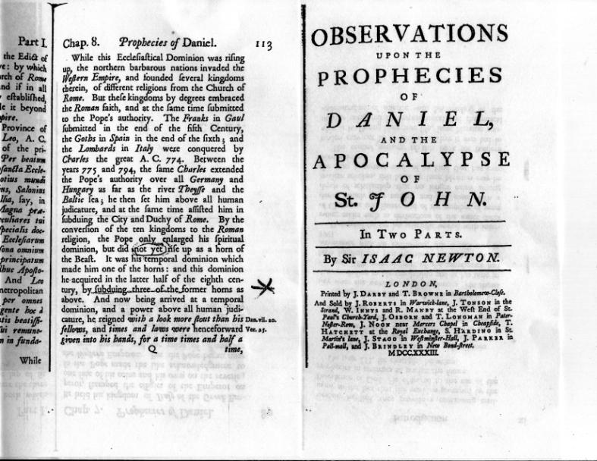

TIME CHART

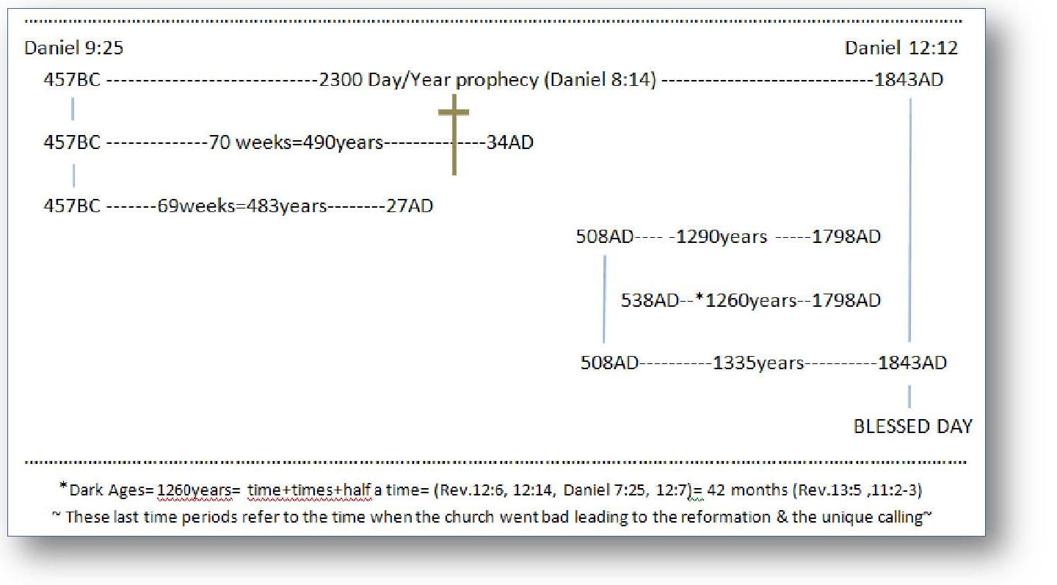

POPE ON EVOLUTION
PROTESTANTS FOLLOW

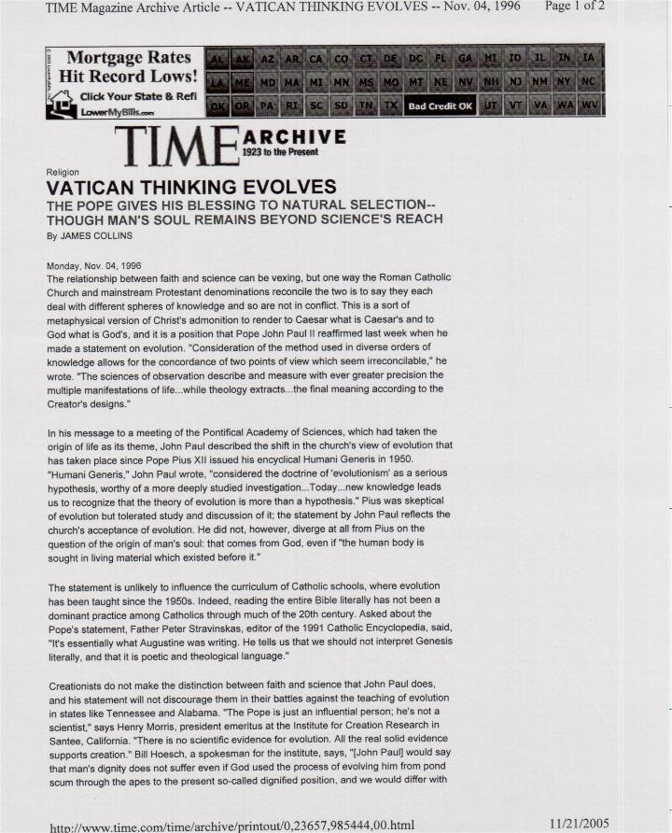
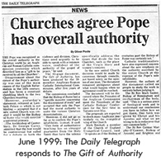

SUNDAY ART

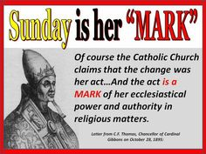
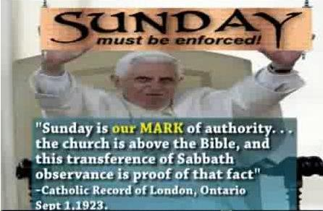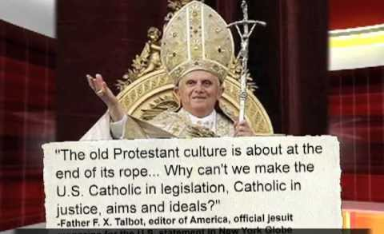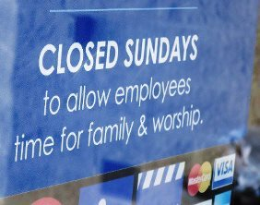
Have you ever heard of “Sunday Blue Laws” that the USA congress adopted in 1888? Did you know they are still on the books of law just not enforced? So get ready; to either accept man’s ‘forced’ mark of worship (Mark of the beast) or Gods (Seal) remember forehead. You can’t ignore this after receiving the knowledge Gods message He has has been sending from Day one, and all will hear the truth He requires of them, some more some less, but we all will be shown everything we need to do to be saved. (Mark 10:17-21) Or is your church still using Satan’s old deception adage that “It doesn’t matter to God what day – what FRUIT YOU EAT” listen to me not Him he was saying, sound familiar? (II Thessalonians 2)
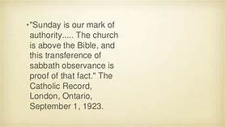
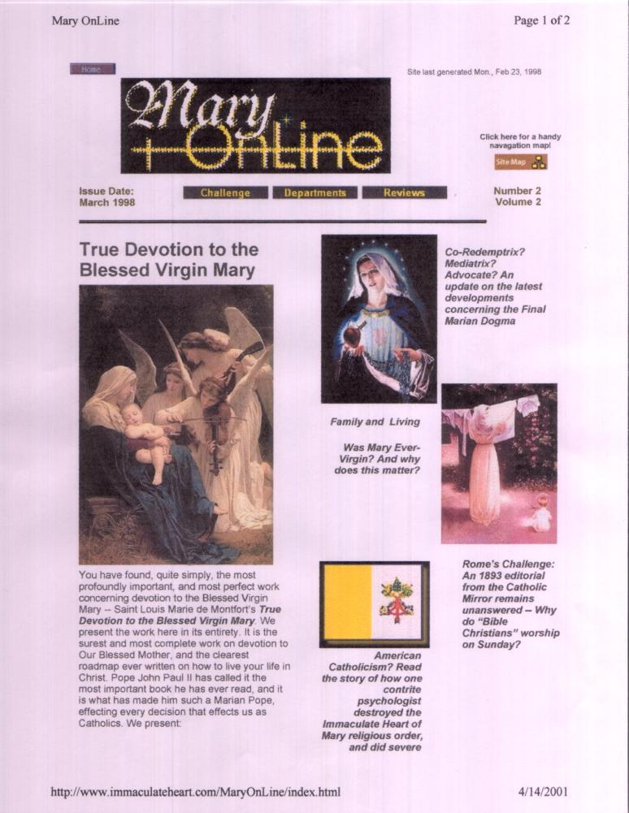
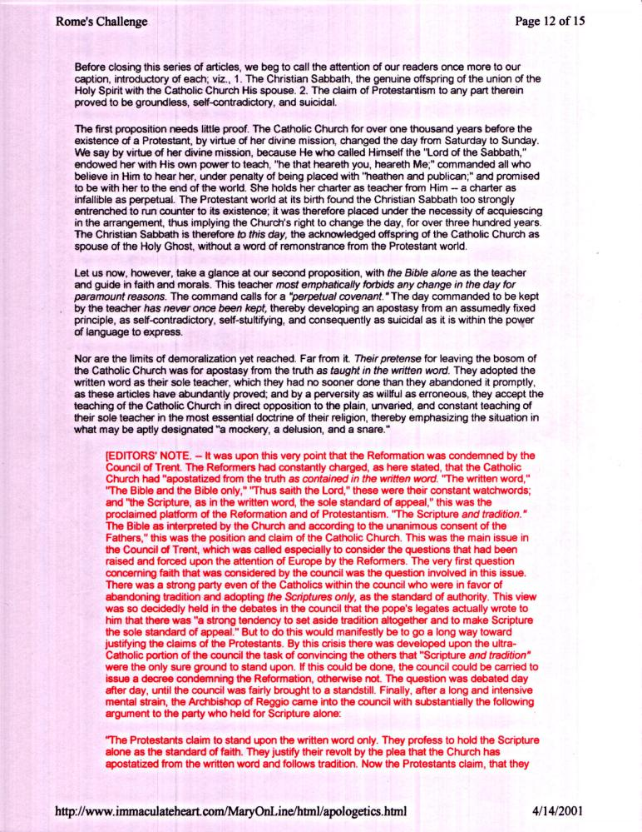
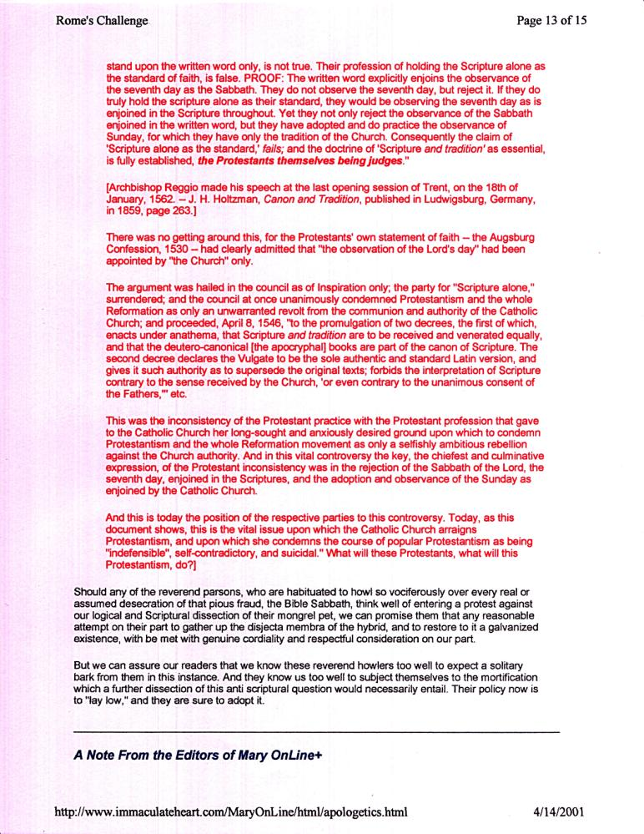
(This site was established when I started my site in 1998, and when I first discovered this article, But, it was strangely taken down when I first published it on my web site in 2004 and when I gave scriptural proof, just who is who according to God through prophecy. See in what subject I attached it to in 2004; www.mosescats.com “The Last World Empire”)

Don’t let this throw you; the first Covenant had two laws governing the plan of Salvation, the Moral and the sacrificial and both pointed to the Messiah to come. One; the moral law describes His (and His/our Fathers) perfect character in not breaking one precept of the 10 commandments “as an example for us towards sanctification”. Two; the other law pointed to the blood of Christ which “justifies us”, which of course only His blood alone is what atones us. But, Paul is clear both laws were to be obeyed by the first church until the Messiah would come as the Lamb of God to die for us sinners (of all of mankind). You see; the Moral law of God was what pointed out sin as a school master and the physical law in types and shadows pointed out the way the plan of salvation works. (Gal. 3:24-29, 19) as long as they kept both physical and moral of old, and we keep the moral today we can be saved, or if not we too will need to be re-schooled, see it? Both Laws then pointed the penitent sinner, them and us, to Christ “who only can save us from the penalty of sin.” But, since sin still remains a problem since Eden to today, it couldn’t be done away with “as todays false teachers teach” till all is fulfilled, essentially they are calling Christ a liar (Math. 5:17-20) because; the Law is still needed to point out sin today (for the terms of sin have not changed nor has the character of God) and by us keeping (fulfilling) it, as did Jesus, “justifies us physically before God,(like bringing the lamb of old)”, and then His Spirit points us to Jesus to remove that sin by His blood at the great Yom Kippur judgment to come someday, (Rev. 20:12) both for us and them; But the more important work, to sanctify us (in our conscience) will be done in us (John 14:15-17) through the lifetime work of the Holy Spirit Jesus sends to purge us of all sin ultimately, if that is we let Him in, and love Him by keeping His/Fathers commandments as He asks us to. BUT! As Christ was emphatic on the conditions of salvation, Paul is just as emphatically clear when it comes to Gods law; in that; we cannot and “will not be justified” by Christ before God and the judgment “if we continue to break Gods moral law of the Ten Commandments”, saying then Christ cannot sanctify us in our “willful sins against their law” IF we continue to break them “any one of them mind you”, justification is prerequisite then for sanctification to take place in us. (Romans 2:12-13) While it’s true, as the false teachers only teach us one side of the truth; “our works cannot save us (Romans 3:20) but they can destroy us”! So in the end any sinful works against Gods Law “will not, cannot exist in heaven, thus they must be purged from us “by the Lord through the Holy Spirit” doing His (Gods) works then through us. (John 14) Like I say; don’t let this throw you because I know this might be confusing and new knowledge, but it’s what the Bible teaches about salvation, and what Paul is really saying in discussing the two covenants and the two laws. (II Peter 3:15-16) We must see this however! Why? “To escape the false religions” that can keep us out of heaven by breaking Gods Laws with impunity. This is what we are going to be discussing in this all important study of “The Same Message,” and really my friend “God is not dividing the old against the new” as we are falsely being led today, for “His message has been the same for them back then as well as us today”, as we are going to discover, it’s the same from and for eternity, from forever to forever thus the Eternal Gospel my friend.
Remember He died for all not just the Jews. (Romans 2:11-29) Paul goes on about salvation….
While it is true many have been called perfect, Noah, there was Enoch, Elijah and Elisha etc., even Moses who did have to die, but they saw an early heaven because they all believed and followed God wherever He went, wherever and whatever, and as our examples they received His promise and power to even be taken to heaven some without tasting death, which means; to be without guile and willful sin, and called so why? “Because of their choice of faith and Godly works”, and as I said their stories were given to as examples for us to follow as well “our Father God as did Jesus”.
By the time the remnant (last of the seed) people/church received this message in 1843-44 and understood it, “the judgment had already come”. (See www.mosescats.com “Yon Kippur”) That’s why the word was translated “is come” instead of “will come” or “had/has come”, because; when John wrote it down the final judgment (The cleansing of the heavenly sanctuary) “had not come”, neither did he nor Daniel fully understood it. BUT; at the end of the 2300 day/year prophecy “, when that message fulfilled (See time chart Appendix) the final judgment just then had begun”, and by the time the remnant people/church figured it out “is come” then was the operative word. For those, who as Daniel and John, who read the words and not fully understanding them “will” would have been the word God could have used or the translators could have used, BUT, the judgment “had” not come so “has come or had come” would not have been accurate, but; “is” was the correct translation God obviously wanted written. Why? For the remnant people/church who; “would come to understand it” after 1843-44 would then see without doubt “when it was to come and when it did come”, get it? Confusing yes! But ultra-important for us to see this truth from this message-messages-all these end time revelations for us here in that end. (Hebrews 9 & 10 in context to the cleansing of the Sanctuary’s both earths and heavens, another must understanding)
Remember the first church was cut off from God and so were all the people that clung to it, and their faulty faith and traditions, and so was and will be the second church, who also have their own doctrines and traditions they claim as the faith by holding on to them. But, they are “not of Gods design” despite the knowledge given in the final words of prophecy found in Revelations, and being the same as found in Daniel, carrying The Same Message as always from the beginning to the end, Gods message which governs the religion of the universe, and why I created this site. (See booklet “Watchman On Wall” this site.)
Can you imagine after the saved have been in heaven, or on the new earth, and at some time after, say 50 years into eternity they decide that the pope could have been right we could just as easily be worshiping on Sunday instead of every 7th day, (Isaiah 66:22-23) what difference does it make, isn’t every day holy then? But as Lucifer we start spreading it around and challenging Gods such strict law again, and suddenly “sin” (James 2:10) raises its ugly head again? Well, don’t even try to imagine that ever happening again because it won’t! Why? “Because all who are saved will, even under the penalty of death, (Rev. 12:11) follow God in every way He asks them too, and would rather die “like Jesus” rather than breach even one commandment of His Covenant. (John 14:10-12 and on) That my friend; is “why they were saved” and, they would never for a trillion years go back on that faith as did the 2/3 part of the angles in heaven originally when Lucifer (the great red dragon beast) tried to sway them away, but they remained faithful to our God. Sin thus in the new heavens and earth (Rev. 21:1) will never rise again “forever”, because “the love of God will be within written upon all of mankind’s minds and hearts”, from Adam to the last woman or man that was saved, of course “by His love”, from this earth and its curse of death. (Rev. 22:1-4) Get the picture yet? You see our faith is in our will “in our thoughts our choices” just as it has been from the beginning (I John 3:7-11) and specifically speaking to us of the remnant people/church; (Rev. 14:1-5, See also Rev. 7:3, 9:4, 13:16 in context, 14:9-12, 20:4, 22:14-16) So we see; Gods “Covenant” will be in their foreheads as is Gods will for His created beings from eternity to eternity. You see; our forehead is where the spiritual battle is waging for us as mankind or against us, (Deut. Hebrews) as it has always been since the garden and the choice of tree of what? (Gen. 1:17, 2:3-5) “Knowledge” is found where within us? So I ask: what’s the difference today than then? They were under grace then as we are now, and sin is still sin against Gods Commandments either “one or ten” (James 2:10-12) so what’s the difference? You tell me; while Satan is still tempting us with “his” knowledge. Surely now the picture is clear what group we are in Gods or mans? The door of change is still open my friend, but soon it will close. (Rev. 22:10-12) It appears to me that mankind at some point will be caught in the middle of decision, a decision that needs to be made “before” time is cut short by our Lord God, who forewarned us; that His long awaited coming will be as a thief in the night to all. (Matthew 24:43-44) So for all of us; now is the time to prepare for the judgment of rewards; either life eternal or death eternal. He said in His last words (Rev. 22:10) “The time is at hand” and that was written how many years ago? If you read my book “Convinced” (this site) you will see that time is nearly come prophetically, it’s closer than ever. This is Gods alter call for me what about you…
America was founded upon Protestantism primarily at first by people trying to escape the beast power who reigned over politics and religion in the old country. Early in America the Papacy was banned from having any power over politics and especially religion. (See “Vanity Fair” magazine archives for this proof, search Pope, Papacy, democrats)
God gives so many prophetic descriptions and prophetic time frames; to Daniel first and then John that could/can only apply to her as the beast power/religion, (See sir Isaac Newton’s book Appendix) we are talking the beast who will deceive the whole world of religion, who nearly deceived the whole world “save that God protected His Message” through her first reign of terror, and of whom He raised at the end of that reign, a remnant church/people to expose her through prophecy, as well as get this message of revelation from God called the Gospel (Rev. 14:6-9) to the whole world’s nations, tongues and people. (See www.mosescats.com “Yom Kippur”) thus, exposing the beast as who she was “and will be” when her wound, God gave her fully heals, BUT not what she will appear to be then; through her many false doctrines, traditions and deceptions. (II Thess. 2) Even when she has taken Gods name out of His worship adding her own ancestral worship ties (Rome) (SAbba-thUNday) through blasphemy and her claiming to forgive sins and to judge man worthy to live or die by her traditions, and by allowing himself a man to be seen and titled as gods sole representative on earth the world will not see her as the beast nor understand Gods forewarnings and promised deceptions of who she was is and will be? (The reason why is found in John 14:15-17 in context, and what this piece is trying to expose as Biblical truths for the end.)
Isaiah 28:9-13 using many texts to see an answer or proof from one text to another ‘is a Biblical principal.”
When one was gone another was chosen, right? To keep it 12 obviously.
This connection is particularly important to our salvation, (remember justification terms) as we see the worship practices today not as God designed but as man has designed, and remember who’s wisdom grants eternal life-which tree? I could end on this note but I have a more conclusive ending.
This day was especially set in time and concluded the weekly cycle of days according to Gods design dividing work days from worship day, and, the Bible is the only source for when the week was first set in time for reckoning along with the planets, sun, moon and stars we still use today to calculate time according to history, just look at the order of days still on most calendars yet today, you’ll see the seventh day still ends the week.
See my book “We Look Like God” this site and others on www.Amazon.com search joseph ancion.
Another deception of the papacy is their false doctrine of eternal punishment in the fires of hell, (See my booklet “Heaven Hell” this site) as this text seems to imply “if taken alone” as do a few other ambiguous texts. To know the truth without further Bible study leaves you (subconsciously) with a gross concept of our loving and forever merciful God, confusing even the “elect”, but the Bible is clear on this subject once you study it from Genesis to Revelation if you “elect” to do so.
A remnant lady’s is what? A piece of cloth, the last on the bolt, that looks like the one on the first of the bolt. Thus the remnant church/people will be like that, as will be their “message the same” as was Jesus’s, and that is the point of this study and what I’ve gone to great lengths to get across, applying texts “in context” both Biblically and subjectively, and yes, I use the same texts over and over and intentionally, why? “Because they one” are important, and two; you won’t get them (the messages) in your church, because most of them paint a negative picture on the state of their art of religion, today being mostly abstract and divergent from the truth as Paul told the Thessalonians. So God speaks of us as well. If you underline or highlight all the texts I give, using King James Version KJV the closest to the original manuscripts (if you don’t have one get it just for my studies) mark them and then look back at them from beginning to end “just those things underlined” (especially the words of Jesus) which we have already seen they are in their correct “context”. Just scan through them and you will see “the common denominator to the eternal life equation.” Jesus said; I am the truth the life and the way follow me, but how can we follow Him if we are following a lying religion of the past, present and future; If they have been proven wrong only “in one point alone” (S-Abba-th) it’s out of sync with scripture and with Gods will? “The WAY is the TRUTH and the LIFE”; all supplied to us through Jesus our Lord and Savior through His Word from the Father, (John 14) to our hearts and minds.
I Kings 3:12 who is wiser than; your preacher, your church, your religion, you? You tell me out loud.
In Matthew 24 Jesus gave us a glimpse of what the end times would be like, but also, He referred us to the past Vs. 15) and warned us to know and understand these things we are studying about prophecy, and that He gave this message back then to Daniel and then again to John and subsequently to us (Revelations) as warnings for our preparation for the end times. When; even the elect vs. 24 could be deceived, and how deceptions and false prophets will try to sway us from the truth and how the beast will in the end deceive all the world, of religion in particular, and Paul tells us that God Himself will let us have our own ways and beliefs and even enforce the deception since it’s our final choice and they never will accept the truth. (II Thessalonians 2)
What we need to take from this is not that the commandments are invalid, just the opposite it’s clear or Jesus would have reprehended the man for doing works as do the nominal churches today, but instead; He told him what it takes to achieve eternal life spelling it out clearly as did Isaiah, and when the man said; “I have been doing this in faith all my life, Jesus loved Him” if only for a moment. Why? Because he, as Jesus himself, they both, to that point, were following God’s message. It’s only when the man walked away, as if turning his back on what he had been doing all his life, and now would not follow as he once had in the faith of Jesus and where that leads was his fate acknowledged by God.

